***ECON 3 IN DIAGRAMS***

***TOPIC 1) THEORY OF PRODUCTION***

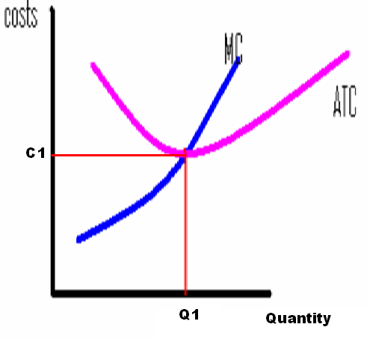

* C1Q1 shows productive efficiency i.e. firm is operating at lowest ATC. All economies of scale have been exploited (e.g. managerial, technical, purchasing and financial) and the onset of diseconomies of scale has not yet occurred i.e. the problems of output becoming too large such as communication, co-ordination and industrial action (raises ATC)
* C1Q1 also achieves optimum output and minimum efficient scale
* Notice that MC cuts ATC at its lowest possible point. This is because to the left of Q1 MC is less than ATC. To the right of Q1, MC exceeds ATC, so leads to ATC increasing.

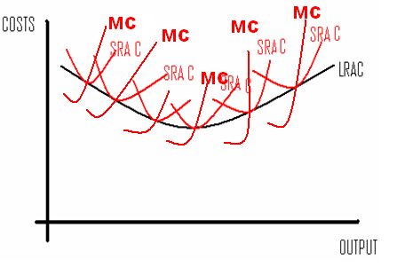

* This diagram differentiates between production in the short-run and long-run. In the short-run, at least one factor of production remains fixed. This means firms will experience economies of scale and diseconomies of scale on their SRATC curves.
* In the long-run all factors of production are variable and means firms can shift SRATC curves BUT still eventually will experience diseconomies of scale

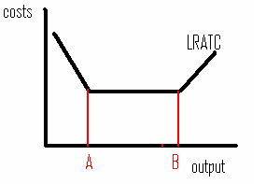

* Point A is known as minimum efficient scale. It is the smallest output the firm must produce in order to achieve productive efficiency i.e. lowest ATC

***TOPIC 2) THE OBJECTIVES OF FIRMS***

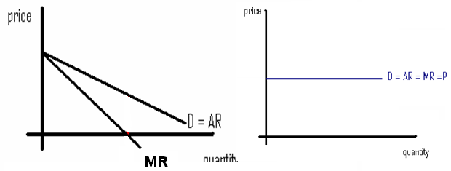

The diagrams above show the revenue lines for two different firms. The left diagram shows the curves for a firm who must lower price in order to increase demand for their output, which means that marginal revenue will constantly fall as output grows (due to lower selling price). This will bring down average revenue.

The right diagram shows the revenue curves for a firm who sell all products at the same price, which means P, AR and MR will always remain constant

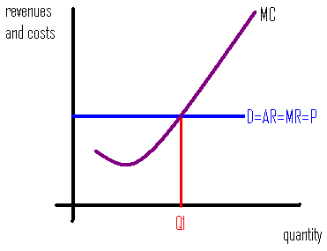

This diagram shows the profit maximisation point for a firm (MC=MR). At Q1 the firm cannot achieve higher profit unless D shifts upwards and/or MC=S moves to the right. At profit maximisation, any additional output will lower profits because the addition to total costs (MC) exceeds the addition to total revenue (MR)

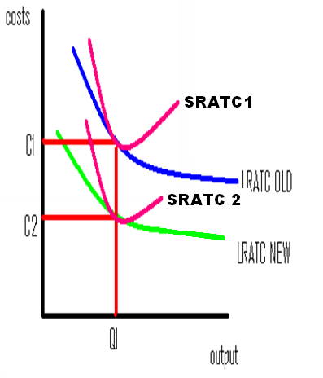

This shows the impact of technological improvements. Greater innovation and invention will mean firms have improved capital and labour. This means ATC will reduce, which means firms can produce Q1 at a lower cost (C1 – C2)

***TOPIC 3) PERFECT COMPETITION***

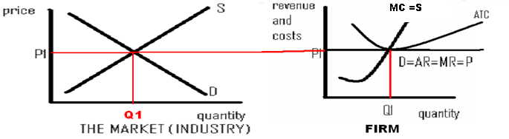

A firm in perfect competition will take the price (price taker) from the market equilibrium price due to all products being homogenous (this means prices cannot increase beyond P1 as this would result in lost demand and a reduction in price below P1 is not worthwhile because output can be sold at P1 i.e. higher price)

At P1 the firm will achieve productive produce at lowest ATC) and allocative efficiency, which collectively is known as static efficiency (produce to where D = S). This will mean the firm will only achieve normal profit because the product is sold at the ATC i.e. AR = ATC

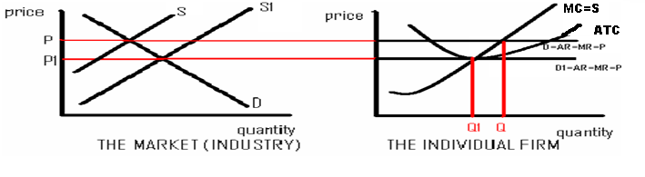

A firm in perfect competition can in the short-run achieve supernormal profit. If for example supply fell to S, then price would increase to P, meaning the firm would profit maximise at Q and therefore sell products at a price above ATC. This supernormal profit will however entice new firms into the market (no barriers to entry or exit), which means supply will increase, prices fall to P1 and mean the firm will again only achieve normal profits.

***TOPIC 4) MONOPOLY***

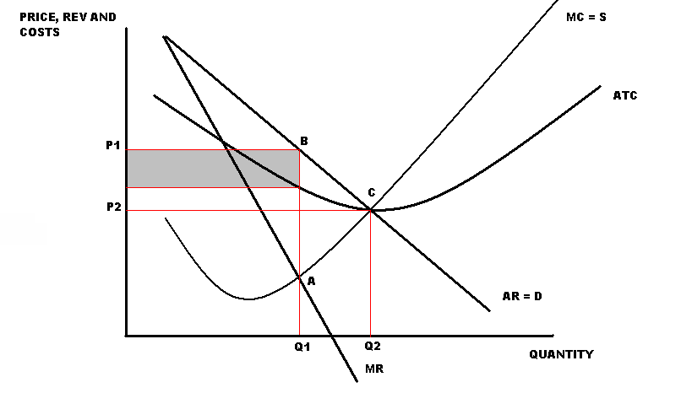

A monopoly will profit maximise at Q1 where MC = MR. These firms are price makers, so will charge P1 (equal to demand price). This will result in the shaded area representing supernormal profits (difference between AR and ATC).

If static efficiency was achieved we would be at point C, which is where allocative efficiency is achieved (D = S) and productive efficiency is achieved (producing at lowest ATC). This would result in lower prices and higher output (P2,Q2). The monopoly therefore under-provides and charges a higher price, which creates a dead-weight-loss (ABC), which measures the loss of economic welfare

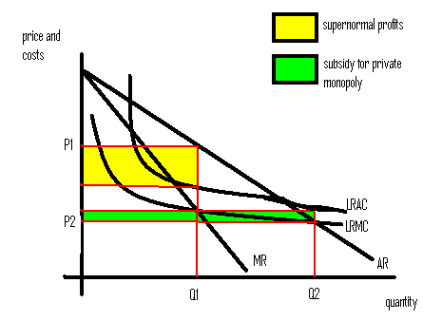

This shows the natural monopoly situation. A natural monopoly provides an argument in favour of a monopoly in certain markets. When set-up costs are high, output levels increasing will always result in economies of scale because the high set up costs are spread over a greater output level. A monopoly will again operate at P1,Q1 and achieve supernormal profits. A more competitive market will however lead to P2,Q2 (D=S). This appears good because output is higher and prices lower. However at this point AR is lower than ATC, which means government subsidies are required to enable firms to cover costs and therefore remain in the industry

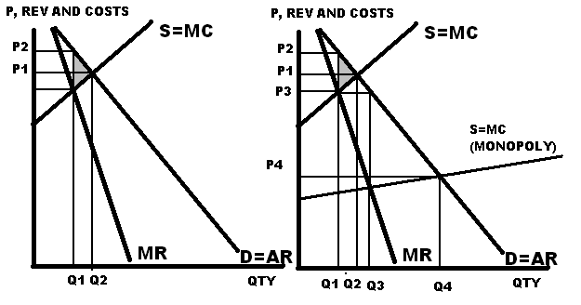

The diagram on the left suggests that monopolies are bad for customers. This is because a monopoly will charge P2 and offer Q1, but competitive firms will offer Q2 at a lower price (P1). This means that the monopoly is creating a dead-weight-loss equal to the shaded area.

The diagram on the right does however suggest that monopolies are able to invest into capital and labour improvements due to supernormal profits. This may mean they can operate on a lower MC curve than a competitive firm. This will mean they can profit maximise at P3,Q3, which is clearly better than a competitive firm can achieve. P3,Q3 is still however not efficient, because this would occur at P4,Q4

***TOPIC 5) OLIGOPOLY***

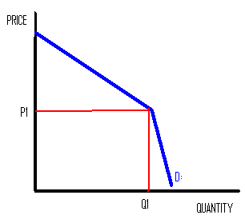

The kinked demand curve suggests that firms in an oligopoly will collude on price and therefore avoid price competition. An increase in price above P1 will result in revenue falling because above P1 the demand curve is price elastic. A reduction in price below P1 will also reduce revenue because below P1 the demand curve is price inelastic

***TOPIC 6) COMPETITION POLICY AND CONTESTABLE MARKETS***

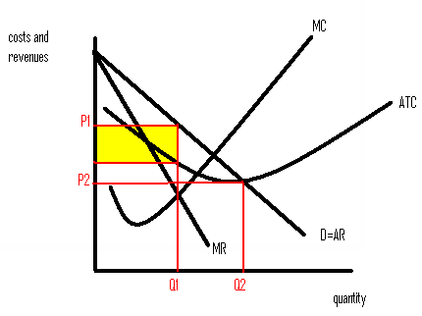

Making a market contestable will mean that a monopoly will no longer be able to charge P1 and offer Q1. The firm will now need to charge P2, offer Q2 and therefore only achieve normal profit. Any supernormal profits will mean new firms would enter the market and compete due to zero barriers to entry and exit. The threat of competition will mean the firm will have to remain efficient.

***TOPIC 7) LABOUR MARKET D & S***

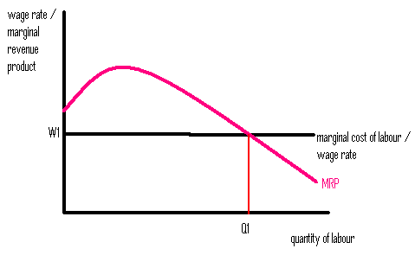

Labour will all be employed at the same wage rate, which means that the MC of labour will remain constant. Firms will here employ Q1 people at W1 because this is where the firm maximises their profits on labour. Anything beyond Q1 will result in lower profits because the revenue generated per worker (MRP) is less than the MC of labour.

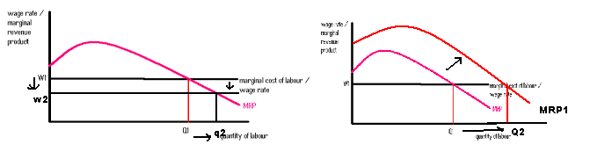

If MRP increased or MC fell then demand for labour would increase. Therefore if MC increased or MRP fell, then demand for labour would fall.

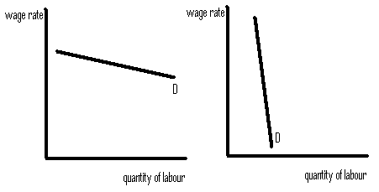

The left diagram shows a wage elastic demand curve i.e. a small fall in wages will lead to a larger increase in demand ALSO a small increase in wage rate will result in a large fall in demand. This could exist when; demand for the product is price elastic, workers can be easily substituted for other factors of production e.g. capital and when labour costs form a large proportion of the overall costs of production. This is also likely to occur in the long-run

The right diagram shows a wage inelastic demand curve i.e. a large increase in wage rates will only lead to a small change in demand for labour ALSO a large fall in wages will only lead to a small increase in demand for labour. This could exist when; demand for the product is price inelastic, workers are difficult to replace with other factors of production and when workers form a small percentage of overall costs of production. This is likely to be the likely outcome in the short-run

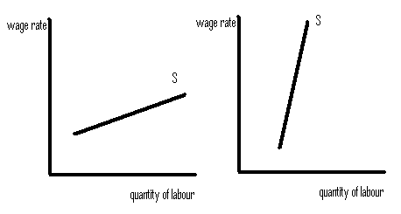

The left diagram shows a wage elastic supply curve i.e. a small increase in wages will lead to a larger change in supply of labour ALSO a small decrease in wages will lead to a larger fall in supply. This could exist when; the job is low-skilled, requires a short training period and is in the long-term

The right diagram shows a wage inelastic supply curve i.e. a large increase in wages will lead to a small increase in supply of labour ALSO a large fall in wages will not drastically affect supply of labour. This could exist when; the job is high-skilled, requires a long training period and is in the short-term

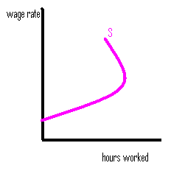

The relationship here is that initially when wage rates increase, people will supply more labour, but eventually, people believe they have earned enough and consider the opportunity cost i.e. leisure time, so start to reduce their supply of labour when wage rates increase beyond a certain point

***TOPIC 8) LABOUR MARKET WAGE DETERMINATION***

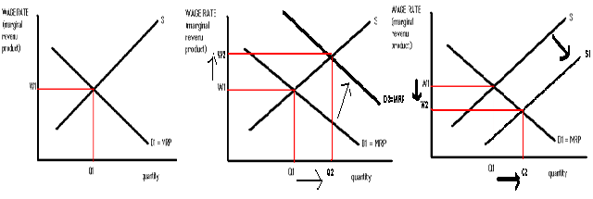

Left diagram shows labour market equilibrium point i.e. the wage rate where the demand for labour is equal to the supply of labour. Demand is based on the marginal revenue product (revenue generated per worker). Supply will increase when wage rates increase.

Middle diagram shows the impact on labour markets of an increase in demand for labour. This may have been caused by a growth in MRP, increase in demand for the product or an increase in the cost of alternative factors of production such as capital

Right diagram shows the impact of an increase in supply of labour. This may have been caused by a reduction in the availability of jobs in other industries, reduction in wages in other industries, reduction in skills/training period to enter this industry or an increase in working population

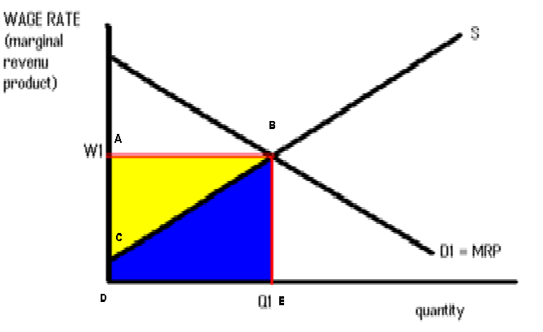

Area CBE (bottom shaded triangle) measures the transfer earnings. This is the area below supply, which means if wages fall into this area, then staff will leave their jobs. Area ABC (top shaded triangle) measures the economic rent. This measures the earnings staff earn above transfer earnings and is money staff earn above their minimum wage expectations

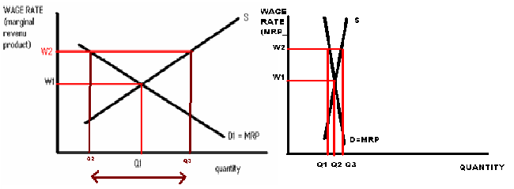

In the above diagram labour market equilibrium occurs at W1Q1. Trade unions will through collective bargaining seek to raise wage rates to W2. If this is however not accompanied by a growth in MRP, then it will create excess supply of labour equal to Q2-Q3. The left diagram shows that the trade union mark-up of W2 will create a larger level of unemployment than in the right diagram where D and S are both wage inelastic. The Trade Union will therefore be more successful and have more power in a wage inelastic labour market

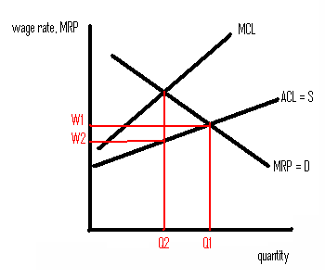

This is the diagram which shows the labour market for a monopsony (sole buyer of labour). The monopsony has control over the full labour market, so can be a ‘wage-maker’. The monopsony faces an upward sloping ACL = S line because to attract additional staff into the industry they need to raise wage rates. The firm will maximise profits on workers when MCL = MRP because anything to the right of this point means the additional to total revenue of labour is less than the addition to total costs of labour. The firm is however a wage-makes, so will pay people the minimum they will work for at Q2, which is W2. A trade union will through collective bargaining be able to raise wages to W1 and demand for labour to Q1.

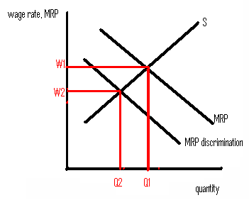

This diagram shows the impacts of negative discrimination. Employers will assume certain sections of society will only offer a low MRP (discrimination), instead of the higher MRP. This will mean some sections of society receive a lower wage rate and lower demand for their labour (W2Q2) instead of W1Q1. This may be caused by; ethnic minorities, women, older people and people in part-time work.

***TOPIC 9) DISTRIBUTION OF INCOME AND WEALTH***

[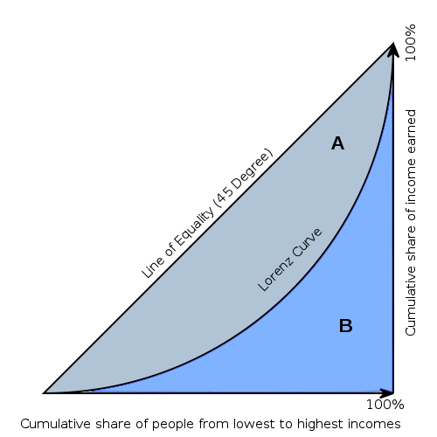](http://visualign.files.wordpress.com/2011/09/lorenzcurve.png)

This diagram is known as the Lorenz Curve. Full equality occurs on the 45 degree line. The further the Lorenz curve is way from this, the greater the inequality. This can be used to calculate the gini co-efficient, which is calculated by A / (A+B). A number between 0-1 is generated. A number near 0 is more equal than a number near 1

***TOPIC 10)GOVERNMENT INTERVENTION IN THE MARKET***

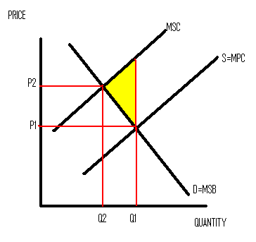

Environmental problems can be measured through the above diagram. In a free market, equilibrium will occur at P1Q1, where only private costs are considered, which means external costs are left for the third party to deal with. This leads to an over-production as the costs of environmental damage are not being paid for. This creates a dead-weight loss equal to the shaded area i.e. this measures the fact that social costs exceed social benefits. An indirect tax or pollution permit can be used to create P2Q2 by making the producer internalise the environmental problems they create