***Macroeconomic Objectives and Macro Stability***



***What are objectives of macroeconomic policy?***

1. Objectives are the goals of government policy
2. Instruments are the means by which these aims might be achieved

For example, the government might want to achieve an objective of a low rate of price inflation. The main instrument to achieve this are changes in monetary policy interest rates, since 1997 they have been set by the Bank of England. Fiscal policy could be another instrument to achieve this aim. This is in the hands of the government. Supply-side policies can also be used to control inflation and promote growth over the longer-term.

The government might have another objective to make the distribution of income more equal. It would then choose the policy instruments it thinks are best suited to reaching to this aim, perhaps a change in the income tax system or a rise in the national minimum wage.

***The main policy instruments available to meet macroeconomic objectives are***

* **Monetary policy** –changes to interest rates, the supply of money and credit and also changes to the value of the exchange rate
* **Fiscal policy** – changes to government taxation, government spending and borrowing
* **Supply-side policies** designed to make markets work more efficiently

***Objectives of UK Macroeconomic Policy are***

* **Stable low inflation** - the Government’s inflation target is **2.0%** for the **consumer price index**.
* **Sustainable growth** – growth of **real gross domestic product** – sustainable in keeping inflation low and reducing the environmental impact of growth.
* **Improvements in productivity** – this is designed to improve competitiveness and global trade performance
* **High employment** - the government wants to achieve **an increase employment** and eventually a situation where all those able and available can find meaningful work
* **Rising living standards and a fall in relative poverty** – cutting child poverty and reducing pensioner poverty.
* **Sound government finances** - including control over state borrowing and the total national debt

***What is meant by macroeconomic stability?***

* Economic **stability** occurs when there is low volatility in key indicators such as prices, jobs, growth, interest rates, investment and trade.
* All countries experience an **economic cycle** which tracks the fluctuations in the rate of growth of a country’s **Gross Domestic Product,** some countries have a more volatile cycle than others

***Economic Cycle***



All countries experience regular ups and downs in the growth of output, jobs, income and spending.

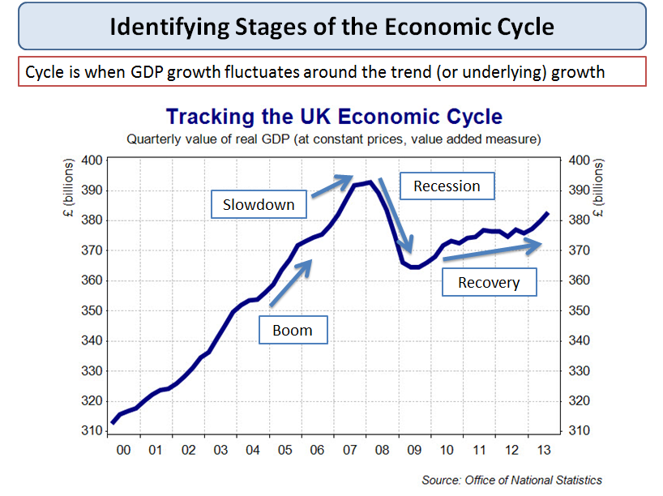

UK economic cycle

***Boom***

* A **boom** occurs when real national output is rising at a rate faster than the trend rate of growth. Some of the characteristics of a boom include:
* A fast growth of **consumption** helped by rising real incomes, strong confidence and a surge in house prices and share prices
* A pick up in **demand for capital goods** as businesses invest in **extra capacity** to meet strong demand and to make higher profits
* More jobs created and **falling unemployment** and higher **real wages**
* High **demand for imports** which may cause the economy to run a larger **trade deficit** because it cannot supply all of the goods and services that consumers are buying
* **Government tax revenues** will be rising as people earn and spend more and companies are making larger profits – this gives the government money to increase spending in areas such as education, the environment, health and transport
* An increase in **inflationary pressures** if the economy overheats and has a positive output gap

***Slowdown***

* A slowdown occurs when the rate of growth decelerates – but national output is still rising
* If the economy grows without falling into recession, this is called a **soft-landing**

***Recession***

A **recession** means a fall in the level of real national output i.e. a period when growth is negative, leading to a contraction in employment, incomes and profits.

A simple definition:

* A fall in real GDP for ***two consecutive quarters*** i.e. six months

***There are many symptoms of a recession – here is a selection of key indicators:***

1. A fall in purchases of components and raw materials (i.e. intermediate products)
2. Rising unemployment and fewer job vacancies available for people looking for work
3. A rise in the number of business failures and businesses announcing lower profits and investment
4. A decline in consumer and business confidence
5. A contraction in consumer spending & a rise in the percentage of income saved
6. A drop in the value of exports and imports of goods and services
7. Large price discounts offered by businesses in a bid to sell their excess stocks
8. Heavy de-stocking as businesses look to cut back when demand is weak – causes lower output
9. Government tax revenues are falling and welfare benefit spending is rising
10. The budget (fiscal) deficit is rising quickly

***The difference between a recession and a depression***

* A **slump** or a **depression** is a prolonged and deep recession leading to a significant fall in output and average living standards
* A depression is where real GDP falls by more than 10% from the peak of the cycle to the trough
* An example of a country that has suffered a depression in recent years is **Greece**. National output has fallen in six successive years and real GDP is more than 25% lower than at the peak of the cycle

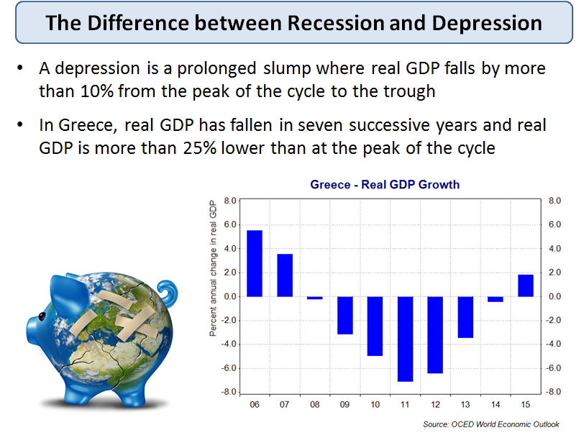

***Recovery***

* This occurs when real GDP picks up from the **trough** reached at the low point of the recession.
* The state of business confidence plays a key role here. Any recovery might be subdued if businesses anticipate that it will be temporary or weak in scale.
* A recovery might follow a deliberate attempt to stimulate demand. In the UK we have seen

1.Cuts in **interest rates** – the policy interest rate fell to 0.5% in the Autumn of 2008 and they have stayed at this low level since then

2.A rise in **government borrowing**

3.A policy of **quantitative easing** (QE) by the Bank of England to pump more money into the banking system in a bid to increase the supply of loans – now worth more than £375 billion

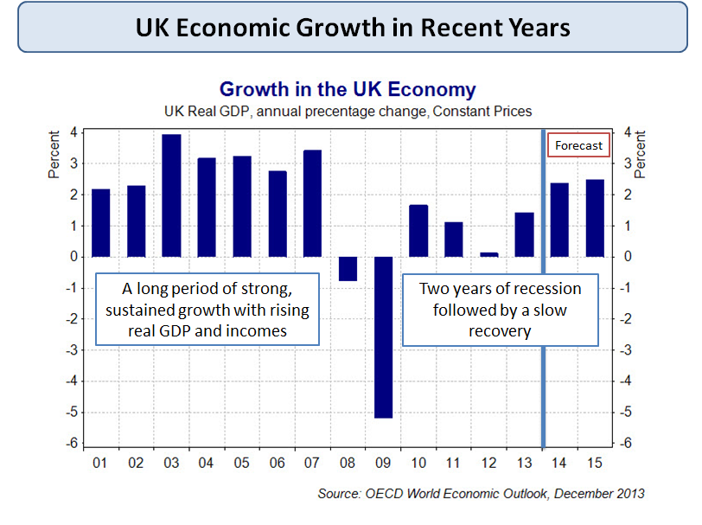

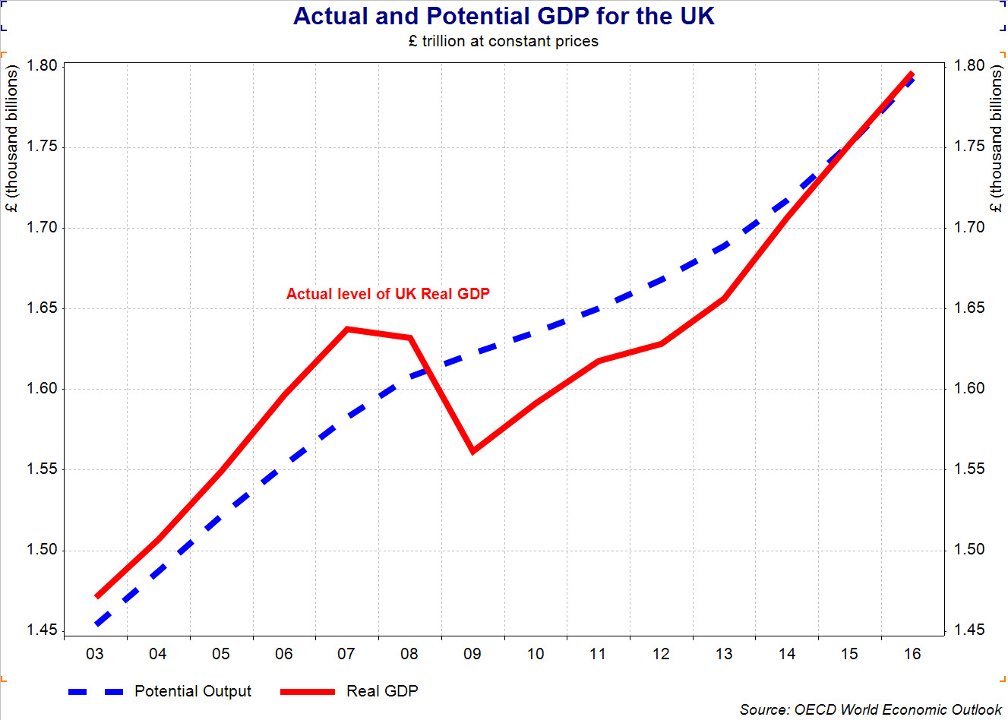Estimated output gap for the UK

***Why is GDP growth difficult to forecast?***

No macroeconomic model can hope to cope with the fluctuations and volatility of indicators such as inflation, exchange rates and global commodity prices.

* Uncertain business confidence levels
* Fluctuations in exchange rate
* External events e.g. volatile oil and gas prices
* Uncertain reactions to macro policy changes
* Rate of business job creation hard to forecast

***Demand shocks***

The equilibrium position of national income will change, ceteris paribus, following an economic shock. Economic shocks either arise from the demand side or the supply side.

***Exogenous and endogenous demand side shocks***

An exogenous demand side shock is one caused by a sudden change in a variable outside the [aggregate demand](http://economicsonline.co.uk/Managing_the_economy/Aggregate_demand.html) (AD) model, whereas an *endogenous* shock comes from within the model. For example, a sudden change in [investment](http://economicsonline.co.uk/Managing_the_economy/Investment.html) is an endogenous shock, because investment, 'I', is in the AD equation, whereas a sudden change in the exchange rate is an exogenous shock because exchange rates are not directly included in the AD equation.

1. Shocks affecting [household](http://economicsonline.co.uk/Managing_the_economy/Household_spending.html) or corporate spending, such as changes in [unemployment,](http://economicsonline.co.uk/Managing_the_economy/Employment_and_unemployment.html) [savings](http://economicsonline.co.uk/Managing_the_economy/Saving.html), confidence, wages, and [profits](http://economicsonline.co.uk/Business_economics/Profits.html).
2. Shocks associated with changes in [liquidity](http://economicsonline.co.uk/Managing_the_economy/Liquidity_and_wealth.html) and the availability of consumer and business credit, as in the recent *credit crunch*.
3. Changes in spending associated with changes in [house prices](http://economicsonline.co.uk/Competitive_markets/The_housing_market.html), [share](http://economicsonline.co.uk/Competitive_markets/The_stock_market.html) and bond prices, called [wealth effects](http://economicsonline.co.uk/Managing_the_economy/Liquidity_and_wealth.html).
4. Shocks affecting [investment](http://economicsonline.co.uk/Managing_the_economy/Investment.html) spending, including changes in bankruptcies, business confidence, and profit levels.
5. Changes in [government finances](http://economicsonline.co.uk/Managing_the_economy/The_public_sector.html), brought about by wars, and changes in unemployment.
6. Other demand side shocks affect planned spending indirectly, such as changes in:
   1. Interest rates, which affect both consumer and investment spending.
   2. Tax rates, which also affect consumer and investment spending.
   3. Exchange rates, which affect exports and imports.

Changes in nay of the above will shift the position of the AD curve.

***Shifts in AD***

An increase in AD, such as that caused by an increase in household spending, is shown by a rightward shift in the whole AD curve.

The shift in demand will have an effect on the price level and national output, but the effects may not be uniform because aggregate supply (AS) may not be linear.

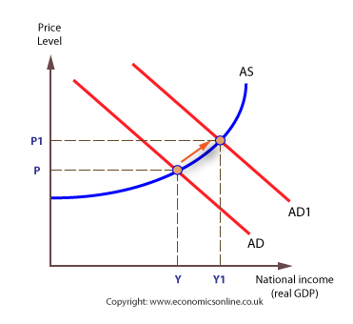

The non-linearity of AS reflects variation in the elasticity of [aggregate supply](http://economicsonline.co.uk/Managing_the_economy/Aggregate+supply.html).

***Full employment***

If the economy is already near full employment (at Yf), with only a small [output gap](http://economicsonline.co.uk/Managing_the_economy/Equilibrium.html), any increase in AD will result in price [inflation](http://economicsonline.co.uk/Managing_the_economy/Inflation_and_deflation.html), but little increase in output.

With a small output gap and an inelastic Aggregate Supply curve the inflationary effects of a sustained increase in Aggregate Demand will be considerable.

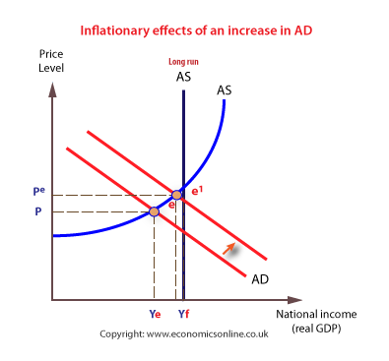

This increase in AD clearly poses an economic problem, as the economy cannot cope with the extra demand. However, [Classical economists](http://economicsonline.co.uk/Managing_the_economy/Aggregate+supply.html) would argue that the macro-economy will self-adjust back to the full employment level.

***Supply-side shocks***

The level of [national income](http://economicsonline.co.uk/Managing_the_economy/National_income.php) can change in the short term if there is a supply-side shock. Many factors can bring about a sudden changes in supply, including changes in the following:

1. [Wage](http://economicsonline.co.uk/Competitive_markets/The_labour_market.html) levels, which affect firms’ unit labour costs.
2. Other costs of production, such as commodity prices, or which changes in [oil prices](http://economicsonline.co.uk/Competitive_markets/The_market_for_oil.html) are significant.
3. Indirect [taxes](http://economicsonline.co.uk/Competitive_markets/Indirect_taxes_and_subsidies.html), such as VAT.
4. Subsidies.
5. Productivity of factors, especially labour.
6. Changes in the use of technology and production methods.
7. Direct taxes, such as income tax, via an incentive or disincentive effect.
8. Length of the working week.
9. Labour migration.

***The effect of cost shocks***

A cost shock will affect the aggregate supply curve in the short run, and the AS curve will shifts upwards and to the left.

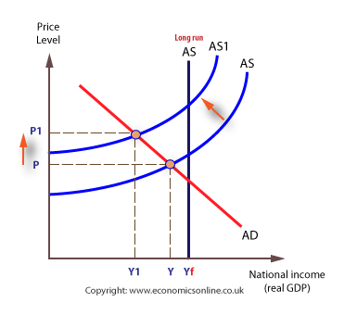

Taking the example of a wage shock, the increase in wages will lead to a rise in business costs, which will shift the AS curve shift upwards, causing the price level will rise from P to P1.

This will cause a contraction of AD, and equilibrium will fall to Y1, resulting in a fall in real output and a probable loss of jobs. Therefore, cost shocks can result in serious economic difficulties for the affected country. Increases in oil prices are always a concern because of the general inflationary effects they can create.

***Long Run Trend Rate of Growth***

The long run trend rate of growth is the average sustainable rate of economic growth over a period of time. It could also be termed as the ‘underlying trend rate of economic growth’ The long run trend rate is determined by growth in productive capacity. It is the rate of growth which is consistent with low inflation.

Actual growth can be quite volatile with booms and busts taking the growth rate away from this underlying trend rate. In the UK, in the post war period, the long run trend rate is approximately 2.5% – but we had many periods of boom and bust.

Graph Showing Long Run Trend Rate

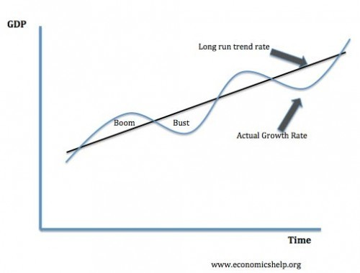

This graph shows the actual growth rate is fluctuating above and below the long run trend rate.

* If growth is above the long run trend rate we say there is a positive [output gap](http://www.economicshelp.org/dictionary/o/output-gap.html) (inflationary pressures – boom)
* If growth is below the long run trend rate, this creates a negative output gap (spare capacity or bust)

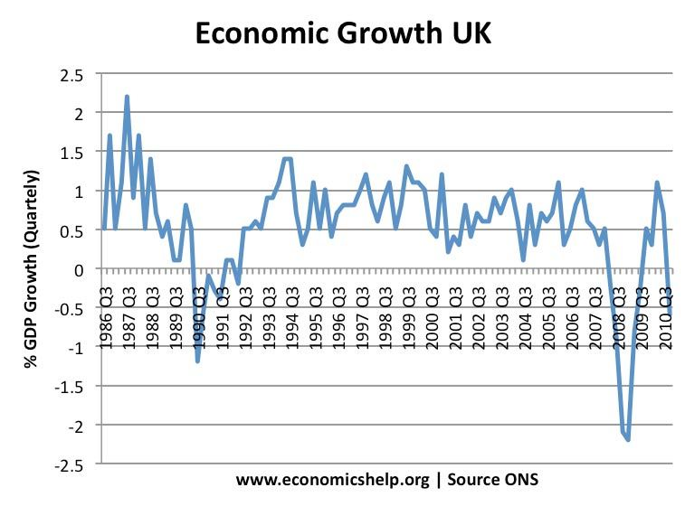

This graph also gives an indication of the underlying trend rate. The average quarterly growth rate is around 0.6 – 0.7%. (annual growth rate of 2.5%) In the late 1980s, we had growth well above the underlying trend, rate – but this led to recession of 1990-1991

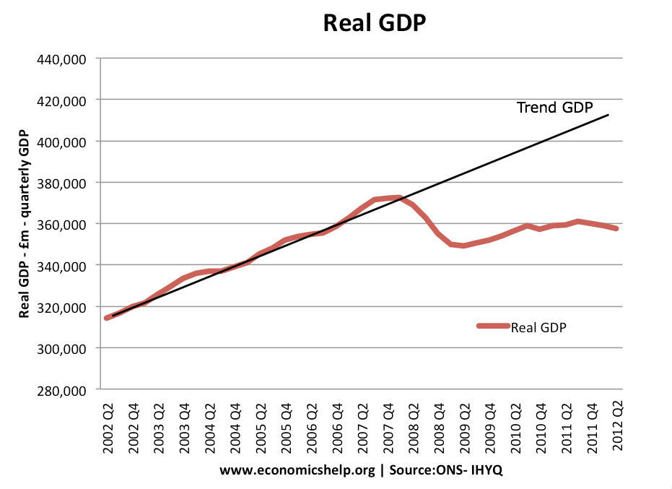

***What Determines the Long Run Trend Rate of Growth?***

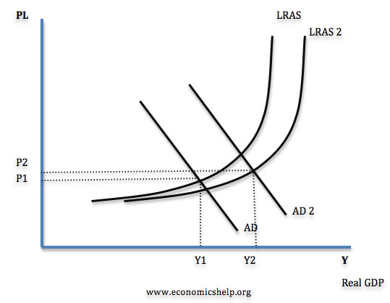

Graph showing increase in LRAS and AD.

The long run trend rate of growth is essentially determined by the growth in productive capacity – the growth in Long Run Aggregate Supply. The long run trend rate will be determined by factors such as:

* Technological improvements
* Labour productivity
* Investment levels and efficiency of investment
* Scope for productivity gains from privatisation
* Labour market flexibility.
* Levels and quality of infrastructure – communication / transport.

Some countries like China may have a high long run trend rate because their productive capacity is increasing at a faster rate than in UK.

***Boom and Bust Cycles***

If the actual growth is above the long run trend rate, then it implies that demand is exceeding the growth of productive capacity. In this case, we tend to get inflation and a worsening of the current account. This inflationary growth tends to be unsustainable and is often followed by an economic downturn.

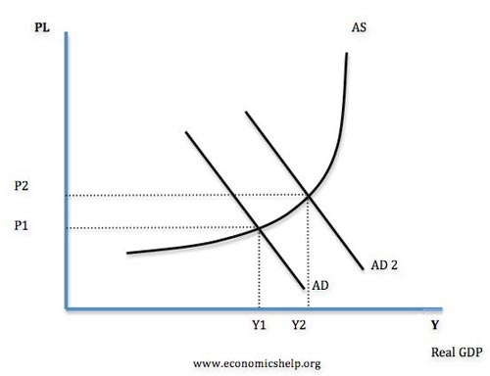  
inflation from increase in AD.

***Economic Growth Well Below the Long Run Trend Rate***

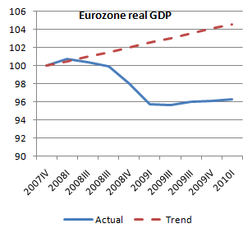  
In 2008-12, we have had an experience of economic growth being persistently below the long run trend rate. In other words actual growth hasn’t caught up with the trend rate.



The prolonged recession of 2008-12 caused GDP growth to fall well below the long run trend rate.

If growth is consistently below the long run trend rate, it may cause the long run trend rate to decrease. In other words, in a serious recession, demand side conditions can have an effect on the average growth and lead to a persistent decline in productivity growth.

***Does economic growth bring increased living standards?***

Increasing the rates of economic growth has long been the holy grail of conventional economics and politics. To a large extent, most developed economies have been highly successful in increasing economic output. But, has such an impressive increase in national output actually improved people’s standard of living?

To decide whether economic growth has increased happiness is highly subjective, and it is difficult for economists to make concrete arguments. However, it is worth noting the various side effects of growth and consider there impact on general living standards.

***Benefits of economic growth***

***1. Increased consumption***

Consumers can benefit from consuming more goods and services. An assumption of economics is that consumption is related to utility, so in theory, with higher consumption levels, there is greater prosperity.

***2. Improved public services***

With increased tax revenues the government can spend more on important public services such as health and education. Improved health care can improve quality of life through treating diseases and increasing life expectancy. Increased educational standards can give the population a greater diversity of skills and literacy. This enables greater opportunity and freedom. Education is seen as an important determinant of welfare and happiness.

3. Reduced unemployment and poverty

Economic Growth helps to reduce unemployment by creating jobs. This is significant because unemployment is a major source of social problems such as crime and alienation. However, despite rapid increases in economic growth since the Second World War, areas of high unemployment in the EU remain. For example, in France and Spain there are currently high levels of structural unemployment.  This kind of unemployment may not be reduced by economic growth.

***Why economic growth may not bring increased happiness***

**1. Diminishing returns**

If a section of the population is living in absolute poverty, economic growth enables people to have higher incomes and therefore they will be able to afford the basic necessities of life such as; food, and shelter. When economic growth can overcome this type of poverty there is a clear link with improved living standards. However, when incomes increase from say $35,000 a year to $36,000 the improvement in living standards is harder to justify. [Diminishing marginal utility of income and wealth](http://www.economicshelp.org/blog/12309/concepts/diminishing-marginal-utility-of-income-and-wealth/) is a basic economic concept, which suggests the tenth unit of a good will give much less satisfaction than the first. If we already have 2 cars, does our living standards really improve if we now have the capacity to own 3 cars? Often as economic growth increases incomes, people increasingly save their money (higher marginal propensity to save) this is basically because they struggle to find anything meaningful to spend their money on.

**2.Externalities of growth**.

Economic Growth with involves increased output causes external side effects, such, as increased pollution. Global warming from pollution is becoming a real problem for society. The economic and social costs could potentially be greater than all the perceived benefits of recent economic growth. However, it is worth noting that economic growth doesn’t necessarily have to cause pollution. The benefits of growth could be used to develop better technologies that create less pollution. It is just at the moment this has been a low priority.

**2. Economic growth can cause increased inequality.**

It is perhaps a paradox that higher economic growth can cause an increase in relative poverty. This is because those who benefit from growth are often the highly educated and those who own wealth. In 1980s and 1990s higher growth in the UK and US has resulted in increased inequality. (1) However, it depends on how growth is managed; economic growth can be used to reduce inequality, for example the economic growth which occurred in the 50s and 60s helped reduce inequality.

**3. Increase in crime and social problems**

It is another paradox that as incomes increase and people are better off the level of crime has increased as well. (2) This suggests that crime is not motivated by poverty but perhaps envy. One reason why crime rates increase is that quite simply there are more things to steal. Back in the 1930s auto theft, mobile phone theft e.t.c were rare or non-existent. Economic Growth has created more goods to steal. However the link isn’t absolute for example in recent years crime rates in US have reduced from their peak. But there has been a general association between growth and crimes.

**5. Higher economic growth has led to more hours worked**

In the beginning of the industrial revolution, higher growth led to people working lower hours.(3) However, in the past couple of decades higher incomes have actually led to people working longer hours. It seems people are unable to enjoy their higher incomes. Feeling the necessity or preferring to work longer hours. This suggest people are valuing earning money more than leisure. However, this trend may also be due to companies wanting people to work longer hours.

6. **Diseases of affluence**

Economic Growth has enabled improved health care treatments, but at the same time there has been an unexpected rise in the number of diseases and illnesses related to increased prosperity.(4) One example is obesity. Modern lifestyles and modern diets have created an epidemic of obesity, with significant proportions of the population expressing a desire to lose weight. It could be argued that problems such as obesity and stress related illnesses are not a direct consequence of growth. This is true, but, it is symbolic of the fact increased prosperity has created as many new problems as it has solved

***Costs Of Economic Growth***

Despite the benefits of economic growth there are potential costs, such as inflation, current account deficit, environment costs and widening inequality. However, it depends on the type of economic growth and how it is managed.

Potential costs of economic growth include:

**1. Inflation**. If AD increases faster than AS then economic growth will be unsustainable. Economic growth tends to cause inflation when the growth rate is above the [long run trend rate of growth](http://www.economicshelp.org/blog/5105/economics/long-run-trend-rate-of-growth/). It is when demand increases too quickly that we get a positive output gap and firms push up prices.

**2. Boom and Bust Economic Cycles.** If economic growth is unsustainable then high inflationary growth may be followed by a recession. This occurred in the late 1980s and early 1990s.

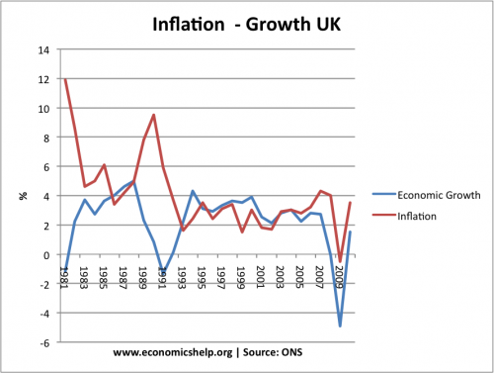

In the 1980s there was an economic boom with growth of over 5% a year. However this caused inflation to rise to over 10%. To reduce inflation the government increased interest rates, this caused the economy to slow down and then enter into a recession.

* However if economic growth is at a sustainable rate this will not occur  
  . For example, between 1993 and 2007, both economic growth and inflation were at a sustainable rate.

**3. Current account Defici**t.  
Increased economic growth tends to cause an increase in spending on imports therefore causing a deficit on the current account.

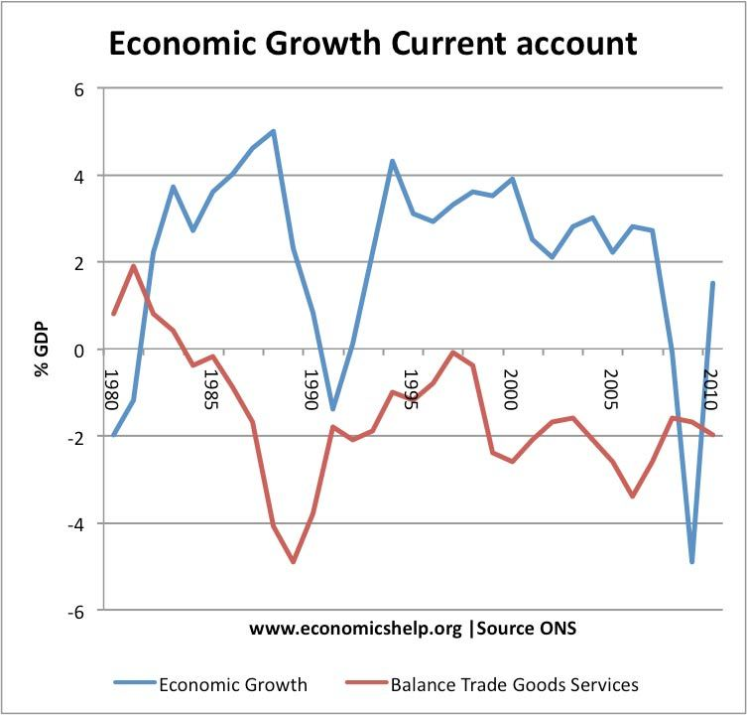

This shows that in the  UK 1980s boom, there was an increasing deficit in the balance of goods and services. In the recession of 1991, there was an improvement in the current account. The UK is susceptible to a current account deficit during high growth because we have a high marginal propensity to import.

**4. Environmental Costs.**  
Increased economic growth will lead to increased output and therefore increased pollution and congestion. This will cause health problems such as asthma and therefore will reduce the quality of life. Economic growth also means greater use of raw materials and can speed up depletion of non-renewable resources.

**5. Reduced Inequality**  
Higher rates of economic growth have often resulted increased inequality because growth can benefit a small section of society more than others. However it depends upon things such as tax rates and the nature of economic growth

**Evaluation**

It depends on the nature of economic growth. If [growth is balanced](http://www.economicshelp.org/blog/glossary/balanced-growth/) and sustainable then it can occur without inflation. Also the environmental costs of economic growth can be minimised through better use of technology.

***Measuring the Standard of Living***



The standard of living measures our material welfare

|  |
| --- |
| *“Equity, dignity, happiness, sustainability – these are all fundamental to our lives but absent in the GDP. Progress needs to be defined and measured in a way which accounts for the broader picture of human development and its context"*  *Source: Helen Clarke, UNDP* |

The baseline measure is **real national output per head of population** or **real GDP per capita**

Real income per capita is an **inaccurate** and **insufficient indicator** of living standards

For many economists, there is a growing disconnect between GDP and wellbeing

National income data can be used to make **cross-country comparisons**. This requires

1. Converting GDP data into a **common currency**
2. Making an adjustment to reflect differences in the cost of products in each country to produce data expressed at **purchasing power parity** standard
3. The PPP dollar takes into account the fact that it is cheaper to live in some countries than others

***Problems in using national income statistics to measure living standards***

* Official data on GDP understates the growth of real national income per capita over time due to the **shadow economy** and the **value of unpaid work** by volunteers and people caring for their family
* The "**shadow economy**" includes illegal activities such as drug production and distribution, prostitution, theft, fraud and concealed legal activities such as tax evasion on otherwise-legitimate business activities such as un-reported self-employment income
* Often official **GDP data is inaccurate**, e.g. many countries in sub-Saharan Africa do not update their reporting often enough, and so their GDP numbers may miss large and fast-growing sectors, like cell phones. In 2014 **Nigeria** became the largest economy in Africa (over-taking South Africa) after a fundamental reassessment of their GDP calculation. GDP data may become a target for **political manipulation.**

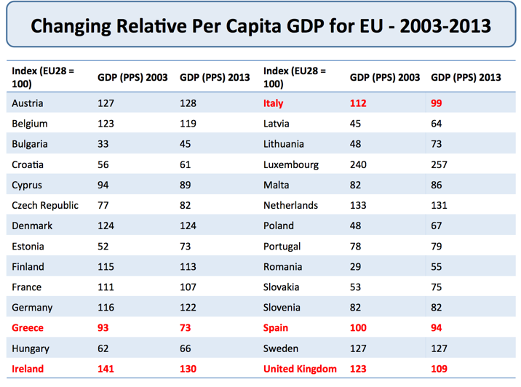Changes in per capita GDP for member nations of the European Union

***Reasons why GDP data may give a distorted picture of living standards in a country:***

|  |
| --- |
| **Bill Gates on Alternative Measures of the Standard of Living**   * The Human Development Index uses health and education statistics in addition to GDP. * The UN's Multidimensional Poverty Index uses 10 indicators; including nutrition, sanitation, and access to cooking fuel and water. * By using purchasing power parity, which measures the cost of the same basket of goods and services in different countries, economists can adjust GDP to gain better insight into living standards. |

1. **Regional variations in income and spending**: National data can hide regional variations in output, employment and income per head of the population
2. **Inequalities in income and wealth**: Average (mean) incomes might rise but inequality could grow
3. **Leisure and working hours and working conditions:** An increase in real GDP might have been achieved at the expense of leisure time if workers are working longer hours or if working conditions have deteriorated
4. **Imbalances between consumption and investment:** High levels of investment as a share of GDP might be superb for creating extra capacity to produce but at the expense of consumer goods and services for the current generation
5. **Changes in life expectancy**: Improvements in life expectancy don't always show through in GDP accounts. Putting a **monetary value** on the benefits of increased longevity is difficult
6. **The value of non**-**marketed output**: Much useful and valuable work is not sold in markets at market prices. The value of the output of people working for charities, self-help groups and of housework might reasonably be added to national income statistics
7. **Innovation and the development of new products**: New goods and services become available because of invention and innovation that simply would not have been available to the richest person on earth less than fifty years ago. About half of what we spend our money on now was not invented in 1870. Examples include air travel, cars, computers, antibiotics, hip replacements, insulin and many other life-enhancing and life-saving drugs
8. **Environmental considerations:** Rising output might have been accompanied by an increase in air and noise pollution and other externality effects that have a negative effect on our social welfare
9. **Defensive expenditures**: Much spending is to protect against an **economic or social bad** e.g. crime, or spending to clean up the effects of pollution and waste

[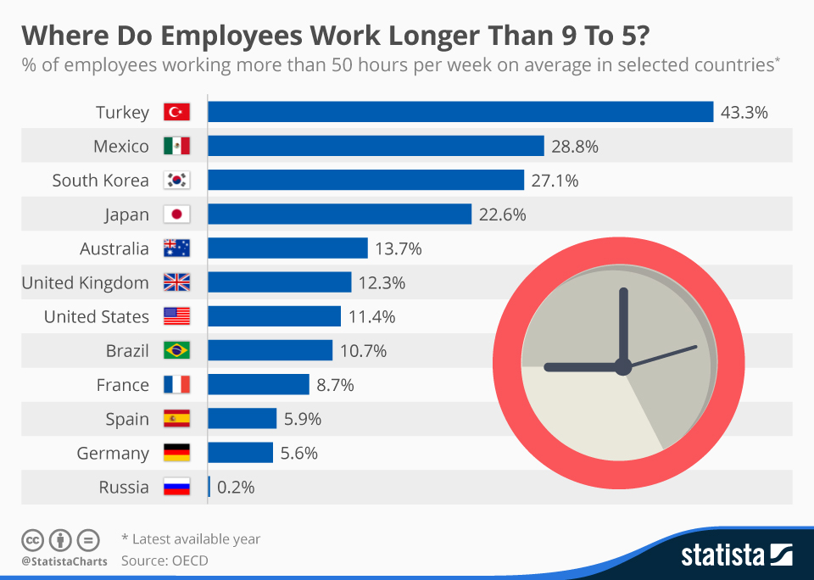](http://www.statista.com/chart/3236/employees-working-longer/)

I

***Moving away from GDP per capita – the case for median household incomes***

There is widespread agreement that changes a nation's GDP per capita are an inadequate measure of human wellbeing.

Instead of tracking changes in mean per capita incomes, some economists are now pushing for an extra indicator – namely **changes in median per capita household incomes**. Household income measures the flow of income that finds its way to households each year.

The median is better than the mean since it is reflective of progress in the middle of the income distribution. For example, increases in GDP that go solely to the rich would not increase this measure. Looking at median income would create more focus on **inclusive growth** that generates wider benefits.

In the United Kingdom, median income growth has lagged behind GDP per capita since the early 1980s, in part because of the growth of **income inequality** reflected in an increase in the **Gini coefficient**.

***Human Development Index***



The **Human Development Index (HDI)** is published annually by the UNDP and focuses on longevity, basic education and minimal income

* It tracks progress made by countries in improving these three outcomes
* The inclusion of education and health indicators is a sign of successful government policies in providing access to important **merit goods** such as health care, sanitation and education

1. **Knowledge**: First an **educational component** made up of two statistics – mean years of schooling and expected years of schooling
2. **Long and healthy life**: Second a **life expectancy component** is calculated using a minimum value for life expectancy of 25 years and maximum value of 85 years
3. **A decent standard of living**: The final element is **gross national income (GNI) per capita** adjusted to purchasing power parity standard (PPP)

***The UNDP classifies each country into one of three development groups:***

* **Low** human development for HDI scores between 0.0 and 0.5,
* **Medium** human development for HDI scores between 0.5 and 0.8
* **High** human development for HDI scores between 0.8 and 1.0.

***Important note****:*

***GNI*** *is now used rather than* ***GDP*** *because of the growing size of* ***remittances*** *in the global economy and also the importance of international aid payments. For example, because of remittances from abroad, GNI in the Philippines greatly exceeds GDP*

***Log of income*** *is used in the HDI calculation because income is instrumental to human development but higher incomes are assumed to have a declining contribution to human development*

**GNI per Capita - Purchasing Power Parity (PPP)**

* This is a method of currency valuation based on the idea that two identical goods in different countries should eventually cost the same
* This is illustrated by the Big Mac index, which takes a Big Mac hamburger and compares its prices in different countries in order to establish the relative value of their currencies
* If PPP holds true, then you can buy the same goods and services with £100 in London as you can in Glasgow, New York and Cape Town. There are many reasons why this will not be the case!

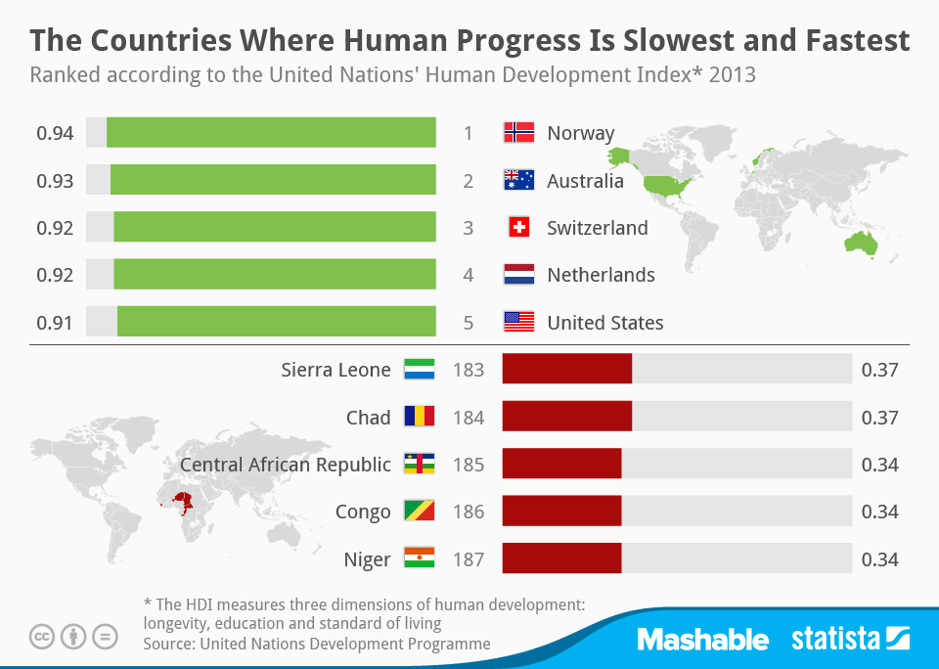

There ought to be a reasonable close connection between GDP per capita and ranking on the human development index but this is not always the case. For some countries there is a strong positive difference between their HDI rank and their ranking by income alone – here are some examples:

|  |  |  |  |  |
| --- | --- | --- | --- | --- |
| Country | Level of human development | Gross national income per capita rank | Human Development Index rank | Difference |
| New Zealand | Very High | 30 | 7 | 23 |
| South Korea | Very High | 33 | 15 | 18 |
| Sri Lanka | High | 103 | 73 | 30 |
| State of Palestine | Medium | 129 | 107 | 22 |
| Rwanda | Low | 171 | 151 | 20 |

Countries with positive differences tend to have a higher HDI value, and the majority have moved to a higher human development group. They also have lower inequality and a lower proportion of poor and near poor people.

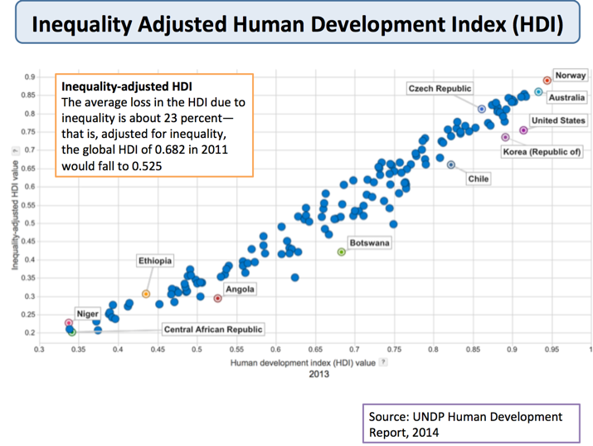Inequality adjusted HDI data

***2013 Human Development Report Data***

* Norway once again comes out top, with Burkina Faso, Chad, Mozambique, the Democratic Republic of the Congo and Niger the bottom ranked countries
* The USA falls 13 places in development rankings once inequality in society is taken into account

***Uneven Progress but Deep Inequalities***

* The world average HDI rose to 0.68 in 2010 from 0.57 in 1990, continuing the upward trend from 1970, when it stood at 0.48
* The fastest progress has been in East Asia & the Pacific, followed by South Asia and Arab States.
* All but 3 of the 135 countries have a higher level of human development today than in 1970
* The exceptions are the Democratic Republic of the Congo, Zambia and Zimbabwe
* From 1970 to 2010 real per capita income in developed countries increased 2.3 per cent a year on average, compared with 1.5 per cent for developing countries
* The real average income of people in 13 countries in the bottom quarter of today's world income distribution is lower than in 1970
* Life expectancy at birth has increased due to lower infant and child mortality, fewer deaths due to HIV/AIDS and better nutrition

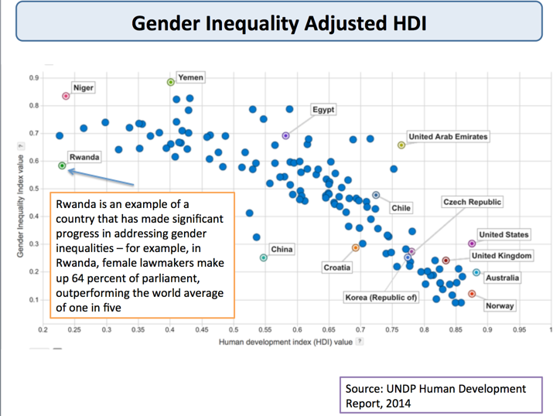Gender inequality

***Limitations of the Human Development Index***

* The HDI notably fails to take account of **qualitative factors**, such as **cultural identity** and **political freedoms** (human security, gender opportunities and human rights for example)
* Many argue that the HDI should become more **human-centred** and expanded to include more dimensions, ranging from **gender equity** to **environmental biodiversity**
* The GNP per capita figure – and consequently the HDI figure – takes no account of **income distribution.** If income is unevenly distributed, then GNP per capita will be an inaccurate measure of the monetary well-being of the people. Inequitable development is not human development
* PPP values change very quickly and are likely to be inaccurate or misleading

The 2010 edition of the Human Development Report marked the launch of a **new Inequality-adjusted HDI** and also a **Gender Inequality Index** and a **Multidimensional Poverty Index**

Inequality HDI – The average loss in the HDI due to inequality is about 23 percent—that is, adjusted for inequality, the global HDI of 0.682 in 2011 would fall to 0.525

***Key exam point****:*

*The HDI is intended to allow economists to draw* ***broad conclusions*** *about which countries enjoy* ***relatively*** *high standards of living, and which are, by comparison, under-developed*

***Aggregate Demand***

Aggregate Demand (AD) is the total demand for goods and services produced within the economy over a period of time.

***Aggregate Demand (AD) is composed of various components.***

**AD = C+I+G+(X-M)**

* C = Consumer expenditure on goods and services.
* I = Gross Capital Investment – i.e. investment spending on capital goods e.g. factories and machines
* G = Government Spending e.g. spending on NHS, education. Note transfer payments in the form of pensions and unemployment benefits are not included because they are not related to output produced.
* X = Exports of goods and Services. Goods leave the country but money from abroad flows into the economy, therefore this is an increase in AD (an injection in to the circular flow)
* M = Imports of goods and Services, although goods enter the country money is leaving the economy to go to other countries, therefore AD falls

[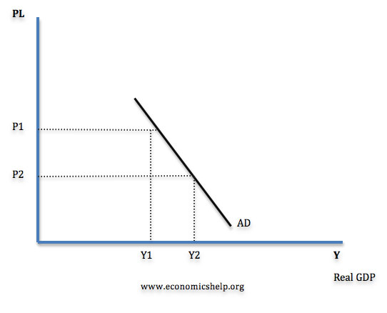](http://www.economicshelp.org/wp-content/uploads/2014/09/AD-curve.jpg)

***AD slopes downwards because:***

* At a lower price level people are able to consume more goods and services, because there real income is higher.
* At a lower price level interest rates usually fall causing increased AD.
* At a lower price level, exports are relatively more competitive than imports.

***Shifts in the Aggregate Demand curve***

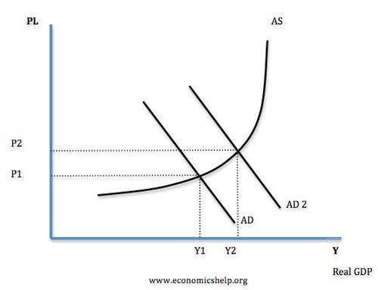

Graph to show Increase in AD

An increase in AD (shift to the right of the curve) could be caused by a variety of factors

***1. Increased Consumption:***

* i) An increase in consumers wealth (higher house prices or value of shares)
* ii) Lower Interest Rate which make borrowing cheaper therefore people spend more on credit cards. Also mortgage payments are cheaper which gives people more disposable income.
* iii) Higher wages
* iv) Lower Taxes
* v) Increased consumer confidence about the future

Consumer Expenditure accounts for about 66% of AD and therefore is a very important component of AD

***2. Increased Investment***

* i) Lower interest rates, this makes borrowing for investment cheaper.
* ii) Increased confidence in the economic outlook
* iii) Improved technology
* iv) Increased economic growth, to meet increased demand firms need to increase capacity

***3. Increased G***

* i) Government pursues expansionary fiscal policy
* ii) Governments invests in infrastructure

***4. Increased X***

* i) UK more competitive, for example an increase in labour productivity would make the UK more competitive
* ii) Increased growth in other countries, therefore they will have higher demand
* iii) Lower value of Sterling, this makes exports cheaper

***5. Decreased M***

* i) UK more competitive, this makes goods from other countries appear less competitive.
* ii) Lower value of Sterling, this makes imports more expensive
* iii) Lower GDP, therefore consumers will have less money to spend.

Components of AD

[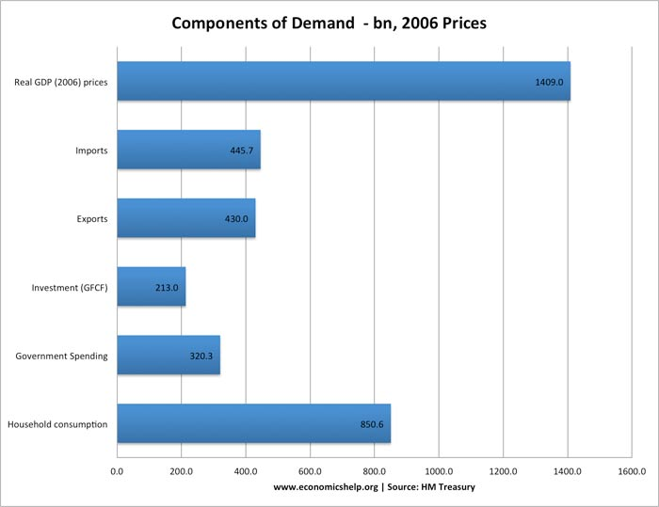](http://www.economicshelp.org/wp-content/uploads/2012/11/components-demand-ad1.jpg)

Components of Aggregate Demand as %

[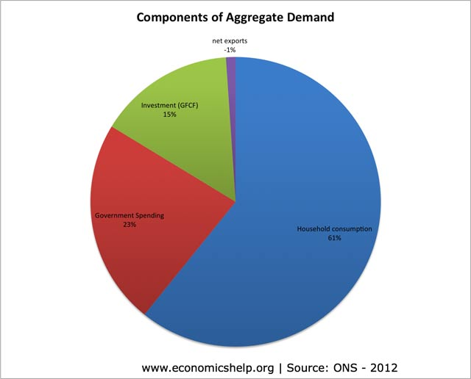](http://www.economicshelp.org/wp-content/uploads/2012/11/components-ad-percentage11.jpg)

A graph showing components of AD as a %

***Difference Between SRAS and LRAS***

***What is the difference between short run aggregate supply and Long Run aggregate Supply?***

Essentially, the SRAS assumes that the level of capital is fixed. (i.e. in the short run you can’t build a new factory). However,  in the short run you can increase the utilisation of existing factors of production, e.g. workers doing overtime.

In the short run an increase in the price of goods, encourages firms to take on more workers, pay slightly higher wages and produce more.

Thus the SRAS suggests an increase in prices leads to a temporary increase in output as firms employ more workers.

The short run aggregate supply is affected by costs of production. If there is an increase in raw material prices (e.g. higher oil prices), the SRAS will shift to the left. If there is an increase in wages, the SRAS will also shift to the left.  
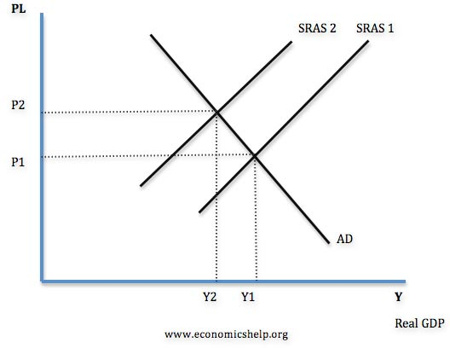

***The Long Run Aggregate Supply curve*** is determined by all factors of production – size of workforce, size of capital stock, levels of education and labour productivity.

If there was an increase in investment or growth in size of labour force this would shift the LRAS curve to the right.

