***Unemployment - Causes of Unemployment***



***What are the Main Types and Causes of Unemployment?***

***Structural Unemployment***

Structural unemployment happens when there is a long-term decline in demand in an industry leading to fewer jobs as demand for labour falls away.

Examples might include:

* Jobs on a production line being replaced by robots e.g. motor manufacturing, online banking and online retailing
* Unemployment caused by foreign competition (or changes in comparative advantage)

Structural unemployment exists where there is a mismatch between their skills and the requirements of the new job opportunities. This problem is due to occupational and geographical immobility of labour and requires investment to improve skills, give the unemployed suitable and effective training and work experience and make them able to move location if needed to take a new job.

* **Globalisation** leads to changes in the patterns of trade between countries. Britain has probably now lost forever a cost advantage in manufacturing goods such as motor cars, household goods and audio-visual goods, UK manufacturing industry has lost jobs as some production has shifted to lower-cost centres in Eastern Europe and countries in Far East Asia.
* Many of these workers may suffer from a period of structural unemployment, particularly if they are in regions of above-average unemployment rates where job opportunities are scarce.

***Cyclical Unemployment:***

* Cyclical unemployment is involuntary unemployment due to a lack of demand for goods and services. This is also known as Keynesian unemployment or demand-deficient unemployment
* When there is a recession or a steep slowdown in growth, we see a rising unemployment because of plant closures, business failures and an increase in worker lay-offs and redundancies. This is due to a fall in demand leading to a contraction in output across many industries.
* Firms are likely to reduce employment to cut costs and/or maintain profits – this is called **“labour shedding"** or “down-sizing"
* The economy does not have to go into recession for cyclical unemployment to start rising. Many jobs can be lost even in a slowdown phase and one reason for this is because of rising productivity. Say for example that a country's GDP is expanding at 1 per cent a year but output per worker is growing by 3 per cent. This means that the same national output can be produced using fewer workers.
* Cyclical unemployment has been a major problem for a number of European Union economies who have suffered from a deep and persistent recession in recent years. For example in 2012, Spanish unemployment rose above 6 million for the first time, with 27% of the workforce unemployed.

Cyclical unemployment is most likely to occur when there is a **negative output gap**

Bank of England research suggests that strong growth in self-employment in the UK is due to rising workforce participation by older people and women and technological changes

*Deloitte Monday Briefing (March 2015)*

***Technological Unemployment***

The term “technological unemployment" was first coined in the 1930s by John Maynard Keynes to describe the way in which productivity-enhancing innovation displaces workers and creates periods of higher unemployment. It is linked to structural unemployment.

Some link the rise of the internet as a cause of technological unemployment for example the US business Kodak went bust in 2013 with its 140,000 employees, in part the result of the rapid expansion of Instagram, which, when it was sold to Facebook employed just 13 people. Evidence over the long term is that innovation and the emergence and uptake of new technologies creates more jobs than it destroys.

Those most at risk from the creative destruction of new technologies are those with **low and out-dated skills** in the labour market.

***Causes of Unemployment***

Different Causes of Unemployment

**1. Frictional Unemployment:**

This is unemployment caused by the time people take to move between jobs, e.g. graduates or people changing jobs. There will always be some frictional unemployment in an economy because information isn’t perfect and it takes time to find work.

**2. Structural Unemployment**

This occurs due to a mismatch of skills in the labour market it can be caused by:

* **Occupational immobilities.** This refers to the difficulties in learning new skills applicable to a new industry, and technological change, e.g. an unemployed farmer may struggle to find work in high tech industries.
* **Geographical immobilities.** This refers to the difficulty in moving regions to get a job, e.g. there may be jobs in London, but it could be difficult to find suitable accommodation or schooling for their children.
* **Technological change**. If there is the development of labour saving technology in some industries, then there will be a fall in demand for labour.
* Structural change in the economy. The decline of the coal mines due to a lack of competitiveness meant that many coal miners were unemployed, however they found it difficult to get jobs in new industries such as computers.

**3. Classical or Real Wage Unemployment:**

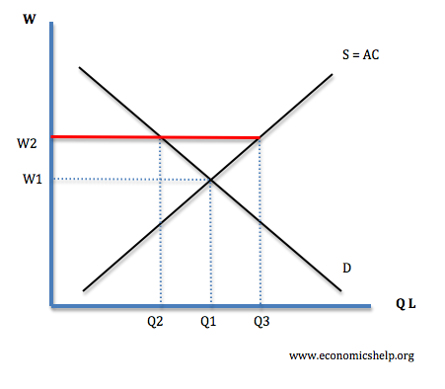

* This occurs when wages in a competitive labour market are pushed above the equilibrium, e.g. at W2 the supply of labour (Q3) is greater than the demand for labour (Q2).
* Wages could be pushed above the equilibrium level by minimum wages or trades unions. This is sometimes known as “disequilibrium” unemployment.

**4. Voluntary Unemployment**

This occurs when people choose to remain unemployed rather than take jobs available. For example, if benefits are generous, people may prefer to stay on benefits rather than get work. Frictional unemployment is also a type of voluntary unemployment as they are choosing to wait until they find a better job.

**5. Demand Deficient or “Cyclical Unemployment”**

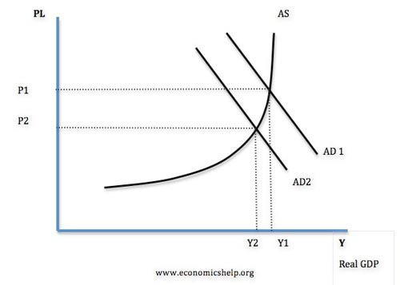

* Demand deficient unemployment occurs when the economy is below full capacity.  
  For example, in a recession Aggregate Demand (AD) will fall leading to a decline in output and negative economic growth.
* With a fall in output firms will employ less workers because they are producing less goods. Also some firms will go out of business leading to large scale redundancies.
* In recessions, unemployment tends to rise rapidly as firms lay off workers.

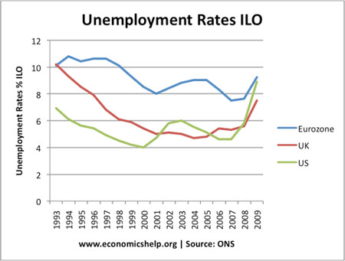

Unemployment in UK fell from 1993-2006 during period of economic growth. It rose sharply during recession of 2008-09.

***Debate on Demand Deficient Unemployment***

Classical economists emphasis supply side factors as the main cause of unemployment. They argue that demand deficient unemployment tends to be only short term. However other Keynesian economists emphasize the importance of aggregate demand in determining unemployment.

1. Wages are stick downwards, this means workers are not willing to accept a wage cut

2. If wages are cut then there is a fall in consumer spending this causes a fall in AD, therefore this makes the unemployment situation worse.

3. Efficiency Wages Theory. This states that if wages are cut workers become dispirited and work less hard leading to lower output.

4. During recession confidence is low and firms are reluctant to spend money on employing more workers even at lower wage.

5. Keynes said in the long run wages may adjust, but in the long run we are all dead!.

In the 1930s mass Unemployment continued until WW2. However, when governments did begin to spend on military expenditure, unemployment fell.

***Consequences of Unemployment***



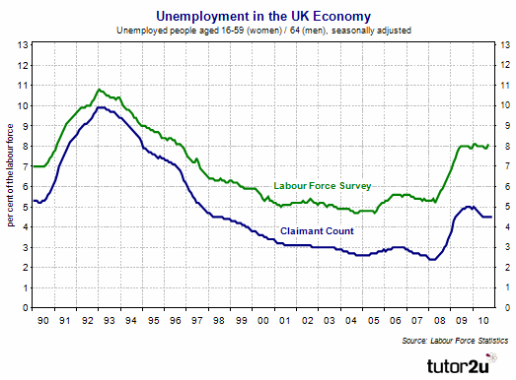

Persistently high unemployment create huge costs for individuals and for the economy as a whole. Some of these costs are difficult to value and measure, especially the longer-term **social costs**.

**1.Loss of income:** Unemployment normally results in a loss of income. The majority of the unemployed experience a decline in their living standards and are worse off out of work. This leads to a decline in spending power and the rise of falling into debt problems. The unemployed for example may find it difficult to keep up with their mortgage repayments.

**2.Negative multiplier effects:** The closure of a local factory with the loss of hundreds of jobs can have a large negative **multiplier effect** on both the local and regional economy. One person’s spending is another’s income so to lose well-paid jobs can lead to a drop in demand for local services, downward pressure on house prices and ‘second-round employment effects’ for businesses supplying the factor or plant that closed down.

**3.Loss of national output:** Unemployment involves a loss of **potential national output** (i.e. GDP operating well below potential) and is a waste of scarce resources. If some people choose to leave the labour market permanently because they have lost the motivation to search for work, this can have a negative effect on long run aggregate supply and thereby damage the economy’s growth potential. Some economists call this the “hysteresis effect”. When unemployment is high there will be an **increase in spare capacity** - in other words the **output gap** will become negative and this can have deflationary forces on prices, profits and output.

**4.Fiscal costs:** The government loses out because of a fall in tax revenues and higher spending on welfare payments for families with people out of work. The result can be an increase in the **budget deficit** which then increases the risk that the government will have to raise taxation or scale back plans for public spending on public and merit goods. The problems facing the UK government at the moment are closely linked to the surge in unemployment.

**5.Social costs:** Rising unemployment is linked to **social deprivation**. For example, there is a relationship with crime and social dislocation including increased divorce rates, worsening health and lower life expectancy. Regions that suffer from persistently high long-term unemployment see falling real incomes and a widening of inequality of income and wealth.

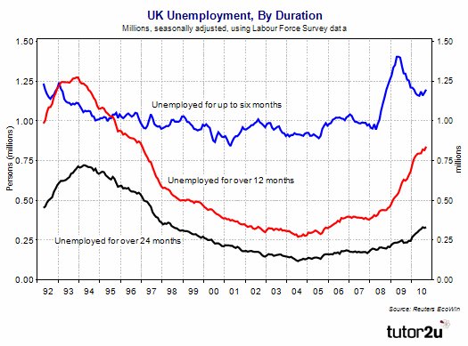

**Evaluation points:**  
Exam questions quite often ask students to discuss some of the effects of a sustained rise in unemployment. Good answers will include AD-AS analysis on the economic impact and also make a distinction between economic and social consequences. Evaluation might also include the following:

*The impact of high unemployment on human capital / labour productivity  
*Structural problems caused by occupational and geographical immobility of labour  
*Effects on wage inflation e.g. the possibility of wage freezes or wage cuts  
*The effects of people leaving the labour market because they have given up the search for work - this is known as a hysteresis effect  
*Mention of some positive effects - e.g. it increases the pool of available labour for businesses wanting to expand and take on more workers  
*Experience of unemployment might prompt some people to become self employed and start their own businesses.

***Phillips Curve***

The Phillips curve suggests there is an inverse relationship between inflation and unemployment.

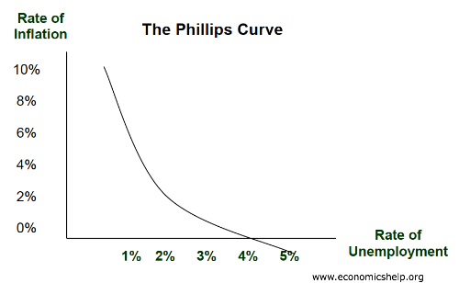

This suggests policy makers have a choice between prioritising inflation or unemployment. During the 1950s and 1960s, Phillips curve analysis, suggested there was a trade off and policy makers could use demand management (fiscal and monetary policy) to try and influence the rate of economic growth and inflation. For example, if unemployment was high and inflation low, policy makers could stimulate aggregate demand. This would help to reduce unemployment, but cause a higher rate of inflation.

In the 1970s, there seemed to be a breakdown in the Phillips curve as we experienced [stagflation](http://www.economicshelp.org/dictionary/s/stagflation.html) (higher unemployment and higher inflation). The Phillips Curve was criticised by monetarist economists who argued there was no trade off between unemployment and inflation in the long run.

However, some feel that the Phillips Curve has still some relevance and policy makers still need to consider the potential trade off between unemployment and inflation.

***Origins of the Phillips Curve***

The Phillips curve originated out of analysis comparing money wage growth with unemployment. The findings of A.W. Phillips in *The Relationship between Unemployment and the Rate of Change of Money Wages in the United Kingdom 1861–1957* suggested there was an inverse correlation between the rate of change in money wages and  unemployment. For example a rise in unemployment was associated with declining wage growth and vice versa.

[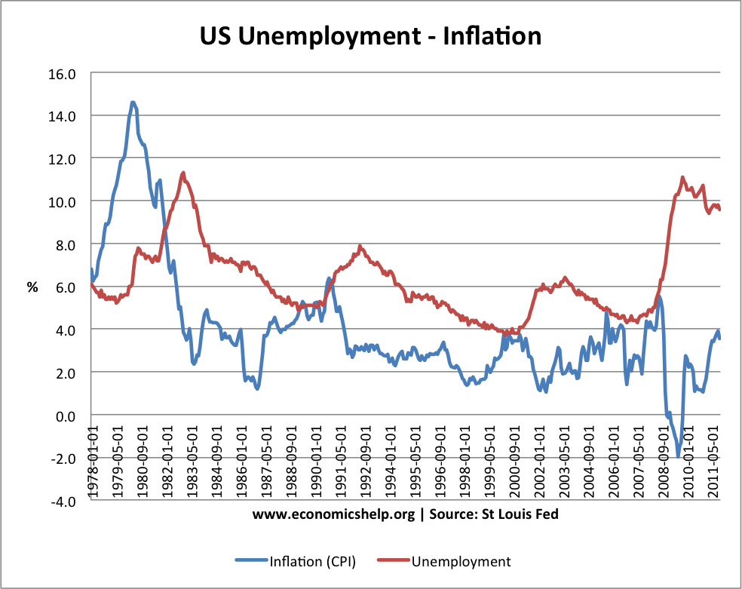](http://www.economicshelp.org/blog/571/unemployment/trade-off-between-unemployment-and-inflation/attachment/unemployment-inflation-trade-off-78-11/)

There are occasions when  you can see a trade off between unemployment and inflation. For example, between 1979 and 1983, we see inflation (CPI) fall from 15% to 2.5%. During this period, we see a rise in unemployment from 5% to 11%. In 2008, the recession caused a sharp rise in unemployment and inflation became negative.

***Why is there a trade off between unemployment and inflation?***

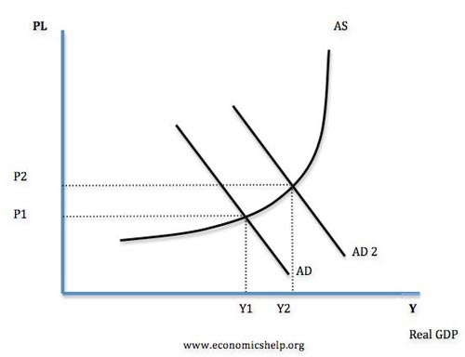

* An increase in aggregate demand (AD to AD2) causes higher real GDP (Y1 to Y2), therefore firms employ more workers and unemployment falls.
* However, as the economy gets closer to full capacity, we see an increase in inflationary pressures. With lower unemployment, workers are able to demand higher money wages, which causes wage inflation. Also firms can put up prices due to rising demand.
* Therefore, in this situation, we see falling unemployment, but higher inflation.

***Monetarist View of Phillips Curve***

However, Monetarists have always been critical of this Phillips curve trade off. They argue that in the long run there is no trade off as Long Run AS is inelastic. Monetarists argue that if there is an increase in aggregate demand, then workers demand higher nominal wages. When they receive higher nominal wages, they work longer hours because they feel real wages  have increased. (their price expectations are based on last year)

However, this increase in AD causes inflation, and therefore, real wages stay the same. When they realise real wages are the same as last year, they change their price expectations and no longer supply extra labour and the real output returns to its original level. Therefore, unemployment remains unchanged, but we have a higher inflation rate. The short run Phillips curve shifts upwards to SRPC II

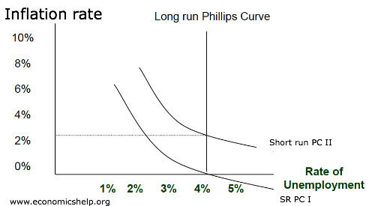

Monetarist view of AD / AS

[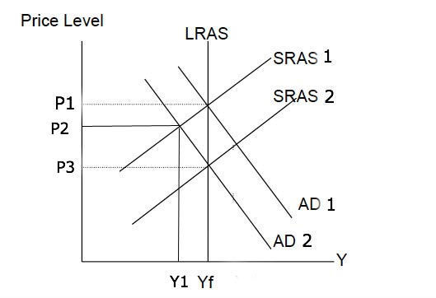](http://www.economicshelp.org/wp-content/uploads/2013/03/LRAS_inelastic-fall-ad.jpg)

Increase in AD only causes temporary increase in real output to Y1. After inflation expectations increase, SRAS shifts to left (SRAS2) and we end up with higher inflation (P3) and output of Yf. This AD/AS model explains why we only get temporary fall in unemployment.

* An adaptive expectation monetarists argues there is only a short-term trade off between unemployment and inflation.
* Rational expectation monetarists argue there is no trade off, even in the short term. The rational expectation model suggests that workers see any increase in AD as inflationary and so predict real wages will stay the same.

***Summary of Monetarist v Keynesian view***

A monetarist would argue unemployment is a supply side phenomena. Monetarists argue using demand side policies can only temporarily reduce unemployment by an ever accelerating inflation rate. Monetarists argue that unemployment is determined by the [natural rate of unemployment](http://www.economicshelp.org/macroeconomics/unemployment/natural_rate.html)

Keynesians argue there can be [demand deficient unemployment](http://www.economicshelp.org/blog/1993/economics/demand-deficient-unemployment/), and during a recession demand side policies can reduce unemployment in the long term (with perhaps some inflation)

***The Phillips Curve Breakdown***

Evidence from the 1970s suggested the trade off between unemployment and inflation had broken down. The [1970s](http://econ.economicshelp.org/2010/02/economy-of-1970s.html) witnessed a rise in stagflation – rising unemployment and inflation. Monetarists argued that increasing the money supply just led to a wage inflation spiral and did not help to reduce unemployment. They advocated reducing the money supply and achieving low inflation – any unemployment would just prove temporary.

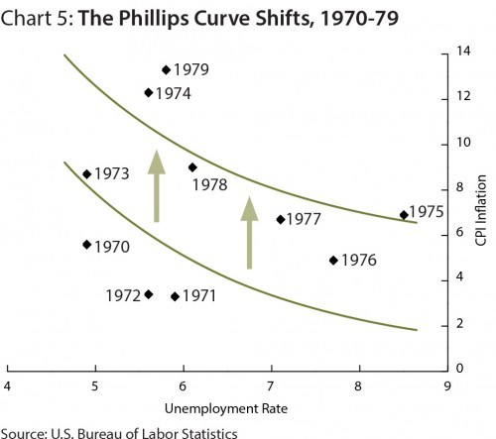

However, others argued there was still a trade off – the Phillips curve had just shifted to the right giving a worse trade off because of cost-push inflation.

In the early 2000s, the trade off seemed to improve. Helped bylow global inflation, unemployment in the UK fell without any rise in inflation. Some argued this period of stability had ended the boom and bust cycles with the classic trade off between inflation and unemployment. See: [great moderation](http://www.economicshelp.org/blog/6901/economics/the-great-moderation/)

In late 2008 we saw a rise in the unemployment rate and a fall in inflation. This was due to the recession and falling oil prices.

However, in 2010-11, the UK experienced higher unemployment and higher inflation because of cost-push inflationary pressures. This was another period of stagflation

***Conclusion on Phillips Curve***

If the economy is operating below full capacity, a significant increase in aggregate demand is likely to cause a reduction in unemployment and higher inflation. Most economists would agree that in the short term, there can be a trade off between unemployment and inflation. However, there is a disagreement whether this policy is valid for the long-term.

Monetarists would tend to argue the trade off will prove short-term, and we will just get inflation. Monetarists place greater stress on the supply side of the economy.

However, Keynesians argue that demand deficient unemployment could persist in the long-term. If there is a significant negative output gap, boosting AD could lead to lower unemployment and a modest increase in inflation. In a deep recession, this fall in unemployment will not just be temporary because there will be no crowding out.

In an ideal world, policy makers will aim for low inflation and low unemployment. To achieve this, we need economic growth that is sustainable (close to long run trend rate) and supply side policies to reduce cost-push inflation and structural unemployment. If these criteria are met then it becomes easier to achieve this goal of lower inflation and lower unemployment.

***Relevance of Phillips Curve Today***

In the current economic climate, many Central Banks and policy makers are weighing up how much importance they should give to reducing unemployment and inflation. For example, the Federal Reserve is considering using monetary policy to achieve an unemployment target and a willingness to accept higher inflation.

During 2009-13, the Bank of England has been willing to tolerate inflation above the governments target of 2% because they feel to reduce inflation would have caused serious problems for unemployment and economic growth.

This willingness to consider a higher inflation rate, suggest policy makers feel that the trade off of higher inflation is worth the benefit of lower unemployment. However, not all economists agree we should be allowing the inflation target to increase. If we allow inflation to increase, inflationary pressures will become engrained and monetary policy will lose credibility. The ECB would be unwilling to tolerate higher inflation – even as a measure to reduce unemployment in Europe.

***The Natural Rate of Unemployment***

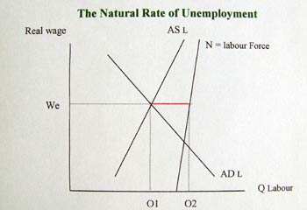

* The Natural Rate of Unemployment is the rate of Unemployment when the labour market is in equilibrium.
* It is the difference between those who would like a job at the current wage rate and those who are willing and able to take a job.

***The Natural Rate of Unemployment will therefore include:***

* + frictional unemployment
  + structural unemployment
  + E.g. a worker who is not able to get a job because he doesn’t have the right skills
* The natural rate of unemployment is unemployment caused by supply side factors rather than demand side factors
* Monetarists argue that the Natural Rate of Unemployment occurs when the Long Run Phillips Curve crosses the x axis
* ***The Natural Rate of Unemployment is sometimes known as the***   
  Non accelerating inflation rate of Unemployment NAIRU  
  This is because when unemployment is 4% there is no tendency for inflation  
  to increase
* In this example the Natural rate of unemployment is 4%. If the govt increased AD there may be a temporary fall in unemployment but in the Long Run it would return to the natural rate of 4%
* Sometimes the natural rate is known as the full employment level of unemployment
* This is because even if the economy is operating at full capacity and there is no demand deficient unemployment then there will still be some unemployment caused by supply side factors.

***What Determines the Natural Rate of Unemployment?***

M. Freidman argued the Natural rate of unemployment would be determined by institutional factors such as:

* **Availability of job information**. A factor in determining frictional unemployment
* **Skills and Education.** The quality of education and retraining schemes will influence the level of occupational mobilities.
* **Degree of labour mobility**
* **Flexibility of the labour market** E.g. powerful trades unions may be able to restrict the supply of labour to certain labour markets
* **Hysteresis.** A rise in unemployment caused by a recession may cause the natural rate of unemployment to increase. This is because when workers are unemployed for a time period they become deskilled and demotivated and are less able to get new jobs.

***Explaining Changing Natural Rates of Unemployment***

It has been argued that the UK has seen a fall in the natural rate of unemployment since the 1980s (even when growth was 5% in 1988 Unemployment was 1.6 million) This has been explained by:

1. Increased labour market flexibilities e.g. unions less powerful
2. Privatisation has helped increased competitiveness of industry leading to more flexible labour markets
3. Better education and Training
4. The New Deal has made it more difficult to remain on benefits

***Natural Rate of Unemployment in EU***

The rest of the EU has seen a rise in the natural rate of unemployment in the 1990s this could have caused by:

1. Rigidity in EU labour markets e.g. min wages, max working week
2. Restrictions on closing factories and mandatory severance pay for workers made unemployed, this makes firms more reluctant to set up in these countries
3. High degrees of unionisation resulting in wage rigidity
4. Generous benefits which lessen the pain of unemployment
5. Hysteresis effects. The cyclical recessions of the 1970s and 1980s had long lasting effects resulting in more unemployment. However this does not appear to have effected the UK
6. Growing competition from Asian countries

However the rising unemployment may not just be due to the Natural rate increasing but also due to lower economic growth. Therefore part of the unemployment is cyclical.

NAIRU and Non-Accelerating Rate of Unemployment

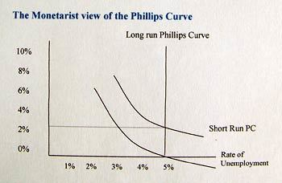

A very similar concept to the natural rate of unemployment is the NAIRU – non-accelerating rate of unemployment.

This is the rate of unemployment consistent with a stable rate of inflation. If you try to reduce unemployment by increasing aggregate demand, then you will get a higher rate of inflation.

The natural rate of unemployment can also be illustrated using the Monetarist view of the Phillips Curve. Monetarists argue that the LRAS is inelastic. Thus increased AD only causes a temporary increase in output and a temporary fall in unemployment.

* If there is an increase in AD, firms pay higher wages to workers in order to increase in output, this increase in nominal wages encourage workers to supply more labour and therefore unemployment falls.
* However the increase in AD also causes inflation to increase and therefore real wages do not actually increased but remain the same. Later workers realise that the increase in wages was only nominal and not a real increase.
* Therefore they no longer work overtime. Therefore the supply of labour falls and unemployment returns to its original or Natural rate of unemployment. It is only possible to reduce unemployment by causing an increase in the rate of inflation. Therefore the natural rate is also known as the NAIRU (non accelerating rate of unemployment.

This model assumes workers do not correctly predict the rate of inflation but have adaptive expectations.

(Some economists argue workers will correctly predict higher AD causes higher inflation and therefore there will not be even a short term fall in unemployment , this is know as rational expectations.)

***Inflation - Measuring Inflation***



Inflation is a sustained increase in the cost of living or the general price level leading to a fall in the purchasing power of money

***How is the rate of inflation measured?***

* The **rate of inflation** is measured by the annual percentage change in consumer prices.
* The British government has set an **inflation target** of 2% using the **consumer price index** (CPI)
* It is the job of the Bank of England to set interest rates so that aggregate demand is controlled, inflationary pressures are subdued and the inflation target is reached

The Bank is independent of the government with control of interest rates and it is free from political intervention. *The Bank is also concerned to avoid* ***price deflation***

**Falling inflation does not mean falling prices!**

Please remember that a ***fall in the rate of inflation*** is not the same thing as a ***fall in prices***! In 2009 there was a steep drop in inflation from 5 per cent to 1 per cent over the course of the year. Inflation was falling – but the rate remained positive – meaning that prices were rising but at a slower rate! A slowdown in inflation is not the same as deflation! For this to happen, the annual rate of price inflation would have to be negative.

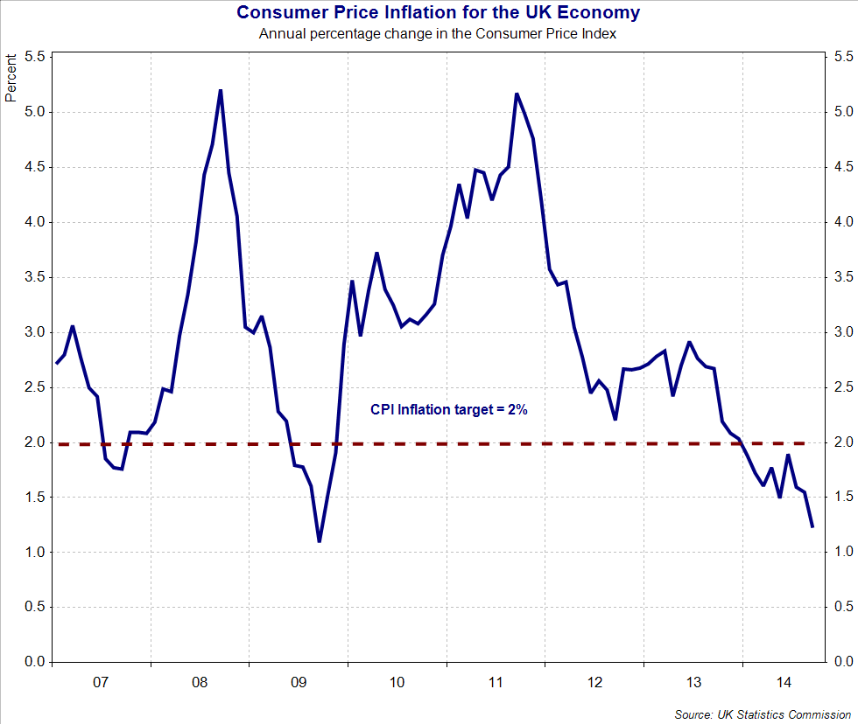CPI Inflation Rate

***How is the rate of inflation calculated?***

* The **cost of living** is a measure of changes in the average cost of buying a basket of different goods and services for a typical household
* In the UK there are two measures, the **Retail Price Index** (RPI) & the **Consumer Price Index** (CPI).
* RPI includes the costs of housing (mortgage interest costs and council tax for example) while CPI does not
* The RPI is an **arithmetic mean** – the prices of everything to be included in it are simply added up and divided by the number of items.
* The CPI is a geometric mean. It is calculated by multiplying the prices of all the items together and then taking the nth root of them, where 'n' is the number of items involved

***Calculating a weighted price index***

CPI is a **weighted price index**. Changes in weights reflect shifts in the spending patterns of households in the British economy as measured by the Family Expenditure Survey.

The following hypothetical example shows how to calculate a weighted price index.

|  |  |  |  |
| --- | --- | --- | --- |
| Category | Price Index | Weighting | Price x Weight |
| Food | 104 | 19 | 1976 |
| Alcohol & Tobacco | 110 | 5 | 550 |
| Clothing | 96 | 12 | 1152 |
| Transport | 108 | 14 | 1512 |
| Housing | 106 | 23 | 2438 |
| Leisure Services | 102 | 9 | 918 |
| Household Goods | 95 | 10 | 950 |
| Other Items | 114 | 8 | 912 |
|  |  | 100 | 10408 |

Weights are attached to each category; we multiply these weights to the price index for each item of spending for a given year.

* The price index for this year is: **the sum of (price x weight) / sum of the weights**
* So the price index for this year is 104.1 (rounding to one decimal place)
* The rate of inflation is the % change in the price index from one year to another.
* So if in one year the price index is 104.1 and a year later the price index has risen to 112.5, then the annual rate of inflation = (112.5 – 104.1) divided by 104.1 x 100. Thus the rate of inflation = 8.07%.

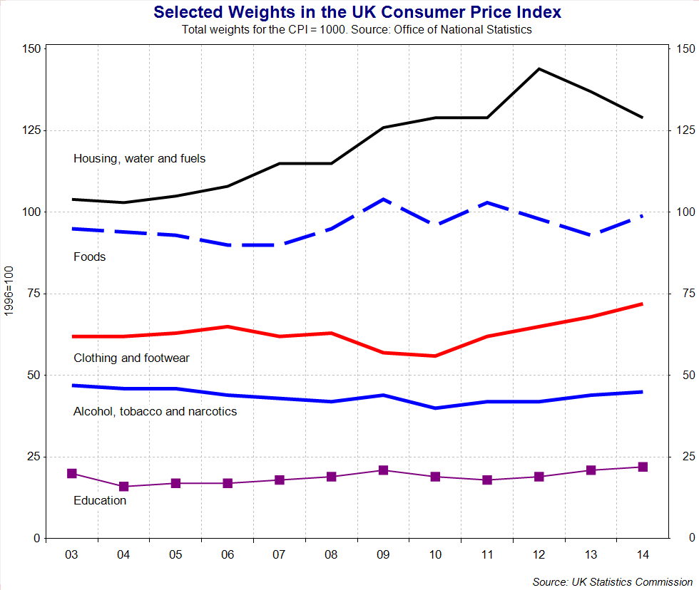

***Limitations of the Consumer Price Index as a measure of inflation***

* **The CPI is not fully representative**:

1. Since the CPI represents the expenditure of the 'average' household, inevitably it will be inaccurate for the 'non-typical' household, for example, 14% of the index is devoted to motoring expenses - inapplicable for non-car owners.
2. Single people have different spending patterns from households that include children, young from old, male from female, rich from poor and minority groups.
3. We all have our own 'weighting' for goods and services that does not coincide with that assigned for the consumer price index.

* **Housing costs:** The 'housing' category of the CPI records changes in the costs of rents, property and insurance, repairs. It accounts for around 16% of the index. Housing costs vary greatly from person to person.
* **Changing quality of goods and services**: Although the price of a good or service may rise, this may also be accompanied by an improvement in quality as the product. It is hard to make price comparisons of, for example, electrical goods over the last 20 years because new audio-visual equipment is so different from its predecessors. In this respect, the CPI may over-estimate inflation. The CPI is slow to respond to the emergence of new products and services.

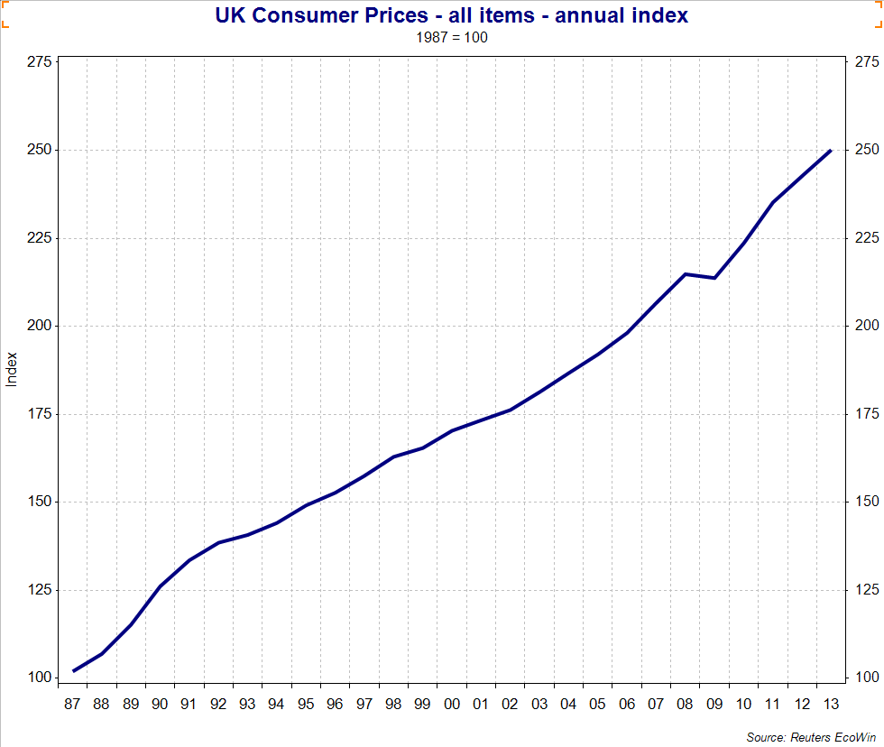UK consumer price index 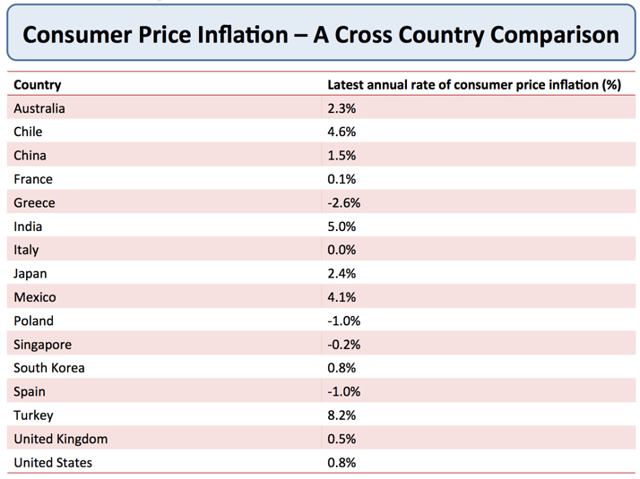A selection of inflation rates by country

***Problems in Measuring Inflation***

Inflation is a measure of changes in the cost of living. Inflation is measured by using a weighted basket of goods and looking at the changes in price. However, in practice, there are many practical difficulties for measuring inflation.

1. Family Expenditure Survey does not include everybody. E.g pensioners are excluded. Pensioners have different spending habits e.g. heating / bus travel account for a higher % of their expenditure. Young people will benefit more from falling prices of mobile phones and electronic goods. Therefore, the basket of goods may not be representative. Also, as it is updated once a year, it may soon become outdated for changes in spending habits.
2. Changes in Quality of goods. Changes in the quality of goods mean that price rises may not reflect inflation, but just the fact it is a different good. For example, computers have many more features than 10 years ago, so it is difficult to compare prices because they are effectively different goods. This is similar situation for many goods such as mobile phones and cars.
3. One off shocks may give a misleading impression. For example, a rise in oil prices will lead to higher inflation. But, this rise in prices may just be temporary. Tax changes have a similar effect.
4. Which Measure to Use? – CPI, RPI or RPIX. RPI includes mortgage interest payments. CPI doesn’t. In 2009, with falling interest rates, RPI gave a negative inflation rate, whilst CPI was positive. Therefore, it is important which measure is used. The government’s preferred measure is currently CPI.
5. People have different inflation rates. Rising electricity and gas prices may effect old people more than young people. Therefore, old people could have a higher inflation rate than the national average. This is important if pensions are index linked because their cost of living may rise more than prices causing a decrease in living standards.

***Different Types of Inflation Measures***

* RPI  – old headline inflation rate
* RPIX  – RPI less mortgage payments this is the underlying rate.
* This is used because interest rates are increased to reduce inflation but this higher interest rates increase the cost of mortgage repayments
* RPIY = RPIX less taxes (This is sometimes known as the harmonized rate)
* CPI – Consumer Price Index

***Inflation - Causes of Inflation***



Inflation can come from both the demand and the supply-side of an economy

Inflation can arise from internal and external events

Some inflationary pressures direct from the domestic economy, for example the decisions of utility businesses providing electricity or gas or water on their tariffs for the year ahead, or the pricing strategies of the food retailers based on the strength of demand and competitive pressure in their markets.

A rise in the rate of VAT would also be a cause of increased domestic inflation in the short term because it increases a firm's production costs.

Inflation can also come from external sources, for example a sustained rise in the price of crude oil or other imported commodities, foodstuffs and beverages.

Fluctuations in the exchange rate can also affect inflation – for example a fall in the value of the pound against other currencies might cause higher import prices for items such as foodstuffs from Western Europe or technology supplies from the United States – which feeds through directly or indirectly into the consumer price index

***Demand-pull inflation***

Demand pull inflation occurs when aggregate demand is growing at an unsustainable rate leading to **increased pressure on scarce resources** and a **positive output gap**

When there is **excess demand**, producers can raise their prices and achieve bigger **profit margins**

Demand-pull inflation becomes a threat when an economy has experienced a boom with GDP rising faster than the long-run trend growth of potential GDP

Demand-pull inflation is likely when there is **full employment of resources** and SRAS is inelastic

**Main Causes of Demand-Pull Inflation**

1. A **depreciation of the exchange rate** increases the price of imports and reduces the foreign price of a country's exports. If consumers buy fewer imports, while exports grow, AD in will rise – and there may be a multiplier effect on the level of demand and output
2. **Higher demand from a fiscal stimulus** e.g. lower direct or indirect taxes or higher government spending. If direct taxes are reduced, consumers have more disposable income causing demand to rise. Higher government spending and increased borrowing creates extra demand in the circular flow
3. **Monetary stimulus to the economy:** A fall in interest rates may stimulate too much demand – for example in raising demand for loans or in leading to house price inflation. Monetarist economists believe that inflation is caused by “too much money chasing too few goods" and that governments can lose control of inflation if they allow the financial system to expand the money supply too quickly.
4. **Fast growth in other countries** – providing a boost to UK exports overseas. Export sales provide an extra flow of income and spending into the UK circular flow – so what is happening to the economic cycles of other countries definitely affects the UK

***Cost-push inflation***

Cost-push inflation occurs when firms respond to **rising costs**, by increasing prices to **protect their profit margins**.

There are many reasons why costs might rise:

1. **Component costs:** e.g. an increase in the prices of raw materials and other components. This might be because of a rise in commodity prices such as oil, copper and agricultural products used in food processing. A recent example has been a surge in the world price of wheat.
2. **Rising labour costs** - caused by wage increases, which are greater than improvements in productivity. Wage costs often rise when unemployment is low because skilled workers become scarce and this can drive pay levels higher. Wages might increase when people **expect higher inflation** so they ask for more pay in order to protect their real incomes. Trade unions may use their bargaining power to bid for and achieve increasing wages, this could be a cause of cost-push inflation
3. **Expectations of inflation** are important in shaping what actually happens to inflation. When people see prices are rising for everyday items they get concerned about the effects of inflation on their real standard of living. One of the dangers of a pick-up in inflation is what the Bank of England calls “**second-round effects**" i.e. an initial rise in prices triggers a burst of higher pay claims as workers look to protect their way of life. This is also known as a “wage-price effect"
4. **Higher indirect taxes** – for example a rise in the duty on alcohol, fuels and cigarettes, or a rise in Value Added Tax. Depending on the price elasticity of demand and supply for their products, suppliers may choose to pass on the burden of the tax onto consumers.
5. **A fall in the exchange rate** – this can cause cost push inflation because it leads to an increase in the prices of imported products such as essential raw materials, components and finished products
6. **Monopoly employers/profit-push inflation** – where dominants firms in a market use their market power (at whatever level of demand) to increase prices well above costs

***Inflation - Consequences of Inflation***



Many government s have a **target for a low but positive rate of inflation**. They believe that persistently high inflation can have damaging economic and social consequences.

* **Income redistribution**: One risk of higher inflation is that it has a **regressive effect** on lower-income families and older people in society. This happen when prices for food and domestic utilities such as water and heating rises at a rapid rate.
* **Falling real incomes**: With millions of people facing a cut in their wages or at best a pay freeze, rising inflation leads to a fall in real incomes.
* **Negative real interest rates**: If interest rates on savings accounts are lower than inflation, people who rely on interest from their savings will be poorer. Real interest rates for millions of savers have been negative for at least four years
* **Cost of borrowing**: High inflation may also lead to higher interest rates for businesses and people needing loans and mortgages as financial markets protect themselves against rising prices and increase the cost of borrowing on short and longer-term debt. There is also pressure on the government to increase the value of the state pension and unemployment benefits and other welfare payments as the cost of living climbs higher.
* **Risks of wage inflation**: High inflation can lead to an increase in pay claims as people look to protect their real incomes. This can lead to a rise in unit labour costs and lower profits for businesses
* **Business competitiveness**:If one country has a much higher rate of inflation than others for a considerable period of time, this will make its exports less price competitive in world markets. Eventually this may show through in reduced export orders, lower profits and fewer jobs, and also in a worsening of a country’s trade balance. A fall in exports can trigger negative multiplier and accelerator effects on national income and employment.
* **Business uncertainty**: High and volatile inflation is not good for business confidence partly because they cannot be sure of what their costs and prices are likely to be. This uncertainty might lead to a lower level of capital investment spending.

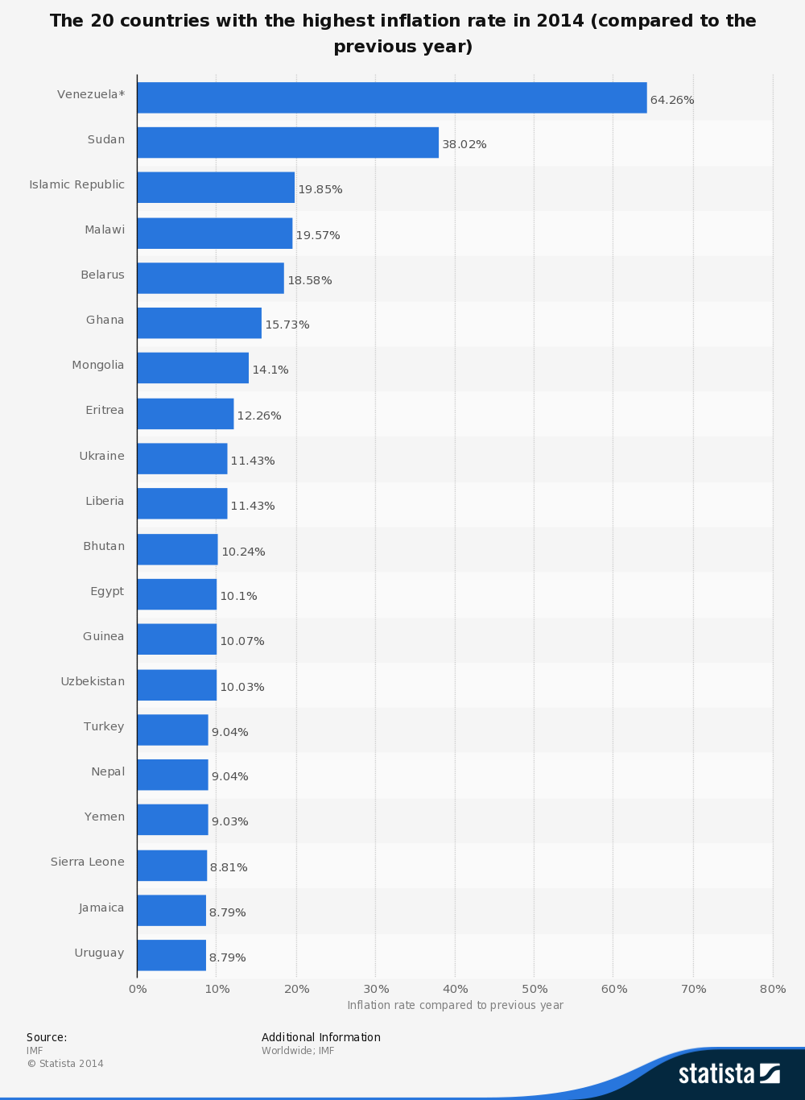

***Deflation***



**Price deflation** happens when the **rate of inflation becomes negative**. I.e. the general price level is falling and the purchasing power of say £1,000 in cash is increasing

* Some countries have experienced periods of deflation in recent years; perhaps the most well-known example was Japan during the late 1990s and in the current decade. In Japan, the root cause of deflation was slow growth and a **high level of spare capacity** that was driving prices lower.
* Greece and a number of Euro Area countries are now experiencing price deflation as are countries such as Switzerland and Denmark



***Monetarist Theory of Inflation***

***Monetarist Theory***

Monetarists argue that if the Money Supply rises faster than the rate of growth of national income then there will be inflation.

· If money supply increases in line with inflation then there will be no inflation.

***M.Friedman stated:***

*“ Inflation is always and everywhere a monetary phenomenon”*

· Quantity theory of Money (fischer Version) MV=PT,

· M = Money Supply, V= Velocity of circulation, P= Price Level and T = Transactions.

· T is difficult to measure so it is often substituted for Y = National Income

· therefore ***MV = PY where Y =national output***

The above equation must hold the value of expenditure on goods and services must equal the value of output. However they argue it is unwarranted increases in the money supply which cause inflation.

Monetarists believe that in the short term velocity (V) is fixed This is because I The rate at which money circulates is determined by institutional factors e.g. how often workers are paid does not change very much.

· M.Friedman admitted it may vary a little but not very much so it can be treated as fixed

· Monetarists also believe Output Y is fixed . They state it may vary in the short run but not in the long Run ( because LRAS is inelastic)

Therefore an increase in the Money Supply will lead to an increase in inflation

E.G. if MS is initially £1000 and the Velocity of circulation is 5. Level of output is 5000 units. The quantity equation is 1000*5 = 1*5000

If the money supply now doubles the equation = 2000*5 =2*5000 (the price level must double

· M. Friedman predicted an increase in the money supply would take about 9-12 months to lead to higher output  
· After another year output will return to its initial equilibrium causing prices to rise to accommodate the rise in money supply

***Monetarist inflation in the AD and AS model***

i) Following a rise in the MS, consumers have more money so spend more goods, this shifts AD to the right

ii) Firms respond by increasing output along SRAS, from A to B

iii) National output now exceeds the equilibrium level of output, therefore there is an inflationary gap.

iv) Firms need to hire more workers so wages rise leading to an increase in costs and hence prices. Initially workers agree to work more hours because they see an increase in nominal wages

v) As prices rise money can buy less therefore there is a movement to the left along the new AD

vi) Also workers realise the increase in nominal wage is not a real wage increase. Therefore, workers also demand higher nominal wages to produce more output and to compensate them for rising prices , therefore SRAS shifts to the left

vii) The economy has returned to the equilibrium level of output, but at a higher price level.

Therefore the rise in the Money Supply cause a rise in AD, But because the LRAS is inelastic there is no increase in therefore this is known as demand pull inflation.