***Fiscal Policy***

**Definition of fiscal policy.** Fiscal policy involves the government changing the levels of taxation and government spending in order to influence Aggregate Demand (AD) and the level of economic activity.

* AD is the total level of planned expenditure in an economy (AD = C+ I + G + X – M)

***The purpose of Fiscal Policy***

* Stimulate economic growth in a period of a recession.
* Keep inflation low (UK government has a target of 2%)
* Basically, fiscal policy aims to stabilise economic growth, avoiding a boom and bust economic cycle.

Fiscal policy is often used in conjunction with [monetary policy.](http://www.economicshelp.org/macroeconomics/monetary-policy/) In fact governments often prefer monetary policy for stabilising the economy.

***Expansionary (or loose) Fiscal Policy***

* This involves increasing AD.
* Therefore the government will increase spending (G) and / or cut taxes (T). Lower taxes will increase consumers spending because they have more disposable income (C)
* This will tend worsen the government budget deficit and the government will need to increase borrowing.

**Diagram showing effect of expansionary fiscal policy**

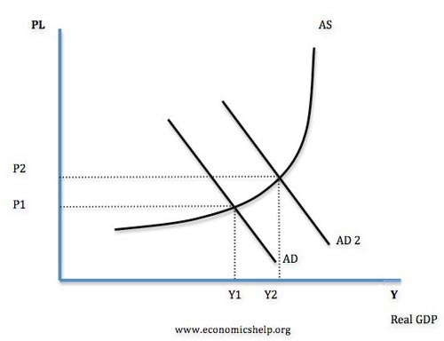

***Deflationary (or tight) Fiscal Policy***

* This involves decreasing AD.
* Therefore the government will cut government spending (G) and / or increase taxes. Higher taxes will reduce consumer spending (C)
* Tight fiscal policy will tend to cause an improvement in the government budget deficit.

**Diagram showing the effect of tight fiscal policy**

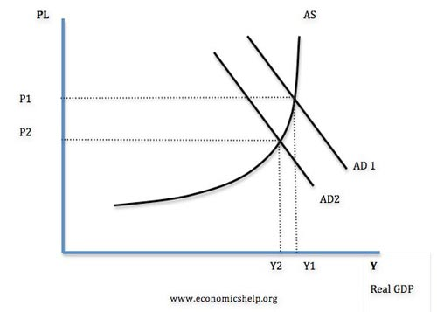

***UK fiscal policy***

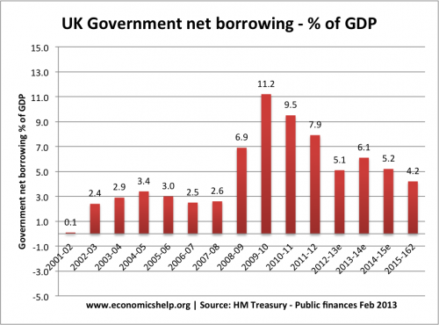

In 2009, the government pursued expansionary fiscal policy. In response to a deep recession (GDP fell 6%) the government cut VAT in a bid to boost consumer spending. This caused a big rise in government borrowing (2009-10). (Government borrowing also rose because of the recession leading to lower tax revenue)

When the new coalition government came into power in May 2010, they argued the deficit was too high and then announced plans to reduce government borrowing. This involved spending limits. This austerity measures were a factor in causing lower economic growth in 2011 and 2012.

***Terms relating to fiscal policy***

* **Fiscal Stance** : This refers to whether the government is increasing AD or decreasing AD, e.g. expansionary or tight fiscal policy
* **Fine Tuning** : This involves maintaining a steady rate of economic growth through using fiscal policy. However this has proved quite difficult to achieve precisely.
* **Automatic fiscal stabilisers** – If the economy is growing, people will automatically pay more taxes ( VAT and Income tax) and the Government will spend less on unemployment benefits. The increased T and lower G will act as a check on AD. But, in a recession the opposite will occur with tax revenue falling but increased government spending on benefits, this will help increase AD
* **Discretionary fiscal stabilisers** – This is a deliberate attempt by the government to affect AD and stabilise the economy, e.g. in a boom the government will increase taxes to reduce inflation.
* [The multiplier effect](http://www.economicshelp.org/blog/1948/economics/the-multiplier-effect/). When an increase in injections causes a bigger final increase in Real GDP.
* **Injections (J) –** This is an increase of expenditure into the circular flow, it includes govt spending(G), Exports (X) and Investment (I)
* **Withdrawals (W) –** This is leakages from the circular flow This is household income that is not spent on the circular flow. It includes: Net savings (S) + Net Taxes (T) + Net Imports (M)

***Criticism of fiscal policy***

1. The government may have poor information about the state of the economy and struggle to have the best information about what the economy needs.
2. Time lags. To increase government spending will take time. It could take several months for a government decision to filter through into the economy and actually affect AD. By then it may be too late.
3. Crowding out. Some economists argue that expansionary fiscal policy (higher government spending) will not increase AD, because the higher government spending will crowd out the private sector. This is because government have to borrow from the private sector who will then have lower funds for private investment.
4. Government spending is inefficient. Free market economists argue that higher government spending will tend to be wasted on inefficient spending projects. Also, it can then be difficult to reduce spending in the future because interest groups put political pressure on maintaining stimulus spending as permanent.
5. Higher borrowing costs. Under certain conditions, expansionary fiscal policy can lead to higher bond yields, increasing the cost of debt repayments.

***Evaluation of fiscal policy***

The success of fiscal policy will depend on several factors, such as

1. It depends on the size of the multiplier. If the multiplier effect is large, then changes in government spending will have a bigger effect on overall demand.
2. It depends on the state of the economy. Fiscal policy is most effective in a deep recession where monetary policy is insufficient to boost demand. In a deep recession (liquidity trap). Higher government spending will not cause crowding out because the private sector saving has increased substantially. See: [Liquidity trap and fiscal policy](http://www.economicshelp.org/blog/economics/liquidity-trap/) – why fiscal policy is more important during a liquidity trap.
3. It depends on other factors in the economy. For example, if the government pursue expansionary fiscal policy, but interest rates rise and the global economy is in a recession, it may be insufficient to boost demand.
4. Bond yields. If there is concern over the state of government finances, the government may not be able to borrow to finance fiscal policy. Countries in the Eurozone experienced this problem in the 2008-13 recession.

***Fiscal Policy - Growth and Development***



Fiscal policy involves the use of government spending, taxation and borrowing to affect the level and growth of aggregate demand, output and jobs

* Fiscal policy is also used to change the pattern of spending on goods and services in an economy
* It is also a means by which a **redistribution of income & wealth** can be achieved
* It is an instrument of government intervention to correct for **free-market failures** such as negative **externalities** and the non-market provision of **public goods**
* Changes in fiscal policy affect aggregate demand (AD) and aggregate supply (AS). The fiscal multiplier effect is important when discussing the impact of changes in fiscal policy on GDP

***Government spending***

Typically government spending in developed and developing countries is broken down into these areas

1.**Transfer Payments:**

1. **Welfare payments** including cash payments paid through the **social security system.** Some of these might be made available in a **universal way**; others will be subject to some kind of **means-test**. Or they might be made **conditiona**l on people making certain choices such as ensuring that that the children in a family attend school or that a mother attends a post-natal or immunisation programme.
2. **Government subsidies** to businesses including state aid to loss-making firms

2.**Current Government Spending**:

i.e. **state-provided goods & services** provided on a recurrent basis - for example salaries paid to those working in a country’s education or health system

3.**Capital Spending**:

Capital spending includes **infrastructure** spending such as new motorways and roads, hospitals, schools and prisons. This investment spending adds to the economy’s **capital stock** and can have important demand and aggregate supply side effects in the long term.

***Economic and Social Justifications for State Spending***

1.To provide a socially efficient level of **public goods and merit goods** and overcome market failure

* Public goods and merit goods tend to be under-provided by the private sector
* Improved and affordable access to education, health, housing and other public services can help to improve **human capital**, raise **productivity** and generate **positive externalities**

2.To provide a **safety-net system of welfare benefits** to supplement the incomes of the poorest in society – this is also part of the **process of redistributing income and wealth**. Government spending has an important role to play in controlling / reducing the level of **relative poverty**

3.To provide **necessary critical infrastructure** via capital spending on transport, education and health facilities – an important component of a country’s long run aggregate supply

4.Government spending can be used to **manage the level and growth of AD** to meet macro policy objectives such as low stable inflation and higher levels of employment

Government spending can be used in **promoting equity** and **inclusive growth and development**.

***Types of Tax in UK***

1. Income tax – This a tax on people’s income. The basic rate of income tax is 20%, paid on income over the income tax threshold of £10,400.
2. National insurance contributions. Another type of income tax is national insurance contributions, which are based on a similar principle of taking a certain percentage of income.
3. Consumption tax –  VAT – 17.5%
4. Excise duties on alcohol, tobacco
5. Corporation tax – tax on company profit
6. [Stamp duty](http://www.economicshelp.org/blog/12245/housing/cut-in-uk-stamp-duty/) – tax on buying houses / shares

**Income tax rates in the UK**

|  |  |
| --- | --- |
| Basic rate 20% | £0 to £31,865 Most people start paying basic rate tax on income over £10,000 |
| Higher rate 40% | £31,866 to £150,000 Most people start paying higher rate tax on income over £41,865 |
| Additional rate 45% | Over £150,000 |

[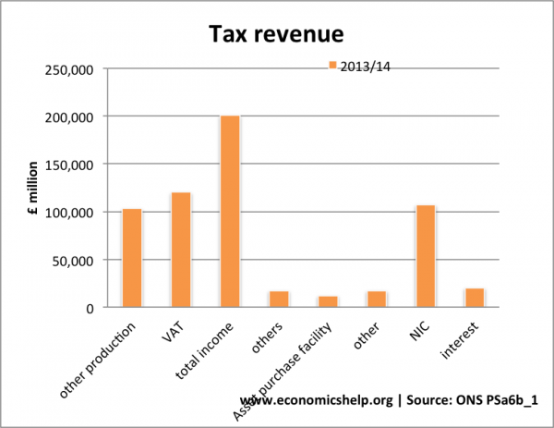](http://www.economicshelp.org/wp-content/uploads/2012/11/tax-revenue-sources.png)

[Public sector finance](http://www.ons.gov.uk/ons/datasets-and-tables/data-selector.html?table-id=PSA1&dataset=pusf)

***How much is income tax?***

Example, if your income is £40,000 of taxable income

* You pay 0% on your Personal Allowance of £10,000.
* You pay 20% on the income from £10,000 to £31,866 (21,866) = £4,372.20
* You pay 40% on income between £31,866 to £40,000  – £8,134 = £3,253
* Total tax – £7,625
* average tax rate 19%

***Progressive tax***

This is a tax that when income rises people pay a higher % of their income in tax e.g. top rate of income tax is 40%. This is paid on earnings over £40,000 a year. (See: [progressive tax](http://www.economicshelp.org/macroeconomics/fiscal-policy/progressive-tax/))

Regressive tax

This occurs when an increase in income leads to a smaller % of their income going on the tax. E.G excise duties. A regressive tax means those on low incomes pay a higher % of tax. (See: [regressive tax](http://www.economicshelp.org/macroeconomics/fiscal-policy/regressive-tax/))

***Proportional tax***

This occurs when an increase in income leads to the same % increase in tax.

***Types of equity***

* **Horizontal equity**: The equal treatment of people in the same situation
* **Vertical equity** : The redistribution from the better off to the worse off in the case of taxes this means the rich paying proportionately more taxes than the poor

***The requirements of a good tax system***

1. Horizontal Equity. I.e. those in the same circumstances should pay the same taxes
2. Vertical Equity. A degree of proportionality is important
3. Cheap to collect
4. Difficult to evade
5. Efficient, Non distortion e.g. if taxes are too high people may be put off working
6. Easy to understand

***Reasons for tax***

1. Raise revenue
2. Promote redistribution of income and wealth
3. Discourse consumption / production of goods with [negative externalities](http://www.economicshelp.org/micro-economic-essays/marketfailure/tax-negative-externality/) or demerit goods

***Negative Income Tax***

This is a progressives system of tax and benefits designed to reduce relative poverty. Those on low incomes are a given benefits, as income increases, the benefit decreases . After a certain level of income people will start paying tax.

***Fiscal Policy - Direct and Indirect Taxes***



This study note looks at the relative advantages and disadvantages of direct and indirect taxation

•Direct taxes – are paid directly to the government by the individual taxpayer – usually through “pay as you earn”. Tax liability cannot be passed onto someone else

•Indirect taxes – include VAT and duties. The supplier can pass on the burden of an indirect tax to the final consumer – depending on the price elasticity of demand and supply for the product.

**Tax Competition between Nations**

* Tax competition describes a process where a national government decides to use reforms to the tax system as a deliberate **supply-side strategy** aimed at attracting new capital investment and jobs into their economy.
* The issue has become important in the European Union because some countries including France and Germany complain that poorer countries are using tax competition as an incentive to attract **inward investment**, yet they are also net recipients of **EU structural funds**.
* If these countries can afford to lower business taxes, can they also afford not to do with the extra EU funding that helps to finance, for example, infrastructural spending required sustaining fast rates of economic growth?

**The Laffer curve**

* Created by the US supply-side economist **Arthur Laffer**, this curve explores a relationship between tax rates and tax revenue collected by governments
* It argues that as tax rates rise, total tax revenues grow at first but at a diminishing rate.
* There may be a tax burden which yields the highest tax revenues. Beyond this, further hikes in taxation serve only to lower revenues
* The Laffer curve has been used as a justification for cutting taxes on income and wealth - the argument being that improved incentives to work and create wealth will broaden the base of tax-paying businesses and individuals and also reduce the incentive to avoid and evade paying tax.
* A Keynesian view on the effects of tax reductions on government tax revenue is that lower direct taxes stimulate higher spending within the circular flow which itself boosts demand, output, profits and employment, all of which can drive tax revenues higher.

**Government spending and taxation levels in different countries**

* There are big variations in the scale and breadth of government spending between countries
* Some evidence for this is shown in the next table which draws on state spending and tax data for the year 2011. The data shows spending and taxes as a share of national income and gives an idea of the extent to which the size of the state varies
* Cuba’s state-dominated economy has a very high level of government spending; so too in the case of Scandinavian countries where the welfare system is extensive and generous – funded largely by a highly progressive income tax system
* In many lower income countries the scale of the state is smaller, not least because the ability to rely on a strong flow of direct and indirect tax revenues is limited by the structure of their economy.

***Government Intervention - Fiscal Policy Intervention***



Fiscal policy can be used to alter the **level of demand** for different products and also the **pattern of demand** within the economy.

* **Indirect taxes** can be used to raise the price of de-merit goods and products with negative externalities designed to increase the opportunity cost of consumption and thereby reduce consumer demand towards a socially optimal level
* **Subsidies** to consumers will lower the price of merit goods. They are designed to boost consumption and output of products with positive externalities – remember that a subsidy causes an increase in market supply and leads to a lower equilibrium price
* **Tax relief:** The government may offer financial assistance such as **tax credits** for business investment in research and development. Or a reduction in **corporation tax** (a tax on company profits) designed to promote new capital investment and extra employment
* **Changes to taxation and welfare payments** can be used to influence the overall distribution of income and wealth – for example higher direct tax rates on rich households or an increase in the value of welfare benefits for the poor to make the tax and benefit system more progressive

***Fiscal Policy - Impact on Aggregate Supply and Economic Growth***



Fiscal policy can have important effects on the **supply-side of developed and developing countries**.

**Labour market incentives:**

1. Changes in income tax can improve incentives for people to actively look for work
2. Lower taxes might also have a positive effect on work effort and labour productivity

2.**Capital spending**:

1. Spending on infrastructure provides the capacity needed for other businesses to flourish.
2. Lower rates of corporation tax might attract inward investment from overseas

3.**Entrepreneurship and investment**:

1. Government spending can be used to fund an expansion in new small business start-ups

4.**Research and development and innovation**

1. Government spending and tax allowances could be used to encourage research
2. Tax incentives can be used to stimulate investment in low carbon technologies

5.**Human capital of the workforce**:

1. Spending on education and increased investment in health and transport can also have important supply-side effects in the long run
2. Government spending can help to improve human capital, employability and productivity

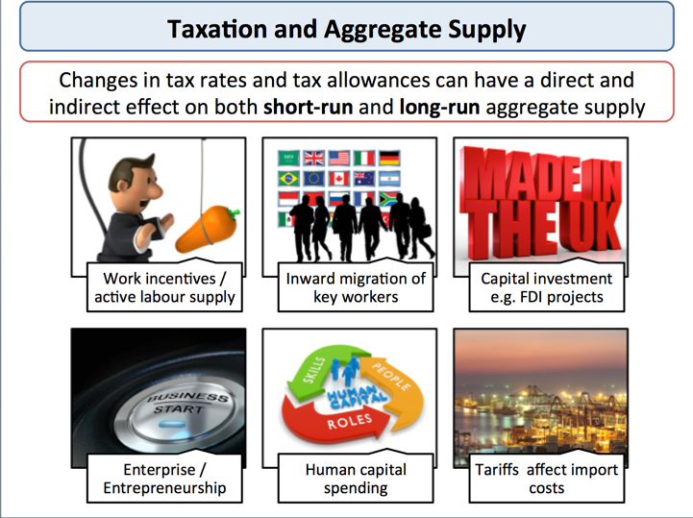Taxation and aggregate supply

***Fiscal Policy - Government Borrowing***



When a government's tax revenues are insufficient to pay for a given level of state spending then a nation must borrow to make up the difference, this is a **budget deficit**. Governments often find that they have to borrow to finance their spending

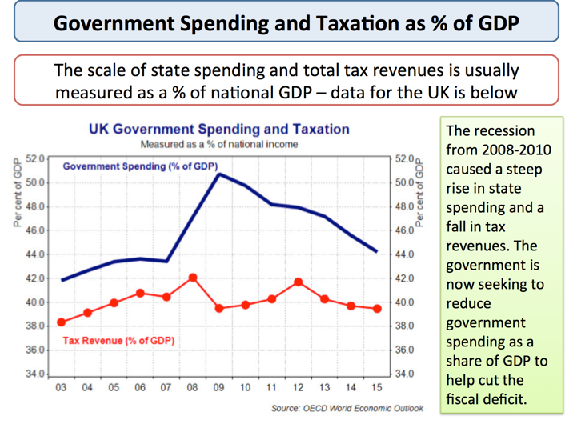

***Causes of a rising budget (fiscal Deficit)***

• Recession causing rising employment

• Decrease in consumer spending, falling profits leading to less tax revenue

• Increase in economic inactivity leading to rise in welfare benefit spending

• Deliberate use of fiscal stimulus by a government to boost aggregate demand

• Increase in interest rates on debt leading to a rise in debt service costs

• Demographioc factors causing state pensions to rise

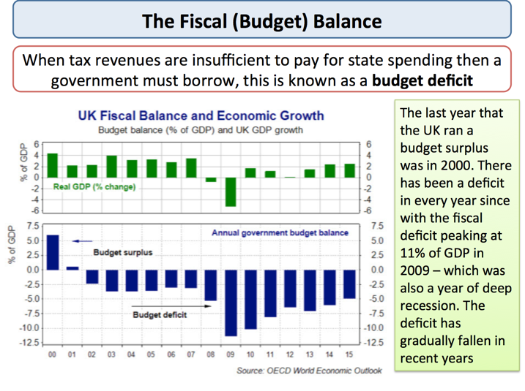 The

Not all countries and groups of countries run budget deficits, there are many both from the richer advanced groupings and fast-growing developing nations who have been running budget surpluses in recent years.

* Most of the member nations of the Group of 7 have seen a significant rise in government borrowing and higher levels of debt.
* A number of newly industrialized Asian countries run budget surpluses as do the oil and gas rich nations of the Middle East

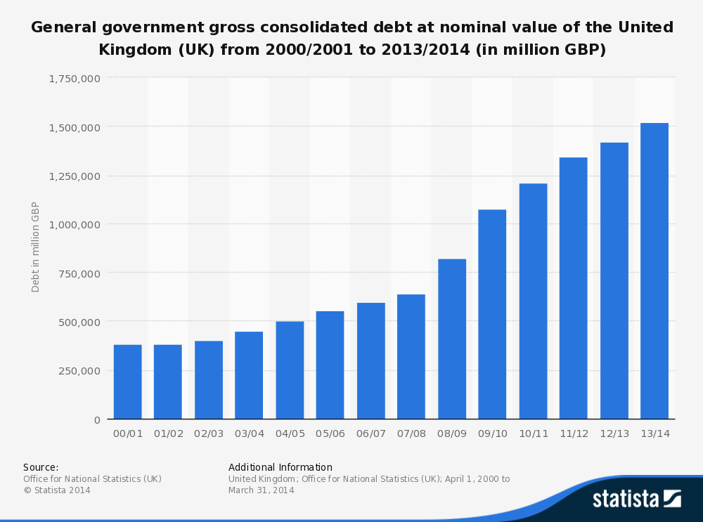

***Fiscal austerity under the 2010-2015 Coalition Government***

The UK coalition government has a deficit-reduction policy with the emphasis on cutting government spending in some areas in real terms and a series of direct and indirect tax increases:

Key policies for deficit reduction:

* Rise in VAT to 20%
* Rise in employee national insurance contributions
* Deep cuts in real government spending e.g. for local authorities
* Welfare caps including £26k pa cap on welfare for each family

Some taxes have been cut

* A series of cuts to corporation tax - down to 20% in 2015
* Freezing of fuel duties (meaning a cut in real terms)
* Increases in the real value of the income tax free allowance
* Freezing of council tax (so that council tax falls in real terms)

The UK government also helped by lower interest rates on newly issued debt. 10 year bond yields fell to a record low of 1.4% in January 2015.

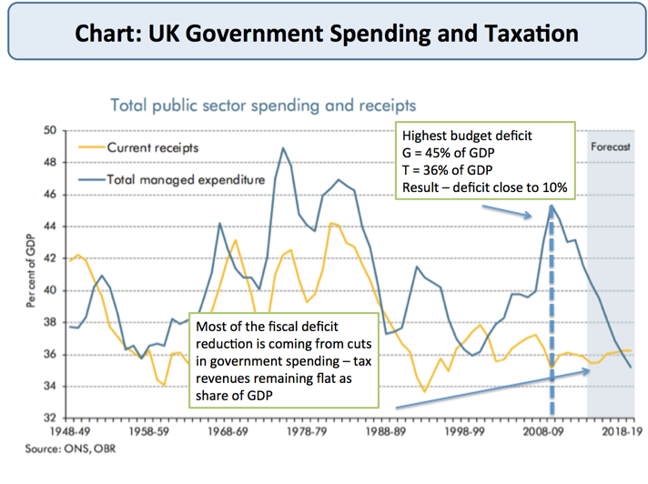

***Fiscal Policy - Managing Aggregate Demand and Inflation***



Government spending, direct and indirect taxation and the budget balance can be used “counter-cyclically” to help smooth some of the volatility of national output when an economy has experienced an external shock

* Discretionary fiscal changes are deliberate changes in taxation and Govt spending – for example a decision by the government to increase total capital spending on road building.
* Automatic fiscal changes (‘automatic stabilisers’) are changes in tax revenues and state spending arising automatically as the economy moves through the trade cycle.

During phases of high GDP growth, automatic stabilizers reduce the growth rate and avoid the risks of an unsustainable boom and accelerating inflation. With higher growth, a government will receive more tax revenues and there will be a fall in unemployment so the government will spend less on unemployment and other welfare benefits. In some cases, a government may run a budget surplus during a boom that acts as a net leakage of demand from the circular flow.

In a recession, because of lower real incomes and a contraction in employment, people and businesses pay less tax, and spending on welfare benefits will increase. The result is an automatic increase in government borrowing with the state sector injecting extra demand into the circular flow.

Recent evidence from the OECD suggests that a government allowing the fiscal automatic stabilizers to work might reduce the volatility of an economic cycle by up to 20 per cent. The strength of the automatic stabilizers is linked to the size of government spending as a % of GDP, the progressivity of the tax system and how many welfare benefits are income-related. In short automatic stabilizers help to provide a cushion of demand in an economy and support output during a recession.

**Keynesian economists** argue that an active use of expansionary fiscal policy beyond relying solely on the automatic fiscal stabilisers is needed to bring a recovery in demand, production, investment and jobs.

***Measuring the fiscal stance***

1. A **‘neutral’ fiscal stance** might be shown if the government runs with a balanced budget.
2. A **reflationary fiscal stance** happens when the government is running a budget deficit.
3. A **deflationary fiscal stance** happens when the government runs a budget surplus (i.e. G<T)

***Keynesian justification for a fiscal stimulus***

* The **Keynesian school** argues that fiscal policy can have powerful effects on AD, output and employment when an economy is operating below full capacity national output
* Keynesians believe that a government should make **active use** of fiscal policy measures to fine-tune aggregate demand particularly when monetary policy is proving ineffective. Here is the justification:
* There is an automatic rise in the budget deficit to cushion the fall in AD caused by a shock such as the credit crunch. A higher deficit is needed to lift AD back towards pre-recession levels
* If this works the budget deficit will improve as a result of higher tax revenues and reductions in welfare spending. A growing economy helps to shrink government debt
* Keynesian economists oppose cutting government spending during a recession

**Monetarist economists** believe that government spending and tax changes can only have a temporary effect on AD, output and jobs and that monetary policy is more effective in controlling AD and inflation.

**The Fiscal Multiplier Effect**

The **fiscal multiplier** measures the final change in national income that results from a deliberate change in either government spending and/or taxation. Several factors affect the likely size of the fiscal multiplier effect.

* **Design**: Evidence from the OECD is that multiplier effects of increases in spending are higher than for tax cuts or increased transfer payments.
* **Who gains from the stimulus**? If tax reductions are targeted on the low paid, the chances are they will spend it adding to aggregate demand
* **Financial stress**: Uncertainty about job prospects, future income and inflation levels might make people save tax cuts. On the other hand if consumers are finding it hard to get credit, they may decide to consume a high % of any boost to their disposable incomes.
* **Temporary or permanent fiscal boost**: Expectations of the future drive behaviour today - most of us now expect taxes to rise in the coming years. Will this prompt a higher household saving and a paring back of spending and private sector borrowing?
* **The availability of credit**:If fiscal policy works in injecting fresh demand, we still need the banking system to supply sufficient credit to businesses who need to borrow to fund an increase in production (perhaps for export) and investment in fixed capital and extra stocks.
* **Openness of the economy**: The more open an economy is (i.e. the higher is the ratio of imports and exports to GDP) the greater the extent to which higher government spending or tax cuts will feed into rising demand for imports, lowering the impact on domestic GDP.
* **Fiscal and monetary policy decisions in other countries** for example a period of fiscal austerity in euro zone countries might dampen an economic recovery in the UK at least in the short term

***Problems with Fiscal Policy as an Instrument of Demand Management***

1. **Recognition lags:** It takes time to for policy-makers to recognise a need for changes in spending or taxation.
2. **Imperfect information:** Key data on the economy is often delayed and subject to revisions.
3. **Response lags:** It takes time to implement an appropriate policy response. Tax cuts can feed through quickly but new capital expenditure is difficult to start; roads have to be planned, hospitals and schools designed – the response lags may run into years not months

***Fiscal Policy - Crowding Out***



The **“crowding-out hypothesis”** is an idea that became popular in the 1970s and 1980s when free-market economists argued against the rising share of GDP being taken by the public sector

* The crowding out view is that a rapid growth of government spending leads to a transfer of scarce productive resources from the private sector to the public sector where productivity might be lower
* If the government runs a big budget deficit, it will have to sell **debt** to the private sector and getting individuals and institutions to purchase the debt may require higher interest rates. A rise in interest rates may then crowd-out private investment and consumption, offsetting the fiscal stimulus
* Eventually higher government spending needs to be funded by higher taxes and this again acts as a squeeze on spending and investment by the private sector of the economy.

***Rational Expectations View***

* According to a school of economic thought that believes in **‘rational expectations’**, when the government sells debt to fund a tax cut or an increase in expenditure, a rational individual will realise that at some future date he will face higher tax liabilities to pay for the interest repayments.
* Thus, he/she should increase his savings as there has been no increase in his permanent income
* The implications are clear. Any change in fiscal policy will have no impact on the economy if all individuals are rational. Fiscal policy in these circumstances may become ineffective.

***Balanced budget fiscal expansion***

* This concept has become a major topic of conversation in the debate over the economic effects of fiscal austerity in many countries in the European Union and beyond. Put simply, a balanced budget fiscal expansion occurs when a change in government spending is matched by an equal change in taxation so that there is a neutral effect on the annual fiscal deficit but with the hope that real national income will expand.
* Central to the concept is that the fiscal multiplier effects of say a £10bn rise in government spending are higher than the negative multiplier effects of an equivalent £10bn rise in taxes

***Keynesian response to the crowding out view and rational expectations view***

* The probability of 100% crowding-out is remote, especially if the economy is operating below its capacity and if there is a plentiful **supply of saving** available to purchase newly issued state debt
* Keynesian economists such as **Paul Krugman** argue that fiscal deficits **crowd-in** private sector investment. Well-targeted, timely and temporary increases in government spending can absorb under-utilised capacity and provide a **strong multiplier effect** that generates extra tax revenue.

***Fiscal Policy and the Distribution of Income and Wealth***



How much and how far can and should a government intervene to change the final distribution of income and wealth in their own country?

Over the last twenty years, inequality in disposable income has grown in many advanced and developing economies

Inequality is substantially higher in developing than in advanced economies but many developing nations lack the resources and fiscal policy structures to make significant differences to inequality

***Using government spending to change incomes***

There are many ways in which a government can use fiscal policy to have a direct or an indirect effect on the disposable income of families:

Welfare state transfers

* Universal child benefits / unemployment assistance
* Public (state) pensions
* Conditional welfare transfers
* Targeted welfare payments rather than universal subsidies

State-provided services (in-kind benefits)

* Education - reduces inequality of market incomes
* Health care - overcoming market failures in health care
* Social housing
* Wage subsidies
* Employment training

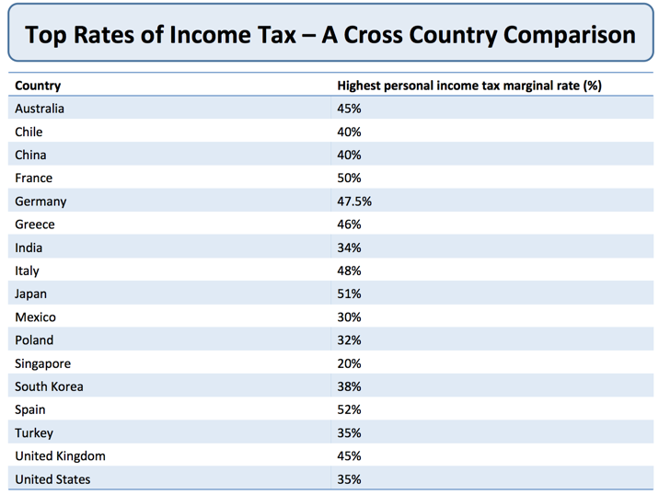

***Using taxation to change incomes***

* Progressive income taxes
* Rising marginal and average tax rates as incomes rise
* Tax free allowances for lowest income households

***Other tax reforms to change inequality***

* Wealth taxes
* Consumption taxes focused on high-income consumers and luxury products
* Reducing tax exemptions, closing tax loopholes, and improving tax compliancer rates
* Ear-marking revenues from certain taxes for intervention spending to help disadvantaged groups in society

***Supply-Side Economics - Introduction***



Supply-side policies are mainly **micro-economic policies** aimed at making markets and industries operate more efficiently and contribute to a **faster underlying-rate of growth of real national output**

* Successful policies have the effect of shifting the LRAS curve to the right leading to a rise in potential output
* Most governments believe that improved supply-side performance is the key to achieving **sustained growth** **without causing a rise in inflation**.
* Supply-side reform on its own is not enough to achieve this growth. There **must also be a high enough level of AD** so that the productive capacity of an economy is actually brought into play.
* Supply-side policies can be implemented by the public or the private sector

***Supply-side objectives***

Key concepts to focus on are incentives, enterprise, technology, mobility, flexibility and efficiency.

* 1.Improve incentives to look for work and invest in people’s skills
* 2.Increase labour and capital productivity
* 3.Increase occupational and geographical mobility of labour to help reduce the rate of unemployment
* 4.Increase investment and research and development spending
* 5.Promoting more competition and stimulate a faster pace of invention and innovation to improve competitiveness
* 6.Provide a platform for sustained non-inflationary growth
* 7.Encourage the start-up and expansion of new businesses / enterprises especially those with export potential
* 8.Improve the trend rate of growth of real GDP

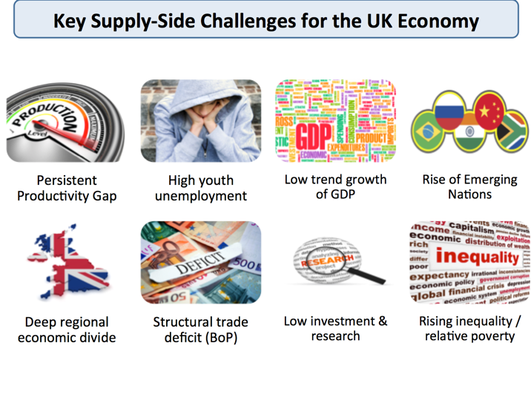

***Market-based supply-side policies***

* 1.Cutting government spending and borrowing
* 2.Lower business taxes to stimulate investment and lower income taxes to improve work incentives
* 3.Reducing red-tape to cut the costs of doing business
* 4.Measures to improve the flexibility of the labour market / reforming employment laws
* 5.Policies to boost competition such as deregulation and tough anti-monopoly and anti-cartel laws
* 6.Privatisation of state assets (selling off public sector businesses into the private sector)
* 7.Opening up an economy to overseas trade and investment

***Interventionist policies***

* 1.State has key role in investing in public services and building critical infrastructure
* 2.Tax incentives and welfare reforms can encourage more people into work
* 3.A commitment to a fair minimum wage / living wage to improve work incentives
* 4.Active regional policy to boost under-performing areas / areas of high unemployment
* 5.Some case for selective import controls to allow domestic industries to expand
* 6.Management of the exchange rate to improve competitiveness of export industries
* 7.Nationalisation of some key industries
* 8.Stronger regulation of industries