***Globalisation***



Globalisation is a process of deeper economic integration between countries and regions of the world.

***The OECD defines globalization as***

"The geographic dispersion of industrial and service activities, for example research and development, sourcing of inputs, production and distribution, and the cross-border networking of companies, for example through joint ventures and the sharing of assets."

***Characteristics of globalisation***

1. Greater trade in goods and services both between nations and within regions
2. An increase in **transfers of capital** including the expansion of foreign direct investment (FDI) by trans-national companies (TNCs) and the rising influence of sovereign wealth funds
3. The development of **global brands** that serve markets in higher and lower income countries
4. **Spatial division of labour**– for example out-sourcing and off shoring of production and support services as production supply-chains has become more international. As an example, the iPhone is part of a complicated global supply chain. The product was conceived and designed in Silicon Valley; the software was enhanced by software engineers working in India. Most iPhones are assembled / manufactured in China and Taiwan by TNCs such as FoxConn
5. High levels of **labour migration** within and between countries
6. New nations joining the world trading system. China and India joined the WTO in 1991, Russia joined the WTO in 2012
7. A fast changing **shift in the balance of economic and financial power** from developed to emerging economies and markets – i.e. a change in the **centre of gravity in the world economy**
8. Increasing spending on investment, innovation and infrastructure across large parts of the world
9. Globalisation is a process of **making the world economy more inter-dependent**
10. Many of the industrializing countries are winning a rising share of world trade and their economies are growing faster than in richer developed nations especially after the global financial crisis (GFC)

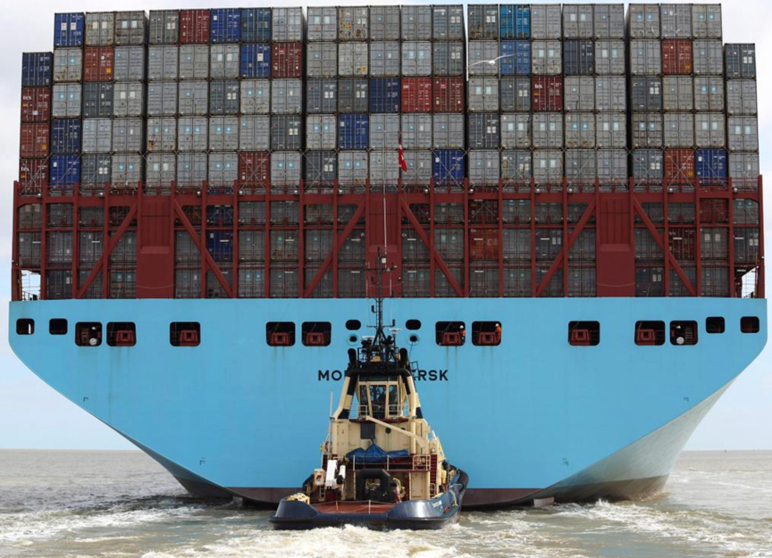Graphic evidence of the container principle at work!

***Among the main drivers of globalisation are the following:***

* **Containerisation** – the costs of ocean shipping have come down, due to containerization, bulk shipping, and other efficiencies. The lower cost of shipping products around the global economy helps to bring prices in the country of manufacture closer to prices in the export market, and makes markets more contestable in an international sense.
* **Technological change** – reducing the cost of transmitting and communicating information – sometimes known as “the death of distance" – a key factor behind trade in knowledge products using web technology
* **Economies of scale**: Many economists believe that there has been an increase in the minimum efficient scale (MES) associated with particular industries. If the MES is rising, a domestic market may be regarded as too small to satisfy the selling needs of these industries.
* **Opening up of global financial markets:** This has included the removal of capital controls in many countries facilitating foreign direct investment.
* **Differences in tax systems**: The desire of corporations to benefit from lower unit labour costs and other favourable factor endowments abroad and develop and exploit fresh comparative advantages in production has encouraged countries to adjust their tax systems to attract foreign direct investment (FDI)
* **Less protectionism** - old forms of non-tariff protection such as import licencing and foreign exchange controls have gradually been dismantled. Borders have opened and average tariff levels have fallen – that said in the last few years there has been a rise in protectionism as countries have struggled to achieve growth after the global financial crisis.

The breakdown of the Doha trade talks a few years back dashed hopes of a globally based multi-lateral reduction in import tariffs and other trade barriers

In its place there has been a rising number of **bi-lateral trade deals** and the emergence of **regional trading blocs** such as NAFTA, MECOSUR and plans for a new Trans-Pacific Partnership (TPP)

Globalization no longer necessarily requires a business to own or have a physical presence in terms of either owning production plants or land in other countries, or even exports and imports. Many businesses use licensing and franchising to help expand their overseas operations.

***Costs and Benefits of Globalisation***

Globalisation is a complex and controversial issue. This is a look at some of the main benefits and costs associated with the greater globalisation of the world economy.

Definition of Globalisation – the process of increased integration and co-operation of different national economies. It involves national economies becoming increasingly inter-related and integrated.

***Globalisation has involved:***

* Greater free trade.
* Greater movement of labour.
* Increased capital flows.
* Growth of Multi-national companies.
* Increased integration of global trade cycle.
* Increased communication and improved transport, effectively reducing barriers between countries.

***Benefits of Globalisation***

***1. Free Trade***

Free trade is a way for countries to exchange goods and resources. This means countries can specialise in producing goods where they have a comparative advantage (this means they can produce goods at a lower opportunity cost). When countries specialise there will be several gains from trade:

1. Lower prices for consumers
2. Greater choice of goods
3. Bigger export markets for domestic manufacturers
4. Economies of scale through being able to specialise in certain goods
5. Greater competition

***2. Free Movement of Labour***

Increased labour migration gives advantages to both workers and recipient countries. If a country experiences high unemployment, there are increased opportunities to look for work elsewhere. This process of labour migration also helps reduce geographical inequality. This has been quite effective in the EU, with many Eastern European workers migrating west.

Also, it helps countries with labour shortages fill important posts. For example, the UK needed to recruit nurses from the far east to fill shortages.

However, this issue is also quite controversial. Some are concerned that free movement of labour can cause excess pressure on housing and social services in some countries. Countries like the US have responded to this process by actively trying to prevent migrants from other countries.

***3. Increased Economies of Scale.***

Production is increasingly specialised. Globalisation enables goods to be produced in different parts of the world. This greater specialisation enables lower average costs and lower prices for consumers.

***4. Greater Competition***

Domestic monopolies used to be protected by lack of competition. However, globalisation means that firms face greater competition from foreign firms.

***5. Increased Investment***

Globalisation has also enabled increased levels of investment. It has made it easier for countries to attract short term and long term investment. Investment by multinational companies can play a big role in improving the economies of developing countries.

***Costs Of Globalisation***

***1. Free Trade can Harm Developing Economies.***

Developing countries often struggle to compete with developed countries, therefore it is argued free trade benefits developed countries more. There is an [infant industry argument](http://www.economicshelp.org/blog/glossary/infant-industry-argument/) which says industries in developing countries need protection from free trade to be able to develop. However, developing countries are often harmed by tariff protection Western economies have on agriculture. [Paradox of Free Trade](http://econ.economicshelp.org/2008/07/free-trade-policy-and-paradox.html)

***2. Environmental Costs***

One problem of globalisation is that it has increased the use of non renewable resources. It has also contributed to increased pollution and global warming. Firms can also outsource production to where environmental standards are less strict. However, arguably the problem is not so much globalisation as a failure to set satisfactory environmental standards.

***3. Labour Drain***

Globalisation enables workers to move more freely. Therefore, some countries find it difficult to hold onto their best skilled workers, who are attracted by higher wages elsewhere.

***4. Less Cultural Diversity***

Globalisation has led to increased economic and cultural hegemony. With globalisation there is arguably less cultural diversity, however it is also led to more options for some people.

***5. Tax Competition and Tax avoidance.***

Multinational companies like Amazon and Google, can set up offices in countries like Bermuda and Luxembourg with very low rates of corporation tax and then funnel their profits through these subsidiaries. This means they pay very little tax in the countries where they do most of their business. This means governments have to increase taxes on VAT and income tax. It is also seen as unfair competition for domestic firms who don’t use same tax avoidance measures.

The greater mobility of capital, means that countries have sought to encourage inward investment by offering the lowest corporation tax. (e.g. Ireland offers very low tax rate). This has encouraged lower corporation tax, which leads to higher forms of other tax. (see: [Tax competition](http://www.economicshelp.org/blog/glossary/tax-competition/))

***Essay: Does Globalisation benefit both developed and developing countries?***

Globalisation involves the increased integration of national economies. It means a reduction in barriers of trade and investment between different economies.  
  
***The benefits of globalisation are related to the benefits of free trade.***  
  
1. Consumers will have a wider choice of goods, and prices are likely to be lower. Globalisation has been an important factor in the falling price of manufactured goods.  
  
2.Globalisation gives an opportunity for domestic firms to export a wider market. Export led growth has been an important factor in increasing economic welfare in Asian countries.  
  
3. Globalisation enables increased specialisation of production. This specialisation enables firms to benefit from economies of scale. This leads to lower average costs and increased efficiency.  
  
4. Globalisation causes increased competition between different firms and countries. This puts pressure on firms to be increasingly efficient and offer better products for consumers.  
  
5. Increased Inward Investment. The process of globalisation has encouraged firms to invest in other countries. For example, many firms are relocating call centres to countries like India, where wage costs are lower. This inward investment benefits developing countries because it creates employment, growth and foreign exchange. Some foreign companies are criticised for exploiting cheap labour. But often the wages are higher than otherwise.  
  
***Problems of Globalisation***  
  
1. Developing Countries May Struggle to compete.  
  
If a developing country wishes to develop a new manufacturing industry, it may face higher costs than advanced industries in the west, who will benefit from years of experience and economies of scale. To develop an industry it may be necessary to have protection from cheap imports; this gives the firm chance to develop and gain economies of scale.  
  
2. Globalisation keeps Developing countries producing primary products. Developing countries may have a comparative advantage in primary products, however, this offers little scope for economic growth. Primary products have a low income elasticity of demand. Therefore, with economic growth demand for products increases only slowly. Primary products often have volatile prices, this can cause the economy to be subject to fluctuations in income  
  
3. Multi national Companies may be able to force out local retailers, leading to less choice for consumers and less cultural diversity.  
  
4. Movement of Labour. globalisation enables workers to move easily around. however, this may cause the highest skilled workers of developing countries to leave for better paid jobs in developed countries.

***Trading Blocs and Regional Trade Agreements (RTAs)***



In recent years there has been a flurry of bi-lateral trade deals between countries and the emergence of regional trading blocs. For example, the **European Union** now has over 30 separate international trade agreements including those with countries such as Colombia and South Korea.

Some of these deals are **free-trade agreements** that involve a reduction in tariff and non-tariff import controls to liberalise trade in goods and services between countries.

The most sophisticated RTAs include rules on flows of investment, co-ordination of competition policies, agreements on environmental policies and the free movement of labour.

**Examples of Regional Trade Agreements (RTAs):**

The number of RTAs has risen from around 70 in 1990 to over 300 now – this both reflects and reinforces a switch towards greater intra-regional trade most notably between many of the world's fast-growing emerging market economies. No regional trade agreement is the same!

The WTO permits the existence of trade blocs, provided that they result in lower protection against outside countries than existed before the creation of the trade bloc

* European Union (EU) – a customs union, a single market and now with a single currency
* European Free Trade Area (EFTA)
* North American Free Trade Agreement (NAFTA) between the USA, Canada and Mexico
* Mercosur - a customs union between Brazil, Argentina, Uruguay, Paraguay and Venezuela
* Association of Southeast Asian Nations (ASEAN) Free Trade Area (AFTA)
* Common Market of Eastern and Southern Africa (COMESA)
* South Asian Free Trade Area (SAFTA) created in 2006 with countries such as India and Pakistan
* Pacific Alliance – 2013 – a regional trade agreement between Chile, Colombia, Mexico and Peru
* **Trans-Pacific Partnership** (TPP) - a proposed free trade agreement being negotiated during 2013 between Australia, Brunei, Chile, Canada, Malaysia, Mexico, New Zealand, Peru, Singapore, the United States, and Vietnam

***General notes on regional trade blocs***

**Trade blocs are usually groups of countries in specific regions that manage and promote trade activities.** Trade blocs lead to **trade liberalisation** (the freeing of trade from protectionist measures) and **trade creation** between members, since they are treated favourably in comparison to non-members. However, **trade diversion** away from non-members is also likely to occur, especially if protectionist measures are imposed against non-members. Trade diversion contradicts the aims of the WTO and distorts comparative advantage

***Multinational Corporations: Good or Bad?***

***Benefits of Multinational Corporations***

* Create wealth and jobs around the world. Inward investment by multinationals offer much needed foreign currency for developing economies. They also create jobs and help raise expectations of what is possible.
* Their size and scale of operation enables them to benefit from [economies of scale](http://www.economicshelp.org/microessays/costs/economies-scale.html) enabling lower average costs and prices for consumers. This is particularly important in industries with very high fixed costs, such as car manufacture and airlines.
* Large profits can be used for research & development. For example, oil exploration is costly and risky; this could only be undertaken by a large firm with significant profit and resources. It is similar for drug manufacturers.
* Ensure minimum standards. The success of multinationals is often because consumers like to buy goods and services where they can rely on minimum standards. i.e. if you visit any country you know that the Starbucks coffee shop will give something you are fairly familiar with. It may not be the best coffee in the district, but it won’t be the worst. People like the security of knowing what to expect.

***Criticisms of Multinational Corporations***

* Companies are often interested in profit at the expense of the consumer. Multinational companies often have monopoly power which enables them to make excess profit. For example, [Shell made profits of £14bn last year](http://www.economicshelp.org/blog/oil/the-most-profitable-company-in-the-uk-shell/)
* Their market dominance makes it difficult for local small firms to thrive. For example, it is argued that big supermarkets are squeezing the margins of local corner shops leading to less diversity.
* In developing economies, big multinationals can use their economies of scale to push local firms out of business.
* In the pursuit of profit, multinational companies often contribute to pollution and use of non renewable resources which is putting the environment under threat.
* MNCs have been criticised for using ‘slave labour’ – workers who are paid a pittance by Western standards

***Evaluation***

* Some criticisms of MNCs may be due to other issues. For example, the fact MNCs pollute is perhaps a failure of government regulation. Also, small firms can pollute just as much.
* MNCs may pay low wages by western standards but, this is arguably better than the alternatives of not having a job at all. Also, some multinationals have responded to concerns over standards of working conditions and have sought to improve them.

***International Trade***



Trade is the exchange of products between countries. When conditions are right, trade brings benefits to all countries involved and can be a powerful driver for sustained GDP growth and rising living standards

One way of expressing the gains from trade in goods and services is to distinguish between static gains (i.e. improvements in allocative and productive efficiency) and dynamic gains (i.e. gains in welfare that occur from improved product quality, increased choice and faster innovative behaviour).

***Gains from Trade – Understanding Comparative Advantage***

First introduced by **David Ricardo** in 1817, comparative advantage exists when a country has a ‘margin of superiority’ in the supply of a good or service i.e. where the marginal cost of production is lower

Countries will generally specialise in and export products which use intensively the factors inputs which they are most abundantly endowed

If each country specializes, total output can be increased leading to better allocative efficiency and welfare.

Because production costs are lower, providing that a good price can be found from buyers, specialisation should focus on goods and services that provide the best value

In many countries, comparative advantage is shifting towards specialising in producing and exporting high-value and high-technology manufactured goods and high-knowledge services

***Example of Comparative Advantage***

Usually we take a standard **two-country + two-product example** to illustrate comparative advantage.

* Consider two countries producing digital cameras and vacuum cleaners
* With the same factor resources (inputs) evenly allocated by each country to the production of both goods, the **production possibilities** are as shown in the table below:

|  |  |  |
| --- | --- | --- |
| OUTPUT BEFORE SPECIALISATION | Digital Cameras | Vacuum Cleaners |
| UK | 600 | 600 |
| United States | 2400 | 1000 |
| Total | **3000** | **1600** |

**Stage 1: Working out the comparative advantage**

* To identify who should specialise in a particular product, consider the **internal opportunity costs**
* Were the UK to shift their resources into supplying more vacuum cleaners, the opportunity cost of each vacuum cleaner is one digital television
* For the United States the same decision has an opportunity cost of 2.4 digital cameras. Therefore, the UK has a comparative advantage in vacuum cleaners
* If the UK chose to **reallocate resources** to digital cameras the opportunity cost of an extra camera is one vacuum cleaner. But for the USA the opportunity cost is only 5/12ths of a vacuum cleaner.
* USA has comparative advantage in producing digital cameras because its opportunity cost is lowest

**Stage 2: Showing the Output after Specialisation**

|  |  |  |
| --- | --- | --- |
| output after specialisation | Digital Cameras | Vacuum Cleaners |
| UK | 0 (-600) | 1200 (+600) |
| United States | 3360 (+960) | 600 (-400) |
| Total | **3360** | **1800** |

* The UK specializes totally in producing vacuum cleaners – doubling its output - now1200
* The United States partly specializes in digital cameras increasing output by 960 having given up 400 units of vacuum cleaners
* As a result of specialisation output of both products has increased - a gain in economic welfare.

**Key point:**

For **mutually beneficial trade** to take place, the two nations have to agree an **acceptable rate of exchange of one product for anothe**r. If the two countries trade at a rate of exchange of two digital cameras for one vacuum cleaner, the post-trade position will be as follows:

* The UK exports 420 vacuum cleaners to the USA and receives 840 digital cameras
* The USA exports 840 digital cameras and imports 420 vacuum cleaners

**Stage 3: Showing the Gains from Trade - Post Trade Output / Consumption**

|  |  |  |
| --- | --- | --- |
|  | Digital Cameras | Vacuum Cleaners |
| UK | 840 | 780 |
| United States | 2520 | 1020 |
| Total | **3360** | **1800** |
|  |  |  |

Compared with the pre-specialisation output levels, consumers now have an increased supply of both goods

**Exam tip**: It is useful to learn a numerical example to illustrate comparative advantage for use in an exam

***What are the key assumptions behind this theory of trade?***

This theory of trade based on comparative advantage rests on a number of assumptions:

1. **Occupational mobility of factors of production (land, labour, capital)** - this means that switching factor resources from one industry to another involves no loss of efficiency and productivity. In reality we know that factors of production are not perfectly mobile – labour immobility is a root cause of structural unemployment.
2. **Constant returns to scale** (i.e. doubling the inputs used in the production process leads to a doubling of output) – this is merely a simplifying assumption. Specialisation might lead to diminishing returns in which case the benefits from trade are reduced. Conversely increasing returns to scale means that specialisation brings even greater increases in output.
3. I**nsignificant externalities from production and/or consumption** – no discussion about the overall costs and benefits of specialisation and trade should ignore environmental considerations arising from increased production and trade between countries.

***Absolute Advantage***

* Absolute advantage means that an economy can produce a good for lower costs than another. It means that less resources are needed to produce the same amount of goods.

Absolute advantage can be hard to measure for many complicated goods, because there are many different factor inputs.

Absolute advantage doesn’t necessarily mean an economy should produce that good. This requires a country to have a [comparative advantage](http://www.economicshelp.org/dictionary/c/comparative-advantage.html). For example, one country may have an absolute advantage in many goods but it is not advisable to try and produce everything. It is better to focus on on goods where you have a relative advantage.

***Sources of Comparative Advantage***



Comparative advantage is a dynamic concept meaning that it changes over time.

What are the Main Sources of Comparative Advantage?

For a country, some of the factors below are important in determining the relative unit costs of production:

1. The quantity and quality of natural resources available for example some countries have an abundant supply of good quality farmland, oil and gas, or easily accessible fossil fuels. Climate and geography have key roles in creating differences in comparative advantage. More recently the shale gas revolution in the United States and elsewhere is leading to shifts in the future pattern of world energy production and trade as North America becomes more energy sufficient. Severe worries about water scarcity in the future in large parts of the developing world might have hugely significant effects on their ability to export products.
2. Demographics - An ageing population, net outward or inward migration, educational improvements and women's participation in the labour force will all affect the quantity and quality of the labour force available for industries engaged in international trade.
3. Rates of capital investment including infrastructure: Greater public infrastructure investment can reduce trade costs and hence increasing supply capacity. Investment in roads, ports and other transport infrastructure strengthens regional trade ties. ICT infrastructure is particularly important for countries wanting to build a competitive advantage in information-intensive sectors such as mobile telecommunications, gaming and financial services
4. Increasing returns to scale and the division of labour – increasing returns occur when output grows more than proportionate to inputs. Rising demand in markets where trade takes place helps to encourage specialisation, higher productivity and internal and external economies of scale. These long-run scale economies can give regions and countries a significant unit cost advantage.
5. Investment in research & development which can drive innovation and invention
6. Fluctuations in the exchange rate, which affect the relative prices of exports and imports and cause changes in demand from domestic and overseas customers.
7. Import controls such as tariffs, export subsidies and quotas – these can be used to create an artificial comparative advantage for a country's domestic producers.
8. Non-price competitiveness of producers - covering factors such as the standard of product design and innovation, product reliability, quality of after-sales support. Many countries are now building comparative advantage in high-knowledge industries and specializing in specific knowledge sectors – an example is the division of knowledge in the medical industry, some countries specialize in heart surgery, others in pharmaceuticals – health tourism is becoming more important.
9. Institutions – these are important for comparative advantage and for growth too. Banking systems are needed to provide capital for investment and export credits, legal systems help to enforce contracts, political institutions and the stability of democracy is a key factor behind decisions about where international capital flows.

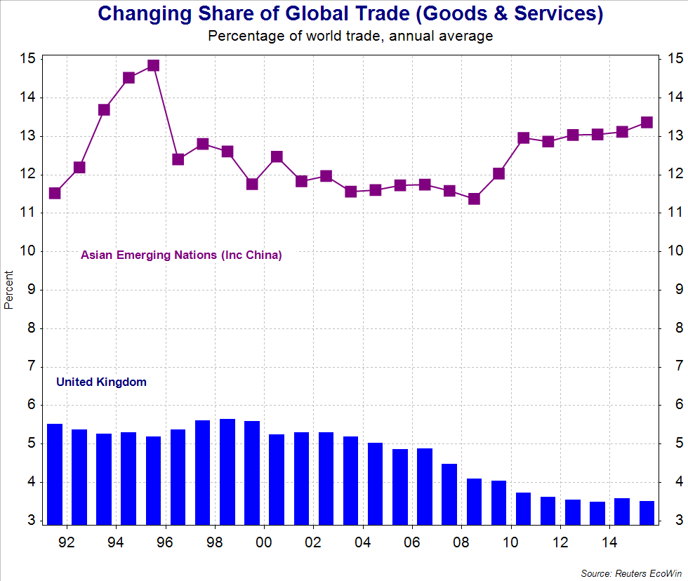

***Comparative advantage is often a self-reinforcing process***

* Entrepreneurs in a country develop a new comparative advantage in a product either because they find ways of producing it more efficiently or they create a genuinely new product that finds a growing demand in home and international markets
* Rising demand and output encourages the exploitation of economies of scale; higher profits can be reinvested in the business to fund further product development, marketing and a wider distribution network. Skilled labour is attracted into the industry and so on
* The expansion of an industry leads to benefits from exploiting external economies of scale.

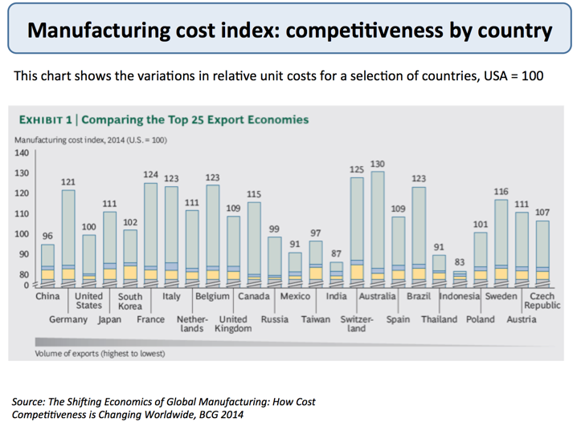Manufacturing unit costs for a selection of countries

***Benefits of Free Trade***

***The benefits of free trade include:***

**1. The theory of comparative advantage**

This explains that by specialising in goods where countries have a lower opportunity cost, there can be an increase in economic welfare for all countries. Free trade enables countries to specialise in those goods where they have a comparative advantage.

**2. Reducing Tariff barriers leads to trade creation**

[Trade creation](http://www.economicshelp.org/blog/glossary/trade-creation/) occurs when consumption switches from high cost producers to low cost producers.

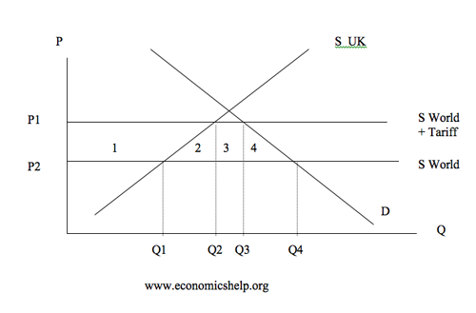

* The removal of tariffs leads to lower prices for consumers  
  and an increase in consumer surplus of areas 1 + 2 + 3 + 4
* Imports will increase from Q3-Q2 to Q4-Q1
* The government will lose tax revenue of area 3
* Domestic firms producing this good will sell less and lose producer surplus equal to area 1
* However overall there will be an increase in economic welfare of **2+4** (1+2+3+4 – (1+3)
* The magnitude of this increase depends upon the elasticity of supply and demand. If demand elastic consumers will have a big increase in welfare

**3. Increased Exports.**

As well as benefits for consumers importing goods, firms exporting goods where the UK has a comparative advantage will also see a big improvement in economic welfare. Lower tariffs on UK exports will enable a higher quantity of exports boosting UK jobs and economic growth.

**4. Economies of Scale.**

If countries can specialise in certain goods they can benefit from [economies of scale](http://www.economicshelp.org/microessays/costs/economies-scale.html) and lower average costs, this is especially true in industries with high fixed costs or that require high levels of investment. The benefits of economies of scale will ultimately lead to lower prices for consumers.

**5. Increased Competition.**

With more trade domestic firms will face more competition from abroad therefore there will be more incentives to cut costs and increase efficiency. It may prevent domestic monopolies from charging too high prices.

**6. Trade is an engine of growth**.

World trade has increased by an average of 7% since the 1945, causing this to be one of the big contributors to economic growth.

**7. Make use of surplus raw materials**

Middle Eastern counties such as Qatar are very rich in reserves of oil but without trade there would be not much benefit in having so much oil.  
Japan on the other hand has very few raw material without trade it would be very poor.

**8. Tariffs may encourage inefficiency**

If an economy protects its domestic industry by increasing tariffs industries may not have any incentives to cut costs.

***Arguments against Free Trade***

1. **Infant Industry Argument.**

If developing countries have industries that are relatively new, then at the moment these industry’s would struggle against international competition. However if they invested in the industry then in the future they may be able to gain Comparative Advantage.

* + This shows that comparative advantage can change over time
  + Therefore protection would allow them to progress and gain experience to enable them to be able to compete in the future.
  + more on [infant industry argument](http://www.economicshelp.org/blog/glossary/infant-industry-argument/)

1. **The Senile industry argument.**

If industries are declining and inefficient they may require large investment to make them efficient again. Protection for these industries would act as an incentive to for firms to invest and reinvent themselves. However protectionism could also be an excuse for protecting inefficient firms

1. **To diversify the economy**

Many developing countries rely on producing primary products in which  
they currently have a comparative advantage. However relying on agricultural products has several disadvantages

* + - Prices can fluctuate due to environmental factors
    - Goods have a low income elasticity of demand. Therefore with economic growth demand will only increase a little

1. **Raise revenue for the government.**

Import taxes can be used to raise money for the governmentt however this will only be a relatively small amount of money

1. **Help the Balance of Payments**

Reducing imports can help the current account. However in the long term this is likely to lead to retaliation

1. **Cultural Identity**

This is not really an economic argument but more political and cultural. Many countries wish to protect their countries from what they see as an Americanisation or commercialisation of their countries

1. **Protection against dumping**

The EU sold a lot of its food surplus from the CAP at very low prices on the world market. This caused problems for world farmers because they saw a big fall in their market prices

1. **Environmental**

It is argued that free trade can harm the environment because LDC may use up natural reserves of raw materials to export. Also countries with strict pollution controls may find consumers import the goods from other countries where legislation is lax and pollution allowed.

* However supporters of free trade would argue that it is up to individual countries to create environmental legislation

## ***The pattern of trade***

The global economy has grown continuously since the Second World War. Global growth has been accompanied by a change in the pattern of trade, which reflects ongoing changes in structure of the global economy. These changes include the rise of regional trading blocs, deindustrialisation in many advanced economies, the increased participation of former communist countries, and the emergence of China and India.

### ***Changes in the global economy***

The main changes in the global economy are:

1. The emergence of regional [trading blocs](http://economicsonline.co.uk/Global_economics/Trading_blocs.html), where members freely trade with each other, but erect barriers to trade with non-members, has had a significant impact on the pattern of global trade. While the formation of blocs, such as the European Union and NAFTA, has led to *trade creation* between members, countries outside the bloc have suffered from *trade diversion*.
2. Like several advanced economies, the UK's trade in manufactured goods has fallen relative to its trade in commercial and financial services. Many of these advanced economies have experienced deindustrialisation, with less national output generated by their manufacturing sectors.
3. The collapse of communism led to the opening-up of many former-communist countries. These countries have increased their share of world trade by taking advantage of their low production costs, especially their low wage levels.
4. Newly industrialised countries like India and China have dramatically increased their share of world trade and their share of manufacturing exports. China, in particular, has emerged as an economic super-power. China's share of world trade has increased in all areas, and not just in clothing and low-tech goods. For example, in 1995, the US had captured nearly 25% of global trade in hi-tech goods, while China had only 3%. By 2005, the US share had fallen to 15%, while China's share had risen to 15%.

###### (Source: European Central Bank - ECB, Occasional Paper - [*China and India's Role in Global Trade and Finance*](http://www.ecb.int/pub/pdf/scpops/ecbocp80.pdf), 2008)

***World Trade Organisation – WTO***

The World Trade Organisation is responsible for dealing with the rules of trade between nations at a global or near-global level.

* The WTO helps to resolve conflicts between nations and provide forums for agreeing over trade agreements and there implementation.
* The aim of WTO is to help trade flow as freely as possible, except where free trade conflicts with other objectives such as environmental or legal.

GATT: This was the forerunner to the WTO, GATT stood for the general agreement on tariffs and trade

The Uruguay Round: This started in 1986 and was not signed until 1993. It attempted to reduce barriers to trade . In recent years countries had increasingly made use of NTBs such as VER.

One of the biggest stumbling blocks was agriculture. In the US and EU, many agricultural markets are protected for political reasons.

The EU CAP caused significant problems.

* The CAP involved high tariffs on imports from outside the EU to protect domestic farmers
* The EU guaranteed to by any surplus at a the minimum target price.this surplus was then dumped onto world markets, causing further problems for world farmers.
* This led to lower incomes for world farmers, the USA retaliated by flouting GATT rules and imposing restrictions on EU exports to the US
* Eventually the EU agreed to make changes to the CAP cutting Import duties and subsidised export volumes

***Other Features of the Uruguay Round – WTO***

1. Cut in tariffs by 38%
2. Prohibition of VERs
3. Protection of international Copyright laws
4. Limiting domestic subsidies from govt
5. Stronger powers for the WTO to settle disputes and enforce its rulings
6. Each country to have its trade policy periodically reviewed by the WTO

N.B. Some food importing countries would be worse off with a reduction in protectionism from the EU because they will lose out on cheap imports “dumped” on world markets

Trade Blocks Groups of countries who have trade agreements amongst themselves and a common external tariff, e.g. EU, NAFTA

Bilateral Trade agreements, Trade agreements between one country and another. These are not encouraged by the WTO because they can involve high tariffs with countries not included.

Multi-lateral Agreements. This occurs when a reduction in tariffs is passed onto all countries

Trading Blocks and The WTO

The WTO seeks to encourage free trade, however there is often a stumbling block between rival trading blocks, For example the US has been aggrieved at EU protectionism in agriculture. This has led to retaliation, such as “The Banana Wars” this involved the US imposing high tariff on imports of bananas from French colony’s in the Caribbean

Conflicts between Trading Blocks

1. “dumping of surplus goods”
2. High Tariffs on agriculture
3. Need for protectionism in third world and developing countries
4. Subsidies given to domestic producers therefore creating unfair subsidies

Doha Round

Began in 2001.

**Advantages and disadvantages of WTO**

*Readers Question: What are the advantages and disadvantages of the WTO formally the GATT?*  
  
The WTO is a body designed to promote free trade through organizing trade negotiations and act as an independent arbiter in settling trade disputes. To some extent the WTO has been successful in promoting greater free trade.  
  
Free trade has many advantages, such as:

1. Lower prices for consumers. Removing tariffs enables us to buy cheaper imports
2. Free trade encourages greater competitiveness. Firms face a higher incentive to cut costs. For example, a domestic monopoly may now face competition from foreign firms.
3. Law of comparative advantage states that free trade will enable an increase in economic welfare. This is because countries can specialise in producing goods where they have a lower opportunity cost.
4. Economies of scale. By encouraging free trade, firms can specialise and produce a higher quantity. This enables more economies of scale, this is important for industries with high fixed costs, such as car and aeroplane manufacture.
5. Free trade can help increase global economic growth.

* See also: [Advantages of Free Trade](http://www.economicshelp.org/trade/benefits_free_trade.html)

**Disadvantages of WTO**

* However, the WTO has often been criticised for ignoring the plight of the developing world.
* It is argued the benefits of free trade accrue mostly to the developed world.
* Free trade may prevent developing economies develop their infant industries. For example, if a developing economy was trying to diversify their economy to develop a new manufacturing industry, they may be unable to do it without some tariff protection.
* [see also :Disadvantages of Free Trade](http://www.economicshelp.org/trade/arguments-against-free-trade.html)

In response to this the WTO may say that free trade has been an important engine of growth for developing countries in Asia. Although there may be some short term pain, it is worth it in the long run.

***Protectionism***



Protectionism represents any attempt to impose restrictions on trade in goods and services

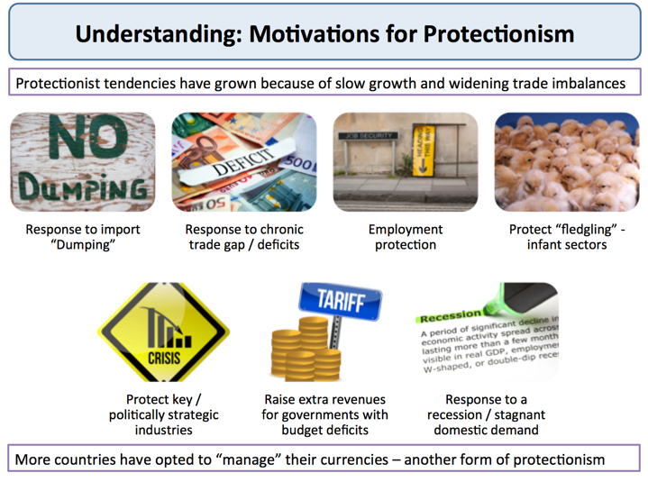Some of the arguments put forward for protectionism 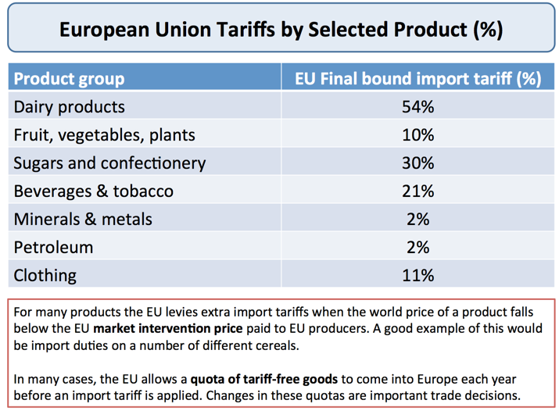

***Examples of EU import tariffs by product***

Trade disputes between countries happen because one or more parties either believes that trade is being conducted unfairly, on an uneven playing field, or because they believe that there is one or more economic or strategic justifications for import controls.

All countries operate with some forms of import controls

The aim is to cushion domestic businesses and industries from overseas competition and prevent the outcome resulting from the inter-play of free market forces of supply and demand.

***Different forms of protectionism***

1. **Tariffs** - a tax or duty that raises the price of imported products and causes a contraction in domestic demand and an expansion in domestic supply. For example, until recently, Mexico imposed a 150% tariff on Brazilian chicken. The United States has an 11% import tariff on imports of bicycles from the UK.
2. **Quotas** – these are quantitative (volume) limits on the level of imports allowed or a limit to the value of imports permitted into a country in a given time period. Until 2014, South Korea maintained strict quotas on imported rice. It has now replaced an annual import quota with import tariffs designed to protect South Korean rice farmers. Quotas do not normally bring in any tax revenue for the government
3. **Voluntary Export Restraint** – this is where two countries make an agreement to limit the volume of their exports to one another over an agreed time period. Sometimes this is enforced by a government for example the USA enforced VER on Japan during the late 1980s
4. **Intellectual property laws e.g.** patents and copyright protection
5. **Technical barriers to trade** including product labeling rules and stringent sanitary standards. These increase product compliance costs and impose monitoring costs on export agencies. Huge vertically integrated businesses can cope with these non-tariff barriers but many of the least developed countries do not have the some technical sophistication to overcome these barriers.
6. **Preferential state procurement policies** – this is where a government favour local/domestic producers when finalizing contracts for state spending e.g. infrastructure projects or purchasing new defence equipment
7. **Export subsidies** - a payment to encourage domestic production by lowering their costs. Soft loans can be used to fund the dumping of products in overseas markets. Well known subsidies include Common Agricultural Policy in the EU, or cotton subsidies for US farmers and farm subsidies introduced by countries such as Russia. In 2012, the USA government imposed tariffs of up to 4.7 per cent on Chinese manufacturers of solar panel cells, judging that they benefited from unfair export subsidies after a review that split the US solar industry.
8. **Domestic subsidies** – government help (state aid) for domestic businesses facing financial problems e.g. subsidies for car manufacturers or loss-making airlines.
9. **Import licensing** - governments grants importers the license to import goods.
10. **Exchange controls** - limiting the foreign exchange that can move between countries – this is also known as capital controls
11. **Financial protectionism** – for example when a national government instructs banks to give priority when making loans to domestic businesses
12. **Murky or hidden protectionism** - e.g. state measures that indirectly discriminate against foreign workers, investors and traders. A government subsidy that is paid only when consumers buy locally produced goods and services would count as an example. Deliberate intervention in currency markets might also come under this category.

Quotas, embargoes, export subsidies and exchange controls are examples of non-tariff barriers

Examiner’s tip: the tariff is frequently examined. Ensure that you can analyse the removal as well as the imposition of a tariff.

