***Balance of Payments***



The balance of payments (BOP) records all financial transactions made between consumers, businesses and the government in one country with others

* The BOP figures tell us about how much is being spent by consumers and firms on imported goods and services, and how successful firms have been in exporting to other countries.
* Inflows of foreign currency are counted as a positive entry (e.g. exports sold overseas)
* Outflows of foreign currency are counted as a negative entry (e.g. imported goods and services)

***The balance of payments is made up of these key parts***

* i) The current account
* ii) The capital account
* iii) Official financing account

**Stylised Example of the Balance of Payments**

The example below refers to a hypothetical country, data is in $ billion

|  |  |  |
| --- | --- | --- |
| **Item of the BoP** | **Net Balance** **$ billion** | **Comment** |
| **Current Account** |  |  |
| (1) Balance of trade in goods | -25 | A trade deficit |
| (2) Balance of trade in services | +10 | A trade surplus |
| (3) Net investment income | -12 | Net outflow of income i.e. due to profits of transnational corporations |
| (4) Net overseas transfers | +8 | Net inflow of transfers perhaps from remittance payments from migrants |
| Sum of 1+2+3+4 = Current account balance | **-19** | Overall – this country runs a current account deficit |
| **Financial Account** |  |  |
| Net balance of foreign direct investment flows | +5 | Positive net inflow of FDI |
| Net balance of portfolio investment flows | +6 | Positive net inflow into equity markets, property etc. |
| Net balance of short term banking flows | -2 | Small net outflow of currency from country's banking system |
| Balancing item | +2 | There to reflect errors and omissions in data calculations |
| Changes to reserves of gold and foreign currency | +8 | +8 means that this country's gold and foreign currency reserves have been reduced |
| Overall balance of payments | 0 |  |

**Key point:**

If a country is running a current account surplus, this means there is a net inflow of foreign currency into their economic system. From a balance of payments point of view, a surplus on the current account would allow a deficit to be run on the capital account. For example, surplus foreign currency can be used to fund investment in assets located overseas. **The balance of payments must balance.**

Countries with current account deficits can run into difficulties. If the deficit is large and the economy is not able to attract enough inflows of foreign investment, then their currency reserves will dwindle and there may come a point when the country needs to seek emergency borrowing from institutions such as the **International Monetary Fund**. Trade deficits and the resulting borrowing lead to a rise in **external debt**.

Examples of inward FDI for the UK - an inflow of capital on the capital account of the balance of payments

***Current Account Balance of Payments***

The current account on the balance of payments measures the inflow and outflow of goods, services and investment incomes.

***The main components of the current account are:***

1. Trade in goods (visible balance)
2. Trade in services (invisible balance) e.g. insurance and services
3. Investment incomes e.g. dividends, interest and migrants remittances from abroad
4. Net transfers – e.g. International aid

* A deficit on the current account means that the value of imports is greater than the value of exports.
* A surplus on the current account means that the value of imports is less than the value of exports.

***Balance of payments and current account***

The balance of payments is composed of two main aspects.

1. Current account
2. Capital  / financial account

If a country has a deficit on the current account, it needs a surplus on the financial account.

To give a simplistic example. If the US runs a current account deficit – buying manufactured clothes and toys from the US. China use this foreign currency to buy US bonds. Therefore, there is a flow of money to the US from China – through the financial account to finance the purchase of imported goods.

**Example of UK current account**

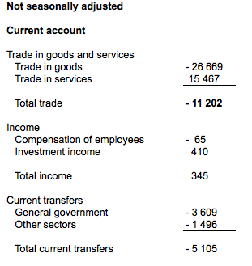

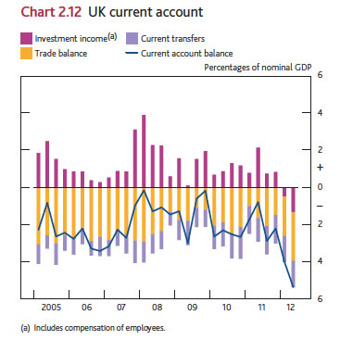

UK current account. This shows in 2007, net investment incomes helped to reduce the trade deficit.

**UK current account**

[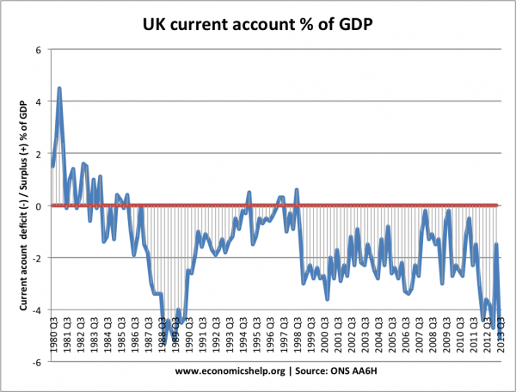](http://www.economicshelp.org/wp-content/uploads/2013/10/current-account-quarterly-1980-2012.png)

This shows the UK has run mainly a current account deficit since 1980. This means the UK has run a surplus on the capital / financial account.

***Capital Account Balance of Payments***

The capital account measures transfer in assets and liabilities. For example, this may involve a Japanese firm building a factor in the UK. This is counted as a credit on the UK Capital Account. The Capital account can also involve the purchase of securities and liabilities, for example a Japanese Banker buying UK Government securities.

Note in the UK the official name for the capital account is now the financial account.

If a country has a [current account](http://www.economicshelp.org/blog/glossary/current-account-bop/) deficit then, assuming exchange rates are floating, it will have an equivalent capital account surplus. This is necessary to finance a current account deficit.

Some people worry about a current account deficit. But, if it is financed by a capital account surplus e.g. investment then this can be beneficial.

 Components of UK balance of payments 2012

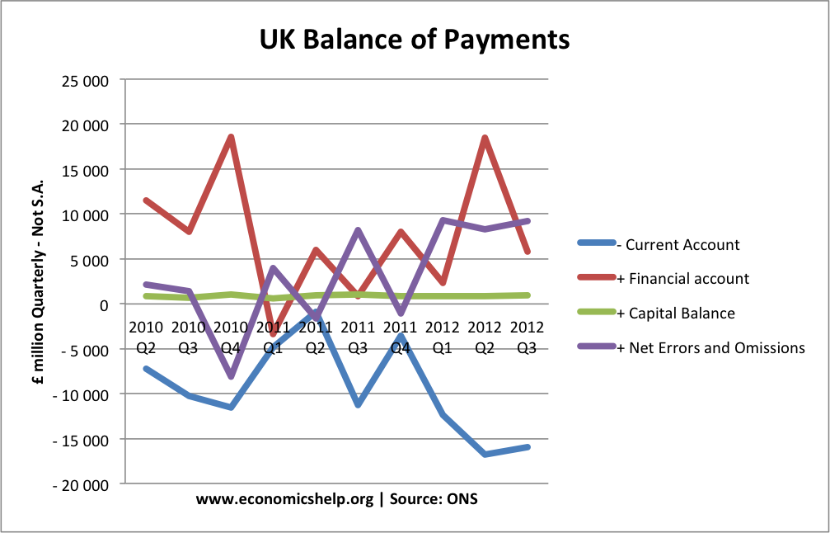

***In Q2 2012, the main components of the balance of payments were***:

* Current Account: £ -15,962m
* Financial Account: + £ 5,785m
* Capital Account + £1,000 m
* net errors and omissions + £9177 m
* net balance = £0 m

These stats show a large amount to account for net errors and omissions – showing difficulty of collecting statistics but, roughly a current account deficit is mirrored by a surplus on the financial / capital account.

***UK Balance of Payments***

The Balance of Payments is the record of a country’s transactions / trade with the rest of the world.

***The balance of payments consists of:***

1. **Current Account (**trade in goods, services + investment incomes + transfers**)**
2. **Capital Account / Financial Account** (capital and financial flows, net investment, portfolio investment)
3. Errors and omissions. It is hard to collect all data so some is missed out.

In theory there should be a balancing between capital and current / financial account. If there is a current account deficit, there should be a surplus on the capital / financial account.

***UK Current Account***

The UK current account deficit wa s£20.7 billion in Quarter 3 2013, up from a revised deficit of £6.2 billion in Quarter 2 2013. The deficit in Quarter 3 2013 equated to 5.1% of GDP at current market prices, up from 1.5% in Quarter 2 2013 (*page updated 8th Jan. 2014*)

In 2012, the UK’s current account deficit was £59.8 billion.

[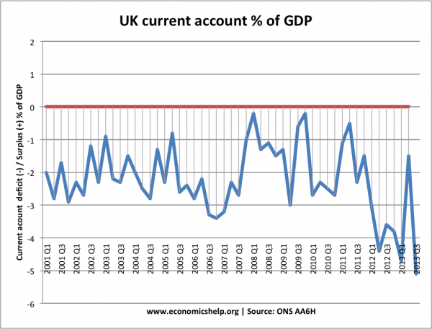](http://www.economicshelp.org/wp-content/uploads/2013/10/current-account-quarterly-2000-2012.png)

This shows a deterioration in the current account. The current account deficit for Q3 2012 was over £12bn (Seasonally adjusted measure). [Q3 2012](http://www.ons.gov.uk/ons/publications/re-reference-tables.html?edition=tcm%3A77-286024) as a % of GDP 3.2%

***Reasons for a Current Account Deficit***

**1. Overvalued exchange rates**. Countries in the Eurozone which became uncompetitive (e.g. Greece, Portugal and Spain) experienced large current account deficits. This is because an overvalued exchange rates means exports are more expensive, but imports are cheaper. This encourages domestic consumers to buy imports. It also makes it hard for exporters because they are relatively uncompetitive. See: [competitiveness in the Euro](http://www.economicshelp.org/blog/3091/economics/competitiveness-in-europe/).

**2. High Consumer Spending**. If there is rapid growth in consumer spending, then there tends to be an increase in imports causing a deterioration in the current account. For example, in the 1980s boom, we saw a fall in the savings rate and a rise in UK consumer spending; this caused a record current account deficit. The recession of 1991 caused an improvement in the current account as import spending fell.

**3. Unbalanced Economy**. An economy focused on consumer spending rather than investment and exports will tend to have a bigger current account deficit.

**4. Competitiveness.** Related to the exchange rate is the general competitiveness of firms. If there is a decline in relative competitiveness, e.g. rising wage costs, industrial unrest, poor quality goods – then it is harder to export causing a deterioration in the current account.

**Components of UK current account deficit**



***What Explains the UK’s Persistent Current Account deficit?***

**1. Deficit in Goods**. Since the process of de-industrialisation accelerated in the early 1980s, the UK has had a large deficit in goods. The UK still manufacturers goods, but we have become a net importer – especially of manufactured goods (e.g. clothes, computers, cars). The graph below shows the sectors with the biggest deficit.

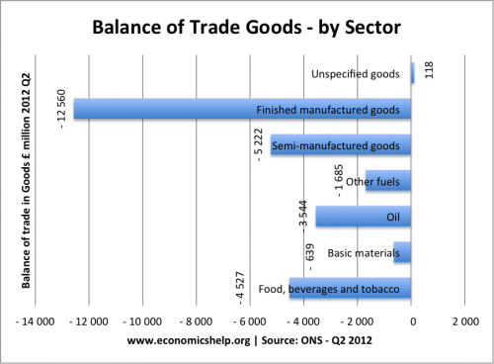

For example, this shows the UK had a deficit of £12.56 bn for finished manufactured goods in Q2 of 2012. The UK is also a net importer of oil and food.

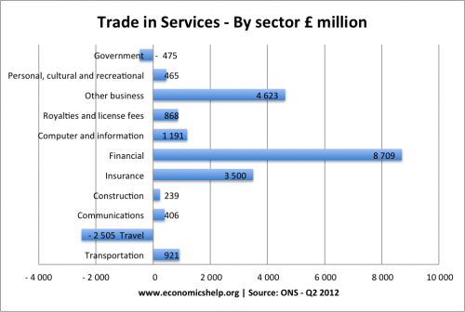

This deficit in goods, is partly offset by a surplus in services (e.g. insurance and finance) but, it is not sufficient to overcome the trade deficit.

**2. Financial flows**. The UK has been able to attract sufficient financial flows, e.g. portfolio flows to finance the UK’s current account deficit.

**3. Relatively Low Saving Rate**

The UK has had a relatively low saving rate – compared to  some of our competitors. Though recent increases in the saving rate haven’t prevented a deterioration in the current account.

***Policies to Reduce a Current Account Deficit***

To reduce a current account deficit, we need to pursue policies involving some or all of the following:

1. Reduce consumer spending – through tight fiscal and tight monetary policy. E.g. higher income tax will reduce disposable income and therefore reduce spending on imports (however, it will also lead to lower economic growth)
2. [Supply side policies](http://www.economicshelp.org/macroeconomics/economic-growth/supply-side-policies.html) to improve competitiveness.
3. Devaluation of the exchange rate. This makes exports cheaper and imports more expensive. See: [exchange rate and balance of payments](http://www.economicshelp.org/blog/2089/economics/exchange-rate-and-current-account/)

See also more on: [Policies to reduce a current account deficit](http://www.economicshelp.org/macroeconomics/bop/policies-to-reduce-deficit.html)

UK Balance of Payments



In **Q2 2012**, the main components of the balance of payments were:

* Current Account – £ -15 962m
* Financial Account + £ 5 785m
* Capital Account + £1000 m
* net errors and Omissions + £9177 m
* net balance = £0 m

In other words, if we have a deficit on the current account to buy goods from China, we need foreign currency to come from some other source to keep buying these imports.

* One example is to think of UK consumers buying Chinese goods – causing a deficit on the current account.
* Then Chinese banks and firms invest some of this money back into UK investment trusts or build a factor in the UK. These leads to a credit on the financial account.
* Our current account deficit is being financed by a surplus on financial flows.
* See also: [balance of payments disequilibrium](http://www.economicshelp.org/blog/185/economics/balance-of-payments-disequilibrium/)

***Components of Financial Account***

* Direct investment
* Portfolio investment
* Financial derivatives (net)
* Other investment
* Reserve assets

UK Current Account Compared to other Countries

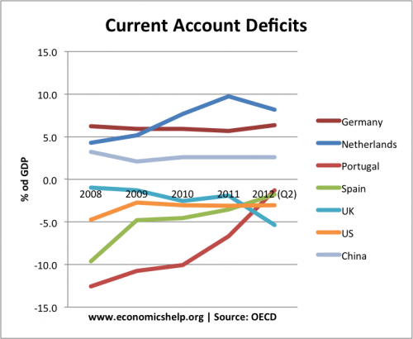

By 2012, the UK has developed one of largest current account deficits.

***Does a Current Account Deficit Matter?***

Should we worry if the UK has a current account deficit?

**Yes, we should worry**

* It is a sign of uncompetitiveness, which will lead to lower economic growth and poorer prospects in the long run.
* If capital / financial flows dry up, it could lead to depreciation in the exchange rate and a fall in living standards
* It is a sign of an unbalanced economy.

***No, we shouldn’t be concerned***

* The UK has had a persistent deficit since the mid 1980s. Countries with large current account surplus have not necessarily done better, e.g. Japan had a long period of stagnation.
* In era of globalisation, financial flows are easier to attract and therefore the deficit is financed by these capital inflows.
* If the current account was too large, there should be a depreciation in the exchange rate to restore the balance. A current account deficit is a bigger concern in a fixed exchange rate (like Euro) because there is no option of depreciation.

***Current and Financial Account Balance***

* Firstly, the current account on balance of payments measures trade in goods,  services, investment incomes and current transfers
* The financial account measures capital flows / short term and long term. For example, long term investment in building a factory or financial flows such as buying bonds or depositing money in bank accounts.

Current Account = (Financial + Capital Account)

Note: The (Financial + Capital Account) used to be just called the capital account

Why does Current Account and Financial account balance?

Basically, if we import goods and services, we need an inflow of capital (financial flows) to be able to pay for them.

If you take a simplistic model.

Suppose, we import £1m of clothes from China. We need to buy £1m of Chinese Yuan. To get this foreign currency, we need an inflow of foreign currency in the financial account.

For example, if the Chinese deposited £1m of Chinese Yuan in British Banks, the foreign currency comes into the UK and this is how we can afford the goods. This bank deposit would be counted as a short term capital flow and included in financial account as a credit item. This balances the debit on our trade in goods.

What would happen if we couldn’t attract capital flows from China?

Suppose we wanted to import goods from China, but, China wasn’t sending capital flows to the UK. This would mean more money is flowing out of the UK than coming in.

This would mean the supply of pounds is greater than the demand and the Pound would fall in value. This would make our exports cheaper and imports more expensive. This depreciation would reduce the current account deficit.

Since the Credit Crunch the UK has found it harder to attract capital flows. Because we have a current account deficit, we have seen the Pound fall in value. So a large current account deficit often causes a depreciation, especially, if the country struggles to attract a balancing item on the financial / capital account.

***Hot Money Flows***

Hot money flows refer to capital flows moving to countries with higher interest rates and / or expected changes in exchange rates.

For international investors, there is substantial gains to be made from moving money between different countries with different interest rates.

Suppose the EU and US both have an interest rate of 0.5%. At that time, it doesn’t make much difference whether you put savings in the US banks or EU banks.

However, if the US increased interest rates to 1.5% then you would get a substantially higher return from saving in a US bank. Therefore, EU investors may sell Euros and buy dollars so that they can gain more interest from their savings.

This increased demand for dollars will push up the value of the dollar against the Euro.

Even small changes in interest rates can make a significant impact on exchange rates. Increased capital mobility means it is easier to transfer money across accounts. Money can be moved from one account to another with ease. Also, the commission from buying dollars will be quite limited making it more attractive to shift accounts.

Example of Swiss Franc

In 2011, the Swiss Franc experienced a rapid rise as investors sought to buy Swiss Francs. Interest rates in Switzerland were not particularly high, but investors saw Switzerland as a safe haven from the Eurozone difficulties. Therefore, these hot money flows went from the Eurozone to Switzerland.

***Problems of Hot Money Flows***

* Hot money flows can be destabilising. A rapid rise in the currency can harm a countries exports because exports become more expensive.
* Hot money flows can create excess liquidity fuelling a future asset boom and creating more long-term problems.

***Measuring Hot Money Flows***

It is hard to measure precisely because there is no clear definition of what exactly constitutes hot money. Also,

Hot Money = Change in foreign exchange reserves – Net exports – Net foreign direct investment.

In other words, hot money is inflow of foreign exchange reserves not related to actual exports or investment.

***London’s importance to the UK economy keeps on growing***

WHEN Nathan Mayer Rothschild left the family home in Frankfurt in 1798, aged just 21, and moved to set up shop in England, it was Manchester he chose as his first base, establishing himself as a successful merchant. He only moved to the City of London in 1809, when he took premises at New Court in St Swithin’s Lane, where N.M. Rothschild & Sons are still based today.   
  
This story illustrates how London’s domination of the UK economy is a relatively recent phenomenon; there was a time when other great English cities were powerful competitors.  
  
For example, by 1961 household incomes in the west Midlands were 13 per cent higher than the UK average, beating even London and the south east; service sector jobs in the Birmingham conurbation grew faster than in any other region between 1953 and 1964 (as pointed out in a History of Birmingham by A. Stutcliffe and R. Smith, cited on the website of the LSE Spatial Economics Research Centre). Needless to say, output per worker today is much higher in central London.  
  
While London last peaked in 1911, and then entered decades of relative decline, our capital city has been in the ascendant again since the 1980s. Its relatively good performance – and the tragic decline of the other great cities – means that London is now the most important it has ever been to the UK economy, accounting for a record high of 21.9 per cent of UK gross value added. When the commuter belt is added in, the London economic region’s lead is now unassailable.  
  
The latest evidence comes from the Investec/Real Business 2013 Hot 100 list of the UK’s fastest growing privately-owned companies. Mid-sized businesses based in London account for 30 per cent of the list, including five of the top 10. Businesses based in London and the south east makes up 49 per cent of the top 100, up from 43 per cent in 2012.   
  
One way of assessing the full reach of London’s economic area is to look at where else house prices move in tandem with London prices. There is the effect from commuters – but also those relocating out of the capital but taking some of its wealth with them.  
  
[Savills](http://www.cityam.com/company/savills) has crunched the numbers. Some areas south and south west of London, including Windsor, Guildford, Dorking and Redhill/Reigate share over 97.5 per cent of their house price movements in previous cycles with the capital, behaving like London boroughs. Large areas to the north, south and west of London, incorporating St Albans, Oxford, Reading and Winchester, share over 95 per cent of their house price movements with Greater London. The M4 corridor, stretching to Bristol, shows a 90-95 per cent correlation. Areas where the correlation is at least 80 per cent include North Suffolk, Somerset and Herefordshire as well as Essex and Kent. On that definition, London’s city state extends over most of southern England, south of a line from the Severn to the Wash, and includes 25.5m people.  
  
There are two lessons. First, much more needs to done to boost the UK’s regions. Corporation tax could be abolished in Northern Ireland, for example, which ought to be turned into a giant, low tax, low regulation enterprise zone. The dead hand of the state has debilitated large swathes of the UK, preventing them from finding a post-industrial future.   
  
But London and its region are the jewels in the UK’s economic crown. They too need lower taxes and a supply-side revolution to fulfil their immense potential. They need more infrastructure, including privately financed airport capacity and a house-building boom to cater for a growing population. The City and the finance industry also need to be allowed to thrive again. London is a great asset; it needs to be set free to grow, prosper and create even more jobs.

***Economic growth and trade***

In the UK, there is a strong connection between a growing economy and trade deficits. Soon after the economy went into recession in 1990, the trade deficit began to fall quickly. However, as the economy came out of recession and into a period of strong growth from 1993, the trade deficit began to rise quickly, and continued to rise through the next 15 years.  The recent recession, which started in late 2008, quickly reduced the deficit.

**Causes of a current account deficit**

There are several possible causes of a persistent current account deficit, including the following:

**Excessive** [**growth**](http://economicsonline.co.uk/Managing_the_economy/Sustainable_growth.html)

If the economy grows too quickly and rises above its own *trend rate*, which in the UK is around 2.5%,  then domestic output (AS) may not be able to cope with domestic aggregate demand. When national income rises above its trend rate it is likely that [income elasticity of demand](http://economicsonline.co.uk/Competitive_markets/Income_elasticity_of_demand.html) for luxury imports such as motor cars is relatively high, so that imports rise relative to exports.

**De-industrialisation**

An increasing *trade deficit* may be a symptom of long-term de-industrialisation. The UK started to lose its manufacturing base in the 1970s, and this process has continued over the last 30 years.

**High export prices**

High export prices will occur if a country's [inflation](http://economicsonline.co.uk/Managing_the_economy/Inflation_and_deflation.html) is higher than its competitors, or if its currency is over-valued which will reduce its price [competitiveness](http://economicsonline.co.uk/Global_economics/Competitiveness.html).

**Non-price competitiveness**

Non-price factors can discourage exports, such as poorly designed products, poor marketing or a worsening reputation for reliability.

**Low levels of investment in human capital**

This involves a lack of investment in education and training, which reduces skill levels relative to competitor countries and forces countries to produce low value exports.

**Poor productivity**

An economy might not be producing enough from its scarce factors of production. Labour productivity, which is defined as output per worker, plays an important role in a country’s [competitiveness](http://economicsonline.co.uk/Global_economics/Competitiveness.html) and trade performance, and the UK has suffered from poor productivity. The *productivity gap* is the gap between the UK’s relatively poor productivity performance and that of the UK’s leading competitors.

**Low levels of investment in real capital**

This could be caused by excessive long-term interest rates, or low levels of research and development.

**Low levels of investment in human capital**

This involves a lack of investment in education and training, which reduce skill levels relative to competitor countries and force countries to produce low value exports.

**The rise of alternative global suppliers**

While the UK has slowly deindustrialised, emerging economies like China and India have increased their share of world trade, with their firms benefitting from access to new technology and from economies of scale. This has reduced the likelihood of smaller UK manufacturers selling abroad, while at the same time increased the likelihood of UK households and firms importing from these economies.

***Policies to reduce a deficit***

There are four basic strategies for dealing with a persistent deficit.

**Deflating demand**

*Deflating* demand means deliberately reducing consumer spending, or reducing its rate of growth, through fiscal contraction, such as raising direct taxes,  or by monetary contraction, such as raising interest rates or reducing the availability of credit.

As a by-product of this, imports are also likely to fall, hence deflating demand is said to work by a process called *expenditure reduction*. This policy targets general [household spending](http://economicsonline.co.uk/Managing_the_economy/Household_spending.html), and given that imports are dependent on spending, then imports will fall as spending falls. The connection between spending and imports is called the [marginal propensity to import](http://economicsonline.co.uk/Managing_the_economy/The_multiplier_effect.html), which is expressed as:

http://economicsonline.co.uk/Global%20macro-economics%20graphs/imgD.gif

**Evaluation:**

The main criticism of deflationary policy is that, as spending-power must fall, personal incomes and standards of living will also fall, and this can trigger demand deficient [unemployment](http://economicsonline.co.uk/Managing_the_economy/Unemployment.html). However, different deflationary policies may result in different effects. For example, raising interest rates may work more quickly than raising tax rates.

For the above reasons, deflation is a politically unpopular policy option. Voters are much more likely to be concerned with recession and unemployment than with a balance of payments deficit, hence politicians are unlikely to prioritise the reduction of a deficit.

It is also difficult to predict the precise effect of a fall in spending on imports, which requires an accurate calculation of the marginal propensity to import.

**The cross diagram**

The cross diagram can be used to illustrate how deflation works. The cross diagram shows the relationship between *injections* and *withdrawals* and [national income](http://economicsonline.co.uk/Managing_the_economy/National_income.php), Y.

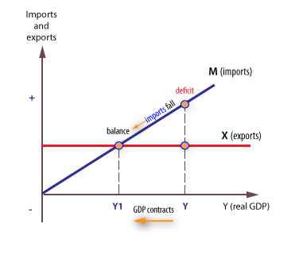

The export line is horizontal because it is determined by overseas GDP and not domestic GDP.

The import line is upward sloping, assuming a positive *marginal propensity to import* (mpm) this means that as income (Y) increases, imports (M) will increase. For example, if the mpm is 0.4, then a £1 increase in income leads to an increase in imports of 40p. The higher the mpm, the steeper the gradient of the import line. Deflating demand, therefore, reduces income and spending with income (Y) falling to Y1, so that imports (M) fall but exports (X) are left unaffected.

**Devaluation**

The second policy option to improve the current account is devaluation, which involves the deliberate reduction in the value of a country’s [currency](http://economicsonline.co.uk/Competitive_markets/The_foreign_exchange_market.html). It works by *expenditure switching*, which means that the policy encourages consumers to alter the distribution of their spending, rather than the total level of spending.

**Achieving an equilibrium exchange rate**

An ‘equilibrium’ exchange rate is the specific rate where export revenue and import spending are equal.

**Equilibrium**

At currency ‘£’, import spending equals export revenue, at Q1. At a higher actual rate, say at £1   imports now appear cheap in the UK, and spending increases to Qm, and exports appear expensive abroad, and fall to Qx.  This opens up a trade gap (QX to QM).

Devaluation will stimulate export revenue and reduce import spending, hence closing the trade gap.

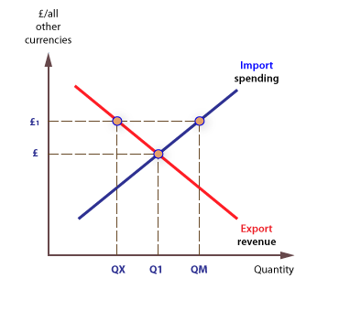

**Fixed exchange rates**

A fall in the exchange rate will, [ceteris paribus](http://economicsonline.co.uk/Competitive_markets/What_is_economics.html), reduce export prices encouraging overseas consumers to switch to UK products. This is likely to lead to a rise in export demand. Devaluation will also lead to an increase in import prices, encouraging UK consumers to switch away from imports to domestically produced products. This will lead to a fall in import demand.

**Evaluation**

Devaluation relies on the assumption that the sum of price elasticity of demand for imports and exports is elastic (>1), the so-called [Marshall-Lerner](http://economicsonline.co.uk/Global_economics/Marshall_Lerner.html) condition. However, this may not be satisfied in the short run, or even the longer run.

Devaluation may also trigger [cost-push inflation](http://economicsonline.co.uk/Managing_the_economy/Inflation_and_deflation.html), where a fall in the value of a currency will increase the price of imported goods, in terms of the domestic currency.

Devaluation could be interpreted as a hostile move against other countries and may lead to retaliation by competitors, so that no long term benefit is derived by the devaluing country.

**Import and export elasticity**

To understand the Marshall-Lerner condition, it is necessary to reconsider [price elasticity](http://economicsonline.co.uk/Competitive_markets/Price_elasticity_of_demand.html) of demand. It should be noted that *imports* and *exports* refer to the value of *spending* on imports and the value of *revenue* from exports. The value of these payments is derived from the prices of imports and exports multiplied by the quantity of imports and exports. For example, if country **A** sells 100 tonnes of steel to country **B** for A$1000 per tonne, export revenue earned by **A** is A$100,000. If we assume that the exchange rate of A$ against B$ is 4-1, then country **B** will have paid B$250 per tonne and spent B$25,000 in total. If the exchange rate of country **A** now falls to 5/1, the impact of this on **A**’s export revenue depends on how many tonnes it now sells at the cheaper rate. Country **B** will now only have to pay B$200 per tonne following devaluation, a fall from B$250, to B$200, of 20%. If demand is elastic, say (-) 2.0, then the 20% devaluation will lead to a 40% increase in demand, from 100 tonnes to 140 tonnes. The result is that payments from **B** to **A** rise from B$25,000 to (140 x 200) B$28,000. The Marshall-Lerner rule simply says that so long as the combined elasticities of demand for imports and exports are greater than 1, devaluation will improve the balance of payments on current account.

**The cross diagram - showing devaluation**

We can also use the cross diagram to illustrate the impact of devaluation.

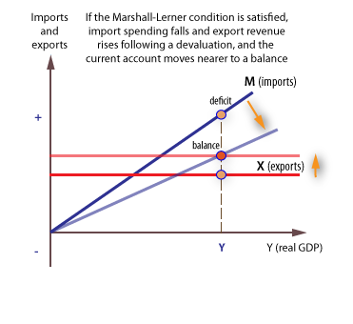

Assuming the [Marshall-Lerner](http://economicsonline.co.uk/Global_economics/Marshall_Lerner.html) condition:

1. The export line will shift up, and:
2. The import line will shift down.
3. At the existing GDP (Y), the deficit will fall.

**The J Curve**

The *J curve* shows what can happen to a country’s balance of payments when it devalues its currency. If we assume the Marshall-Lerner condition is satisfied, devaluation will improve the balance of payments.

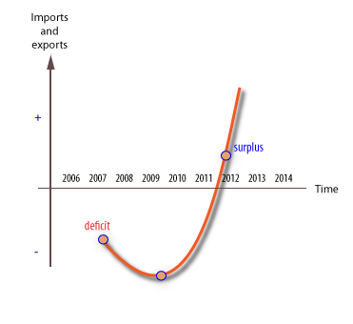

If the condition is not satisfied, devaluation will worsen the balance of payments.

The J-Curve effect exists because the condition is met in the long run but not the short run. In the short run, households and firms may not respond immediately to a change in price caused by a change in the exchange rate.

There are a number of reasons for this:

1. Consumers may wait and see if the price rise is sustained.
2. Businesses  may find it difficult to switch to or from an overseas supplier. It may take considerable *search* time to find alternatives.
3. Households and firms do not purchase consumer durables very often, so changes in exchange rates only take effect when decisions to purchase are made.
4. Consumers may be loyal to overseas brands.
5. Price is not the only factor that affects demand for imports - indeed, there are many other non-price factors.

**Direct controls**

A third option to help reduce a current account deficit is to impose direct controls on imports by erecting barriers against imports or by providing assistance to exporters.

Specific measures include:

1. [Tariffs](http://economicsonline.co.uk/Global_economics/Trade_protectionism.html)
2. Non-tariff barriers, such as [quotas](http://economicsonline.co.uk/Global_economics/Trade_protectionism.html), subsidies to domestic firms and discrimination against imports and in favour of domestic firms.

**Evaluation**

In the short run, trade barriers may help to reduce imports and help improve the current account. However, retaliation is a likely response, and any short-term gains will be eroded away. Therefore, direct controls are not generally considered an effective long-term solution to a current account deficit.

**Supply-side policy**

Finally, [supply-side policy](http://economicsonline.co.uk/Global_economics/Supply-side_policies.html) could be used to help improve an economy’s ability to produce. There are several actions that a government can take to improve supply-side performance. These measures include improving *labour productivity* and *labour market flexibility*.

**Evaluation**

Supply-side policy can provide a highly effective policy framework for long term improvement in competitiveness and current account performance. The main problem is that supply-side policy may take decades to work and is not a quick-fix.