***The Exchange Rate***

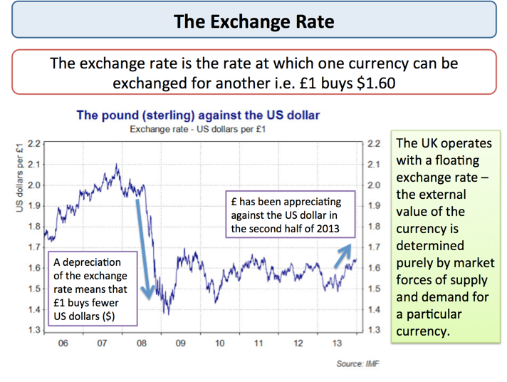

* The value of the currency is determined in the **foreign exchange market** where billions of $s of currencies are traded every hour.
* The main traders are businesses, international investors and governments
* London is the biggest centre of foreign exchange trading.

|  |
| --- |
| ***A Weaker Yen Helps Japanese Exports and GDP Growth***  Japanese exports have been rising for a fourth month in a row in June, boosted by a weak yen and a revival in demand from Europe. Exports rose 7.4% from a year earlier and sales to the European Union (EU) rose by 8.6%.  The Japanese yen has weakened 25% against the US dollar since November last year after a series of aggressive policy moves by Japan. A weak currency makes Japanese goods cheaper for foreign buyers. Meanwhile, imports into Japan rose 11.8% from a year ago, resulting in a trade deficit of 180.8bn yen (£ 1.2bn). |

***How does a change in the exchange rate influence the economy?***

* Changes in the exchange rate can have powerful effects on the macro-economy affecting variables such as the demand for exports and imports; real GDP growth, inflation, business profits and jobs
* As with most variables in economics, there are **time lags** involved. The impact of movements in currencies on the economy depends in part on:

1. The **scale** of any change in the exchange rate i.e. a 5%, 10% or even larger movement
2. Whether the change in the currency is **short-term or long-term –** i.e. is the change in the exchange rate temporary or likely to persist for some time?
3. How **businesses and consumers respond** to exchange rate fluctuations – price elasticity of demand is important here i.e. will there be a large change in demand for exports and imports?
4. The size of any multiplier and accelerator effects
5. When the currency movement takes place – i.e. at which point of an economic cycle

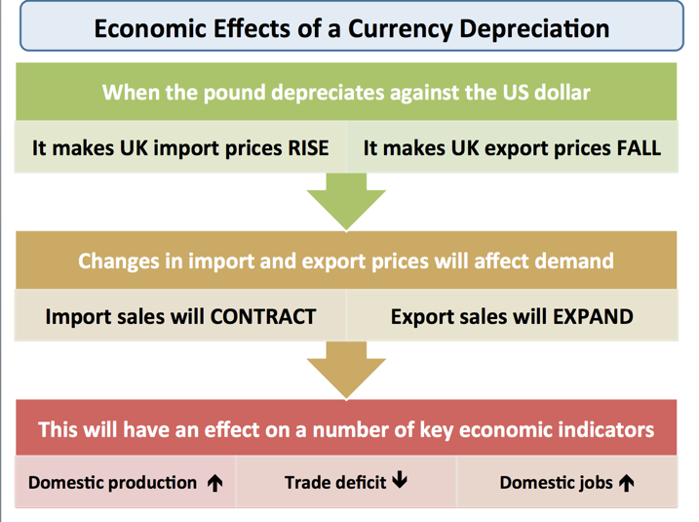

***How can changes in the exchange rate affect the rate of inflation?***

The exchange rate affects the rate of inflation in a number of direct and indirect ways:

* ***1.Changes in the prices of imports*** – this has a **direct effect** on the **consumer price index**. For example, an appreciation of the exchange rate usually reduces the sterling price of imported consumer goods and durables, raw materials and capital goods.
* ***2.Commodity prices and the CAP***: Many commodities are priced in US dollars – so a change in the sterling-dollar exchange rate has a direct impact on the UK price of commodities such as foodstuffs. A stronger dollar makes it more expensive for Britain to import these items.
* ***3.Changes in the growth of UK exports***: A higher exchange rate makes it harder to sell overseas because of a rise in relative UK prices. If exports slowdown (price elasticity of demand is important in determining the scale of any change in demand), then exporters may choose to cut their prices, reduce output and cut-back employment levels.

Bank of England research suggests that a10% depreciation in the exchange rate can add up to 3% to the level of consumer prices three years after the initial change in the exchange rate. But the impact on inflation of a change in the exchange rate depends on what else is going on in the economy. For example a lower pound is unlikely to have the same inflationary effects during a recession.

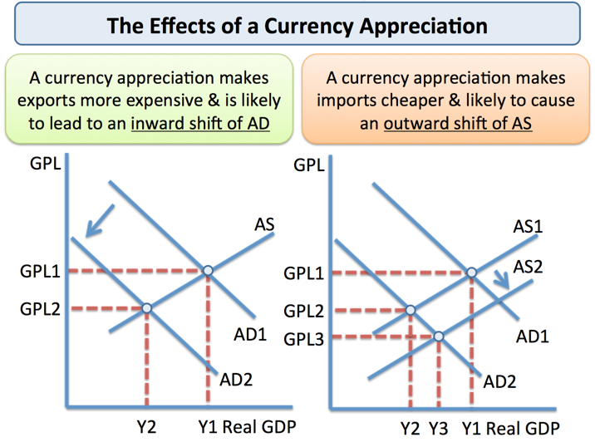Using AD-AS analysis to explain effects of a currency appreciation

***Evaluation points on the effects of exchange rate changes***

Changes in the exchange rate have quite a powerful effect on the economy but we tend to assume **ceteris paribus** – all other factors held constant – which of course is highly unlikely to be the case

* **Counter-balancing use of fiscal and monetary policy:** For example the government can alter **fiscal policy** to manage AD
* **Time lags –** it takes time for demand for exports and imports to change following a movement in the currency. Businesses need to have the capacity and access to credit to expand their production.
* **Low price elasticity of demand:** In the short term, the effects of exchange rates on export and import demand tends to be low because of low price elasticity of demand
* **Business response to the challenge of a high exchange rate:** Businesses can and do adapt to a high exchange rate. There are several ways in which industries can adjust to the competitive pressures that a strong pound imposes. Some of the options include:
* a) **Cutting their export prices** when selling in overseas markets and therefore accepting lower profit margins to maintain competitiveness and market share
* b) **Out-sourcing** components from overseas to keep production costs down
* c) **Seeking productivity / efficiency gains** to keep unit labour costs under control or perhaps trying to negotiate a reduction in pay levels
* d) **Investing extra resources in new product lines** where demand is price inelastic and less sensitive to exchange rate fluctuations. This involves producing products with a higher income elasticity of demand, where non-price factors such as product quality, design and effective marketing are as important in securing orders as the actual price

***Factors which influence the exchange rate***

Exchange rates are determined by supply and demand. For example, if there was greater demand for American goods then there would tend to be an appreciation (increase in value) of the dollar. If markets were worried about the future of the US economy, they would tend to sell dollars, leading to a fall in the value of the dollar.

* Appreciation = increase in value of exchange rate
* Depreciation / devaluation = decrease in value of exchange rate.

***Main Factors that Influence Exchange Rates***

**1. Inflation**

If inflation in the UK is relatively lower than elsewhere, then UK exports will become more competitive and there will be an increase in demand for Pound Sterling to buy UK goods. Also foreign goods will be less competitive and so UK citizens will buy less imports.  
Therefore countries with **lower inflation rates** tend to see an **appreciation** in the value of their currency.

**2. Interest Rates**

If UK interest rates rise relative to elsewhere, it will become more attractive to deposit money in the UK. You will get a better rate of return from saving in UK banks, Therefore demand for Sterling will rise.  This is known as “[hot money flows](http://www.economicshelp.org/dictionary/h/hot-money-flows.html)” and is an important short run factor in determining the value of a currency. **Higher interest rates** cause an **appreciation**.

**3. Speculation**

If speculators believe the sterling will rise in the future, they will demand more now to be able to make a profit. This increase in demand will cause the value to rise. Therefore movements in the exchange rate do not always reflect economic fundamentals, but are often driven by the sentiments of the financial markets. For example, if markets see news which makes an interest rate increase more likely, the value of the pound will probably rise in anticipation.

**4. Change in Competitiveness**

If British goods become more attractive and competitive this will also cause the value of the Exchange Rate to rise. This is important for determining the long run value of the Pound. This is similar factor to low inflation.

**5. Relative strength of other currencies.**

In 2010 and 2011, the value of the Japanese Yen and Swiss Franc rose because markets were worried about all the other major economies – US and EU. Therefore, despite low interest rates and low growth in Japan, the Yen kept appreciating.

**6. Balance of Payments**

A deficit on the current account means that the value of imports (of goods and services) is greater than the value of exports. If this is financed by a surplus on the financial / capital account then this is OK. But a country who struggles to attract enough capital inflows to finance a current account deficit, will see a depreciation in the currency. (For example current account deficit in US of 7% of GDP was one reason for depreciation of dollar in 2006-07)

**7. Government Debt.**

Under some circumstances, the value of government debt can influence the exchange rate. If markets fear a government may default on its debt, then investors will sell their bonds causing a fall in the value of the exchange rate. For example, Iceland debt problems in 2008, caused a rapid fall in the value of the Icelandic currency.

For example, if markets feared the US would default on its debt, foreign investors would sell their holdings of US bonds. This would cause a fall in the value of the dollar.

**8. Government Intervention**

Some governments attempt to influence the value of their currency. For example, China has sought to keep its currency undervalued to make Chinese exports more competitive. They can do this by buying US dollar assets which increases the value of the US dollar to Chinese Yuan.

**9. Economic growth / recession**

A recession may cause a depreciation in the exchange rate because during a recession interest rates usually fall. However, there is no hard and fast rule. It depends on several factors.   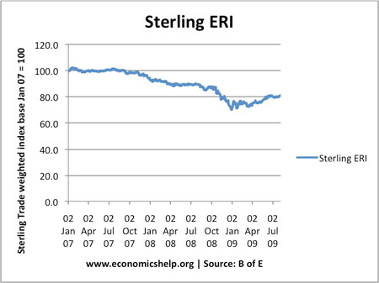

During this period, the value of Sterling fell over 20%. This was due to:

* Restoring UK’s lost competitiveness. UK had large current account deficit in 2007
* Bank of England cut interest rates to 0.5% in 2008.
* Recession hit UK economy hard. Markets expected interest rates in UK to stay low for a considerable time.
* Bank of England pursued quantitative easing (increasing money supply). This raised prospect of future inflation, making UK bonds less attractive.

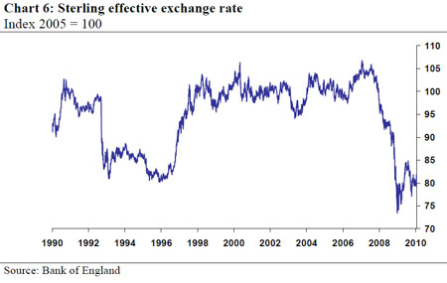

Large devaluation in 1992, occurred when [UK left Exchange Rate Mechanism](http://econ.economicshelp.org/2008/12/exchange-rate-mechanism-crisis-1992.html).

***Advantages of Fixed Exchange Rate***

A fixed exchange rate occurs when a country tries to keep the value of its currency at a certain level against another currency. Often countries join a semi-fixed exchange rate, where the currency can fluctuate within a small target level.

For example, the European Exchange Rate Mechanism ERM was a semi fixed exchange rate system.

***Advantages of Fixed Exchange Rates***

**1. Avoid Currency Fluctuation**s. If the value of currencies fluctuate significantly this can cause problems for firms engaged in trade.

* For example if a firm is exporting to the US, a rapid appreciation in sterling would make its exports uncompetitive and therefore may go out of business.
* If a firm relied on imported raw materials a devaluation would increase the costs of imports and would reduce profitability

**2. Stability encourages investment**. The uncertainty of exchange rate fluctuations can reduce the incentive for firms to invest in export capacity. Some Japanese firms have said that the UK’s reluctance to join the Euro and provide a stable exchange rates maker the UK a less desirable place to invest.

**3. Keep inflation Low**. Governments who allow their exchange rate to devalue may cause inflationary pressures to occur. This is because AD increases, import prices increase and firms have less incentive to cut costs.

4. A rapid appreciation in the exchange rate will badly effect manufacturing firms who export, this may also cause a worsening of the current account.

5. Joining a fixed exchange rate may cause inflationary expectations to be lower

***Disadvantage of Fixed Exchange Rates***

**1. Conflict with other objectives**. To maintain a fixed level of the exchange rate may conflict with other macroeconomic objectives.

· If a currency is falling below its band the government will have to intervene. It can do this by buying sterling but this is only a short term measure.

· The most effective way to increase the value of a currency is to raise interest rates. This will increase hot money flows and also reduce inflationary pressures.

· However higher interest rates will cause lower AD and economic growth, if the economy is growing slowly this may cause a recession and rising unemployment

**2. Less Flexibility**. It is difficult to respond to temporary shocks. For example an oil importer may face a balance of payments deficit if oil price increases, but in a fixed exchange rate there is little chance to devalue.

**3. Join at the Wrong Rate**. It is difficult to know the right rate to join at. If the rate is too high, it will make exports uncompetitive. If it is too low, it could cause inflation.

**4. Current Account Imbalances**. Fixed exchange rates can lead to current account imbalances. For example, an overvalued exchange rate could cause a current account deficit. See: [problems of overvalued exchange rate](http://www.economicshelp.org/blog/2882/currency/problems-of-overvalued-exchange-rate/).

***Problems of Overvalued Exchange Rate***

An overvalued exchange rate implies that a countries currency is too high for the state of the economy. An overvalued exchange rate means that the countries exports will be relatively expensive and imports cheaper. An overvalue exchange rate tends to depress domestic demand and encourage spending on imports.

An overvalued exchange rate can also be measured by looking at [purchasing power parity PPP](http://www.economicshelp.org/blog/economics/purchasing-power-parity-ppp-for-exchange-rates/). An overvalued exchange rate will mean goods are relatively more expensive in that country. (a more sophisticated form of PPP also takes into account difference in real GDP per capita – [Beefed up Big Mac Index](http://www.economist.com/node/21524811) at Economist)

An overvalued exchange rate is particularly a problem during a period of sluggish growth. If the economy is booming, an overvalued exchange rate can help reduce inflationary pressure, but in a recession an overvalued exchange rate can cause deflationary pressures.

***Example Overvalued Exchange Rates***

In 2011, both Switzerland and Japan have witnessed an appreciation in their currency. This appreciation occurred because investors are worried over finding secure investments in a period of economic uncertainty. However, because the global economy remains depressed (slow growth, high unemployment). This appreciation is unwelcome. It makes it more difficult to export goods and can lead to lower growth. For an economy like Japan which relies on a strong export sector, this decline in competitiveness could be very damaging for the their economy.

This is why both Switzerland and Japan have sought to intervene to try and reduce the value of their currency.

In a period of global economic stagnation, we often see countries trying to devalue their currency to boost their exports. This is known as [competitive devaluation](http://www.economicshelp.org/dictionary/c/competitive-devaluation.html)

Overvalued Exchange Rates in the Euro

[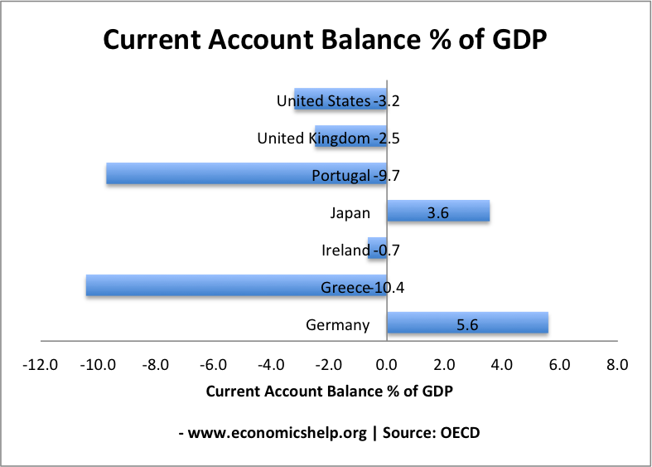](http://www.economicshelp.org/blog/wp-content/uploads/2011/05/current-account-oecd-2011.png)

Another potential problem of countries in the Eurozone is that there is a danger of running a large current account deficit due to a decline in competitiveness.

For example, countries like Portugal and Greece have a current account deficit of close to 10%. This is because they don’t have their own exchange rate to depreciate against other countries.

They have a current account deficit because they have had relatively higher inflation rates than other Eurozone economies. For example, rising labour costs not met by improved productivity.

This combination of higher prices and lower productivity makes their goods less attractive, leading to more imports and less exports. Hence the very large current account deficits

If they had their own exchange rate, we would see a devaluation in the currency  making exports more competitive and imports cheaper. This would help reduce the size of the current account deficit.

For example, the UK has had a persistent current account deficit, but with an independent exchange rate, the exchange rate can depreciate to reduce the size of deficit.

Dealing with Current Account Deficit.

The problem is that in the absence of a floating exchange rate it becomes more painful to solve the current account deficit.

To regain competitiveness, Greece and Portugal will have to rely on deflationary policies. For example, higher tax and lower spending to reduce consumer spending on imports. Also by reducing inflation this makes exports more expensive.

The problem is that it requires a prolonged period of deflation to regain competitiveness. Also deflation will bring other problems such as low growth, high unemployment.

***Floating Exchange Rates Definition***

A floating exchange rate occurs when governments allow the exchange rate to be determined by market forces and there is no attempt to influence the exchange rate.

In recent years, several countries have pursued inflation targets as the primary goal of monetary policy. Therefore, by targeting inflation, they have given less importance to the exchange rate and more countries have allowed their exchange rate to float freely.

***Dirty Floating***

Sometimes, countries are not in an official exchange rate mechanism, but they still do pay attention to the value of the exchange rate. Though they have no published target for the exchange rate, they may intervene under certain circumstances. For example, if the exchange rate deteriorated rapidly, they may increase interest rates to keep the value stronger.

For example, in the late 1980s, the UK had a policy of ‘shadowing D-Mark’ as precursor to joining the ERM.

***Arguments in Favour of a Floating Exchange Rate***

* **Automatic balance of payments adjustment** - Any balance of payments disequilibrium will tend to be rectified by a change in the exchange rate. For example, if a country has a balance of payments deficit then the currency should depreciate. This is because imports will be greater than exports meaning the supply of sterling on the foreign exchanges will be increasing as importers sell pounds to pay for the imports. This will drive the value of the pound down. The effect of the depreciation should be to make your exports cheaper and imports more expensive, thus increasing demand for your goods abroad and reducing demand for foreign goods in your own country, therefore dealing with the balance of payments problem. Conversely, a balance of payments surplus should be eliminated by an appreciation of the currency.
* **Freeing internal policy** - With a floating exchange rate, balance of payments disequilibrium should be rectified by a change in the external price of the currency. However, with a fixed rate, curing a deficit could involve a general deflationary policy resulting in unpleasant consequences for the whole economy such as unemployment. The floating rate allows governments freedom to pursue their own internal policy objectives such as growth and full employment without external constraints.
* **Absence of crises** - Fixed rates are often characterised by crises as pressure mounts on a currency to devalue or revalue. The fact that, with a floating rate, such changes are automatic should remove the element of crisis from international relations.
* **Flexibility** - Post-1973 there were great changes in the pattern of world trade as well as a major change in world economics as a result of the OPEC oil shock. A fixed exchange rate would have caused major problems at this time as some countries would be uncompetitive given their inflation rate. The floating rate allows a country to re-adjust more flexibly to external shocks.
* **Lower foreign exchange reserves** - A country with a fixed rate usually has to hold large amounts of foreign currency in order to prepare for a time when they have to defend that fixed rate. These reserves have an opportunity cost.

***Disadvantages of the Floating Rate***

* **Uncertainty** - The fact that a currency changes in value from day to day introduces instability or uncertainty into trade. Sellers may be unsure of how much money they will receive when they sell abroad or what their price actually is abroad. Of course the rate changing will affect price and thus sales. In a similar way importers never know how much it is going to cost them to import a given amount of foreign goods. This uncertainty can be reduced by hedging the foreign exchange risk on the forward market.
* **Lack of investment** - The uncertainty can lead to a lack of investment internally as well as from abroad.
* **Speculation** - Speculation will tend to be an inherent part of a floating system and it can be damaging and destabilising for the economy, as the speculative flows may often differ from the underlying pattern of trade flows.
* **Lack of discipline in economic management** - As inflation is not punished there is a danger that governments will follow inflationary economic policies that then lead to a level of inflation that can cause problems for the economy. The presence of an inflation target should help overcome this.
* **Does a floating rate automatically remedy a deficit?** - UK experience indicates that a floating exchange rate probably does not automatically cure a balance of payments deficit. Much depends on the price elasticity of demand for imports and exports. The Marshall-Lerner condition says that a depreciation in the exchange rate will help improve the balance of payments if the sum of the price elasticities for imports and exports is greater than one.
* **Inflation** - The floating exchange rate can be inflationary. Apart from not punishing inflationary economies, which, in itself, encourages inflation, the float can cause inflation by allowing import prices to rise as the exchange rate falls. This is, undoubtedly, the case for countries such as UK where we are dependent on imports of food and raw materials.