***European Union***

***Background to the EU***

1957 Treaty Of Rome established the EEC between 6 original members  
1960 EFTA between UK, Aus, Den, Nor, Port, Swis and Swe  
1973 UK, Ireland and Denmark join EC  
1999 Creating of Euro single currency.

***Community Institutions***

1. European Commission, this is the civil service of the EU
2. Council of Ministers from different countries make decisions on policy
3. European Council. Meets twice a year to make decisions which fundamentally alter EU policy
4. European Parliament directly elected body of 626 members
5. The Court OF Justice. Is based in Luxembourg

**Single European Act 1986**

This was an attempt to “relaunch” the EU by attempting to create a Single Market.  
It was necessary to drop unanimous decision making with an increase in Qualified Majority Voting.  
The SEA also committed the EU Economic and Monetary Union (EMU)

***Treaty of Maastricht 1992***

1. Economic, social and Political extensions to the EU
2. Common foreign and security policy
3. Intergovernmental cooperation on justice and home affairs

**Economic Integration**

* Preference Areas. The Lome conference of 1975 gave preferential treatment to certain developing countries
* Customs Union. This is s free trade area with a common external tariff

**Single Market.** – European Union

This occurs when the member countries act as a single economic area with the free movement of labour and capital

This involves:

1. No Tariffs on trade between member states
2. Elimination of border controls
3. Free movement of People
4. Mutual recognition of qualifications
5. Harmonization of taxes and other industrial and economic laws

***Monetary Union is a single market plus***

1. A common currency
2. N0 internal exchange Rates
3. Common monetary policy

***Obstacles To Completing the Single Market in the EU***

1. Customs Formalities
2. Different Tax Rates, especially on Alcohol and tobacco
3. State Subsidies to domestic industries, or tax breaks to encourage inward investment. This creates unfair competition within the EU
4. Different regulations added to the cost of business
5. Different currencies (until the Euro was launched)
6. Until 1994 there were restrictions on the movement of capital, but these controls have been abolished and gradual liberalization has been made on other aspects of financial services.

***Benefits of A Single Market***

* Trade Creation. Exploitation of comparative adv allows lower prices and costs. Leading to higher output and more employment
* Reduction in the direct costs of barriers
* Economies of scale from specialization
* Greater competition

***Costs of a Single Market***

* Structural Change due to increased specialization
* Adverse Regional multiplier effects. The creation of a single market tends to attract capital and jobs away from the periphery areas to the centre.
* Development of Monopoly/ Oligopoly power
* Trade Diversion. If external barriers remain high countries could lose out

***EU Competition Policy***

The EU competition has the power to examine mergers to see whether they are in the public interest. They are not always opposed to mergers because they can have benefits such as

1. Economies of scale
2. Greater international competition.

However the abuse of market power can cause problems such as higher prices, unfair competition.

***A merger could be referred to the commission if***

1. New Firm has greater than £3.6 billion
2. Less than 2/3 of the new firm comes from one member state (therefore there is still a role for national commissions)

Other unfair business practices include

1. Price fixing and market sharing Cartels. In 1994 the major steel manufacturers were fines 7% of their turnover for fixing prices

***Social Aspects of the Single Market***

***The Social Charter***

This aimed to give greater protection to workers in the EU it included the following:

* Free movement of labour
* Min wages
* Max working week
* Right to paid holidays
* Freedom to join in trades union
* Vocational training for all EU citizens
* Equal treatment between men and women
* Protection for elderly and disabled
* Health and Safety at work
* The creation of Eur ES, this is a European information network for job vacancies
* Criticism of European Union EU

***European Monetary Union***



The European single currency was created in 1999 and entered common circulation in January 2002

|  |  |
| --- | --- |
| **Some Landmarks for European Monetary Union** | |
| 1944 | The Bretton Woods system of fixed exchange rates based on dollar-gold standard is created |
| 1973 | Breakdown of the fixed exchange rate system – move to floating exchange rates |
| 1979 | European Monetary System (EMS) is created – a forerunner to the single currency |
| 1991 | The Maastricht Treaty creates convergence process for countries wanting to join the Euro |
| 1999 | Euro is launched and the European Central Bank sets official interest rates |
| 2000 | Denmark votes in a referendum not to join the Euro, Greece joins the Euro (12th member) |
| 2002 | Euro notes and coins come into common circulation on the 1st of January, 2002 |
| 2003 | Sweden votes in a referendum not to join the single currency |
| 2007 | Slovenia becomes the 13th member state to enter the single currency area |
| 2008 | Malta and Cyprus join the single currency |
| 2009 | Slovakia joins the single currency |
| 2010 | Financial crisis hits the Euro Zone – several countries forced into emergency budgets Greece  rescued by a Euro110bn emergency bail-out led by Germany Ireland given emergency financial support |
| 2011 | Estonia becomes the 17th country to join the single currency |
| 2013 | A financial crisis engulfs Cyprus as the country seeks a bail out from the EU |
| 2014 | Latvia joins the Euro Zone and becomes the 18th member on 1st January 2014 |

***Joining the Euro – Meeting the Convergence Criteria***

In principle, to join the single currency a country must meet each of the following **convergence criteria**. They are designed to produce monetary stability and convergence for countries that share the Euro:

* **Stable prices**: Inflation must not be more than 1.5% higher than the average in the three member countries with best price stability, i.e. lowest inflation.
* **Stable exchange rate**: The national currency must have been stable relative to other EU currencies for a period of two years prior to entry into the monetary union (ERMII entry).
* **Sound government finances**:
* *Total government debt must not exceed 60 per cent of GDP*
* *The annual budget deficit must not be greater than 3 per cent of GDP*
* **Interest rate convergence**: 5-year Treasury bond interest rate must not be more than 2 percentage points higher than average of Euro Zone members

***Real Economic Convergence***

Some economists believe that economies entering the single currency are likely to perform better in the long run if members are closer in a real sense:

* Trend growth of GDP / LRAS (linked to the rate of productivity growth & capital investment)
* Labour market flexibility e.g. flexible skills, mobility, flexible wages
* Patterns of international trade are similar
* Housing market structure e.g. home ownership, mortgage finance, size of the rented housing sector
* Countries whose economies respond in a symmetrical way to a change in monetary policy e.g. when the ECB makes a change to policy rates
* Countries who respond in a symmetrical way to a variety of demand and supply-side external shocks in the global economy

Because the member nations of the Euro are markedly different – this makes it virtually impossible for the ECB to find a 'one-size fits all' interest rate. The Euro Area is not an **optimal currency area**.

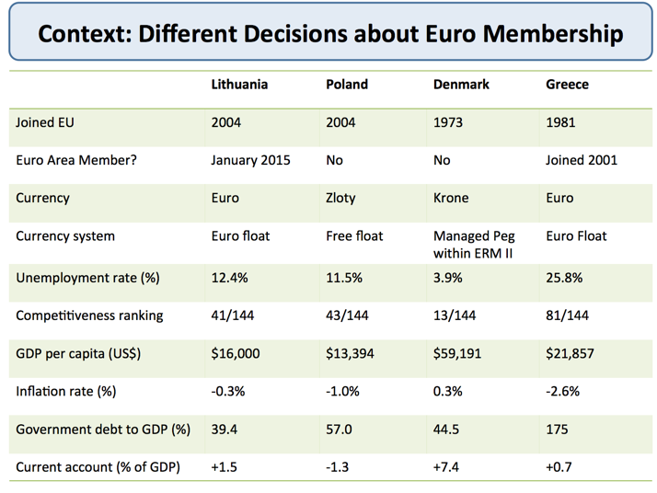

***Different decisions on the Euro for four EU countries***

***The UK and the Single Currency***

* The UK opted out of the Euro at the time of the 1993 Maastricht Treaty
* The Coalition government (in power since 2010) has no plans to consider entry. Britain will remain outside of the Euro Area
* Britain operates with a floating exchange rate and an independent central bank – it has the flexibility to change monetary policy to suit domestic needs – for example to increase the size of quantitative easing or to find other ways of unfreezing the supply of loans to businesses.
* This freedom is not necessarily available to countries part of the Euro Zone.

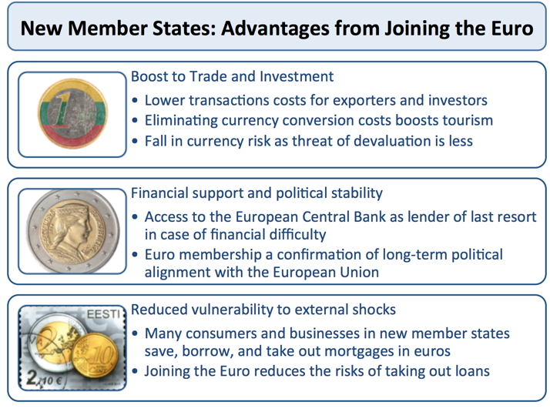

***Interest rates inside the Euro***

* Policy interest rates for Euro Area countries are set by the European Central Bank (ECB) and as such, members of the Euro must accept the prevailing short term monetary policy decisions taken by the ECB.
* Being outside of the Euro, means that the UK can set their own policy rates
* Interest rates on government bonds are set by international capital markets.
* One of the features of the recent financial crisis, recession and fiscal problems facing many Euro Zone countries has been the sharp upward spike in bond yields (the interest paid on a bond) as investor confidence has fallen and the risk of sovereign debt defaults has grown.

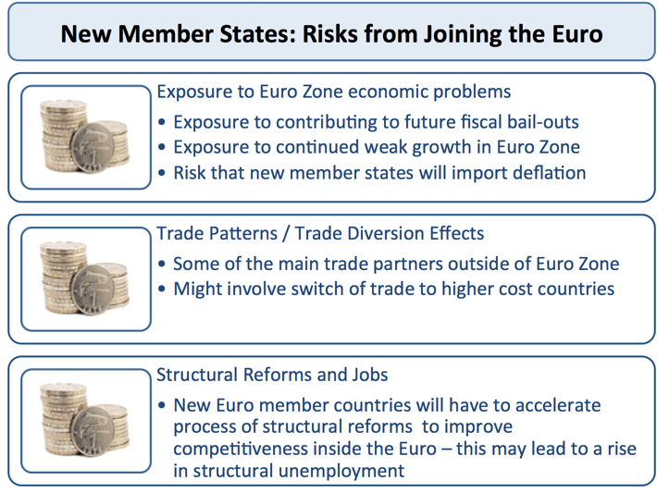

***From an economic perspective the EU can be criticised for various reasons***

* ***Common Agricultural Policy CAP***
* The CAP was one of the most inefficient economic policies and waste of money. It subsidised farmers to produce goods that nobody wanted. The excess supply was often dumped on world markets creating falling prices and incomes for world farmers. After many years, the worst excesses of CAP have been reformed. But, it remains persistently difficult to end the culture of subsidising agriculture. The taxpayer pays the burden of higher prices and cost to EU.
* ***Regulated Labour Markets***
* Unemployment in the European Union has been persistently high for the past two decades. This is especially a problem in countries like France and Spain. One reason is the highly regulated labour markets that the EU social charter encourages. The EU has failed to deal with regional unemployment.
* ***Anti Inflation Bias***
* The ECB has inherited the German Bundesbank’s anti inflationary stance. However, they often overdo this leading to lower growth. This is especially a problem for countries in the EU, who may struggle with a common monetary policy and interest rate.
* ***Euro has Created Lower Economic Growth.***
* The EU pushed the creation of the Euro. However, in practise, member countries have struggled to cope with the fixed exchange rate, and lack of independent monetary policy.
* Countries in the Euro have been pushed into bond crisis because markets fear a lack of liquidity (ECB can’t act as lender of last resort and print money to buy bonds). This has seen higher bond yields on debt of Euro countries. As a result of bond crisis, governments have been pushed into spending cuts and budget austerity.
* However, despite the fiscal austerity, there is no alternative for promoting economic recovery. Monetary policy is set by the ECB. As a consequence economic growth in the Eurozone has been disappointing.

***Benefits of European Union***

The European Union is a political and economic union of 28 countries. Originally formed in 1958 by six countries (then the EEC), the EU has expanded in terms of size and integration. The aim of the EU is to promote European harmony through creating a single market, enabling the free movement of goods, services and people.  
  
**Some of the benefits of the European Union include:**  
  
**Broad political and legal benefits**

1. European harmony - European Union countries are no longer at loggerheads like they were in the past. With the exception of civil war in Yugoslavia (which wasn't in the EU at the time), Europe has managed to heal the divisions which were so painfully exposed in the two World Wars in the Twentieth Century. The EU was awarded the Nobel Peace Prize in 2012 for helping to promote peace and international co-operation. Many Eastern European countries are keen to join the EU because they feel it will help promote economic and political stability.
2. Legal and human rights. The EU has a strong commitment to human rights, preventing discrimination and the due process of law. This makes the EU attractive to countries, such as the Ukraine who wish to share in similar legal and human rights.
3. Prospect of membership has helped modernise countries, such as Turkey. The Copenhagen Criteria for EU membership enshrine commitment to human rights, rule of law and market economy. The prospect of gaining membership of the EU, encourage countries to implement human rights legislation.

**Economic benefits**

1. EU is one of strongest economic areas in the world. With 500 million people, it has 7.3% of the world's population, but accounts for 23% of nominal global GDP.
2. Free trade and removal of non-tariff barriers have helped reduce costs and prices for consumers. Increased trade to the EU creates jobs and higher income. Over 52% of UK exports are to the EU. Trade within the EU has increased 30% since 1992.
3. According to [one study](http://webarchive.nationalarchives.gov.uk/+/http:/www.dti.gov.uk/europeandtrade/europe/benefits-eu-membership/page22676.html) - over ten years (1993-2003), the Single Market has boosted the EU’s GDP by €877 billion [£588 billion]. This represents €5,700  [£3,819] of extra income per household.
4. A paper, [Campos, Coricelli, and Moretti (2014)](http://www.voxeu.org/article/how-rich-nations-benefit-eu-membership) used the synthetic counterfactuals method (SCM) pioneered by Abadie and Gardeazabal (2003). The red dotted line shows estimated GDP if the country had not been a member of the EU. This shows that even more prosperous EU countries, such as the UK have benefited from higher GDP as a result of being in the EU.  
     
   [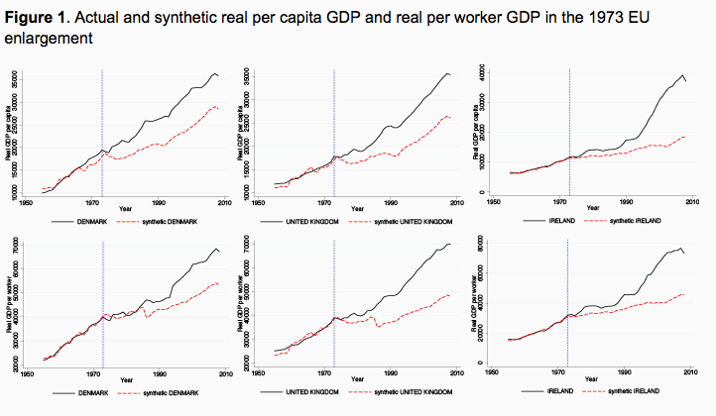](http://2.bp.blogspot.com/-pxr_nNKy5VM/U4Bd4zqrViI/AAAAAAAAAlk/plRa_gVB0RA/s1600/Screen+Shot+2014-05-24+at+09.52.12.png)
5. Removal of customs barriers mean 60 million customs clearance documents per year no longer need to be completed, cutting bureaucracy and reducing costs and delivery times
6. Countries in the EU, are amongst the highest positions in the [Human Development Index](http://www.economicshelp.org/dictionary/h/human-development-index.html) (HDI)
7. Poorer counties, such as Ireland, Portugal and Spain have made significant degrees of economic development since they joined the European Union. A report suggests that  over the period of the 1980s and 2004 enlargement, there are substantial positive pay-offs of EU membership, with a gain in per capita GDP of approximately 12% for poorer countries
8. Social cohesion fund. This has invested in poorer areas of the EU to help reduce regional disparities. For example, Ireland benefited from the [EU social cohesion fund](http://eu2013.ie/ireland-and-the-presidency/abouttheeu/theeuandyou/irelandharnessingthepotentialofeumembership/) (over €6 billion of investment in education and infrastructure spending)
9. EU structural funds to help Eastern European economies develop will benefit the UK in the long term because as they become more affluent, they will be able to buy more UK exports.
10. The European Union has attracted greater inward investment from outside the EU. Inward investment grew from €23 billion  [£15.4 billion] in 1992 to €159 billion [ £106.5 billion] in 2005. The UK is the 5th largest source of inward investment in the world, and being a member of the single market is an important factor in encouraging Japanese firms.

**Labour and free movement of people**

1. Free movement of labour and capital have helped create a more flexible economy. For example, UK and Ireland have benefited from the immigration of Eastern European workers to fill labour market shortages in certain areas, such as plumbing, nursing and cleaning.
2. Far from 'taking jobs', migration has helped increase productive capacity and makes a net contribution to tax revenues.
3. Free movement of labour also enables British people to live and work in Europe. Roughly 1.6 million British citizens live in the EU outside the UK (*UNCTAD World Investment Report 2010*)
4. EU has enabled people to travel freely across national boundaries making trade and tourism easier and cheaper. According to the European Commission, more than 15 million EU citizens have moved to other EU countries to work or to enjoy their retirement.
5. 1.5 million young people have completed part of their studies in another member state with the help of the Erasmus programme. The possibility to study abroad is considered positive by 84% of EU citizens.
6. Easier to use qualifications in different member countries. This makes it easier to work abroad without having to retrain in different national qualifications.
7. Mutual recognition of safety standards and rules have helped reduce costs for firms. This has encouraged the development of small and medium business who rely on low cost of exports.
8. Social charter enshrines protection for workers such as maximum working week, right to collective bargaining and fair pay for employment.
9. European Arrest Warrant (EAW) scheme has made it easier to track criminals across the European continent.

**Environmental benefits of the EU**

* The EU have raised the quality of sea water and beeches, by implementing regulations on water standards 'Bathing Water Directive'. 92% of tourist locations now meet minimum water quality standards.
* Tackling global warming. In 2006, the (EU) committed to reducing its global warming emissions by at least 20 percent of 1990 levels by 2020. The EU has also committed to spending $375 billion a year to cut greenhouse gas emissions by at least 80 percent by 2050 compared to 1990 levels.
* Tackling acid rain. Environmental treaties which have sought to deal with European wide environmental problems such as acid rain. The EU has set strict restrictions on emissions of pollutants, such as sulphur, and other causes of acid rain.

**Consumer benefits of the EU**

* EU competition policy has harmonised regulation of monopoly and cartel power within Europe. The EU competition policy seeks to avoid abuses of cartels / monopoly / dominant market power and protect the interest of consumer. There has been successful deregulation of airlines, electricity and gas markets.
* The EU has reduced the price of making mobile phone calls abroad. In 2007 EU legislation set maximum charges for making and receiving calls.  The EU also agreed with 14 mobile phone manufacturers to create standard design for chargers from 2011 in order to make life easier for consumers and reduce wastage. In 2014, it is has voted to scrap roaming charges which will drastically reduce the cost of using a mobile phone abroad.
* Consumers are free to shop in any EU countries without paying any tariffs or excise duties when they return home.

***Should the UK stay in the European Union?***

In the past few years, there have been a noticeable increase in the calls for the UK to consider leaving the European Union. A few years ago, we may have enjoyed complaining about EU directives on the bendy banana (which didn’t really exist) but it was taken as almost sacrosanct that membership of the EU was in the UK’s interest.

What has changed and would we really benefit from leaving – and negotiating a free trade agreement, which enables the benefits of EU membership without the supposed costs?

***Should We stay in the EU?***

**The Ideal of European unity**.

The relative peace and prosperity in Europe since 1945, is a huge achievement, given the past century of inter-European conflict. Britain is an intrinsic part of Europe, whether it likes it or not. We should take the opportunity to be a member of the European Union and help maintain this European integration and harmony. If the UK left the EU, we would be increasingly politically isolated.

* However, do we need to be a member of the European Union to achieve this? The UK could still contribute to European ideals without signing up for all the political and economic integration that the EU elite wish to pursue. European countries, who have stayed out of the EU, such as Switzerland and Norway maintain friendly relations with Europe.

**Free Trade**

One of the strongest benefits of the European union is the fact that it is our main trading partner, and membership of the EU has helped reduce trade barriers – both tariff and non-tariff barriers. European trade is critical to the UK economy. Leaving the EU, could put this important aspect of our economy under threat.

* The hope of Eurosceptics is that we could leave the political integration of the EU, but maintain all the free trade agreements. Again the model is that Switzerland and Norway have not been disadvantaged by staying out of the European Union. Evidence suggests, the EU would be keen to accommodate the UK as a free trade partner.

“If the British cannot support the trend towards more integration in Europe, we can nevertheless remain friends, but on a different basis. I could imagine a free trade agreement.”

**Free Movement of labour and capital**

Another benefit of the EU is enabling the free movement of people across borders. According to the European Commission, more than 15 million EU citizens have moved to other EU countries to work or to enjoy their retirement. British people have been able to work and retire in other countries. Migration from eastern Europe has helped fill in labour market vacancies, making the UK labour market more flexible. Migration has also helped reduce the dependency ratio, which improves the governments budgetary position.

* Eurosceptics might argue that the free movement of labour from eastern Europe creates more problems. Given housing shortage, mass immigration could put strain on UK housing and aggravate issue of overcrowding

**Ease of Studying Abroad**.

1.5 million young people have completed part of their studies in another Member State with the help of the Erasmus programme. The possibility to study abroad is considered positive by 84% of EU citizens. ([benefits of EU](http://webarchive.nationalarchives.gov.uk/+/bis.gov.uk/policies/europe/benefits-of-eu-embership)) Higher education is important industry and source of foreign earnings, which could be compromised by leaving the EU.

* Again, there is the hope that the UK could maintain free movement of labour, but with more restrictions on the numbers of immigrants from Eastern Europe.

***Economic Strength of the EU.***

In the post war period, the EU economy performed very well, enabling a sustained increase in real GDP per capita and living standards. This  used to be an argument in favour of UK membership.

* This is perhaps the biggest weakness now facing the EU. The EU can no longer point to economic stability and strength. Structural problems with the Euro and monetary union, are creating a European Union of austerity, high unemployment and low economic growth. Eurosceptics argue that the political pursuit of the Euro and single currency has been at the cost of economic common sense.

For more details, we can examine the [problems of the Eurozone](http://econ.economicshelp.org/2007/03/economic-problems-of-european-union.html). But, in summary

* The Euro fails to account for the divergence in competitiveness, this has caused trade imbalances and lower domestic demand
* Bond yields have been higher because of failure of European Central Bank to act as lender of last resort. Higher bond yields have created the necessity for unsuitable austerity policies.
* The German dominated ECB prioritise low inflation and monetary stability over more practical goals like full employment and positive economic growth.

However, it is worth pointing out that the UK did not join the Euro, so is not sharing in the costs of a single currency. However, the economic performance of the UK hasn’t been much better than our Eurozone partners. Leaving the EU, wouldn’t change that much. We are not in the Euro anyway, and the ECB will not change their economic policy, just because the UK left the EU.

**Cost of Membership.**

The Treasury state that the net cost of the EU was £7.6 billion, in 2010-11 –  up from £4.7 billion in 2009-10. This is relatively small percentage of [UK government spending](http://www.economicshelp.org/blog/142/economics/what-does-the-government-spend-its-money-on/) (e.g. social security accounts for £194bn) The UK does benefit from some EU spending, and the structural funds help to reduce regional inequality in the EU. Supporters of the EU argue that this £7bn isasily be funded by the increased trade and lower consumer prices resulting from EU membership

* However, sceptics argue the actual cost is closer to £10 billion. Furthermore, much of EU spending is highly inefficient and wasteful. Despite reforms, the biggest target of EU spending is still agriculture, which benefits economies with big agricultural sector. The UK gains little from the common agricultural policy; some of the main recipients are large wealthy landowners who perversely  benefit from the subsidies they are entitled to.

**Democracy in a global economy**

Many issues like fishing, agriculture, global warming, competition policies are issues that need European agreement. In today’s highly global economy, you can’t tackle these issues independently. If fishing policy. is inadequate, the UK needs to work within the structure of the EU to improve it. Leaving will mean the UK have no say, and will be even worse off. We don’t have any choice, but to work for European wide agreement on these issues of a global nature.

* However, critics argue that the EU has become so large and cumbersome, that it is too difficult to have a meaningful say  on important issues. Increasingly issues will have to be decided by Qualified Majority Voting, which means that the UK may have to accept rules and regulations we didn’t support.

**Personal View**

My personal view is instinctively to support attempts at European union and integration. Even if there are some costs, like inefficient agricultural policies, the hope is that the net benefits outweigh this. In particular, I don’t feel that the UK can go it alone – which some Eurosceptics seem to give opinion. The nature of globalisation is that we are increasingly integrated and interdependent on our European neighbours (whether we like or not).

However, I can also see the attraction of the viewpoint which says – why not have the benefits of European membership (free trade, acceptance of qualifications, free movement of capital) without all the unnecessary political integration and economic policies which are damaging the EU. You can often find yourself agreeing with people, even if you don’t share their motives.

In particular, the attitude of the EU towards the Single currency and unemployment is a real cause for concern. In my view, the Single currency is structurally unsound, and rather than bringing European nations together, is causing a rise in extremist political activity, because of the high social costs surrounding the consequences of austerity and high unemployment.

The management of the EU crisis makes you wonder at the direction of the European Union and whether they are losing sight of the best way to promote European integration.

One final note is that  leaving the EU, would change things much less than either side might admit. Trade may be relatively unaffected. There is no reason why leaving the EU, should have to significantly change the way we do business. But, also leaving the EU, wouldn’t change the problems arising from the Single Currency experiment. Also the money saved from leaving the EU would be relatively insignificant. It wouldn’t make much of a dent in the UK budget deficit.

|  |  |  |
| --- | --- | --- |
| **Q&A: EU enlargement** | | |
| |  | | --- | | Italian policeman guarding EU summit  Enlargement is meant to make Europe safer |   **Bulgaria and Romania joined the European Union on 1 January 2007.**  They take the membership of the bloc from 25 to 27 member states - a long way from its beginnings as a six-nation Economic Community in 1958.  Why is the EU enlarging, is it a good thing or a bad thing, and what do Bulgaria and Romania bring to the EU?  **Why are these two countries joining the EU, and why now?**  Bulgaria and Romania applied to join the EU in the early 1990s along with eight other former communist states of Central and Eastern Europe, once they were no longer under the power of the Soviet Union.  The other eight moved quickly to carry out political and economic reforms, and joined the EU in 2004. Bulgaria and Romania were slower, and are only now judged to have met the EU's membership conditions.  **Are Bulgaria and Romania really ready for membership?**   |  |  | | --- | --- | | http://newsimg.bbc.co.uk/shared/img/o.gif | **JOINED IN 2004**  Cyprus  Czech Republic  Estonia  Hungary  Latvia  Lithuania  Malta  Poland  Slovakia  Slovenia  http://newsimg.bbc.co.uk/nol/shared/img/v3/inline_dashed_line.gif  [**Watch the EU grow**](http://news.bbc.co.uk/2/shared/spl/hi/europe/04/enlarging_europe/html/eu_expansion.stm) |   Officials at the European Commission have been quoted as saying that they are not really ready, but that delaying accession may not be the best way to encourage further reforms.  The Commission was hoping, for example, that Bulgaria would take big steps over the summer to tackle high-level corruption and organised crime, but officials in Brussels say they have been disappointed.  Nonetheless, a decision has been taken that it is better to have Bulgaria and Romania inside the club - under threat of strong sanctions if EU funds are not properly administered or crime gangs continue to flourish - rather than leaving them out in the cold.  **How will they fit in with the rest of the EU?**  Bulgaria and Romania make up 6% of the EU's population and less than 1% of its GDP. Two extra seats are being added to the European Commission, and 54 to the European Parliament.  Bulgaria and Romania are the poorest members of the EU, with GDP per head about a third of the EU average. However their economies are growing quickly, at 5-7% per year..  **What do they bring to the club?**  The European Commission says the two countries' rapid growth and highly motivated workforce will be an asset for the EU economy.  It also says both countries can help shape the EU's foreign and security policy - Romania as a bridge to Eastern Europe, including Moldova, and Bulgaria as an interface with the Balkan and Black Sea region.  **Will the expansion of the EU now come to a halt?**   |  |  | | --- | --- | | http://newsimg.bbc.co.uk/shared/img/o.gif | **FUTURE MEMBERS**  Bulgaria and Romania joined on 1 January 2007  Turkey and Croatia started membership talks in October 2005  Macedonia officially gained "candidate" status in December 2005  Albania, Bosnia, Kosovo, Montenegro and Serbia are expected to join in future  http://newsimg.bbc.co.uk/nol/shared/img/v3/inline_dashed_line.gif  [**Guide to membership queue**](http://news.bbc.co.uk/2/shared/spl/hi/europe/04/enlarging_europe/html/introduction.stm) |   Probably not. The EU has promised the Balkan countries they can all join when they meet the conditions. Croatia and the Former Yugoslav Republic of Macedonia are already officially labelled as "candidates" for membership.  However, most experts expect the EU to go slow on further enlargement from now on. For one thing, opposition to the whole process is growing in some member states. For another, EU treaties will have to be revised before any more countries can join. Experts say the EU may be prepared to "tinker" with treaties to allow Croatia in, but major reform will be necessary after that.  **Wasn't the EU already big enough before 2004, when it had 15 members?**  Some member states have always had misgivings about enlarging the EU to the east - and these only intensified after France and the Netherlands voted against the proposed EU constitution in 2005.  However, EU treaties say any European country can apply to join if it meets the conditions, such as democracy, respect for human rights, the rule of law and a market economy.  **Is public opinion in the EU in favour of more enlargement?**   |  | | --- | | Graphic showing public opinion on EU enlargement |   Polls suggest attitudes towards enlargement are cooling. Forty-six per cent of people questioned in an autumn 2006 Eurobarometer poll were in favour of further enlargement (down from 49% a year months earlier), and 42% were against (up from 39% six months earlier). The rest did not know.  However, the picture varies from country to country. People in countries which joined the EU in 2004 seem to be broadly in favour of further enlargement, as are the people of Greece, Sweden and Spain. But in five other member states - Austria, France, Germany, Luxembourg and the UK - only 30-36% support the idea.  **How much does enlargement cost?**  In 2005, the 10 countries which joined the EU in 2004 received about 4bn euros (£2.7bn) more from the EU than they paid into the budget. This comes to about 4% of the EU budget, which is itself about 1% of the EU's gross national income. In 2006, Bulgaria and Romania are getting about 1.5bn euros in pre-accession aid.  Of the older EU members, Spain, Greece, Portugal and Ireland also traditionally end up getting more back than they paid in. Spain's "positive balance" in 2005 was in fact bigger than that of the 10 new member states put together. In future Spain will do less well from the EU budget, and the newer member states - the poorer ones, at least - will do better.  These calculations do not take into account the fact that EU money spent in one country - for example to build a road - will often be paid to contractors from a different EU country. Nor do they take into account that expansion of the single market is financially beneficial for all concerned.  **What are the arguments against enlargement?**  Here are some of them:   * It could lead to mass immigration, and increased organised crime * Workers from poorer countries take jobs from richer ones, and companies relocate to countries with lower labour costs and worse social protection * The richer member states cannot afford to pay huge subsidies to the poorer states * The broader the EU gets, the more difficult it is to achieve deep integration * The EU will grind to a halt, because with so many members it will never be able to agree on anything   **What are the arguments in favour of enlargement?**  Supporters say it is reuniting a continent divided by the Cold War, spreading stability and prosperity, expanding the single market, and giving Europe more weight on the world stage.  They also have a specific response to each of the above arguments against enlargement:   * Immigration helps drive economic growth, and the EU will be able to work with new member states to tackle organised crime and trafficking * Cheaper labour is good for the economies of richer European nations - and it is better for them if companies relocate to Central Europe than to India or China * The richer member states gain more from being members of a large single market than they pay out in transfers to the poorer countries * A broader union can also be a deeper one - the EU has been expanding at regular intervals since 1973 and all the while integration has been steadily increasing * Decision-making in the EU has not ground to a halt yet, despite the failure to pass a new constitution which would have simplified procedures.   **Can EU member states refuse to accept migrant workers from another member state?**  The EU regards free movement of workers as a fundamental right - but has nonetheless allowed member states to place restrictions on workers from eight of the 10 countries which joined the EU in 2004.  Restrictions will also be allowed in the case of workers from Bulgaria and Romania.  However, they cannot be continued for more than seven years. Countries which impose restrictions must tell the European Commission why they think the foreign workers would distort their labour market. They have to justify the decision again after two years, and again after five years.  **Have EU voters ever been asked if they support enlargement?**  Each enlargement has to be approved unanimously by the elected governments of each member state, and ratified in each national parliament.  No enlargement has yet been put to a referendum, though Ireland held two referendums on the Nice Treaty, which, among other things, paved the way for the 2004 enlargement. (The treaty was rejected at the first time of asking and approved at the second.)  Also, France has changed its constitution to ensure that French voters will have a say on future enlargements, after the accession of Croatia. Austria has also given notice that it will hold a referendum on Turkish membership, when the time comes. |  |  |