|  |  |  |  |
| --- | --- | --- | --- |
| Topic | Page numbers to read from associated study pack | Deadline | Tick when completed |
| 1 The Economic Problem | 1-17 |  |  |
| 2 Allocation of Resources | 18-67 |  |  |
| 3 Elasticity | 68-84 |  |  |
| 4 Production & Efficiency | 84-91 |  |  |
| 5 Market Failure | 92-126 |  |  |
| 6 Government Intervention & Govt Failure | 127-153 |  |  |

**Topic 1) The Economic Problem**

***Use pages 1-17 from the associated study pack to answer the following:***

***Complete the table below:***

|  |  |  |
| --- | --- | --- |
| Key term | Definition | Example |
| Finite resources |  |  |
| Factors of production |  |  |
| Land |  |  |
| Labour |  |  |
| Capital |  |  |
| Entrepreneurship/  enterprise |  |  |

***Complete the table below on Factor Rewards:***

|  |  |
| --- | --- |
| Factor of production | Factor reward and explanation |
| Labour |  |
| Capital |  |
| Enterprise |  |

***Identify a range of different objectives of businesses:***

|  |
| --- |
|  |

***Define the term ‘production possibility boundary’ (also known as a production possibility frontier***

|  |
| --- |
|  |

***Below shows a range of different production possibilities for Country A***

|  |  |
| --- | --- |
| Consumer Goods | Capital Goods |
| 20 | 0 |
| 18 | 8 |
| 14 | 14 |
| 8 | 18 |
| 0 | 20 |

***Use the data above to produce a PPB for country A:***

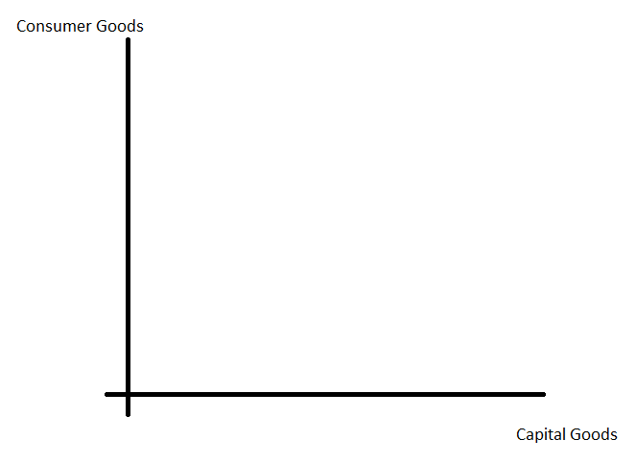

***Use your completed PPB to explain the following key terms:***

|  |  |
| --- | --- |
| Key term | Explanation |
| Inefficiency |  |
| Unattainable |  |
| Allocative efficiency |  |
| Opportunity cost |  |

***The diagrams below show two different types of PPB. Use the space below to explain the reasons for the difference between PPB 1 and PPB 2:***

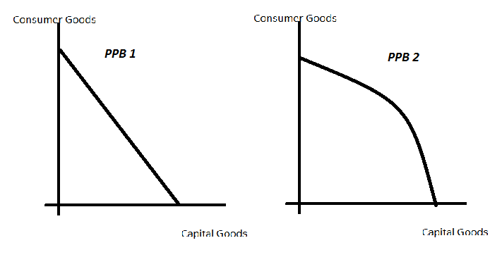

|  |
| --- |
|  |

***On the PPB below show the impacts of an increase in a PPB:***

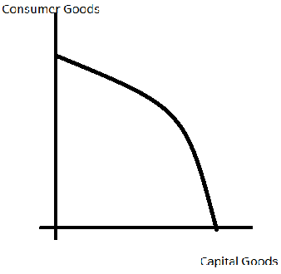

***Identify 2 reasons why a PPB might increase:***

|  |  |
| --- | --- |
| ***1)*** |  |
| ***2)*** |  |

***Explain the difference between a free good and an economic good***

|  |
| --- |
|  |

***Define the following key terms and give examples***

|  |  |  |
| --- | --- | --- |
| Key term | Explanation | Example |
| Economic activity |  |  |
| Economic problem |  |  |
| Wants |  |  |
| Needs |  |  |
| Scarcity |  |  |
| Making choices |  |  |
| Trade-offs |  |  |

***What do economists mean by an ‘economic system’?***

|  |
| --- |
|  |

***Explain the following types of economic systems:***

|  |  |
| --- | --- |
| Economic system | Explanation |
| Free market economy |  |
| Planned economy |  |
| Mixed economy |  |

***Explain the following ‘sectors of production’:***

|  |  |
| --- | --- |
| Sector of economy | Explanation |
| Primary |  |
| Secondary |  |
| Tertiary |  |
| Quaternary |  |

***Explain the differences between ‘specialisation and division of labour’***

|  |
| --- |
|  |

Define and give an example of the following:

|  |  |
| --- | --- |
| Key term | Definition and example |
| Positive statements |  |
| Normative statements (value judgements) |  |