**Topic 2) Allocation of Resources**

***Use pages 18-67 from the associated study pack to answer the following:***

***Define the following key terms:***

|  |  |
| --- | --- |
| Key term | Definition |
| Demand |  |
| Effective demand |  |
| Latent demand |  |
| Derived demand |  |

***Below shows data for a demand curve. Use the axis below to draw this demand curve:***

|  |  |
| --- | --- |
| Price | Demand |
| 10 | 4 |
| 8 | 6 |
| 6 | 8 |
| 4 | 10 |
| 2 | 12 |

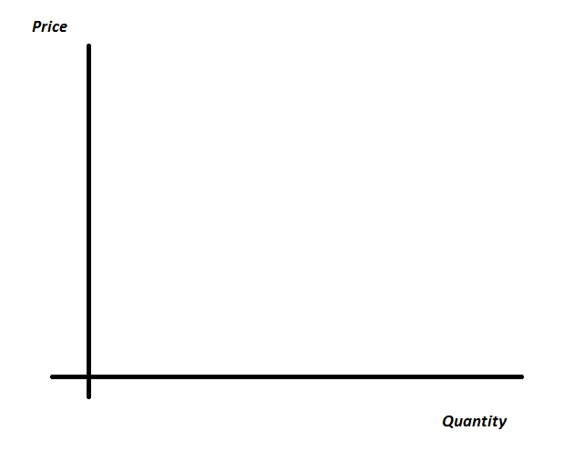

***Explain why an inverse relationship exists between price and demand***

|  |
| --- |
|  |

***On your demand curve use arrows to label the following:***

* ***Extension in demand***
* ***Contraction in demand***

***The diagram below shows an outward shift of a demand curve i.e. at the same price level there is now a higher demand:***

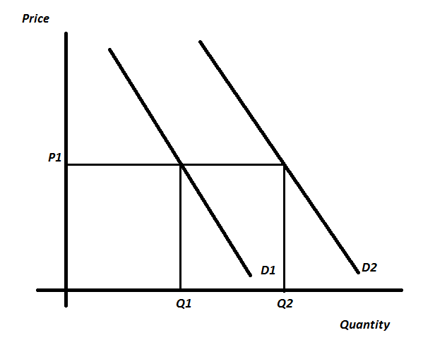

***Outline a range of causes of this outward shift in D:***

|  |  |
| --- | --- |
| Cause of outward shift in D | Explanation |
|  |  |
|  |  |
|  |  |
|  |  |
|  |  |

***Define the key term ‘supply’***

|  |
| --- |
|  |

***Below shows data for a supply curve. Use the axis provided to draw this supply curve:***

|  |  |
| --- | --- |
| Price | Supply |
| 10 | 17 |
| 8 | 14 |
| 6 | 11 |
| 4 | 8 |
| 2 | 5 |



***Explain why a positive relationship exists between price and supply***

|  |
| --- |
|  |

***On your supply curve use arrows to indicate the following:***

* ***Extension in supply***
* ***Contraction in supply***

***The diagram below shows an increase in supply i.e. at the same price level, firms are willing and able to supply more of a good/service:***

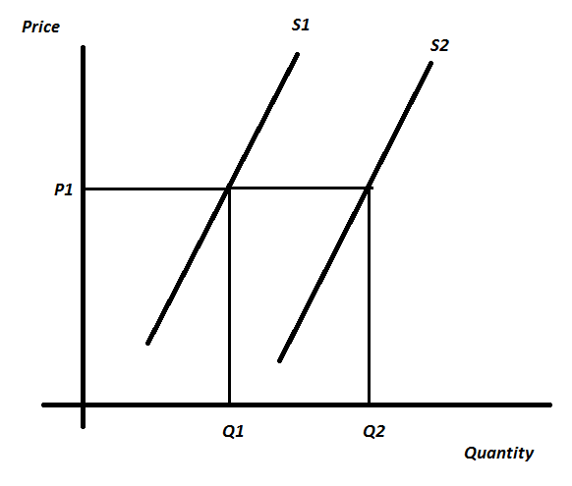

***Explain a range of possible causes of this increase in supply***

|  |  |
| --- | --- |
| Cause of outward shift in S | Explanation |
|  |  |
|  |  |
|  |  |
|  |  |

***Explain the following key terms:***

|  |  |
| --- | --- |
| Key term | Explanation |
| The invisible hand |  |
| The signalling function |  |
| The rationing function |  |

Define the following key terms:

|  |  |
| --- | --- |
| Key term | Definition |
| Derived demand |  |
| Composite demand |  |
| Joint supply |  |

***Use the data below to plot a D & S diagram. On this label the equilibrium price and quantity***

|  |  |  |
| --- | --- | --- |
| **Price** | **Demand** | **Supply** |
| 10 | 3 | 12 |
| 8 | 5 | 10 |
| 6 | 7 | 8 |
| 4 | 9 | 6 |
| 2 | 11 | 4 |



***Add an additional line to each diagram (based on the scenario below each diagram) below and label the new equilibrium point:***

