**Topic 3) Elasticity**

***Use pages 68-84 from your associated study pack to answer the following:***

***Complete the following table:***

|  |  |
| --- | --- |
| Definition of price elasticity of demand = |  |
| Formula used to calculate % change = |  |
| Formula for calculating PED = |  |
| Price inelastic demand |  |
| Price elastic demand |  |

***Use the axis below to draw a price inelastic demand curve and a price elastic demand curve:***

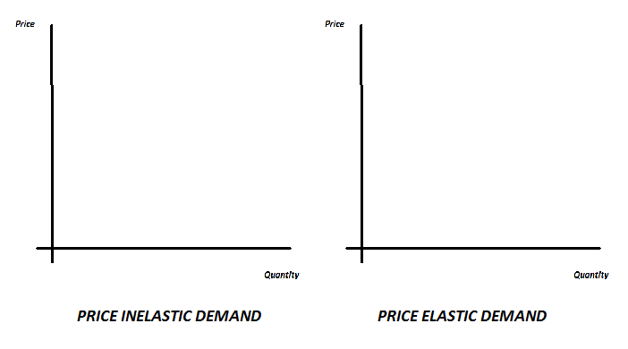

***Explain using the diagrams what a firm should do to their prices if the demand for their good/service is price inelastic? (explain your answer)***

|  |
| --- |
|  |

***Explain using the diagrams what a firm should do to their prices if the demand for their good/service is price elastic? (explain your answer)***

|  |
| --- |
|  |

***Identify and explain a range of factors which will make demand for a good/service price inelastic:***

|  |  |
| --- | --- |
| ***Factor that makes demand price inelastic*** | ***Explanation*** |
|  |  |
|  |  |
|  |  |
|  |  |

***When using the price elasticity of demand formula the results fall between -0.01 and –infinity. Based on this complete the following table:***

|  |  |
| --- | --- |
| Values from formula | What does this value mean? |
| 0 to -1 |  |
| -1 |  |
| -1 to –infinity |  |

***Define the following key terms:***

|  |  |
| --- | --- |
| Key term | Definition |
| Subsidy |  |
| Indirect tax |  |

***Use the axis below to show the impact of indirect taxes / subsidies:***

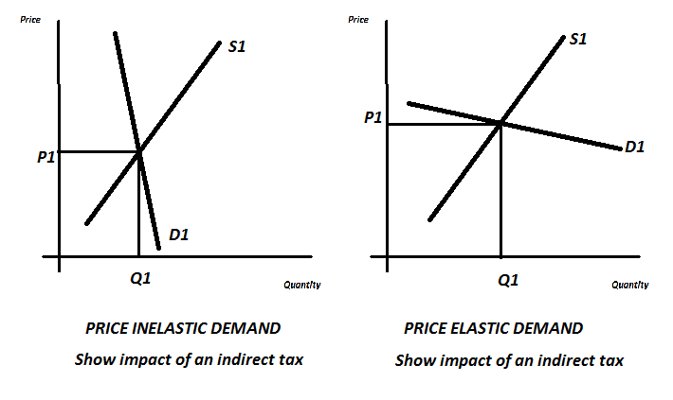

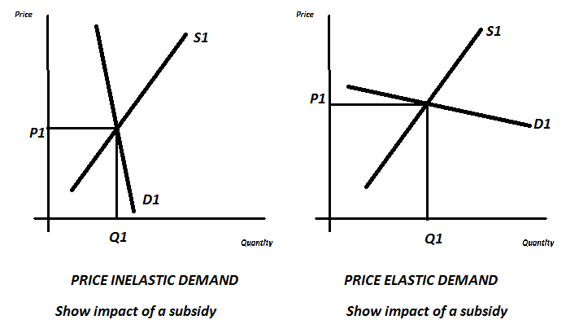

***Explain using your diagrams above when an indirect taxation would not impact on demand***

|  |
| --- |
|  |

***Explain using your diagrams above when a subsidy would have a minimal impact on demand***

|  |
| --- |
|  |

***Below shows the impact that price has on demand. Use this data to draw the demand curve for this good/service:***

|  |  |
| --- | --- |
| Price | Demand |
| 4 | 10 |
| 8 | 9 |
| 12 | 8 |
| 16 | 7 |
| 20 | 6 |

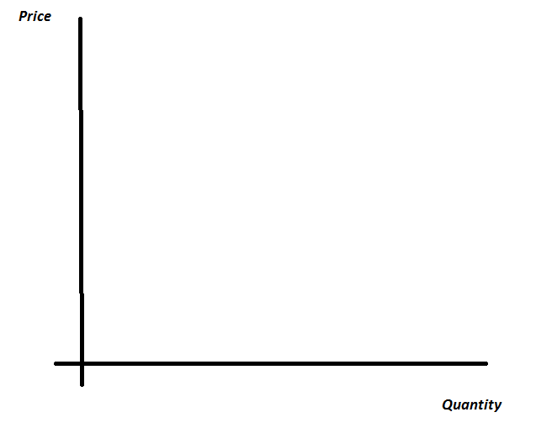

***Calculate the price elasticity of demand as price falls increases from £4 to £20 and explain what this number means (show all your workings):***

|  |
| --- |
|  |

***Explain two uses of price elasticity of demand for producers:***

|  |
| --- |
|  |
|  |

***Define the following key terms:***

|  |  |
| --- | --- |
| Key term | Definition |
| Income elasticity of demand |  |
| Income elasticity of demand formula |  |
| Normal good (and give examples) |  |
| Inferior good (and give examples) |  |

***The table below identifies the values that come out of the formula for income elasticity of demand. Explain what these values mean:***

|  |  |
| --- | --- |
| Value | Meaning |
| 0 to +1 |  |
| +1 and higher |  |
| Negative numbers |  |

***Use the case study on p77 to explain the impact on demand for a range of goods and services of the recession:***

|  |
| --- |
|  |

***Define the following key terms:***

|  |  |
| --- | --- |
| Key term | Definition |
| Cross elasticity of demand |  |
| Cross elasticity of demand formula |  |
| Complements |  |
| Substitutes |  |

***Explain the impact on the demand for good A if the price of good B increases (assume that goods A and B are substitute goods)***

|  |
| --- |
|  |

***Explain the impact on the demand for good A if the price of good B increases (assume that goods A and B are complement goods)***

|  |
| --- |
|  |

***Explain why the number generated from the cross elasticity of demand formula is positive for substitutes***

|  |
| --- |
|  |

***Explain why the number generated from the cross elasticity of demand formula is negative for complements***

|  |
| --- |
|  |

***Define the following key terms:***

|  |  |
| --- | --- |
| Key term | Definition |
| Price elasticity of supply |  |
| Price elasticity of supply formula |  |
| Price inelastic supply |  |
| Price elastic supply |  |

***The table below identifies the values that come out of the formula for price elasticity of supply. Explain what these values mean:***

|  |  |
| --- | --- |
| Value | Meaning |
| 0 to +1 |  |
| +1 |  |
| +1 to + infinity |  |

***Explain a range of factors which will make supply price inelastic:***

|  |  |
| --- | --- |
| Factors that make supply price inelastic | Explanation |
|  |  |
|  |  |
|  |  |

***Complete the diagrams below:***

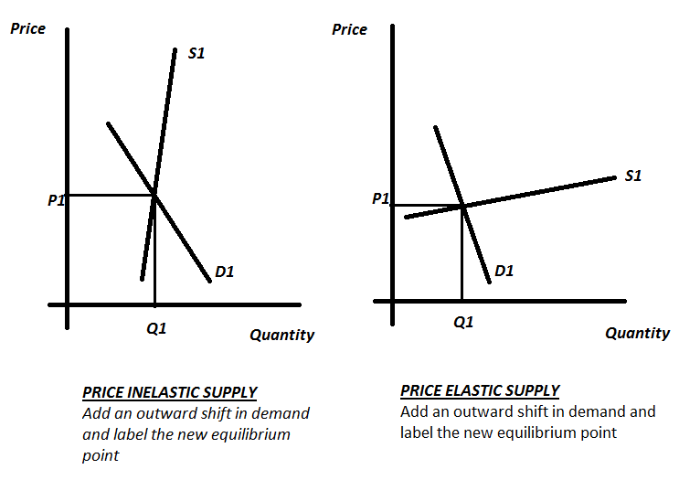

***Explain the differences and the causes of the differences of the increases in demand in the diagrams above:***

|  |
| --- |
|  |