**Topic 4) Production & Efficiency**

***Use pages 85-91 from your associated study pack to answer the following:***

***Define the following key terms:***

|  |  |
| --- | --- |
| Key term | Definition |
| Productivity |  |
| Productivity gap |  |

***Outline 3 benefits of a growth in productivity***

|  |  |
| --- | --- |
| Benefits of a growth in productivity | Explanation |
|  |  |
|  |  |
|  |  |

***Outline 3 reasons why UK has a productivity gap with countries such as France & Germany***

|  |  |
| --- | --- |
| Cause of productivity gap | Explanation |
|  |  |
|  |  |
|  |  |

***Complete the table below:***

|  |  |  |  |  |
| --- | --- | --- | --- | --- |
| Long run output level | Total Fixed Costs | Total Variable Costs | Total Costs | Long-run Average Total Costs |
| 1 | 20 | 25 |  | 45 |
| 2 |  | 20 | 40 |  |
| 3 |  | 15 |  | 11.7 |
| 4 |  | 10 |  | 7.5 |
| 5 |  | 25 |  |  |
| 6 | 20 | 40 |  |  |
| 7 |  | 55 | 75 | 10.7 |

***Plot the LRATC curve on the axis below:***

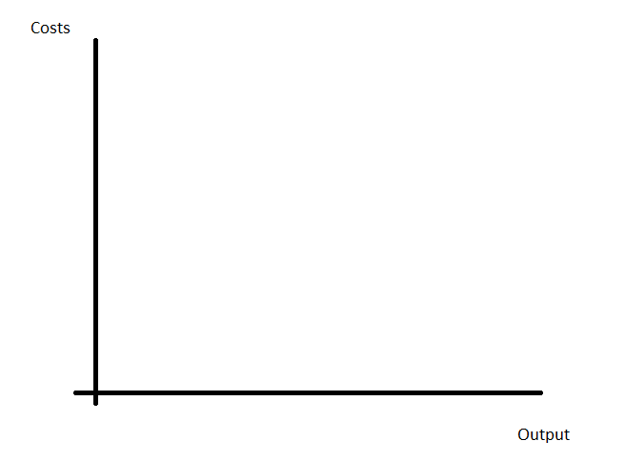

***Use arrows on your diagram to indicate where this business is experiencing:***

* ***Economies of scale***
* ***Diseconomies of scale***

***Define the following key terms:***

|  |  |
| --- | --- |
| Key term | Explanation |
| Internal economies of scale |  |
| External economies of scale |  |
| Diseconomies of scale |  |

***Explain a range of examples of economies of scale:***

|  |  |
| --- | --- |
| Economy of scale | Explanation |
|  |  |
|  |  |
|  |  |
|  |  |

***Explain a range of examples of diseconomies of scale:***

|  |  |
| --- | --- |
| Diseconomy of scale | Explanation |
|  |  |
|  |  |