**Topic 5) Market Failure**

***Use pages 92-126 from your associated study pack to answer the following:***

***Define the term ‘market failure’***

|  |
| --- |
|  |

***Define the following types of market failure:***

|  |  |
| --- | --- |
| Type of market failure | Explanation |
| Negative externalities |  |
| Positive externalities |  |
| Merit goods (imperfect information) |  |
| Demerit goods (imperfect information) |  |
| Public goods |  |
| Monopolies |  |
| Factor immobility |  |
| Equity (inequality) issues |  |

***Public good v private good – complete the table below:***

|  |  |  |
| --- | --- | --- |
|  | Private goods | Public goods |
| Excludable OR non-excludable? (explain meanings) |  |  |
| Rival OR non-rival? (explain meanings) |  |  |
| Rejectable OR non-rejectable? (explain meanings) |  |  |

***Identify a range of examples of public goods***

|  |
| --- |
|  |

***Explain the differences between a public good and a quasi-public good***

|  |
| --- |
|  |

***Explain why public goods are regarded as a ‘market failure’***

|  |
| --- |
|  |

***What do economists mean by a ‘public bad’?***

|  |
| --- |
|  |

***Explain the key term ‘information failure’***

|  |
| --- |
|  |

***Explain 3 examples of information failure:***

|  |  |
| --- | --- |
| Example of information failure | Explanation |
|  |  |
|  |  |
|  |  |

***Explain using examples the key term ‘asymmetric information’***

|  |
| --- |
|  |

***Explain using examples what economists mean by a ‘merit good’***

|  |
| --- |
|  |

***Define the following key terms:***

|  |  |
| --- | --- |
| Key term | Definition |
| Marginal private benefits (MPB) |  |
| Marginal external benefits (MEB) |  |
| Marginal social benefits (MSB) |  |

***Complete the table below:***

|  |  |  |  |
| --- | --- | --- | --- |
| Quantity | MPB | MEB | MSB |
| 1 | 10 | 5 |  |
| 2 | 8 | 4 |  |
| 3 |  | 3 | 9 |
| 4 | 4 | 2 |  |
| 5 | 2 | 1 |  |

***Use the axis below to plot the MPB and MSB lines:***

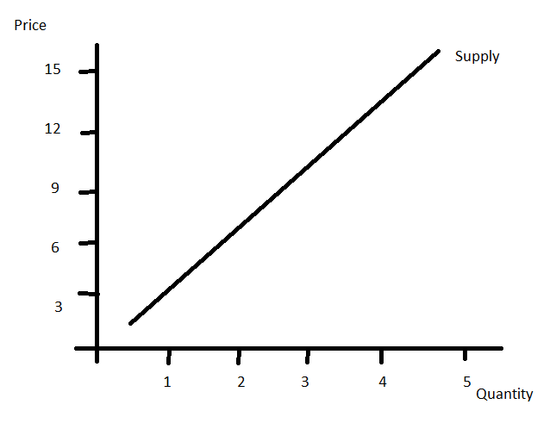

***On your diagram indicate the following:***

* ***Private optimum output***
* ***Social optimum output***
* ***Welfare loss triangle***

***Why are merit goods regarded as a market failure?***

|  |
| --- |
|  |

***Explain using examples what economists mean by a ‘demerit good’***

|  |
| --- |
|  |

***Define the following key terms:***

|  |  |
| --- | --- |
| Key term | Definition |
| Marginal private costs (MPC) |  |
| Marginal external costs (MEC) |  |
| Marginal social costs (MSC) |  |

***Complete the table below:***

|  |  |  |  |
| --- | --- | --- | --- |
| Quantity | MPC | MEC | MSC |
| 1 | 2 | 1 |  |
| 2 | 4 | 2 |  |
| 3 | 6 | 3 |  |
| 4 | 8 | 4 |  |
| 5 |  | 5 | 15 |

***Use the axis below to plot the MPC and MSC lines:***

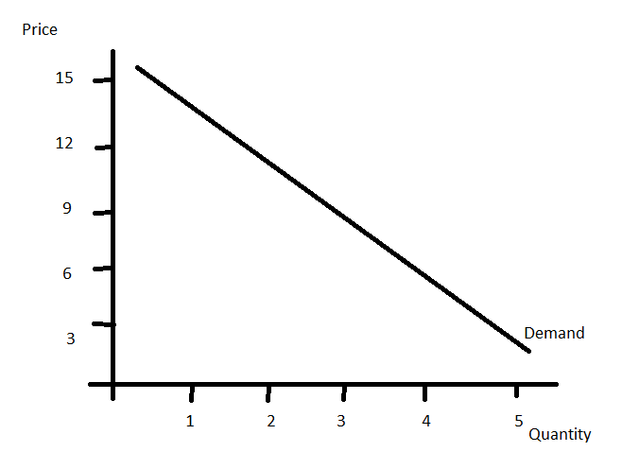

***On your diagram indicate the following:***

* ***Private optimum output***
* ***Social optimum output***
* ***Welfare loss triangle***

***Why are demerit goods regarded as a market failure?***

|  |
| --- |
|  |

***Explain using examples the key term ‘positive externalities’;***

|  |
| --- |
|  |

***Why are positive externalities regarded as a market failure?***

|  |
| --- |
|  |

***Use the axis below to draw a diagram which demonstrates positive externality market failure***

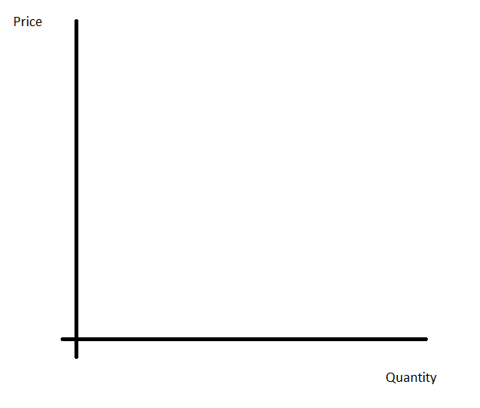

***Explain using examples the key term ‘negative externalities’***

|  |
| --- |
|  |

***Explain the following key terms:***

|  |  |
| --- | --- |
| Key term | Explanation |
| Property rights |  |
| Tragedy of the Commons |  |
| External costs from production |  |
| External costs from consumption |  |

***Use the axis below to draw a diagram which demonstrates negative externality market failure***



***Explain the meanings of the following key terms:***

|  |  |
| --- | --- |
| Key term | explanation |
| Occupational immobility |  |
| Geographical immobility |  |

***Explain the differences between a ‘working monopoly’ and a ‘pure monopoly’***

|  |
| --- |
|  |

***Define the key term ‘barriers to entry’***

|  |
| --- |
|  |

***Outline a range of examples of barriers to entry***

|  |  |
| --- | --- |
| Barrier to entry | Explanation |
|  |  |
|  |  |
|  |  |
|  |  |

***Is a monopoly good or bad?***

|  |  |
| --- | --- |
| Benefits of monopoly | Drawbacks of monopoly |
|  |  |

***Explain the following:***

|  |  |
| --- | --- |
| Area for explanation | Explanation |
| Absolute poverty |  |
| Relative poverty |  |
| Unequal distribution of income and wealth |  |
| Poverty trap |  |

***Look back over pages 92 -126 to complete the following table on market failure and government interventions:***

|  |  |  |  |
| --- | --- | --- | --- |
| Market failure | Explanation of market failure | Examples | Possible government intervention strategies |
| Public goods (p93-95) |  |  |  |
| Merit goods (p98-99) |  |  |  |
| Demerit goods (p100-103) |  |  |  |
| Positive externalities (p110-112) |  |  |  |
| Negative externalities (p110-112) |  |  |  |
| Factor immobility (p114) |  |  |  |
| Monopoly (p122-123) |  |  |  |
| Poverty and inequality (p126) |  |  |  |