**Topic 6) Government intervention & Government failure**

***Use pages 127-153 from your associated study pack to answer the following:***

***What is lasissez faire economics?***

|  |
| --- |
|  |

***What is government intervention and why do governments intervene in markets?***

|  |
| --- |
|  |

***Government regulation is one form of intervention. Outline a range of examples of regulation within markets***

|  |  |
| --- | --- |
| Example of regulation | Explanation |
|  |  |
|  |  |
|  |  |
|  |  |

***Direct state provision of goods and services is another form of government intervention. Explain what this means and why it might be better for the state to own certain industries rather than private firms***

|  |
| --- |
|  |

***Identify 3 examples of state ownership***

|  |  |
| --- | --- |
| Example of state ownership | Explanation |
|  |  |
|  |  |
|  |  |

Fiscal policy is another form of intervention. Explain how the following can be used to correct market failure:

|  |  |
| --- | --- |
| Fiscal policy intervention | Explanation |
| Indirect taxes |  |
| Subsidies |  |
| Tax relief |  |
| Welfare payments |  |

***Complete the diagrams below:***

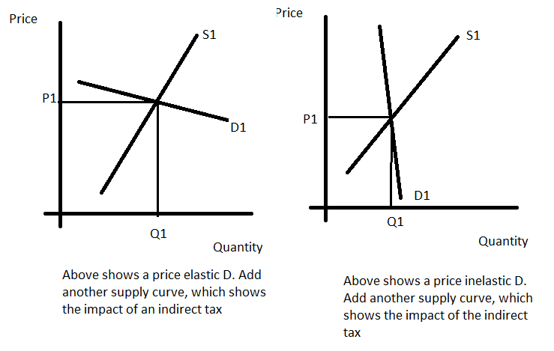

***Use your diagrams to explain when the imposition of an indirect tax would have very little impact on demand and when it would have a large impact on demand***

|  |
| --- |
|  |

***Complete the diagrams below:***

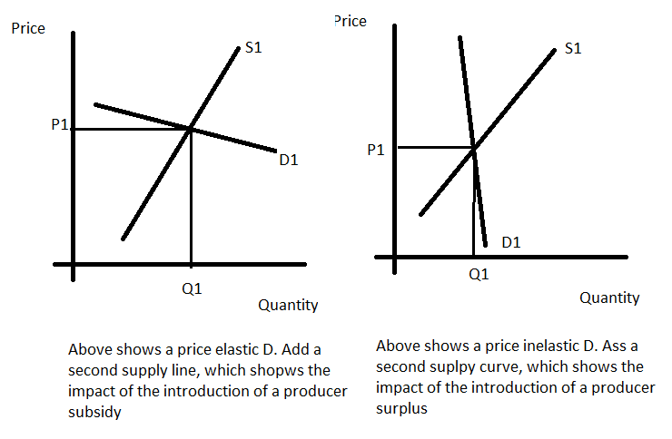

***Use your diagrams to explain when the imposition of a producer subsidy would have very little impact on demand and when it would have a large impact on demand***

|  |
| --- |
|  |

***Explain using examples a range of intervention strategies which can be used to close information gaps i.e. solve merit good and demerit good market failures***

|  |  |
| --- | --- |
| Method of closing information gap | Explanation |
|  |  |
|  |  |
|  |  |
|  |  |

***Explain using a diagram and examples how a minimum price (price floor)is used within certain markets***

|  |
| --- |
|  |

***Explain using a diagram and examples how a maximum price (price ceiling) is used within certain markets***

|  |
| --- |
|  |

Explain using a diagram and examples how Buffer Stock Schemes are used as a form of government intervention

|  |
| --- |
|  |

***Define the key term ‘government failure’***

|  |
| --- |
|  |

***Explain using examples a range of examples of government failure***

|  |  |
| --- | --- |
| Government failure | Explanation and examples |
|  |  |
|  |  |
|  |  |
|  |  |

***Look back over pages 92 -126 to complete the following table on market failure and government interventions:***

|  |  |  |  |
| --- | --- | --- | --- |
| Market failure | Explanation of market failure | Examples | Possible government intervention strategies |
| Public goods (p93-95) |  |  |  |
| Merit goods (p98-99) |  |  |  |
| Demerit goods (p100-103) |  |  |  |
| Positive externalities (p110-112) |  |  |  |
| Negative externalities (p110-112) |  |  |  |
| Factor immobility (p114) |  |  |  |
| Monopoly (p122-123) |  |  |  |
| Poverty and inequality (p126) |  |  |  |