**Aggregate Demand**

***Author****:* [*Geoff Riley*](http://www.tutor2u.net/blog/index.php/site/author/3/)***Last updated:*** *Sunday 23 September, 2012*

**Introduction**

Aggregate means **‘total’** and in this case we use the term to measure how much is being spent by all consumers, businesses, the government and people and firms overseas.

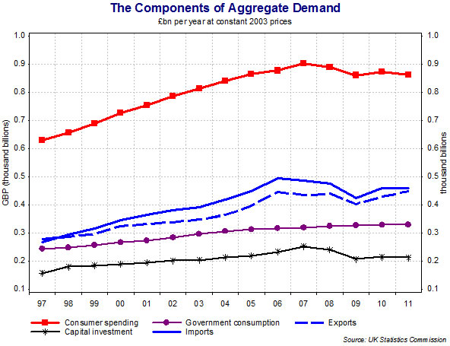

[Aggregate demand](http://www.tutor2u.net/blog/index.php/economics/C214/) (AD) = total spending on goods and services

**AD = C + I + G + (X-M)**

* **C:** **[Consumers' expenditure on goods and services](http://www.tutor2u.net/blog/index.php/economics/C217/)** : Also known as consumption, this includes demand for durables e.g. audio-visual equipment and motor vehicles & non-durable goods such as food and drinks which are “consumed” and must be re-purchased.
* **I:** [Capital Investment](http://www.tutor2u.net/blog/index.php/economics/C222/) – This is spending on capital goods such as plant and equipment and buildings to produce more consumer goods in the future. Investment also includes spending on working capital such as stocks of finished and semi-finished goods.
* Capital investment spending in the UK accounts for between 16-20% of GDP in any given year. Of this investment, 75% comes from private sector businesses such as Tesco, British Airways and British Petroleum and the remainder is spent by the government – for example building new schools or in improving railway or road networks. So a mobile phone company such as O2 spending £100 million on extending its network capacity and the government allocating £15 million of funds to build a new hospital are both capital investment. Investment has important effects on the [supply-side](http://www.tutor2u.net/blog/index.php/economics/C67/) as well as being an important component of AD. A small part of investment spending is the change in the value of stocks –i.e. unsold products. Producers may find either than demand is running higher than output (i.e. stocks will fall) or that demand is weaker than expected and less than current output (in which case the value of unsold stocks will rise.)

* **G:** [Government Spending](http://www.tutor2u.net/blog/index.php/economics/C46/) – This is spending on state-provided goods and services including [public goods](http://www.tutor2u.net/blog/index.php/economics/C171/) and [merit goods](http://www.tutor2u.net/blog/index.php/economics/C169/) . Decisions on how much the government will spend each year are affected by developments in the economy and the political priorities of the government.
* Government spending on goods and services is around 18-20% of GDP but this tends to understate the true size of the government sector in the economy. Firstly some spending is on investment and a sizeable slice goes on welfare state payments. Transfer payments in the form of benefits (e.g. state pensions and the job-seekers allowance) are not included in current government spending because they are a transfer from one group (i.e. people in work paying income taxes) to another (i.e. pensioners drawing their state pension having retired from the labour force, or families on low incomes).
* **X:** [Exports](http://www.tutor2u.net/blog/index.php/economics/tagged/tag/exports/) **of goods and services** - Exports sold overseas are an inflow of demand (an injection) into our circular flow of income and spending adding to aggregate demand.
* **M: Imports of goods and services**. Imports are a withdrawal of demand (a leakage) from the circular flow of income and spending.

* [Net exports](http://www.tutor2u.net/blog/index.php/economics/C58/) measure the value of exports minus the value of imports. When net exports are positive, there is a trade surplus (adding to AD); when net exports are negative, there is a trade deficit (reducing AD). The UK has been running a large trade deficit for several years now.

**Aggregate Demand in the UK Economy**

*All of the data above is expressed in £ billion at constant prices*

*Source: Office for National Statistics, Economic Trends 2011*

The main components of aggregate demand are shown in the table above  
Remember that  
**AD = C + I + G + X – M**

The change in the value of stocks is a small component of the equation, it relates to changes in how much investment businesses are making in stocks (unsold products) to be consumed at a later stage.

* **Recession:** 2009 was a year of recession – what happened to each of the components of aggregate demand in 2009 compared to 2008?
* **Recovery:** The British economy started to recover in 2010; using the table can you explain why this happened?

[**Shocks**](http://www.tutor2u.net/blog/index.php/economics/C207/) **to aggregate demand**

* Many unexpected events can happen which causes changes in the level of **demand, output and employment**
* Headwinds can alter direction with great speed leading to uncertainty about where the economy is heading
* These events are called **“shocks”**. Some of the causes of AD shocks are as follows:
* A big **rise or fall in the exchange rate** – affecting export demand and having follow-on effects on output, employment, incomes and [profits](http://www.tutor2u.net/blog/index.php/economics/tagged/tag/profits/) of businesses linked to export industries.
* A [recession](http://www.tutor2u.net/blog/index.php/economics/tagged/tag/recession/) **in one or more of our main trading partners** which affects demand for our exports of goods and services.
* A slump in the **housing market** or a big change in share prices.
* An event such as the [credit crunch](http://www.tutor2u.net/blog/index.php/economics/C204/) (global financial crisis) – involving a fall in the amount of credit available for borrowing by households and businesses.
* An unexpected cut or an unexpected rise in [interest rates](http://www.tutor2u.net/blog/index.php/economics/tagged/tag/interest+rates/) or change in government **taxation** and spending – for example the shock of deep cuts in state spending expected in 2011 and beyond.

These shocks will bring about a **shift in the aggregate demand curve** – and we turn to this next.

**The Aggregate Demand Curve**

The AD curve shows the relationship between the general price level and real GDP.

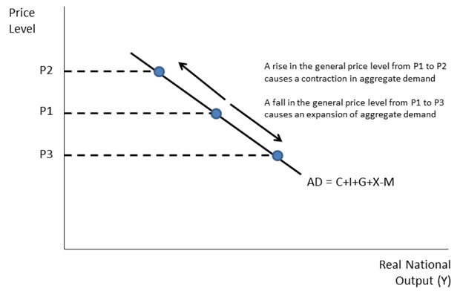

**Aggregate Demand and the Price Level**

There are several explanations for an inverse relationship between AD and the price level in an economy. These are summarised below:

* **Falling real incomes:** As the price level rises, so the real value of people’s incomes fall and consumers are less able to buy the items they want or need. If over the course of a year all prices rose by 10 per cent whilst your money income remained the same, your real income would have fallen by 10%
* **The balance of trade:** A persistent rise in the price of level of Country X could make foreign-produced goods and services cheaper in price terms, causing a fall in exports and a rise in imports. This will lead to a reduction in net trade and a contraction in AD
* **Interest rate effect:** if the price level rises, this causes inflation and an increase in the demand for money and a consequential rise in interest rates with a deflationary effect on the economy. This assumes that the central bank (in our case the Bank of England) is setting interest rates in order to meet a specified inflation target

**Shifts in the AD Curve**

* A change in the factors affecting any one or more **components of aggregate demand** i.e. households (C), firms (I), the government (G) or overseas consumers and business (X) changes planned spending and results in a shift in the AD curve.

Consider the diagram below which shows an inward shift of AD from AD1 to AD3 and an outward shift of AD from AD1 to AD2. The increase in AD might have been caused for example by a fall in interest rates or an increase in consumers’ [wealth](http://www.tutor2u.net/blog/index.php/economics/tagged/tag/wealth/) because of rising house prices.

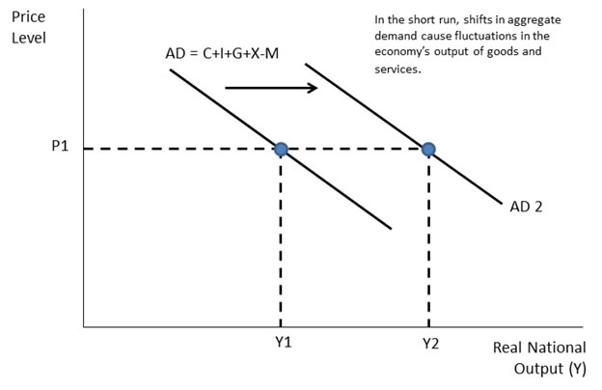

|  |  |
| --- | --- |
| **Factors causing a shift in AD** | |
| **Changes in Expectations**  *Current spending is affected by anticipated income and inflation* | *The expectations of consumers and businesses* have a powerful effect on spending  When confidence falls, we see an increase in saving and businesses postpone investment projects because of worries over weak demand and lower expected [profits](http://www.tutor2u.net/blog/index.php/economics/tagged/tag/profits/). |
| **Changes in Monetary Policy** – i.e. a change in [interest rates](http://www.tutor2u.net/blog/index.php/economics/tagged/tag/interest+rates/) | If interest rates fall – this lowers the cost of borrowing and the incentive to save, encouraging consumption. Lower interest rates encourage firms to borrow and invest  There are **time lags** between changes in interest rates and the changes in aggregate demand. |
| **Changes in Fiscal Policy** *Fiscal Policy refers to changes in government spending, welfare benefits and taxation, and the amount that the government borrows* | The Government may increase its expenditure e.g. financed by a higher [**budget deficit**](http://www.tutor2u.net/blog/index.php/economics/tagged/tag/budget+deficit/) - this directly increases AD  Income tax affects disposable income e.g. lower rates of income tax raise disposable income and should boost consumption.  An increase in transfer payments increases AD – particularly if welfare recipients spend a high % of the benefits they receive. |
| **Economic events in the international economy** *International factors such as the exchange rate and foreign income (e.g. the economic cycle in other countries)* | A fall in the value of the pound (£) (a [depreciation](http://www.tutor2u.net/blog/index.php/economics/tagged/tag/depreciation/)) makes imports dearer and exports cheaper - the net result should be that UK AD rises  The impact depends on the price elasticity of demand for imports and exports and also the elasticity of supply of UK exporters in response to exchange rate depreciation.  An increase in overseas incomes raises demand for exports. In contrast a [recession](http://www.tutor2u.net/blog/index.php/economics/tagged/tag/recession/) in a major export market will lead to a fall in exports and an inward shift of aggregate demand. |
| **Changes in household wealth** *Wealth is the  value of assets owned e.g. houses and shares* | A fall in the value of share prices or a slump in the housing market can lead to a decline in household financial wealth and a fall in consumer demand  Declining asset prices also have a negative effect on consumer confidence / a fall in expectations |
| **Changes in the supply of credit** | The availability of credit is vital for the smooth functioning of most modern economies  We have seen in recent years how the bursting of the credit bubble in countries such as the UK and the USA has created many problems for businesses and individuals  Many banks and other lenders are now more reluctant to lend  Interest rates on different loans have become more expensive  Instead of taking out new loans, in recent times businesses have been paying back debt. In the 5 years before the financial crisis UK companies borrowed £107m from banks every day. Since then they've been repaying £5.8m a day. |