**Aggregate Supply**

***Author****:* [*Geoff Riley*](http://www.tutor2u.net/blog/index.php/site/author/3/)***Last updated:*** *Sunday 23 September, 2012*

**Introduction**

**What do we mean by aggregate supply?**

[**Aggregate supply**](http://www.tutor2u.net/blog/index.php/economics/C215/) (AS) measures the **volume of goods and services** produced within the economy at a given price level.

AS represents the ability of an economy to deliver goods and services to meet demand

The nature of this relationship will differ between the long run and the short run

1. **Short run aggregate supply (SRAS)** shows total **planned output** when prices in the economy can change but the prices and productivity of all factor inputs e.g. wage rates and the state of technology are held constant.
2. **Long run aggregate supply (LRAS):**  LRAS shows total planned output when both prices and average wage rates can change – it is a measure of a country’s potential output and the concept is linked to the **production possibility frontier**

**In the long run**, the LRAS curve is assumed to be vertical (i.e. it does not change when the general price level changes)

**In the short run**, the SRAS curve is assumed to be upward sloping (i.e. it is responsive to a change in aggregate demand reflected in a change in the general price level)

**The short run aggregate supply curve**

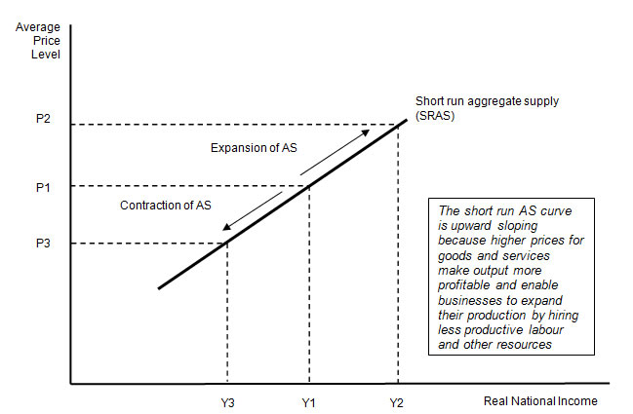

A change in the price level brought about by a shift in AD results in a *movement along* the short run AS curve. If AD rises, we see an **expansion** of SRAS; if demand falls we see a **contraction** of SRAS.

**Shifts in Short Run Aggregate Supply (SRAS)**

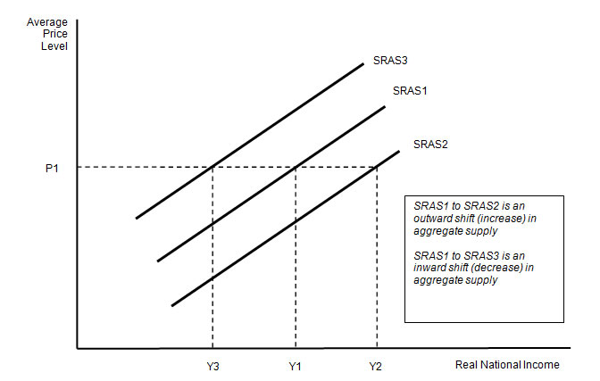

The main cause of a shift in the supply curve is a **change in business costs** – for example:

* **Changes in unit labour costs**: Unit labour costs are **wage costs** adjusted for the level of productivity. A rise in unit labour costs might be brought about by firms paying higher wages or a fall in the level of productivity
* [**Commodity prices**](http://www.tutor2u.net/blog/index.php/economics/C198/)**:** Changes to raw material costs and other components e.g. the prices of oil, copper, rubber, iron ore, aluminium and other inputs will affect a firm’s costs
* **Exchange rates:** Costs might be affected by a change in the exchange rate which causes fluctuations in the prices of imported products. A fall ([depreciation](http://www.tutor2u.net/blog/index.php/economics/tagged/tag/depreciation/)) in the **exchange rate** increases the costs of importing raw materials and component supplies from overseas
* **Government taxation and subsidies:**
  1. An increase in taxes to meet environmental objectives will cause higher costs and an inward shift in the SRAS curve
  2. Lower duty on petrol and diesel would lower costs and cause an outward shift in SRAS
* **The price of imports**:
  1. Cheaper imports from a lower-cost country has the effect of shifting out SRAS
  2. A reduction in a tariff on imports or an increase in the size of an import quota will also boost the supply available at each price level
  3. The exchange rate affects how much a business must pay for imported raw materials and components

**Long Run Aggregate Supply (LRAS)**

In the long run, the ability of an economy to produce goods and services to meet demand is based on the **state of production technology** and the **availability and quality of factor inputs**.

**Growth and size of economy**

*“Seemingly small differences in growth rates can have a large impact over a period of many years. For example, if an economy grew by 2 per cent every year, it would double in size within 35 years; if it grew at 2½ per cent a year, it would double in size after 28 years - seven years earlier”*

*Source: UK Treasury*

A long run production function for a country is often written as follows:

**Y*t = f (Lt, Kt, Mt)**

* Y* is a measure of **potential output**
* t is the **time period**
* L represents the **quantity and ability of labour input** available
* Kt represents the **available capital stock**
* Mt represents the **availability of natural resources**

LRAS is determined by the **stock of a country’s resources** and by the **productivity of factor inputs** (labour, land and capital). Changes in the **technology** also affect potential real national output.

**Causes of shifts in the long run aggregate supply curve**

Any change in the economy that alters the **natural rate of growth of output** shifts LRAS. Improvements in productivity and efficiency or an increase in the stock of capital and labour resources cause the LRAS curve to shift out. This is shown in the diagram below.

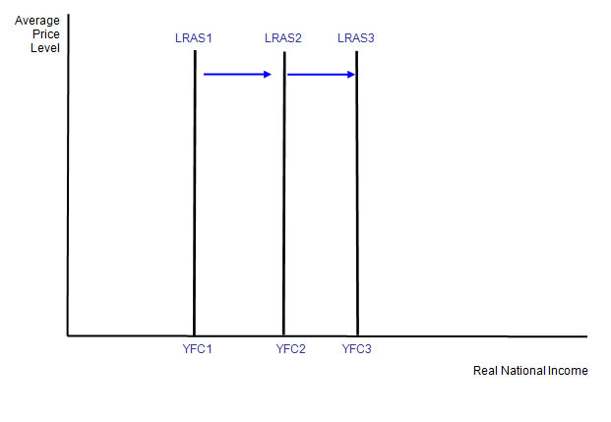

**Policies to increase LRAS**



1. **Expanding the labour supply** - e.g. by **improving work incentives** and relaxing controls on **inward labour migration**. In the long term many countries must find ways of overcoming the effects of an **ageing population and a rising ratio of dependents to active workers**
2. **Increase the productivity of labour** – e.g. by investment in training of the labour force and improvements in the quality of management of human resources. Productivity can be measured in several ways including output per person employed and output per hour worked
3. **Improve mobility of labour** to reduce certain types of unemployment for example structural unemployment caused by occupational [immobility](http://www.tutor2u.net/blog/index.php/economics/tagged/tag/labour+immobility/) of labour. If workers have more skills and flexibility, they will find it easier to get work. Conversely when unemployment remains high, the economy loses out on potential output and there is a waste of scarce resources
4. **Expanding the capital stock** – i.e. increase investment and research and development
5. **Increase business efficiency** by promoting greater competition within markets
6. **Stimulate invention and innovation** – to promote lower costs and improvements in the **dynamic efficiency** of markets. Innovation creates new goods and services and encourages investment

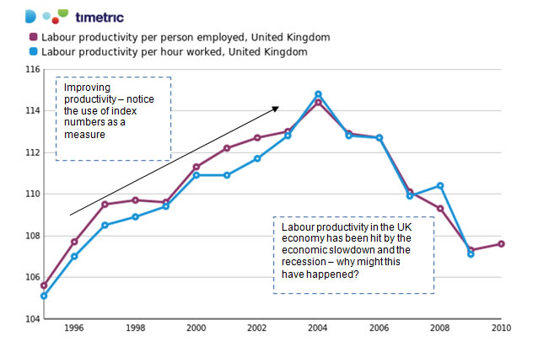

For most advanced nations it is the growth of productivity that is critical to raising the long term growth of real GDP. Our chart above tracks an index of labour productivity in the UK and shows that, after a period of strong growth from the mid 1990s inwards, productivity improvements stalled. Can this be reversed now that the economy is trying to sustain a recovery?  
**Aggregate Supply Shocks**

Aggregate supply shocks might occur when there is

A sudden rise in **oil prices** or other essential inputs such as foodstuffs used in food-processing industries. Foodstuffs are an example of intermediate products – items that are used up in manufacturing goods for consumers to buy

***Vulnerable economies***  
*“The inter-connectedness of the global economy makes it more vulnerable to major shocks......these shocks include cyber attacks, pandemics, geomagnetic storms, social unrest and financial crises.”*

*Source: OECD Report on Future Global Shocks, June 2011*

The invention and diffusion of a **new production technology**

* A major change in the movement of **migrant workers** from one economy to another

[**Shocks**](http://www.tutor2u.net/blog/index.php/economics/C207/) **and long run aggregate supply**

* The effects of [supply-side](http://www.tutor2u.net/blog/index.php/economics/C67/) shocks are normally to cause a shift in the SRAS curve. For example changes in the world prices of foodstuffs, oil and gas and minerals.
* There are occasions when changes in production technologies or step-changes in the productivity of factors of production that were not expected, feed through into a shift in the long run aggregate supply curve.
* Natural disasters and political conflicts including civil wars can also have a significant effect on a country’s productive potential and therefore affect the LRAS although it is often difficult to measure accurately just how damaging these events have been.

An example of volatile commodity prices – the US dollar price of Brent Crude Oil

