**Capital Investment**

***Author****:* [*Geoff Riley*](http://www.tutor2u.net/blog/index.php/site/author/3/)***Last updated:*** *Sunday 23 September, 2012*

**Introduction**

**Investment** is spending on **capital goods** such as new factories & other buildings machinery & vehicles

Much new investment includes advances in **technology**

Investment is an important **component of AD**, and is a factor affecting **competitiveness** of a country in a globalising world

In market economies, most investment is done by **private sector businesses** but a substantial amount of new capital is purchased by the **government** (state sector)

A broader definition of investment includes spending on **improving the** [**human capital**](http://tutor2u.net/blog/index.php/economics/tagged/tag/human+capital/) **of the workforce** through **training and education** to improve the skills and competences of workers

[**Infrastructure**](http://www.tutor2u.net/blog/index.php/economics/tagged/tag/infrastructure/) is spending on new sewers, roads, wind farms, telecommunications networks and ports – this can be done by the private and the public sector

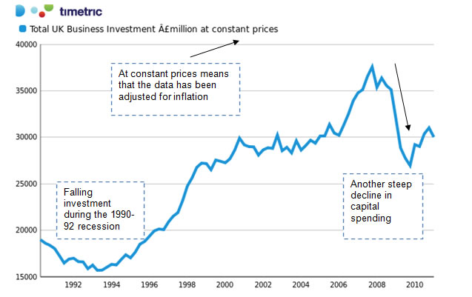

**Gross and Net Investment**

* **Gross investment** spending is the total amount that the economy spends on new capital. But this figure includes an estimate for the value of **capital depreciation** since some investment is needed each year just to replace technologically obsolete or worn-out plant and machinery.
* If gross investment is higher than depreciation, then **net investment** will be positive and this means that businesses will have a higher **productive capacity** and can meet rising demand in the future
* G*ross investment – capital depreciation = net investment*

**Analysing the Economic Importance / Significance of** [**Capital Investment**](http://www.tutor2u.net/blog/index.php/economics/C222/)

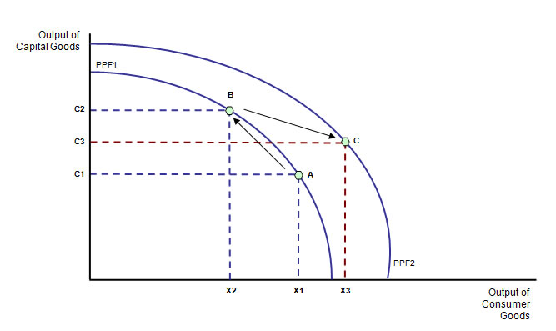

**Example: Economic effect of investment**

*“The point of investment is to improve the capacity of the economy to improve its productivity, and to capture the gains from technical improvement that happen almost naturally. The delivery van of today is quicker, more economical to run, and generally more productive than its counterparts from the past – and cheaper with it.”*

*That is progress, but you take advantage of that only if you invest in a new fleet of vans. Investment thus means enjoying better human and physical capital, and having improved ways of putting it to work. It means new machinery and plant; new laptops; new and more powerful web servers; more efficient and greener power generation; better infrastructure such as road, rail and airports.”*

*Source: Sean Kelly, Independent, 2011*

In the short run, devoting more of a country’s resources to investment might require a reduction in today’s output of consumer goods and services. This would be shown by a movement along the PPF from point A to B.

* But if the investment is successful and leads to an increase in a country’s **productive capacity** then the PPF can shift out and allow an increased output of consumption goods to meet people’s needs and wants in the future. This is shown by a movement from point B to point C which lies on the new PPF.

Businesses often invest in new capital goods to exploit **economies of large scale production**. This, together with **technological advances** is vital to improving **competitiveness** and to causing a shift in the **production possibility frontier**.

**Investment and Aggregate Demand**

* Investment is a component of AD i.e. (C+I+G+X-M). Businesses involved in developing, [manufacturing](http://www.tutor2u.net/blog/index.php/economics/C212/), testing, distributing and marketing the capital goods themselves stand to benefit from increased orders for new plant and machinery.

A rise in capital spending will have important effects on both the demand and supply-side – including a positive [**multiplier effect**](http://www.tutor2u.net/blog/index.php/economics/tagged/tag/multiplier+effect/) on national income.

* **Demand side effects**: Increase spending on capital goods boosts demand for industries that manufacture the technology / hardware / construction sector
* **Supply side effects:** Investment is linked to higher productivity, an expansion of a country’s productive capacity, a reduction in unit costs (e.g. through the exploitation of economies of scale) – and therefore a source of an increase in potential national output

**Investment and** [**jobs**](http://www.tutor2u.net/blog/index.php/economics/tagged/tag/jobs/)

* Some investment projects cost people their jobs – this is true when a business is looking to achieve **greater efficiency** and cost savings perhaps by replacing labour with capital inputs.
* Most new investment creates **fresh demand** for workers in producing, designing and installing new plant and equipment and in working with

**Capacity, costs and competitiveness**

* One way to remember the importance of investment is to consider the 3 Cs - **capacity, costs and competitiveness**
* Higher investment should allow businesses to lower their production costs per unit, increase their supply capacity and become more competitive in overseas markets.

**Quality of investment**

* A high level of investment on its own may not be sufficient to create an increase in LRAS  since workers need training to work the new machinery and there will be **time lags** between new capital spending and the effects on output and productivity.
* If there is insufficient demand, a growing capital stock may lead to **excess capacity** putting downward pressure on prices and [profits](http://www.tutor2u.net/blog/index.php/economics/tagged/tag/profits/)

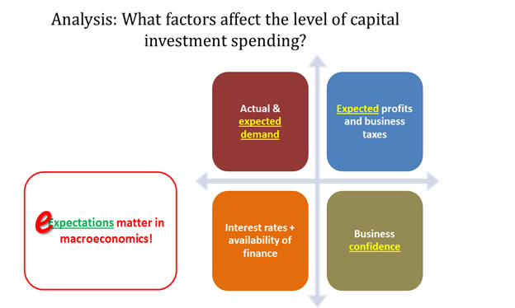

What are the main factors that affect how much businesses can commit to investment projects?

1. [**Interest rates**](http://www.tutor2u.net/blog/index.php/economics/tagged/tag/interest+rates/):
   1. If the rate of interest increases, the cost of funding investment increases, lowering the expected rate of return on a capital project
   2. Higher interest rates raise the **opportunity cost** of using [profits](http://www.tutor2u.net/blog/index.php/economics/tagged/tag/profits/) to finance investment – i.e. a business might decide that they can earn a better return by simply investing the cash
2. **Risk**: Committing money to a project involves taking a risk for no business can be certain that a given project will succeed and bring about a profit. When risk and uncertainty is high for example during times of volatility then business investment spending may fall
3. **The rate of growth of demand**: Investment tends to be stronger when consumer spending is rising. Higher expected sales also increase **potential profits** – in other words, the [**price mechanism**](http://www.tutor2u.net/blog/index.php/economics/C226/) should allocate extra funds and factor inputs towards capital goods into those markets where consumer demand is rising.
4. **Corporate taxes** **and other government policies**
   1. Corporation tax is paid depending on the level of business profits. If the government reduces the rate of corporation tax there is a greater incentive to invest.
      1. The main rate of corporation tax in the UK has been reduced from 28% in 2010 to 23% in 2013
      2. The Small Profits Corporation Tax Rate can be claimed by qualifying companies with profits at a rate not exceeding £300,000 per year. This tax rate has come down from 21% to 20%
5. **Technological change and degree of market competition:** In markets where technological change is rapid, companies may have to invest simply to remain competitive.  A good example is the intense competition in the markets for smart-phones.
6. **Business confidence:** When confidence is strong then planned investment will rise. In contrast, during a downturn many businesses may postpone investment because they feel that demand will not be high enough to give them the rate of profit they need.
7. **Social costs and benefits**: In the public (government) sector, a different set of criteria may be used. Typically local and central government will use **cost-benefit analysis** when assessing the likely economic and social effects of investment; this is often used for infrastructure projects.

**Capital investment in the UK economy – measured as a share of GDP**

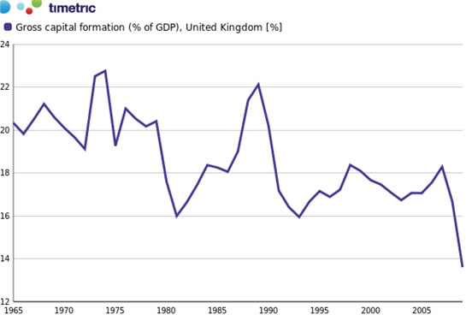

**Key reasons for the fall in investment during the recession**

1. **Sharply weakening demand** – the result of a slump in domestic and external demand for goods and services, for example a dip in export sales overseas
2. **Rising levels of spare capacity** – falling demand means less capacity was being fully used
3. **Worsening cash flows** – many businesses struggled to generate cash as demand tailed away, they have less spare funds available for investment
4. **Tight credit conditions** – lines of funding for investment became frozen or more expensive because of the credit crunch – hitting investment by smaller and medium sized businesses
5. **Deteriorating profitability** – the recession cut profit margins in many industries
6. **Weak confidence:** Concerns about the potential length and depth of the recession – leading to a decline in business confidence.