**Introduction to Macroeconomics**

***Author****:* [*Geoff Riley*](http://www.tutor2u.net/blog/index.php/site/author/3/)***Last updated:*** *Sunday 23 September, 2012*

**Introduction**

**What is macroeconomics?**

Macroeconomics considers the **economy as a whole** – this is the total amount of different goods and services produced by all businesses and the government sector

Macroeconomics also studies **relationships** and **connections** between one country and another for example, how a slowdown in the Chinese economy can affect businesses in the UK. Or how a change in the exchange rate affects British firm trying to export to countries around the world

The scope of macroeconomics includes looking at the success or failure of **government policies** – for example does the government have effective policies in reducing unemployment? Or has the Coalition government succeeded in creating the conditions for a strong economic recovery?

Macroeconomics involves looking at some big numbers! GDP is a good example, or figures for a country’s balance of payments. We will be studying inflation, economic growth, human development, international trade and globalisation. These are BIG topics and BIG issues – welcome to macro!

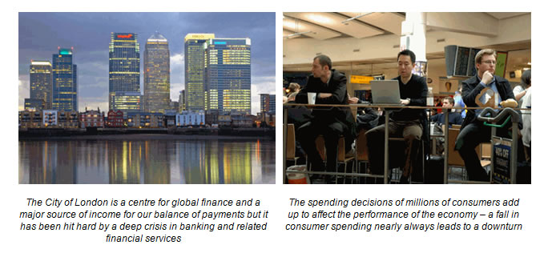

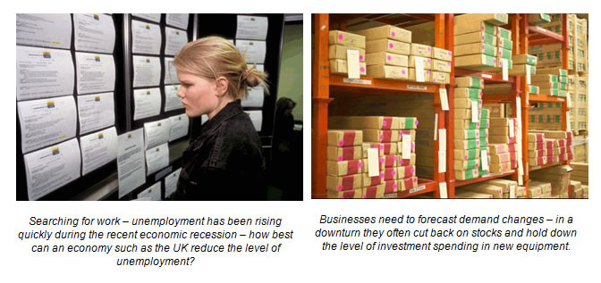

**10 Introductory Background Notes on the United Kingdom Economy**

* The UK has the 2nd largest economy in the European Union behind Germany
* The UK is the 7th largest world economy and is a member of the G7, a group which brings together the Finance Ministers of the seven largest developed economies in the world – UK, US, Japan, Italy, Germany, France and Canada - to discuss economic policy
* In 2011 the UK contributed 3 per cent to global output and 4% of global trade in goods and services
* In terms of per capita income, the UK is [ranked in the top fifteen nations](http://web.worldbank.org/WBSITE/EXTERNAL/DATASTATISTICS/0,,contentMDK:20535285%7EmenuPK:1192694%7EpagePK:64133150%7EpiPK:64133175%7EtheSitePK:239419,00.html) and it also has one of the highest levels of [human development](http://hdr.undp.org/en/reports/global/hdr2010/) as measured by the United Nations index
* Britain enjoyed economic growth from 1992 through to 2008 but in 2009 the economy suffered a recession. Real GDP fell by five per cent in 2009 and started a weak recovery during 2010-12
* Over a quarter of the UK’s GDP comes from selling goods and services overseas ([exports](http://www.tutor2u.net/blog/index.php/economics/tagged/tag/exports/))
* The value of imports exceeds exports; this means the UK runs a trade deficit with other countries
* The UK is the largest exporter of creative services in the world
* The UK is inside the [European Union](http://europa.eu/index_en.htm) and is a founder member of the [World Trade Organisation](http://www.wto.org/)
* The UK retains its own currency having decided not to join the [single currency area](http://ec.europa.eu/economy_finance/the_euro/index_en.htm?cs_mid=2946) (or Euro Zone).

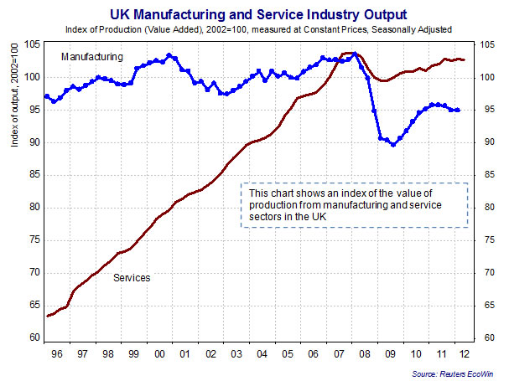

In macroeconomics we look at things *‘in the whole’* and, in doing so, we use these terms:

* **Households**: receive **income** through wages and salaries from their [jobs](http://www.tutor2u.net/blog/index.php/economics/tagged/tag/jobs/) and from their investments and then buy the output of firms (this is known as **consumer spending** and is labelled as **C**)
* **Firms**: Businesses hire land, labour and capital inputs when making products for which they pay wages and rent (income). Firms receive payment from consumers and profitable businesses may invest (**I**) a percentage of [profits](http://www.tutor2u.net/blog/index.php/economics/tagged/tag/profit/) in new producer goods such as equipment and technology
* **Government**: collect taxes (**T**) to fund spending on public services such as education, healthcare and defence. Government spending is given the label (**G**)
* **International sector**: The UK buys imports from other countries, (**M**) and overseas businesses and consumers buy UK products – known as exports (**X**). [International trade](http://www.tutor2u.net/blog/index.php/economics/C199/) is important for the UK. Millions of jobs depend directly or indirectly on the UK remaining competitive in overseas market.

**How do we measure the economic performance of developed and developing countries?**

* **Macroeconomic performance** refers to how well a country is doing in reaching a number of **objectives or targets** of government policy.
* The main aim is an improvement in the average **real standard of living**
* The term **‘real’** means that we have taken into account the effects of **rising prices** so that we get a better picture of how many products we can afford to buy and consume.
* The main aims are macroeconomic policies are to improve outcomes in these indicators:
* [**Jobs**](http://www.tutor2u.net/blog/index.php/economics/tagged/tag/jobs/) – how high is unemployment? Is the economy creating enough new jobs for people entering the labour market each year? Are there sufficient opportunities for people looking for work?
* **Prices** –are price rises under control? Can the economy avoid a period of price deflation? Price stability refers to low, stable, positive inflation of between 1-3% per year.
* **Trade** – is the economy performing well in trading goods and services with other countries? How competitive are British businesses in the global economy?
* **Growth** – how successful has the country been in achieving growth and in laying foundations for future expansion and development
* **Development** - the expansion of people’s freedom to live long, healthy and creative lives
* **Efficiency** - is the economy improving productivity so that more goods and services can be supplied at lower cost? Are we cutting the amount of energy we use per unit of output?
* **Public services** – have the benefits of growth flowed through into better provision of state services such as education, law and order, the National Health Service and transport?
* **The** [**environment**](http://www.tutor2u.net/blog/index.php/economics/C6/) – many economists now focus on whether an expanding economy is sustainable in terms of its environmental impact.
* **Inequality of income and wealth -** leaving aside changes in average living standards, has the economy made progress in achieving an acceptable distribution of income and wealth? Or has the gap between lower and higher-income families become wider leading to higher relative poverty?

Macroeconomic performance covers a wide range of indicators – summarised as:

* Economic growth (short term and long term)
* Jobs (unemployment and employment)
* Prices
* Trade
* Productivity
* Average standard of living
* The distribution of income and wealth
* Quality of and financing of public services

The macroeconomic performance of any one nation is affected by events, policies and [shocks](http://www.tutor2u.net/blog/index.php/economics/C207/) in **other** countries. No economy is immune to what is happening in the global financial and economic system.