**Macroeconomic Equilibrium**

***Author****:* [*Geoff Riley*](http://www.tutor2u.net/blog/index.php/site/author/3/)***Last updated:*** *Sunday 23 September, 2012*

**Introduction**

You may already be familiar with the concept of equilibrium from your study of microeconomics – equilibrium occurs at a **market clearing price** which balances supply and demand. Now we look at the concept of equilibrium at a macroeconomic level.

**Equilibrium for the whole economy**

**Macro-economic equilibrium** is established when **AD intersects with SRAS**. This is shown in the next diagram. At price level P1, AD is equal to SRAS – i.e. at this price level, the value of output produced within the economy equates with the level of demand for goods and services.  The output and the general price level in the economy will tend to adjust towards this equilibrium position

If the general price level is too high, there will be an excess supply of output and producers will experience an increase in unsold stocks. This is a signal to cut back on production to avoid an excessive level of inventories. If the price level is below equilibrium, there will be excess demand in the short run leading to a rundown of stocks – a signal for producers to expand output.

*Equilibrium is where the level of income flowing round the system is constant in successive time periods.*

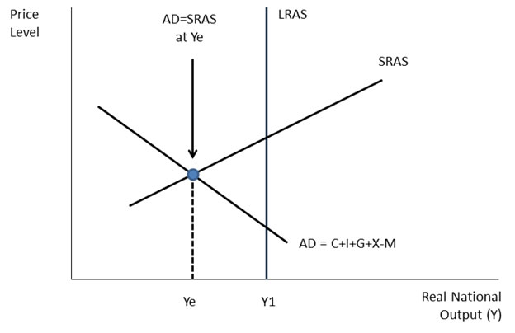

Some people question whether it can ever be the case that an economy can come close to reaching equilibrium since it would only take one market to be out of equilibrium for this to be blocked?

Our interpretation of the idea of equilibrium is a little different from a microeconomic level. What matters here is whether the **total demand for goods and services** is close to the actual level of production from domestic and external sources.

We will come back to this when we look at excess demand and supply and the concept of the **output gap**.

**Changes in Aggregate Demand**

In our diagram below we see the effect of **an increase in aggregate demand** which causes an expansion of aggregate supply and a higher equilibrium level of national output / income (i.e. higher real GDP)

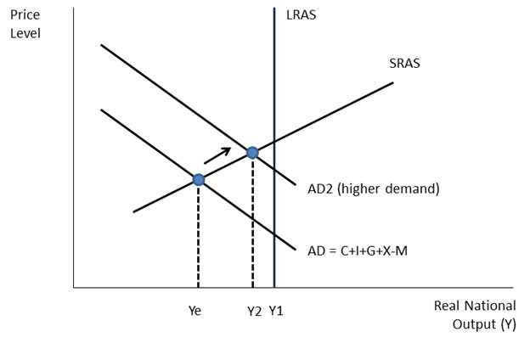

**Changes in short-run aggregate supply (SRAS)**

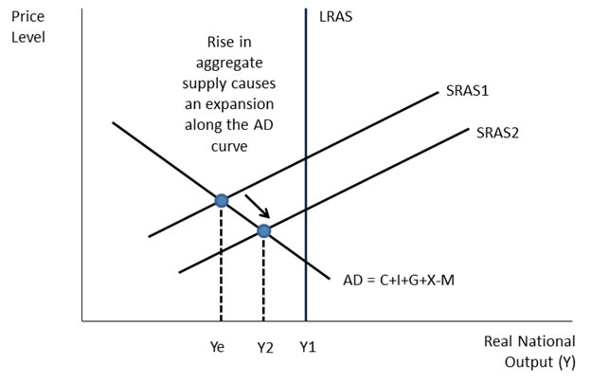

In the example above we see the impact of a **rise in supply** (i.e. due to falling costs of production)

**Changes in Aggregate Demand and Supply**

In the example below there has been an **outward shift of AD** (e.g. caused by a rise in exports) and an **inward shift of SRAS** (e.g. caused by a rise in unit wage costs). Our focus is on the equilibrium level of real GDP but also consider what is likely to happen to the general price level shown on the vertical axis.

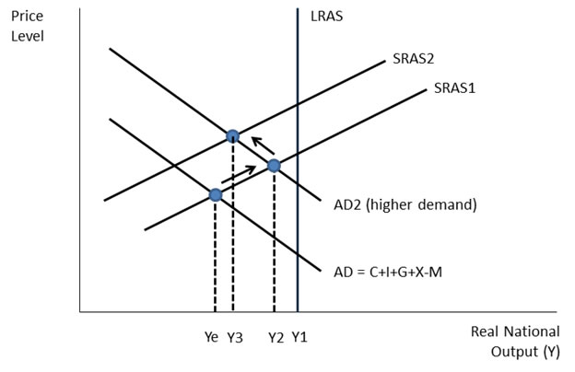

In the next example we see **the impact of a recession** where aggregate demand has fallen and also the impact of a **rise in the cost of importing energy and other raw materials**. Both factors have the effect of depressing the real value of output.

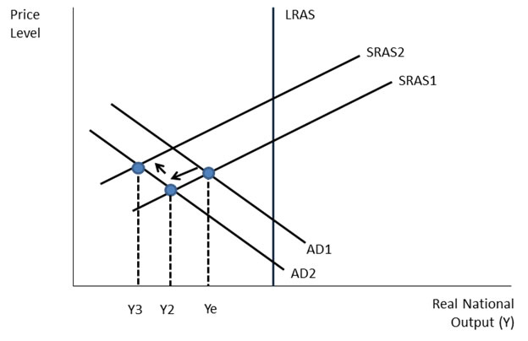

**The Output Gap**

* How much **spare capacity** does an economy have to meet a rise in demand?
* How close is an economy to operating at its **productive potential**?
* Will the 2008-10 [recessions](http://www.tutor2u.net/blog/index.php/economics/tagged/tag/recession/) have a **permanent effect** on our ability to supply goods and services?

These sorts of questions all link to an important concept – the [output gap](http://www.tutor2u.net/blog/index.php/economics/tagged/tag/output+gap/).

The output gap is the difference between the **actual level of national output** and its **potential level** and is usually expressed as a percentage of the level of potential output.

The estimated output gap for the UK is shown in the chart below. Notice the big swing in the output gap from being positive to negative during the years 2008-2010 as the recession hit Britain.

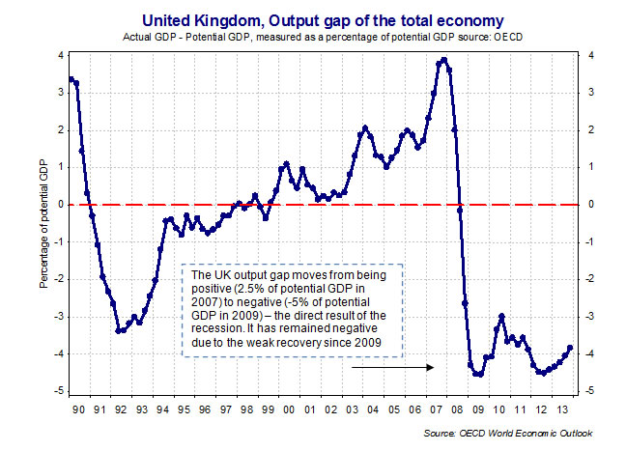

***Negative output gap – downward pressure on inflation***

* The actual level of real GDP is given by the intersection of AD & SRAS – the short run equilibrium.
* If actual GDP is less than potential GDP there is a negative output gap. Some factor resources such as labour and capital machinery are under-utilized; the main problem is likely to be higher unemployment.
* More people out of work indicate an excess supply of labour, which causes downward pressure on real wage rates.

***Positive output gap – upward pressure on inflation***

* If actual GDP is greater than potential GDP then there is a positive output gap.
* Some resources including labour are likely to be working beyond their normal capacity e.g. making extra use of shift work and overtime.
* The main problem is likely to be an acceleration of consumer price inflation.

**Reces*s*ion and the output gap**

The latest forecasts from the OECD suggest that the UK will operate with a large negative output gap for some time to come. There are some economists who argue that the fall-out from the slump will have long-term damage to our **productive capacity** and that the economy may experience a permanent loss of output. This might arise from a sharp rise in the number of business failures together with a long-term loss of people from the labour market if they suffer extended periods out of work.

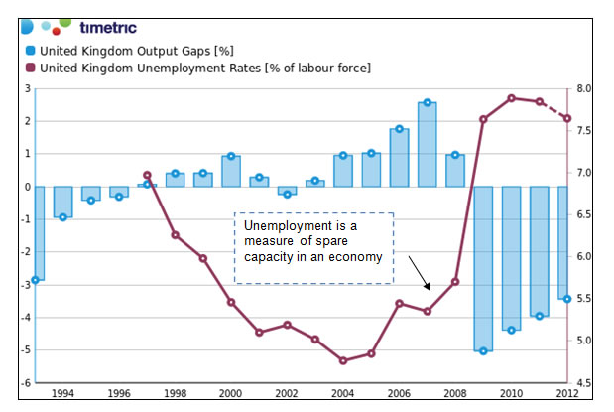

In our chart above we plot the output gap and the rate of unemployment in the UK. During years of strong growth the British economy operated with a positive output gap (peaking in 2007) with unemployment rates falling steadily (measured as a percentage of the labour force.) But when the recession struck the unemployment rate soared to nearly 8 per cent – this is an indication of spare capacity in the economy.

[**Spare Capacity**](http://www.tutor2u.net/blog/index.php/economics/tagged/tag/spare+capacity/)

When a business is operating at less than 100% capacity, it is said to have “spare capacity”.

Demand factors:

* Lower demand due to a decline in consumption
* Loss of market share due to poor marketing or competitors having better products
* Seasonal variations in demand - i.e. temporary spare capacity during off-peak times

Supply factors:

* Increase in capacity not yet matched by increased demand
* Because new technology has been introduced in anticipation of higher demand
* Improvements in [productivity](http://www.tutor2u.net/blog/index.php/economics/tagged/tag/productivity/) mean capacity increases for a given level of demand

Spare capacity can be useful in that it allows businesses to respond to short-term or an unexpected increase in demand, when there is some **productive slack**, aggregate supply is price elastic.