**Macroeconomic Policy Objectives**

***Author****:* [*Geoff Riley*](http://www.tutor2u.net/blog/index.php/site/author/3/)***Last updated:*** *Sunday 23 September, 2012*

**Introduction**

**What are objectives and how are they different from instruments?**

1. **Objectives** are the **aims** or **goals** of government policy
2. **Instruments** are the means by which these aims might be achieved

For example, the government might want to achieve an objective of a **low rate of inflation**.

The main instrument to achieve this are changes in **monetary** **policy** [**interest rates**](http://www.tutor2u.net/blog/index.php/economics/tagged/tag/interest+rates/) and since 1997 they have been set by the Bank of England. Fiscal policy could be another instrument to achieve this aim. This is in the hands of the government. Supply-side policies can also be used to control inflation and promote growth.

The government might have another objective – namely to make the **distribution of income and wealth** more equal. It would then choose the policy instruments it thinks are best suited to reaching to this aim, perhaps a change in the income tax system or a rise in the national [minimum wage](http://tutor2u.net/blog/index.php/economics/tagged/tag/minimum+wage/) .

The main **policy instruments** available to meet macroeconomic objectives are

* [**Monetary policy**](http://www.tutor2u.net/blog/index.php/economics/C7/) –changes to interest rates, the supply of money and credit and also changes to the value of the exchange rate
* [**Fiscal policy**](http://www.tutor2u.net/blog/index.php/economics/C46/) – changes to government taxation, government spending and borrowing
* [**Supply-side policies**](http://www.tutor2u.net/blog/index.php/economics/C67/) designed to make markets work more efficiently

**Objectives of UK Macroeconomic Policy**

The key objectives for the UK are:

* [**Stable low inflation**](http://www.tutor2u.net/blog/index.php/economics/C164/) - the Government’s inflation target is **2.0%** for the **consumer price index**. The [Monetary Policy Committee](http://search.bbc.co.uk/cgi-bin/search/results.pl?tab=ns&q=Monetary%20Policy%20Committee%20&recipe=all&scope=all&edition=d) sets interest rates at a level it thinks will meet the inflation target over a two year horizon.
* [**Sustainable growth**](http://www.tutor2u.net/blog/index.php/economics/C206/) – as measured by the growth of **real gross domestic product** – sustainable in keeping inflation low and in reducing the [environmental](http://www.tutor2u.net/blog/index.php/economics/C6/) impact of growth.
* **Improvements in productivity** – this is designed to improve competitiveness and trade performance. The pressures of [**globalisation**](http://www.tutor2u.net/blog/index.php/economics/C20/) and the increasing competition within the European Single Market make this one of the key objectives of the government.
* [**High employment**](http://www.tutor2u.net/blog/index.php/economics/C5/) - the government wants to achieve **full-employment** – a situation where all those able and available to find work have the opportunity to work. At the time of writing, the key aim is to limit the effects of the [recession](http://www.tutor2u.net/blog/index.php/economics/tagged/tag/recession/) on the level of unemployment.
* [**Rising living standards**](http://www.tutor2u.net/blog/index.php/economics/C140/) **and a fall in** [**relative poverty**](http://www.tutor2u.net/blog/index.php/economics/C10/)– for example the objective of cutting child poverty and reducing pensioner poverty.
* **Sound government finances** - including control over government borrowing and the total national debt.

**What is meant by economic stability?**

Economic **stability** occurs when there is an absence of big swings in prices, output and jobs.

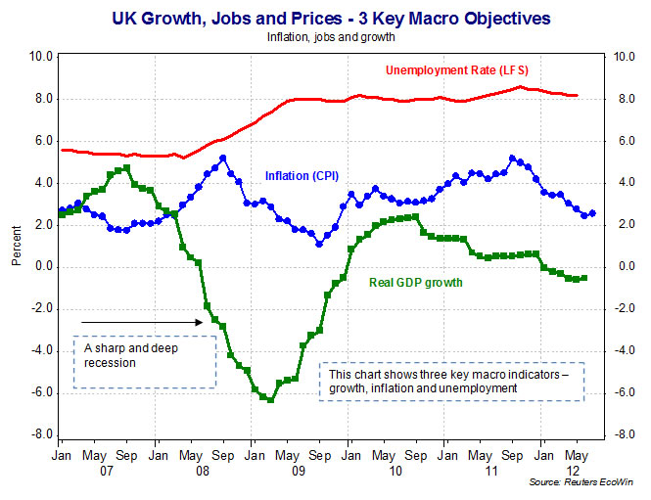

The national output of a country does not grow in a steady fashion from one year to the next.  All countries experience an **economic cycle** which tracks the fluctuations in the rate of growth of a country’s **Gross Domestic Product** ([GDP](http://www.tutor2u.net/blog/index.php/economics/tagged/tag/gdp/)).

Here is a reminder of some key terms that we will return to in later topics

|  |  |
| --- | --- |
| **Economic cycle** | Variations in the annual rate of growth of an economy over time |
| **Forecast** | A prediction made about the likely future performance of an economy |
| **GDP** | The monetary value of goods and services produced within the geographical boundaries of a country in a given time period |
| [**Recession**](http://www.tutor2u.net/blog/index.php/economics/tagged/tag/recession/) | A period of at least six months when an economy suffers a fall in output |
| **Recovery** | An upturn phase in the business cycle when GDP recovers from a trough |
| **Slowdown** | A fall in the rate of growth of an economy but not a full-scale recession |
| **Sustainable growth** | The rate of growth “which meets the needs of the present without compromising the ability of future generations to meet their own needs”. |
| **Target** | A target is an aim or an objective of government policy e.g. low inflation |