**Measuring National Income**

***Author****:* [*Geoff Riley*](http://www.tutor2u.net/blog/index.php/site/author/3/)***Last updated:*** *Sunday 23 September, 2012*

**Introduction**

**What is National Income?**

**National income** measures the **monetary value of the flow of output of goods and services** produced in an economy over a period of time.

Measuring the level and rate of growth of national income (Y) is important for seeing:

* The rate of **economic growth**
* Changes to average **living standards**
* Changes to the **distribution of income** between groups within the population

**Gross Domestic Product**

* **Gross domestic product** (GDP) is the total value of output in an economy
* GDP includes the output of foreign owned businesses that are located in a nation following foreign direct investment. For example, the output produced at the [Nissan car plant on Tyne and Wear](http://news.bbc.co.uk/1/hi/england/wear/5159162.stm) contributes to the UK’s GDP

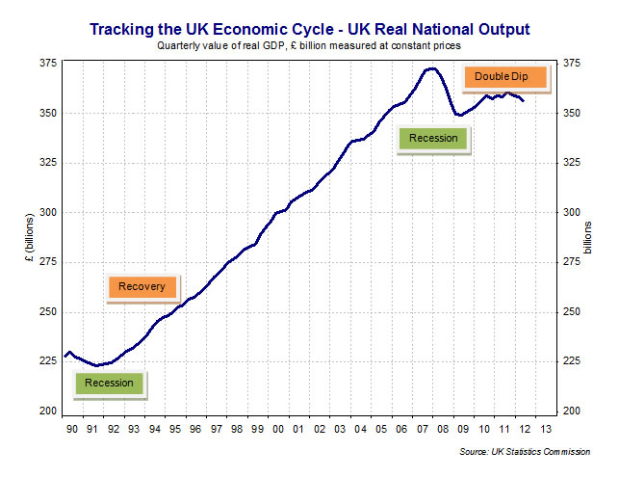

There are three ways of calculating GDP - all of which should sum to the same amount:

**National Output = National Expenditure (Aggregate Demand) = National Income**

**(i) The Expenditure Method - aggregate demand (AD)**

The full equation for GDP using this approach is **GDP = C + I + G + (X-M)** where  
**C:** Household spending  
**I:** [Capital Investment](http://www.tutor2u.net/blog/index.php/economics/C222/) spending  
**G**: Government spending   
**X:** [Exports](http://www.tutor2u.net/blog/index.php/economics/tagged/tag/exports/) of Goods and Services  
**M:** Imports of Goods and Services

**The Income Method – adding together factor incomes**

GDP is the sum of the incomes earned through the production of goods and services. This is:

Income from people in jobs and in self-employment   
+  
Profits of private sector businesses   
+  
Rent income from the ownership of land  
=   
Gross Domestic product (by factor incomes)

Only those **incomes** that are come from the production of goods and services are included in the calculation of GDP by the income approach. We **exclude**:

* **Transfer payments** e.g. the state pension; income support for families on low incomes; the Jobseekers’ Allowance for the unemployed and other welfare assistance such housing benefit
* **Private transfers of money** from one individual to another
* **Income not registered with the tax authorities** Every year, billions of pounds worth of activity is not declared to the tax authorities. This is known as the **shadow economy.**
* Published figures for GDP by factor incomes will be inaccurate because much activity is not officially recorded – including **subsistence farming** and **barter transactions**

**Value Added and Contributions to a nation’s GDP**

* There are three main wealth-generating sectors of the economy – manufacturing and construction, primary (including oil& gas, farming, forestry & fishing) and a wide range of service-sector industries.
* This measure of GDP adds together the **value of output** produced by each of the productive sectors in the economy using the concept of **value added**.  .

Value added is ***the increase in the value of goods or services as a result of the production process***

**Value added = value of production - value of intermediate goods**  
  
Say you buy a pizza from Dominos at a price of £9.99. This is the **retail price** and will count as consumption. The pizza has many **ingredients** at different **stages of the supply chain** – for example tomato growers, dough, mushroom farmers and also the value created by Dominos as they put the pizza together and deliver to the consumer.

Some products have a low value-added, for example cheap tee-shirts that you might find in a supermarket for little more than £5. These are low cost, high volume, low priced products.

Other goods and services are such that lots of value can be added as we move from sourcing the raw materials through to the final product. Examples include designer jewellery, perfumes, meals in expensive restaurants and sports cars. And also the increasingly lucrative computer games industry.

**GDP by output – the distribution of GDP from different industries**

The UK is an economy where the majority of GDP comes from the service industries such as banking and finance, tourism, retailing, education and health. In 2008 less than half of one per cent of our GDP came from agriculture. Manufacturing accounted for less than 15 per cent of GDP and construction a further 6 per cent. In contrast, the service industries now contribute nearly three quarters of national income.

Manufacturing and service industries are not separate! For example the health of a car exporting business will have a direct bearing on demand, output, [profits](http://www.tutor2u.net/blog/index.php/economics/tagged/tag/profits/) and [jobs](http://www.tutor2u.net/blog/index.php/economics/tagged/tag/jobs/) in many service businesses such as transportation, design, marketing and vehicle retailing.  Equally service businesses such as online banking require plenty of physical inputs such as machinery and [infrastructure](http://www.tutor2u.net/blog/index.php/economics/tagged/tag/infrastructure/) to be successful.

The main **service sector industries** in the UK are:

* Hotels and restaurants, and a range of services provided by local government
* Transport, logistics, storage and communication
* Business services and finance, motor trade, wholesale trades and retail trade
* Land transport   and air transport, post and telecommunications
* Real estate activities, computer and related activities, Education, Health and social work
* Sewage and refuse disposal
* Recreational, cultural and sporting activities

**The Share of National Output (GDP) for the UK Economy**

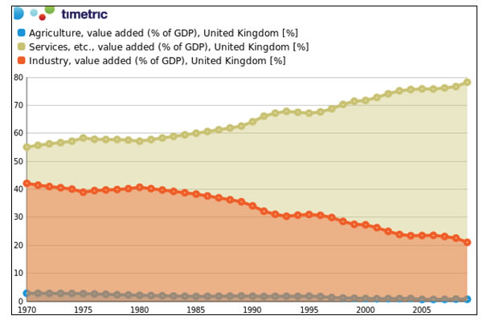

Notice in the chart above how there are long-term shifts in the value added from the three main sectors – the pattern of GDP depends on many factors including the stage of a country’s development and the extent to which a nation has built up industries of competitive advantage in the world economy.

**Gross National Income (GNI)**

* **Gross National Income** (GNI) measures the final value of incomes flowing to UK owned factors of production *whether they are located in the UK or overseas*.
* Gross Domestic Income is concerned only with the incomes generated within the geographical boundaries of the country. Fr example the value of the output produced by Toyota in the UK counts towards our GDP but some of the profits made by overseas companies with production plants here in the UK are sent back to their country of origin – adding to their GNP.

**GNI = GDP + Net property income from abroad (NPIA)**

* **NPIA** is the net balance of **interest, profits and dividends** (IPD) coming into the UK from our assets owned overseas matched against the flow of profits and other income from foreign owned assets located within the UK.
* There has been an increasing flow of direct investment (FDI) into and out of the UK. Many foreign firms have set up production plants here whilst UK firms have become multinational organisations.

**Nominal and Real - Measuring Real National Income**

* When we want to measure growth in the economy we have to adjust for the **effects of inflation**
* **Real GDP** measures the **volume of output.** An increase in real output means that AD has risen faster than the rate of inflation and therefore the economy is experiencing positive growth. Consider this example

The money value of a country’s GDP is calculated to be $4,000m in 2007

In 2008, the money value of GDP expands to $4,500m but during the year, inflation is 3% causing the general index of prices to rise from a 2007 base year value of 100 to 103 in 2008.

The real value of GDP in 2008 is calculated thus:

Real GDP = money value of GDP in 2008 x 100 / general price index in 2008

= £4,500 x 100/103 = $4,369 (measured at constant 2007 prices)

*Note here that the real GDP data is expressed at constant prices* *which mean that we have made an inflation adjustment. Look for this in the data response questions in the exam.*

**Total and Per Capita – Measuring Income per capita**

How much does each person earn on average? We use per capita measures to give us a guide to this. **Income per capita** is a way of measuring the [standard of living](http://www.tutor2u.net/blog/index.php/economics/tagged/tag/standard+of+living/) for the inhabitants of a country.

Gross National Income per capita = Gross National Income / Total Population

Our next chart shows two pieces of economic data

* The level of UK gross national income (GNI) which has been expressed in real terms (i.e. it is inflation adjusted) and is measured in pounds sterling
* The annual rate of change of real gross national income measured in percentage terms

The chart shows that real incomes per head of the population have risen over the years, i.e. average living standards have improved but that the rate of improvement is not uniform each year. We see that economic growth in the UK fluctuates from year to year, i.e. there is an economic cycle with periodic recessions (where the value of real national income declines.)

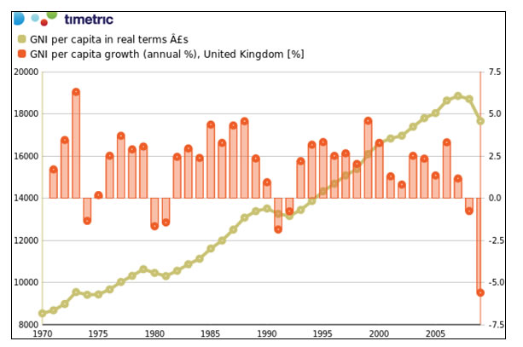

*Real Gross National Income for the UK Economy –*   
*During the recession (2008 to 2009) GDP per head decreased by 5.5 per cent*

**Remittances and Gross National Income**

Remittances are **transfers of money** across national boundaries by migrant workers. Despite a dip because of the global recession, remittance flows have grown in the world economy over the longer-term as the scale of migration between countries has grown. For many developing countries, money coming in from remittances is an importance source of income.  
  
Using data from the World Bank, for the world as a whole in 2010:

* Stock of immigrants: 215.8 million or 3.2 percent of population
* Females as percentage of immigrants: 48.4 percent
* Refugees: 16.3 million or 7.6 percent of the total immigrants

Top 10 remittance recipients in 2010 (billions): India ($55.0bn), China ($51.0bn), Mexico ($22.6bn), Philippines ($21.3bn), France ($15.9bn), Germany ($11.6bn), Bangladesh ($11.1bn), Belgium ($10.4bn), Spain ($10.2bn), Nigeria ($10.0bn)

Top 10 remittance recipients in 2009 (percentage of GDP): Tajikistan (35.1 percent), Tonga (27.7 percent), Lesotho (24.8 percent), Moldova (23.1 percent), Nepal (22.9 percent), Lebanon (22.4 percent), Samoa (22.3 percent), Honduras (19.3 percent), Guyana (17.3 percent), and El Salvador (15.7 percent)