**Multiplier & Accelerator Effects**

***Author****:* [*Geoff Riley*](http://www.tutor2u.net/blog/index.php/site/author/3/)***Last updated:*** *Sunday 23 September, 2012*

**Introduction**

In this chapter we look at two ideas, the **multiplier process** and the **accelerator effect**, both of which help to explain how we move from one stage of an economic cycle to another

**What is the multiplier process?**

* An initial change in aggregate demand can have a much greater final impact on equilibrium national income
* This is known as the **multiplier effect**
* It comes about because **injections of new demand** for goods and services into the **circular flow of income** stimulate further rounds of spending – in other words *“one person’s spending is another’s income”*
* This can lead to a bigger eventual effect on output and employment

**What is a simple definition of the multiplier?**

It is the number of times a rise in national income exceeds the rise in injections of demand that caused it  
  
**Examples of the multiplier effect at work**

* Consider a **£300 million increase in** [**capital investment**](http://www.tutor2u.net/blog/index.php/economics/C222/)– for example created when an overseas company decides to build a new production plant in the UK
* This may set off a chain reaction of increases in expenditures. Firms who produce the capital goods and construction businesses who win contracts to build the new factory will see an increase in their incomes and [profits](http://www.tutor2u.net/blog/index.php/economics/tagged/tag/profits/)
* If they and their employees in turn, collectively spend about 3/5 of that additional income, then £180m will be added to the incomes of others.

**At this point, total income has grown by (£300m + (0.6 x £300m).**

The sum will continue to increase as the producers of the additional goods and services realize an increase in their incomes, of which they in turn spend 60% on even more goods and services.

**The increase in total income will then be (£300m + (0.6 x £300m) + (0.6 x £180m).**

Each time, the extra spending and income is a fraction of the previous addition to the circular flow.

**The Multiplier and Keynesian Economics**

* The concept of the multiplier process became important in the 1930s when **John Maynard Keynes** suggested it as a tool to help governments to maintain high levels of employment
* This “demand-management approach”, designed to help overcome a shortage of capital investment, measured the amount of government spending needed to reach a level of national income that would prevent unemployment.

**Factors that affect the value of the multiplier effect**

* The higher is the **propensity to consume** domestically produced goods and services, the greater is the [multiplier effect](http://tutor2u.net/blog/index.php/economics/tagged/tag/multiplier+effect/). The government can influence the size of the multiplier through changes in direct taxes. For example, a cut in the rate of income tax will increase the amount of extra income that can be spent on further goods and services
* Another factor affecting the size of the multiplier effect is the **propensity to purchase imports**. If, out of extra income, people spend their money on imports, this demand is not passed on in the form of fresh spending on domestically produced output. It leaks away from the circular flow of income and spending, reducing the size of the multiplier.

The multiplier process also requires that there is **sufficient spare capacity** for extra output to be produced.

If **short-run aggregate supply is inelastic**, the full multiplier effect is unlikely to occur, because increases in AD will lead to higher prices rather than a full increase in real national output. In contrast, when SRAS is perfectly elastic a rise in aggregate demand causes a large increase in national output.

In short – the multiplier effect will be larger when

1. The propensity to spend extra income on domestic goods and services is high
2. The marginal rate of tax on extra income is low
3. The propensity to spend extra income rather than save is high
4. Consumer confidence is high (this affects willingness to spend gains in income)
5. Businesses in the economy have the capacity to expand production to meet increases in demand

**Time lags and the multiplier effect**

* It is important to remember that the multiplier effect will take time to come into full effect
* A good example is the [fiscal stimulus](http://www.tutor2u.net/blog/index.php/economics/tagged/tag/fiscal+stimulus/) introduced into the US economy by the Obama government. They have set aside many billions of dollars of extra spending on [infrastructure](http://www.tutor2u.net/blog/index.php/economics/tagged/tag/infrastructure/) spending but these sorts of capital projects can take years to be completed. Delays in sourcing raw materials, components and finding sufficient skilled labour can limit the initial impact of the spending projects.

**Calculating the value of the multiplier**

The formal calculation for the value of the multiplier is

***Multiplier = 1 / (sum of the propensity to save + tax + import)***

Therefore if there is an initial injection of demand of say £400m and

* The marginal propensity to save = 0.2
* The marginal rate of tax on income = 0.2
* The marginal propensity to import goods and services is 0.3

Then the value of national income multiplier = (1/0.7) = 1.43

An initial change of demand of £400m might lead to a final rise in GDP of 1.43 x £400m = £572m

If

* The marginal propensity to save = 0.1
* The marginal rate of tax on income = 0.2
* The marginal propensity to import goods and services is 0.2

The value of the multiplier = 1/0.5 = 2 – the same initial change in aggregate demand will lead to a bigger final change in the equilibrium level of national income.

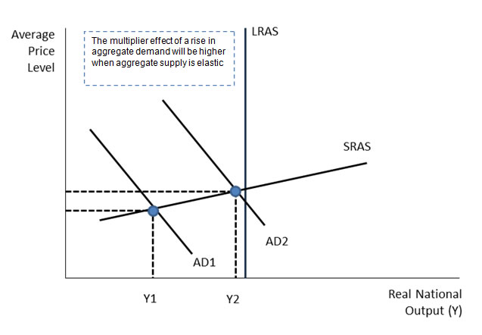

**The Accelerator Effect**

The accelerator effect is when an increase in national income results in a proportionately larger rise in investment

Consider an industry where demand is rising at a strong pace.

Firms will respond to growing demand by **expanding production** and making fuller use of their **existing productive capacity**. They may also choose to meet higher demand by **running down their stocks** of finished products.

At some point – and if they feel that the higher level of demand will be **sustained** – they may choose to increase spending on capital goods such as plant and machinery, factories and new technology in order to increase their **capacity**. If this investment goes beyond what is needed simply to replace worn out, fully depreciated machinery, then the capital stock of the business will become larger.

In this sense, the **demand for capital goods** is being driven by the demand for the products that the firm is supplying to the market. This gives rise to the accelerator effect - the principle states that a given change in demand for consumer goods will cause a greater percentage change in demand for capital goods.

A good example might be the surge in capital investment in **wind turbines** due to the super-high level of oil and gas prices and a rising market demand for renewable energy. In this case, strong demand created a positive accelerator effect. But this can also go into reverse e.g. during an economic slowdown or recession. World oil prices have collapsed and many wind farm projects have been scaled back or postponed.

Similarly the sharp fall in UK **motor car production** is also leading to a **reverse accelerator effect** with planned investment spending subject to severe cut-backs and many jobs lost.

**The Capital Output Ratio**

* The accelerator model works on the basis of a fixed capital to output ratio
* For example if demand in a given year rises by £4 million and each extra £1 of output requires an average of £3 of capital inputs to produce this output, then the net level of investment required will be £12 million.

One criticism of this simple accelerator model is that the capital stock of a business can rarely be adjusted immediately to its desired level because of ‘adjustment costs’ and ‘time lags’. The adjustment costs include the cost of lost business due to installation of new equipment or the financial cost of re-training workers. Firms will usually make progress towards achieving an optimum capital stock rather than moving smoothly from one optimal size of plant and machinery to another.

A further criticism of the basic accelerator model is that it ignores the spare capacity that a business might have at their disposal and also their ability to outsource production to other businesses to meet a short term rise in demand.

The accelerator principle is used to help explain **business cycles**. The accelerator theory suggests that the level of net investment will be determined by the rate of change of national income. If national income is growing at an increasing rate then net investment will also grow, but when the rate of growth slows net investment will fall. There will then be an interaction between the multiplier and the accelerator that may cause larger fluctuations in the trade cycle.

The accelerator effect will tend to be high when

* The rate change of consumer income and spending is strongly positive
* The amount of spare productive capacity for businesses is low
* The available supply of investment funds is high

