**Topic 1) National Income, Economic Growth & Economic Cycle**

***Use pages 1-42 from the associated study pack to answer the following:***

***What is macroeconomics?***

|  |
| --- |
|  |

***Explain the following macroeconomic targets:***

|  |  |
| --- | --- |
| Macroeconomic target | Explanation |
| Growth |  |
| Inflation |  |
| Unemployment |  |
| Trade |  |

***Explain the following key terms:***

|  |  |
| --- | --- |
| Key term | Explanation |
| National Income |  |
| Gross Domestic Product (GDP) |  |
| Income per capita |  |

***What is Aggregate Demand (AD)?***

|  |
| --- |
|  |

***Explain the meaning of the following components of AD:***

|  |  |
| --- | --- |
| Component of AD | Explanation |
| Consumers expenditure ( C ) |  |
| Capital investment ( I ) |  |
| Government spending ( G ) |  |
| Exports ( X ) |  |
| Imports ( M ) |  |

***Draw an AD curve on the axis provided:***

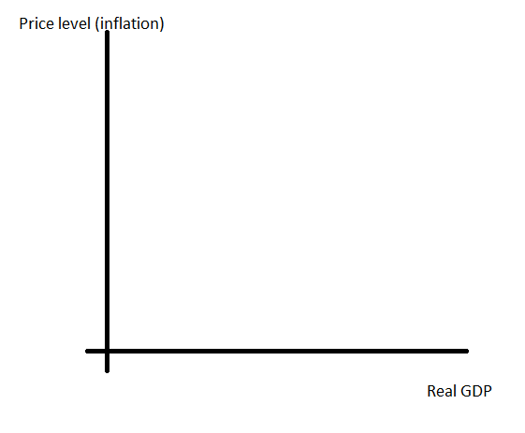

***Use your diagram to explain why AD slopes downwards***

|  |
| --- |
|  |

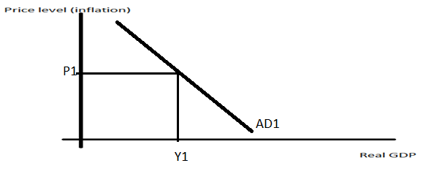

***On the diagram above add another AD curve which shows an outward shift of AD***

***Explain 5 causes of an outward shift of AD:***

|  |  |
| --- | --- |
| Causes of an outward shift of AD | Explanation |
|  |  |
|  |  |
|  |  |
|  |  |
|  |  |

***Explain how the following will influence consumption within the economy:***

|  |  |
| --- | --- |
| Factor influencing consumption | Explanation |
| Marginal propensity to consume (Spend) |  |
| Level of real disposable income |  |
| Interest rates |  |
| Consumer confidence |  |
| Wealth |  |
| Employment/unemployment |  |

***Define the term ‘savings’***

|  |
| --- |
|  |

***Explain a range of reasons why people save***

|  |  |
| --- | --- |
| Reasons why people save | Explanation |
|  |  |
|  |  |
|  |  |

***Define the term Investment (capital investment)***

|  |
| --- |
|  |

***Use a PPB diagram on the axis below to help you explain the impact on the economy of an increase in capital spending***

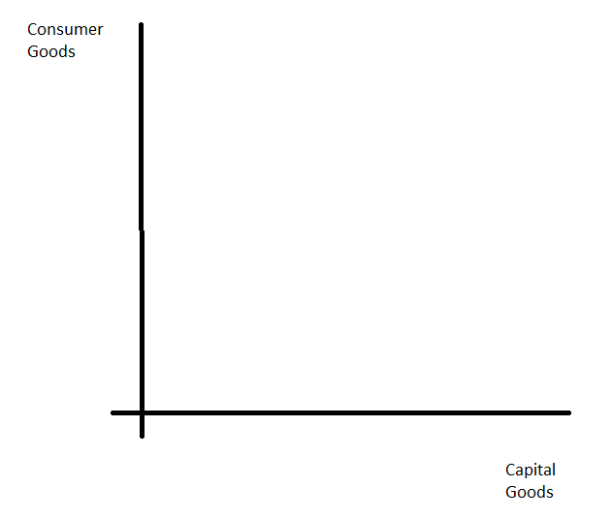

|  |
| --- |
|  |

***Outline a range of reasons why capital investment spending may increase***

|  |  |
| --- | --- |
| Factors that will influence the level of capital investment spending | Explanation |
|  |  |
|  |  |
|  |  |
|  |  |

***Explain the meaning of the key term ‘Aggregate Supply (AS)’***

|  |
| --- |
|  |

***Explain using a diagram the difference between SRAS and LRAS***

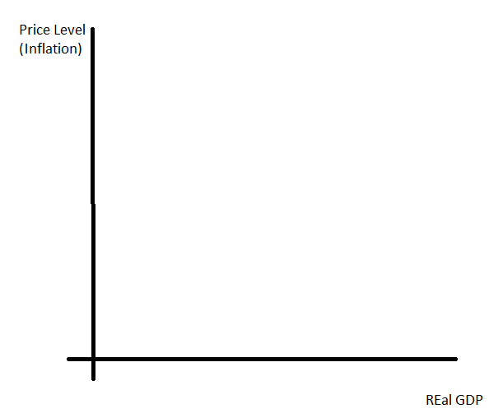

|  |
| --- |
|  |

***The diagram below shows an outward shift (increase) in SRAS. Explain a range of reasons that might explain why this may have happened***

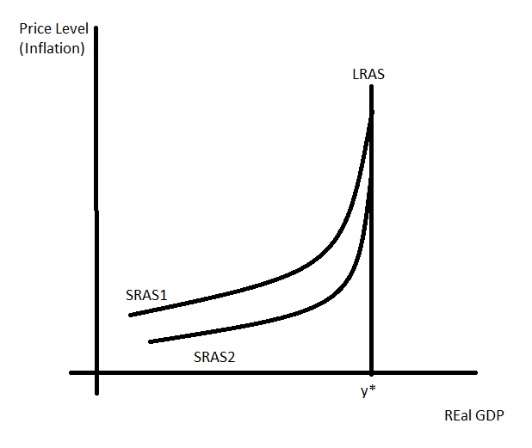

|  |  |
| --- | --- |
| ***Reason for increase in SRAS*** | ***Explanation*** |
|  |  |
|  |  |
|  |  |

***The diagram below shows an outward shift (increase) in LRAS. Explain a range of reasons that might explain why this may have happened***

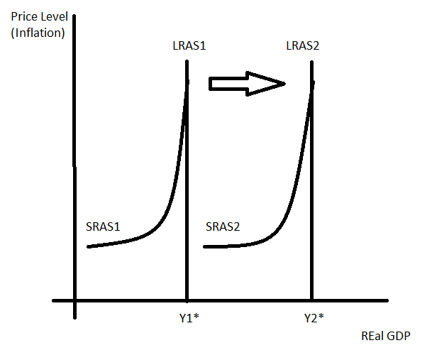

|  |  |
| --- | --- |
| ***Reason for increase in LRAS*** | ***Explanation*** |
|  |  |
|  |  |
|  |  |
|  |  |

***Below shows 4 macro-equilibrium diagrams. Add the relevant additional line and show the impact on the macro-equilibrium point:***

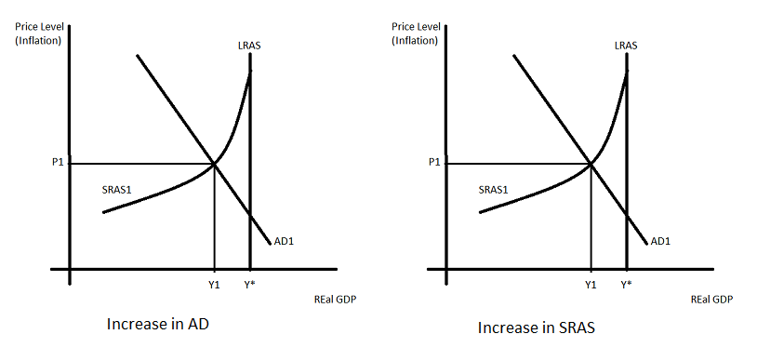

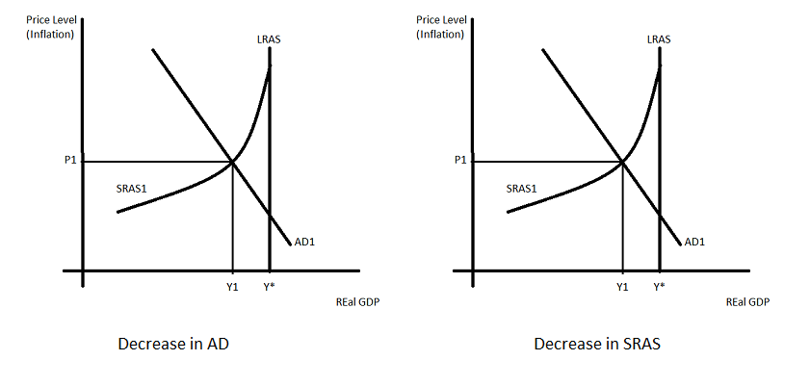

***Define the following key terms:***

|  |  |
| --- | --- |
| Key term | Explanation |
| Positive output gap |  |
| Negative output gap |  |

***Use a diagram to explain the differences between a positive and negative output gap***



|  |
| --- |
|  |

***Draw an economic cycle on the axis provided:***

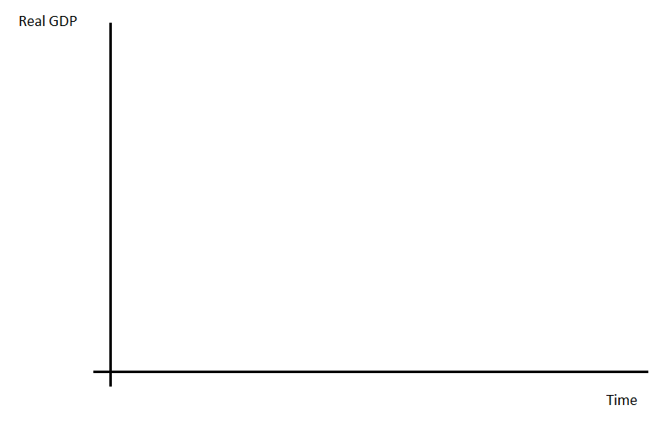

***Explain the following stages of the economic cycle***

|  |  |
| --- | --- |
| Stage of economic cycle | Explanation |
| Boom |  |
| Slowdown |  |
| Recession |  |
| Recovery |  |

***Explain in detail the following key terms:***

|  |  |
| --- | --- |
| Key terms | Explanation |
| Multiplier effects |  |
| Accelerator effects |  |