**Balance of payments**

***Author****:* [*Geoff Riley*](http://www.tutor2u.net/blog/index.php/site/author/3/)***Last updated:*** *Sunday 23 September, 2012*

**Introduction**

**What is the Balance of Payments?**

The **balance of payments** (BOP) records financial transactions made between consumers, businesses and the government in one country with others

* The BOP figures tell us about how much is being spent by consumers and firms on imported goods and services, and how successful firms have been in exporting to other countries
* For Unit 2 you focus only on the current account of the balance of payments

**Measuring the current account**

* The **current account** of the balance of paymentscomprises the **balance of trade** in goods and services plus **net investment incomes** from overseas assets and **net transfers**
* **Net investment income** comes from interest payments, [profits](http://www.tutor2u.net/blog/index.php/economics/tagged/tag/profit/) and dividends from external assets located outside the UK.
  + For example a UK firm may own a business overseas and send back some of the operating profits to the UK. This would count as a credit item for our current account as it is a stream of profits flowing back into the UK.
  + Similarly, an overseas investment in the UK might generate a good rate of return and the profits are remitted back to another country – this would be a debit item in the balance of payments accounts.
* **Transfers** into and out of a country include foreign aid payments. For the UK the net transfers figure is negative each year, mainly due to the UK being a net contributor to the budget of the European Union. As a rich nation, the UK makes sizeable **foreign aid** payments to many other countries.

Summary details for the UK current account are shown in the table below

In 2011 for the first time, the UK ran a trade deficit in goods in excess of £100 billion. But there was also a record surplus in trade in services. The overall current account deficit was £29 billion which looks like a large sum unless one expresses it as share of GDP – this latter measure was a deficit of around 2% of GDP.

|  |  |  |  |  |  |  |
| --- | --- | --- | --- | --- | --- | --- |
|  | (A) Trade in goods | (B)  Trade in services | (C) Total trade in goods and services | (D)  Total net investment income | (E)  Current transfers | Current balance = A+B+D+E |
|  |
|  | £ billion | £ billion | £ billion | £ billion | £ billion | £ billion |
| 2005 | -68.7 | 33.2 | -35.4 | 21.4 | -11.8 | -25.9 |
| 2006 | -76.4 | 41.4 | -35.0 | 7.8 | -11.9 | -39.1 |
| 2007 | -90.5 | 52.9 | -37.6 | 19.0 | -13.5 | -32.2 |
| 2008 | -94.1 | 61.0 | -33.1 | 32.4 | -13.8 | -14.4 |
| 2009 | -82.8 | 62.2 | -20.6 | 18.0 | -15.1 | -17.7 |
| 2010 | -98.5 | 67.0 | -31.5 | 14.6 | -20.4 | -37.3 |
| 2011 | -100.3 | 76.4 | -24.0 | 17.1 | -22.2 | -29.0 |

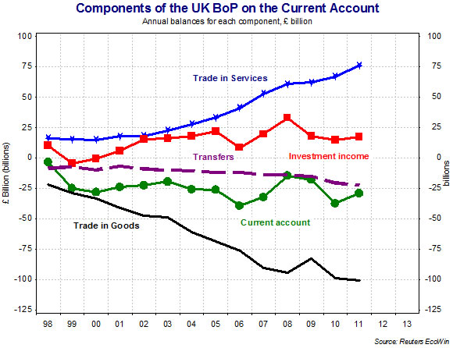

|  |  |
| --- | --- |
| **Trade in goods includes items such as:**   * Manufactured goods * Semi-finished goods and components * Energy products * Raw Materials * Consumer goods * (i) Durable goods * (ii) Non-durable goods e.g. foods * Capital goods (e.g. equipment) | **Trade in services includes:**   * Banking, insurance and consultancy * Other financial services including foreign exchange and derivatives trading * Tourism industry * Transport and shipping * Education and health services * Research and development * Cultural arts |

**Trade in services**

Trade in services includes the exporting and importing of **intangible products** – for example, Banking and Finance, Insurance, Shipping, Air Travel, Tourism and Consultancy.

Britain has a **strong trade base in services** with over 30% of export earnings coming from services

The success of our service sector industries has been one of the strong points in our performance over the last twenty years.

In 1999 the UK became the second largest exporters of services in the world. Strong surpluses are especially common in **financial and business services** and **hi-tech knowledge services**

The UK is also a major net exporter of **creative services** such as film and television programmes, books, advertising and marketing services and architecture and design.

But the UK runs a deficit in **international travel and transportation** in part because of rising demand for overseas holidays as living standards have improved. Once again, rising incomes have caused a large rise in the demand for leisure and business travel and the recent strength of the exchange rate (until recently) and the rapid expansion of low cost airlines offering short haul overseas breaks has also played its part.

Britain has a **comparative advantage** in selling **financial services** to the rest of the world.

**London** is one of the three main financial centres in the world and has the largest share of trading in many international financial markets.

For example, around one third of all of the currency dealing takes place in London’s trading platforms and many overseas banks have established themselves in London’s money and capital markets.

Numerous British financial businesses have world class status in their areas of expertise.  Our UK based commercial banks, fund managers, securities dealers, futures and options traders, insurance companies and money market brokerage businesses are part of a complex network of financial and business services that represent a huge asset for the UK balance of payments accounts.

**What does a current account deficit mean?**

* Running a deficit on the current account means that the UK is not paying its way in the global economy. There is a net outflow of demand and income from the circular flow of income and spending.
* The current account does not have to balance because the balance of payments also includes the capital account. The capital account tracks capital flows in and out of the UK. This includes portfolio capital flows (e.g. share transactions and the buying and selling of Government debt) and direct capital flows arising from foreign investment.

*The capital account is not covered at AS level; you only need to understand the current account of the balance of payments.*

**What are the main causes of a current account deficit?**

* High income elasticity of demand for imports – when consumer spending is strong, the volume of imports grows quickly
* Long-term decline in the capacity of manufacturing industry because of de-industrialization. There has been a shift of manufacturing to lower-cost emerging market countries who then export products back into the UK. Many UK businesses have out-sourced assembly of goods to other countries whilst retaining other aspects of the supply chain such as marketing and research within the UK
* The UK is a net importer of foodstuffs and beverages and has also seen a sharp rise in spending on imports of oil and gas as our North Sea oil and gas production is long past its peak levels
* The trade balance is vulnerable to shifts in world commodity prices and exchange rates. The UK imports a large volume of raw materials, component parts and pieces of capital equipment.

**Exports and Aggregate Demand**

For the UK economy the value of exported goods and services in a normal year accounts for between 25-30% of total GDP. In some industries, the percentage of output exported is much higher than this. It is clear that developing and growing successful export businesses and industries is key to the present and future health of the UK economy. A fall in exports will have a direct negative effect on aggregate demand and the final impact on national income, employment and investment can be amplified by multiplier and accelerator effects.

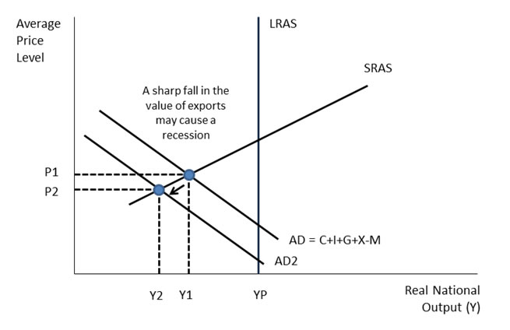

Many industries rely heavily on our key export industries remaining competitive – these include:

* Transportation / freight businesses
* Trade finance businesses
* Insurance businesses

Many other service businesses that operate in ports and airports

**The Exchange rate and the Balance of Payments**

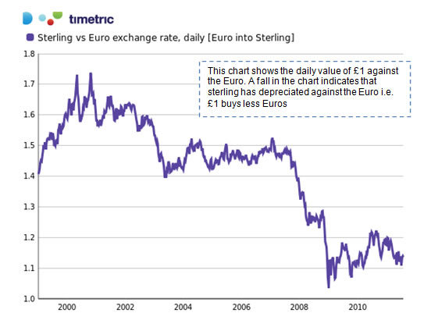

*The pound has depreciated by a large amount against the Euro in recent years – has this improved the UK’s balance of trade in goods and services with the Euro Zone economy?*

* Changes in the exchange rate can have a big effect on the balance of payments although these effects have uncertain **time lags**.
* When [sterling](http://www.tutor2u.net/blog/index.php/economics/tagged/tag/sterling/) is strong, the price of UK goods and services in foreign markets rises and UK exporters find it harder to sell their products overseas. It is also cheaper for UK consumers to buy imported goods and services because the pound buys more foreign currency than it did before
* So a strong pound may lead to a worsening of the balance of trade – much depends on the value of price elasticity of demand for exports and imports.

**The balance of payments and the standard of living**

* A common misconception is that balance of payments deficits are always bad for the economy. This is not necessarily true.
* In principle, there is nothing wrong with a trade deficit. It simply means that a country must rely on foreign direct investment or borrow money to make up the difference
* In the short term, if a country is importing a high volume of goods and services this is a boost to living standards because it allows consumers to buy more consumer durables.

**Countries with current account surpluses**

|  |  |
| --- | --- |
| **Surplus countries (balance of payments on current account for 2011)** | % of GDP |
| China | 3.1 |
| Germany | 5.3 |
| Malaysia | 11.1 |
| Switzerland | 13.9 |
| Singapore | 17.7 |
| Norway | 18.2 |
| Saudi Arabia | 31.8 |
| Kuwait | 39.7 |

Many countries operate with a trade and current account surplus – good examples are China, Germany, Norway and emerging market countries with strong export sectors. There are several causes and each country will have a unique set of circumstances:

**Export-oriented growth**: Some countries have set out to increase the [capacity](http://www.tutor2u.net/blog/index.php/economics/tagged/tag/capacity/) of their export industries as a growth strategy. Investment in new capital provides the means by which economies of scale can be exploited, unit costs driven down and comparative advantage can be developed.

**Foreign direct investment**: Strong export growth can be the result of a high level of foreign direct investment where foreign affiliates establish production plants and or exporting.

**Undervalued exchange rate**: A trade surplus might result from a country attempting to depreciate its exchange rate to boost [competitiveness](http://www.tutor2u.net/blog/index.php/economics/tagged/tag/competitiveness/). Keeping the exchange rate down might be achieved by currency intervention by a nation’s central bank, i.e. selling their own currency and accumulating reserves of foreign currency. One of the persistent disputes between the USA and China has revolved around allegations that the Chinese have manipulated the Yuan so that export industries can continue to sell huge volumes into North American markets.

**High domestic savings rates**: Some economists attribute current account surpluses to high levels of domestic savings and low domestic consumption of goods and services. China has a high household saving ratio and a huge trade surplus; in contrast the [savings ratio](http://tutor2u.net/blog/index.php/economics/tagged/tag/savings+ratio/) in the United States has collapsed and their trade deficit has got bigger. Critics of countries with persistent trade surpluses argue they should do more to expand domestic demand to boost world trade.

**Closed economy** – some countries have a low share of national income taken up by imports – perhaps because of a range of tariff and non-tariff barriers.

**Strong investment income from overseas investments**:  A part of the current account that is often overlooked is the return that investors get from purchasing assets overseas – it might be the profits coming home from the foreign subsidiaries of multinational businesses, or the interest from money held on overseas bank accounts, or the dividends from taking equity stakes in foreign companies.

**Economic Policies to Improve the Balance of Payments**

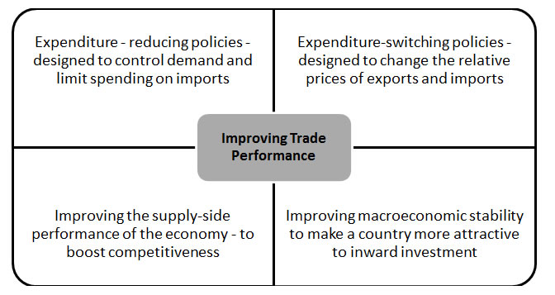

* There are a number of policies that can be introduced to achieve an improvement in a country’s trade balance – some of them focus on changing the growth of demand, others look to improve the supply-side competitiveness of an economy
* As with any macroeconomic ‘problem’ effective policies are those that target the underlying causes.

**Policy options**

**Demand management**:

1. Reductions in government spending, higher interest rates and higher taxes could all have the effect of dampening consumer demand reducing the demand for imports
2. When domestic demand is low, this creates an incentive and the spare capacity for businesses to export overseas to replace low spending in the home economy

**Natural effects of the economic cycle**: One would expect to see a trade deficit fall during a recession – so some of the deficit is partially self-correcting.

**A lower exchange rate**:

1. A lower exchange rate provides a way of improving [competitiveness](http://www.tutor2u.net/blog/index.php/economics/tagged/tag/competitiveness/), reducing the overseas price of exports and making imports more expensive
2. For those countries operating with a managed exchange rate, the government may decide to authorise intervention in the currency markets to manipulate the value of the currency

**Supply-side improvements**:

1. Policies to raise productivity, measures to bring about more [innovation](http://www.tutor2u.net/blog/index.php/economics/tagged/tag/innovation/) and incentives to increase investment in industries with export potential are supply-side measures designed to boost exports performance and compete more effectively with imports. The time-lags for supply-side policies to have an impact are long.
2. Policies to encourage business start-ups – successful small businesses with export potential
3. Investment in education and health-care to boost human capital and increase competitiveness in fast-growing and high value industries such as bio-technology, engineering, finance, medicine
4. Investment in modern critical infrastructure to support businesses and industries involved in international markets

**Protectionist measures** such as import quotas and tariffs

**How do events in the USA affect the British economy?**

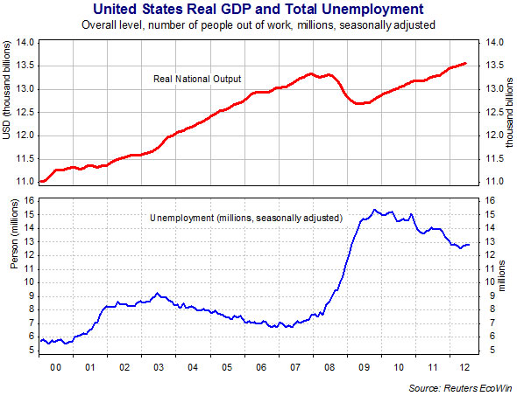

The United States is the largest economy in the world and developments in her economy inevitably have a significant impact on the global economy and prospects for Britain.

**1/ Trade**

Around 16% of the UK’s trade in goods and services is with the United States, indeed, save for the European Union, the USA is the largest single export market for the UK. The UK runs a trade surplus with the USA

**2/ Investment**

The UK has many large-scale investments in the United States and the USA is the leading overseas destination for British investment. When the US economy is strong, successful external investments from UK companies and individuals generate a flow of interest, profits and dividends back into the UK - adding to GNP and helping to improve the current account of the balance of payments.

**3/ Exchange rates and commodity prices**

The US dollar ($) - sterling exchange rate is one of the most heavily traded currencies in the international financial system. The value of the dollar (which is a floating currency) is determined by factors such as relative interest rates, expected rates of return on overseas investments, the strength of the domestic US economy, growth and inflation expectations and world demand for the US dollar as a reserve currency.

Consider a situation where the US dollar weakens against a basket of international currencies. This is likely to cause an appreciation in the value of sterling against the dollar. Because many commodities are priced in dollars, then a rising $/£ exchange rate will make it cheaper for the UK to import commodities and raw materials.