**Economic Growth**

***Author****:* [*Geoff Riley*](http://www.tutor2u.net/blog/index.php/site/author/3/)***Last updated:*** *Sunday 23 September, 2012*

**Introduction**

**What is meant by economic growth?**

[Economic growth](http://www.tutor2u.net/blog/index.php/economics/C206/) is a **long-term expansion of a country’s productive potential**

Short term growth is measured by the annual % change in real national output – this is mainly driven by the level of aggregate demand (C+I+G+X-M) but is also affected by shifts in SRAS

Long term growth is shown by the increase in trend or potential GDP and this is illustrated by an outward shift in a country’s long run aggregate supply curve (LRAS)

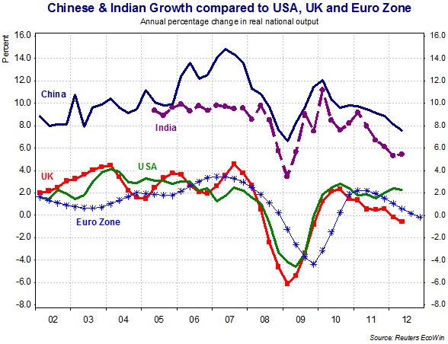

There are big variations in average growth rates for different countries and evidence for this is shown in the chart above which tracks real GDP changes for China, India, the UK, USA and average growth for nations inside the Euro Zone.

* China and India are examples of very fast-growing countries. Their annual growth has far exceeded that for most advanced economies; China has out-paced India although both have experienced a slowdown in growth over the last couple of years
* For nations such as the USA and the UK, “normal growth” is of the order of 2 – 3% per year – depending on where each economy is in their business (trade) cycle. The Euro Zone growth rate is similar but keep in mind that this is an average, there are seventeen countries at present who share the same currency, some have been growing quite quickly and others have struggled to escape from a deep recession and the persistent risk of a depression.

**Economic Growth and the Production Possibility Frontier**

An increase in long run aggregate supply is illustrated by an outward shift in the PPF

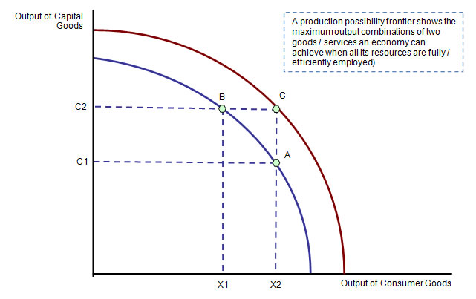

* In our diagram we see how a rise in a nation’s productive capacity causes the PPF to shift out and this allows increased supply both of consumer and capital goods.
* Where the economy ends up depends on the decisions made about the allocation of scarce resources between products to be bought and consumed today and the production of capital goods such as new technology, plant and equipment and buildings.

**Growth is not the same as development!**

The table below tracks the growth rates achieved in the world economy for three recent years and also for developing countries excluding China and India.

|  |  |  |  |  |
| --- | --- | --- | --- | --- |
| **Real GDP growth (annual % change)** | | 2010 | 2011 | 2012 |
|  | World Economy | 4.1 | 2.7 | 2.5 |
|  | Developing countries excluding China and India | 5.6 | 4.4 | 3.6 |

**Key drivers of growth**

* There have been numerous research studies in what determines long term GDP growth
* Every country is different, each factor will vary in importance for a country at a given point in time

Remember too that in our increasingly inter-connected globalising world, economic growth does not happen in isolation. Events in one country and region can have a significant effect on growth prospects in another

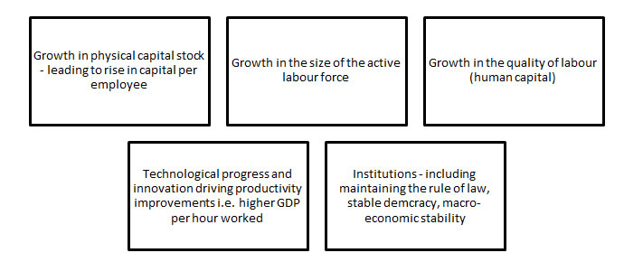

**Advantages of Economic Growth**

1. **Higher living standards** – i.e. an increase in real income per head of population
2. [**Employment**](http://www.tutor2u.net/blog/index.php/economics/tagged/tag/employment/) **effects** - growth stimulates more jobs to help new people as they enter the labour market

*In the long term, an economy grows because technology gets better and we get better at producing things. In the short term, growth is an indication that the economy is producing as much as it could be and resources are not being needlessly wasted. With a growing population and rising wages, the economy has to grow to create sufficient new jobs.*

*Professor Jon Von Reenan, LSE*

**Fiscal dividend** – sustained GDP growth boosts tax revenues and provides the government with extra money to improve public services such as education and healthcare. It makes it easier for a government to reduce the size of a budget deficit

1. **Investment - the accelerator effect** - rising demand and output encourages investment – this sustains growth by increasing long run aggregate supply
2. **Consumer and business confidence** - growth has a positive impact on business [profits](http://www.tutor2u.net/blog/index.php/economics/tagged/tag/profits/) & confidence. A stronger economy will help to persuade consumers that the time is right to make major purchases
3. Growth can also help protect the environment such as low-carbon **investment**, **innovation** and **research and development**, resulting in more efficient production processes to reduce costs. **Ethical consumerism** and **corporate social responsibility** has become important in recent years.

**Virtuous circle of growth**

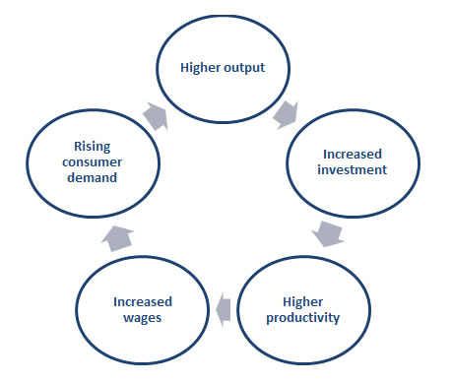

**Disadvantages of economic growth**

There are **economic and social costs** of a fast-expanding economy.

**Inflation risk**: If demand races ahead of aggregate supply the scene is set for rising prices. Many fast growing developing countries have seen high rates of inflation in recent years, a good example is India

**Working hours** – sometimes there are fears that a fast-growing economy places increasing demands on the hours that people work and can upset work-life balance

**Structural change** – although a growing economy will be creating more jobs, it also leads to structural changes in the pattern of jobs. Some industries will be in decline whilst others will be expanding. Structural unemployment can rise even though it appears that a country is growing – the labour force needs to be occupationally mobile.

[**Environmental**](http://www.tutor2u.net/blog/index.php/economics/C6/) **concerns**:

* Fast growth can create **negative externalities** for example higher levels of noise pollution and lower air quality arising from air pollution and road congestion
* Increased consumption of de-merit goods which damages social welfare
* It can leads to a huge increase in household and industrial waste which again creates external costs for society

Growth that leads to environmental damage may lower the **sustainable rate of growth**.  Examples include the destruction of rain forests through **deforestation**, the **over-exploitation of fish stocks** and **loss of natural habitat** and bio-diversity created through the construction of new roads, hotels, retail malls and industrial estates.

**Deforestation** releases more CO2 into the atmosphere each year than all of the world's planes, trains and automobiles put together. Globally, an area almost the size of England and Wales is cut down every year releasing billions of tons of CO2 into the atmosphere.

**Using-up scarce resources**

*“The consequences of environmentally unsustainable production are already visible. Increased exposure to drought, floods and environmental stress is a major impediment to realizing people’s aspirations”*  
*Source: UNDP Report, 2011*

The world’s resources are limited, and recognizing this fact and trying to preserve them for future generations is vital for sustainable growth. Our rampant use of oil has run many reserves dry and each year it becomes more difficult to find new oil fields.

Even water, which so many people take for granted will become a scarce resource, like many other raw materials. According to the United Nations, by 2025 1.8bn people will be affected by **water scarcity**. The pollution caused by [economic growth](http://www.tutor2u.net/blog/index.php/economics/C206/) is another concern.

The [Stern Report](http://www.hm-treasury.gov.uk/independent_reviews/stern_review_economics_climate_change/sternreview_index.cfm) highlighted the dangers of our disregard for the environment, especially large CO2 [emissions](http://www.tutor2u.net/blog/index.php/economics/tagged/tag/emissions/). It is predicted that many species will become extinct as forests and jungles, homes for many animals, are cut down to pave way for the growing world population.

At present 16,000 species are threatened today. In 1900 according to the UN’s [Global Environmental Outlook](http://www.unep.org/geo/), there were 7.91 hectares per person, while it is estimated that there will only be 1.63 by 2050 if present trends continue.

**Economic Growth and Inequality**

*"Although economic growth in China has created vast wealth for some, it has amplified the disparities between rich and poor. Although the average wealth per Chinese citizen was $17,126 - almost double that of other high growth economies such as India - median wealth was just $6,327. In 2010, China's Gini-coefficient stood at 0.47. Inequality in China has now surpassed that in the United States."*

*Source: Dr Damian Tobin School of Oriental and African Studies*

Not all of the benefits of growth are evenly distributed. A rise in real GDP can lift millions of people out of **absolute poverty** but it can often be accompanied by widening **income and wealth inequality** in society that is reflected in an increase in **relative poverty**

If inequality grows as a country becomes richer, this raises important questions about a potential trade-off between equity and efficiency

The **Gini coefficient** is one way to measure the inequalities in the distribution of income and wealth in different countries. The higher the value for the Gini co-efficient (the maximum value is 1), then greater the inequality.

Countries such as Japan, Denmark and Sweden typically have low values for the Gini coefficients whereas African and South American countries have an enormous gulf between the incomes of the richest and the poorest elements of the population.

When economists look at data on income and income inequality they nearly always focus on median rather than mean incomes per capita.

The reason is that the very uneven distribution of income means that there are people who earn astounding salaries and wages and the income of the super-rich tends to drive up mean incomes. For example, In the United States, mean income is almost a third higher than median income, and the gap is growing

***Inequality in the UK in 2011: Households below average income***

*18% of children (2.3 million) in households with incomes below 60 per cent of medium disposable income*

*15% of working-age adults (5.5 million) had incomes below 60 per cent of medium disposable income*

*17% of pensioners (2.0 million) had incomes below 60 per cent of medium disposable income*

Why does fast growth often lead to a **widening of inequalities** in both developed and developing countries?

* Very high increases in the pay of people in the top-paying jobs – market-based economies offer the highest rewards to households with the most valuable skills, education and access to capital
* Increasing wealth including rising property prices – fast-growing economies will often seen a rapid increase in property prices
* Growing gaps between urban and rural areas with rural poverty on the increase
* High fertility in the poorest households
* Linked effects of inequality in health and education

Much depends on the extent to which a particular government has a welfare benefits and/or a progressive tax system in place and also a desire to redistribute rising incomes and wealth so that the benefits of growth can be more equitably shared out.

**Evaluation: What are the main constraints or limits on economic growth?**

*The USA economy is no longer the biggest single driver of global demand. 70% of world economic growth in the next few years will come from the emerging world*

**The Importance of Infrastructure**  
*“Infrastructure systems – transport, electricity, telecommunications, water, etc. – play a vital role in economic and social development. Increasingly interdependent, they are a means towards ensuring the delivery of goods and services that promote economic prosperity and growth, and contribute to quality of life”*  
*Source: OECD Report, 2008*

In this section we outline some of the possible constraints or limitations on the sustained growth of a country.   
Some of these factors apply mainly to developed countries and some are focused on the growth potential of lower-income emerging economies many of whom have enjoyed rapid growth in recent years.

Remember that economic growth is a long-term concept referring in the main to a nation’s productive potential and international competitiveness – the factors discussed below are some of the demand and supply-side issues that can hold back potential output growth for a country.

**What can limit the rate of economic growth?**

**Infrastructure** – infrastructure includes capital such as ports, transport networks, energy, power and water supplies and telecommunications networks. Poor infrastructure hampers growth because it causes higher costs and delays for businesses, reduces the mobility of labour and hits the ability of export businesses to get their products to international markets. A good example is [India](http://www.economist.com/node/18986387) whose future growth is often said to be threatened by structural weaknesses in her infrastructure. Many countries will need to increase their spending on infrastructure in the years ahead to adapt to and deal with the consequences of climate change.

**Dependence on limited exports** – many nations still relying on specialising and then exporting low value added primary commodities and the prices of these goods can be highly volatile on world markets. When prices fall, an economy will see a sharp reduction in export incomes, a higher trade deficit and a growing risk that a nation will not be able to finance investment in education, healthcare and core infrastructure. Over-specialisation can make a country vulnerable to the global economic cycle.

**Vulnerability to external shocks** – in today’s global economy, events in one part of the world can quickly have an effect in many other countries. Consider the fall-out from the global financial crisis of 2007-2010 which brought about recession and deep financial distress in many regions.

**Access to Finance**  
*“Ensuring access to finance is essential for businesses to survive, invest and grow. Finance might come from banks, private investors or capital markets. Barriers to accessing appropriate finance can prevent new companies from starting up and existing businesses from investing and growing”*  
*Source: UK Treasury Report*

**Low national savings and low absolute savings** – savings are needed to provide finance for investment. In many smaller low-income countries, high levels of poverty make it almost impossible to generate sufficient savings to provide the funds needed to fund investment projects. This increases reliance on international borrowing or tied aid.

**Limited access to financial capital** and poorly developed domestic capital markets – this is particularly the case for many small, low-income countries

**Corruption and poor governance** – this is a crucial factor for many developing countries. High levels of deeply embedded corruption and bureaucratic delays can harm growth in many ways for example inhibiting inward investment and also making it more likely that domestic businesses will invest overseas rather than at home. Governments need a stable and effective legal framework to collect taxes to pay for public services. Look at deficit and debt problems facing countries such as Greece. In India, there are 15 times more phone subscribers than taxpayers. If a legal system cannot protect private property rights then there will be less research and development & innovation.

**Declining and/or ageing population** – in some countries the actual size of the population is declining partly as a result of net outward migration. If a nation loses many younger workers this can have a damaging effect on growth. The changing age-structure of a population also matters, leading for example to a fall in the ratio of workers to dependants.

**Rising inflation** – fast growing countries may experience an accelerating rate of inflation which can have damaging economic consequences – these are covered in the chapter on inflation. Two effects in particular can hit growth, namely falling real incomes and profits together with higher costs and reduced competitiveness in international markets. In our chart below we track real GDP growth and inflation rates in India – notice the steep rise in inflation in recent years. Many other developing countries have seen high rates of inflation in large part because of booming food and other commodity prices.

**Sustainability**  
*“Anyone who believes exponential growth can go on forever in a finite world is either a madman or an economist.”*  
*Kenneth Boulding, economist*

**Persistent trade deficits due to rising imports** – Some countries may experience large and widening deficits on the current account of their balance of payments. This means that the value of imported goods and services is greater than the value of exports and net investment incomes leading to an outflow of money from their economy. High trade deficits might have to be covered by foreign borrowing or a reliance on inflows of capital investment from overseas multinationals. And large trade gaps can eventually lead to a currency crisis and possible loss of investor confidence.

**Over-extraction of the natural resource base** – natural resources provide an important source of wealth for many lower-income countries and when world prices are high, there is incentive to increase extraction rates to boost export earnings. However this might lead to an excessive rate of extraction that ultimately damages the growth potential of an economy. Deforestation and rapid extraction of oceanic fish stocks are two good examples of this.

**Inadequate investment in human capital** – to sustain growth requires longer-term improvements in productivity, research & development and innovation. Whilst physical capital such as factories and technology plays a role, so too does the quality of the human input into production. Economic growth might be limited by skills shortages as businesses seek to expand which forces up average wages and labour costs. High level skills and qualifications are also needed to help businesses (and ultimately countries) to move up the value chain and supply products that can be sold for higher prices in the world economy.

**Weaknesses in promoting and supporting entrepreneurship** – a thriving enterprise culture is crucial to encouraging new business start-ups and supporting them through the early growth stage.

**Economic and social costs from high levels of inequality of income and wealth** – this is an issue that has grown in significance over the years. Although two decades or more of globalisation has strengthened average growth rates in many lower and middle-income countries, it has brought an increase in inequalities of income and wealth. When the gap between rich and poorer communities gets bigger there are many possible dangers not least the costs of social tension and conflict and increasing spending on insurance, law and order systems and government welfare bills.

**Excessive borrowing** – this feature is common in fat-growth phases for richer developed countries. In particular we have seen in recent years a huge rise in personal sector borrowing and debt, much of it linked to easy credit availability and rising property prices. When a housing bubble bursts and house prices fall, many thousands find themselves in deep trouble.

**Protectionism** – Protectionism is the use of tariff and non-tariff restrictions on imports to protect domestic producers from foreign competition. These barriers to exporting restrict access to international markets and damage growth for nations who have chosen an open approach to trade and investment as a key pathway to expanding their economies. China and South Korea have had export-led growth during most of their rapid-growth years. In the wake of the global financial crisis there have been widespread fears of a return to protectionist trade policies.