**Inflation**

**Introduction**

**What is inflation?**

* [Inflation](http://www.tutor2u.net/blog/index.php/economics/C164/) is a **sustained increase in the cost of living or the average / general price level** leading to a fall in the **purchasing power of money**.
* The opposite of inflation is deflation which is a decrease in the cost of living or average price level.

**How is the rate of inflation measured?**

* The **rate of inflation** is measured by the annual percentage change in consumer prices.
* The British government has set an **inflation target** of 2% using the **consumer price index** (CPI)
* It is the job of the [Bank of England](http://www.bankofengland.co.uk/Links/setframe.html) to set interest rates so that aggregate demand is controlled, inflationary pressures are subdued and the inflation target is reached
* The Bank is independent of the government with control of interest rates and it is free from political intervention. *The Bank is also concerned to avoid* ***price deflation*** *– we return to this a little later.*

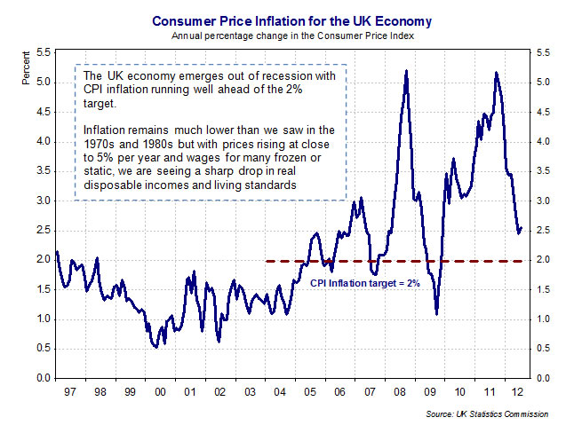

**Falling inflation does not mean falling prices!**

Please remember that a ***fall in the rate of inflation*** is not the same thing as a ***fall in prices***! Have a look at the chart above which measures the rate of consumer price inflation for the UK. Notice how in 2009 there was a steep drop in inflation from 5 per cent to 1 per cent over the course of the year. Inflation was falling – but the rate remained positive – meaning that prices were rising but at a slower rate! A slowdown in inflation is not the same as deflation! For this to happen, inflation would have to be negative.  
**How is the rate of inflation calculated?**

* The **cost of living** is a measure of changes in the average cost of buying a basket of different goods and services for a typical household
* In the UK there are two measures, the **Retail Price Index** (RPI) & the **Consumer Price Index** (CPI).
* The major difference between the two measures, is that CPI calculations excludes payments on mortgage interest - it is thought that by excluding mortgages, the CPI is a better measure of the impact of macroeconomic policy
* The CPI is a **weighted price index**. Changes in weights reflect shifts in the spending patterns of households in the British economy as measured by the Family Expenditure Survey.

**Calculating a weighted price index**

The following hypothetical example shows how to calculate a weighted price index.

|  |  |  |  |
| --- | --- | --- | --- |
| Category | Price Index | Weighting | Price x Weight |
| Food | 104 | 19 | 1976 |
| Alcohol & Tobacco | 110 | 5 | 550 |
| Clothing | 96 | 12 | 1152 |
| Transport | 108 | 14 | 1512 |
| Housing | 106 | 23 | 2438 |
| Leisure Services | 102 | 9 | 918 |
| Household Goods | 95 | 10 | 950 |
| Other Items | 114 | 8 | 912 |
|  |  | 100 | 10408 |

The price index for this year is: **the sum of (price x weight) / sum of the weights**

* So the price index for this year is 104.1 (rounding to one decimal place)
* The rate of inflation is the % change in the price index from one year to another.
* So if in one year the price index is 104.1 and a year later the price index has risen to 112.5, then the annual rate of inflation = (112.5 – 104.1) divided by 104.1 x 100. Thus the rate of inflation = 8.07%.

**Limitations of the Consumer Price Index as a measure of inflation**

* **The CPI is not fully representative**:
  + Since the CPI represents the expenditure of the ‘average’ household, inevitably it will be inaccurate for the ‘non-typical’ household, for example, 14% of the index is devoted to motoring expenses - inapplicable for non-car owners.
  + Single people have different spending patterns from households that include children, young from old, male from female, rich from poor and minority groups.
  + We all have our own ‘weighting’ for goods and services that does not coincide with that assigned for the consumer price index.
* **Housing costs:** The ‘housing’ category of the CPI records changes in the costs of rents, property and insurance, repairs. It accounts for around 16% of the index. Housing costs vary greatly from person to person.
* **Changing quality of goods and services**: Although the price of a good or service may rise, this may also be accompanied by an improvement in quality as the product. It is hard to make price comparisons of, for example, electrical goods over the last 20 years because new audio-visual equipment is so different from its predecessors. In this respect, the CPI may over-estimate inflation. The CPI is slow to respond to the emergence of new products and services.

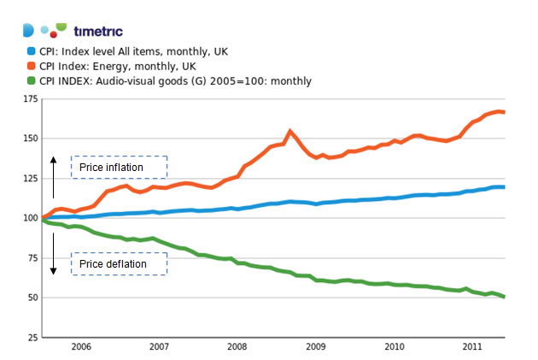

Our chart above illustrates sub-sections of the UK consumer price index. The base year for the calculation is 2005 so prices in January 2005 are given an index number of 100. Since then overall the consumer price index has increased by nearly 24% but energy prices (e.g. electricity and gas bills) have jumped by much more whereas there has been persistent and deep deflation in the prices of many audio-visual products.

**Deflation**

* **Price deflation** happens when the **rate of inflation becomes negative**. I.e. the general price level is falling and the purchasing power of say £1,000 in cash is increasing
* Some countries have experienced periods of deflation in recent years; perhaps the most well-known example was Japan during the late 1990s and in the current decade. In Japan, the root cause of deflation was slow growth and a **high level of spare capacity** that was driving prices lower.

**Hyperinflation**

* **Hyperinflation** is extremely rare. Recent examples include Yugoslavia [Argentina](http://news.bbc.co.uk/hi/english/world/americas/country_profiles/newsid_1192000/1192478.stm) , [Brazil](http://news.bbc.co.uk/hi/english/world/americas/country_profiles/newsid_1227000/1227110.stm) , [Georgia](http://news.bbc.co.uk/hi/english/world/europe/country_profiles/newsid_1102000/1102477.stm) and [Turkey](http://news.bbc.co.uk/hi/english/world/europe/country_profiles/newsid_1022000/1022222.stm) (where inflation reached 70% in 1999)
* The classic example of hyperinflation was the [rampant inflation in Weimar Germany between 1921 and 1923](http://wueconb.wustl.edu/E1043S00/schenkcd/EconomicCatastrophe/HyperInflation.html) .
* When hyperinflation occurs, the value of money becomes worthless and people lose all confidence in money both as a **store of value** and also as a **medium of exchange**
* The [recent hyperinflation in Zimbabwe](http://news.bbc.co.uk/1/hi/business/7474136.stm) is a good example of the havoc that can be caused when price inflation spirals out of control. It has made it virtually impossible for businesses to function in any kind of normal way.

For Britain the worst inflation experienced in modern times was during the [mid to late 1970s](http://www.telegraph.co.uk/money/main.jhtml?xml=/money/2008/06/09/ccoil109.xml) when prices were rising at an annual rate of over twenty per cent. At the same time the economy was suffering from slow growth and rising unemployment and this gave rise to the idea of [**stagflation**](http://www.tutor2u.net/blog/index.php/economics/tagged/tag/stagflation/)**.**

**Understanding the main causes of inflation**

* Inflation can come from both the **demand** and the **supply-side** of an economy
* Inflation can arise from **internal** and **external** events

Some inflationary pressures direct from the **domestic economy**, for example the decisions of utility businesses providing electricity or gas or water on their tariffs for the year ahead, or the pricing strategies of the food retailers based on the strength of demand and competitive pressure in their markets.

A rise in the rate of VAT would also be a cause of increased domestic inflation in the short term because it increases a firm’s production costs.

Inflation can also come from **external sources**, for example a sustained rise in the price of crude oil or other imported commodities, foodstuffs and beverages.

**Fluctuations in the exchange rate** can also affect inflation – for example a fall in the value of the pound against other currencies might cause **higher import prices** for items such as foodstuffs from Western Europe or technology supplies from the United States – which feeds through directly or indirectly into the consumer price index.

**Demand-Pull Inflation**

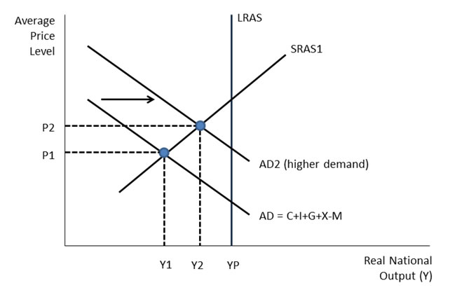

* Demand pull inflation occurs when aggregate demand is growing at an unsustainable rate leading to **increased pressure on scarce resources** and a **positive output gap**
* When there is **excess demand**, producers are able to raise their prices and achieve bigger **profit margins** because demand is running ahead of supply
* Demand-pull inflation becomes a threat when an economy has experienced a boom with [GDP](http://www.tutor2u.net/blog/index.php/economics/tagged/tag/gdp/) rising faster than the long-run trend growth of potential GDP
* Demand-pull inflation is likely when there is **full employment of resources** and SRAS is inelastic

**Main Causes of Demand-Pull Inflation**

* A [**depreciation**](http://www.tutor2u.net/blog/index.php/economics/tagged/tag/depreciation/) **of the exchange rate** increases the price of imports and reduces the foreign price of a country’s exports.  If consumers buy fewer imports, while exports grow, AD in will rise – and there may be a [multiplier effect](http://www.tutor2u.net/blog/index.php/economics/tagged/tag/multiplier+effect/) on the level of demand and output
* **Higher demand from a** [**fiscal stimulus**](http://www.tutor2u.net/blog/index.php/economics/tagged/tag/fiscal+stimulus/) e.g. lower direct or indirect taxes or higher government spending.  If direct taxes are reduced, consumers have more disposable income causing demand to rise. Higher government spending and increased borrowing creates extra demand in the circular flow
* **Monetary stimulus to the economy:** A fall in interest rates may stimulate too much demand – for example in raising demand for loans or in leading to house price inflation. Monetarist economists believe that inflation is caused by “too much money chasing too few goods” and that governments can lose control of inflation if they allow the financial system to expand the money supply too quickly.
* **Fast growth in other countries** – providing a boost to UK exports overseas. Export sales provide an extra flow of income and spending into the UK circular flow – so what is happening to the economic cycles of other countries definitely affects the UK

**Cost-Push Inflation**

Cost-push inflation occurs when firms respond to **rising costs**, by increasing prices to **protect their profit margins**.

There are many reasons why costs might rise:

* **Component costs:** e.g. an increase in the prices of raw materials and other components. This might be because of a rise in commodity prices such as oil, copper and agricultural products used in food processing. A recent example has been a surge in the world price of wheat.
* **Rising labour costs** - caused by wage increases, which are greater than improvements in productivity. Wage costs often rise when unemployment is low because skilled workers become scarce and this can drive pay levels higher. Wages might increase when people **expect higher inflation** so they ask for more pay in order to protect their real incomes. Trade unions may use their bargaining power to bid for and achieve increasing wages, this could be a cause of cost-push inflation
* [**Expectations**](http://www.tutor2u.net/blog/index.php/economics/tagged/tag/expectations/) **of inflation** are important in shaping what actually happens to inflation. When people see prices are rising for everyday items they get concerned about the effects of inflation on their real standard of living. One of the dangers of a pick-up in inflation is what the [Bank of England](http://www.tutor2u.net/blog/index.php/economics/tagged/tag/bank+of+england/) calls “**second-round effects**” i.e. an initial rise in prices triggers a burst of higher pay claims as workers look to protect their way of life. This is also known as a “wage-price effect”
* **Higher indirect taxes** – for example a rise in the duty on alcohol, fuels and cigarettes, or a rise in Value Added Tax. Depending on the price elasticity of demand and supply for their products, suppliers may choose to pass on the burden of the tax onto consumers.
* **A fall in the exchange rate** – this can cause cost push inflation because it leads to an increase in the prices of imported products such as essential raw materials, components and finished products
* **Monopoly employers/profit-push inflation** – where dominants firms in a market use their market power (at whatever level of demand) to increase prices well above costs

Cost-push inflation such as that caused by a large and persistent rise in the world price of crude oil can be shown in a diagram by an **inward shift of the short run aggregate supply curve**. The fall in SRAS leads to a contraction of national output together with a rise in the level of prices.  This is shown in the next diagram.

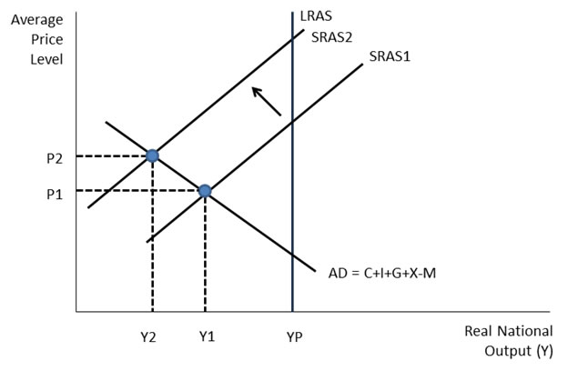

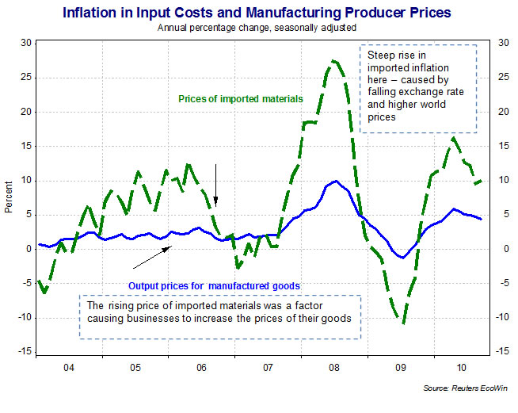

**What are some of the main consequences of inflation?**

*"The lesson of the past fifty years is that, when inflation becomes embedded, the cost of getting it back down again is a prolonged period of sluggish output and high unemployment. Price stability – returning inflation to the target – is a precondition for sustained growth."*

*Source: Mervyn King, Governor of the Bank of England, Mansion House speech, June 2008*

Many government s have a **target for a low but positive rate of inflation**. They believe that persistently high inflation can have damaging economic and social consequences.

* **Income redistribution**: One risk of higher inflation is that it has a **regressive effect** on lower-income families and older people in society. This happen when prices for food and domestic utilities such as water and heating rises at a rapid rate.
* **Falling real incomes**: With millions of people facing a cut in their wages or at best a pay freeze, rising inflation leads to a fall in real incomes.
* **Negative real interest rates**: If interest rates on savings accounts are lower than inflation, people who rely on interest from their savings will be poorer. Real interest rates for millions of savers have been negative for at least four years
* **Cost of borrowing**: High inflation may also lead to higher interest rates for businesses and people needing loans and mortgages as financial markets protect themselves against rising prices and increase the cost of borrowing on short and longer-term debt. There is also pressure on the government to increase the value of the state pension and unemployment benefits and other welfare payments as the cost of living climbs higher.
* **Risks of wage inflation**: High inflation can lead to an increase in pay claims as people look to protect their real incomes. This can lead to a rise in unit labour costs and lower profits for businesses
* **Business competitiveness**:If one country has a much higher rate of inflation than others for a considerable period of time, this will make its exports less price competitive in world markets. Eventually this may show through in reduced export orders, lower profits and fewer jobs, and also in a worsening of a country’s trade balance. A fall in exports can trigger negative multiplier and accelerator effects on national income and employment.
* **Business uncertainty**: High and volatile inflation is not good for business confidence partly because they cannot be sure of what their costs and prices are likely to be. This uncertainty might lead to a lower level of capital investment spending.

*High and volatile inflation can have serious economic and social consequences – summarized below*

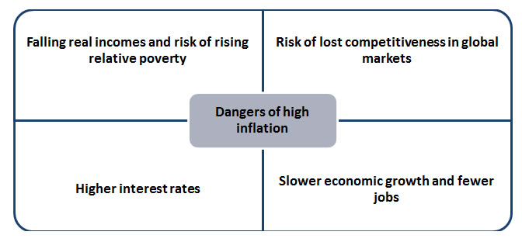

**Why is the rate of inflation difficult to forecast accurately?**

The rate of inflation is one of the most important macroeconomic indicators that we study in macroeconomics. Data on prices is published regularly and given lots of attention by the media and the financial markets. Many agents be they businesses, households and governments would like to have accurate forecasts of what is likely to happen to prices in the future because they affect spending, saving and investment decisions.

Inflation is a difficult indicator to forecast accurately. Our chart below shows the UK CPI inflation forecast published by the Bank of England in their quarterly Inflation Report. Remember that the Bank of England has a mandate to control the rate of inflation so that CPI inflation remains close to the 2% target. The probability fan chart for inflation indicates the range of probabilities for inflation in the forecast period. Notice how wide is that range, there is much uncertainty about what is likely to happen to inflation in the UK. In 2014, there is the possibility of deflation (inflation of -1%) or inflation higher than 4%. The darker the shading, the higher the probability attached to the outcome.

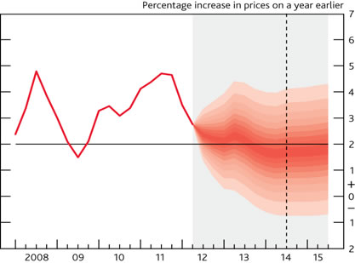

**Some reasons for difficulties in forecasting inflation**

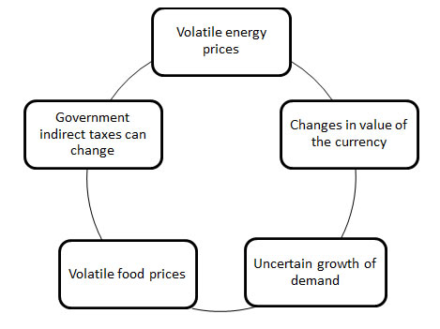

***The Bank’s Inflation Target***  
*In order to maintain price stability, the Government has set the Bank’s Monetary Policy*  
*Committee (MPC) a target for the annual inflation rate of the Consumer Prices Index of 2%. Subject to that, the MPC is also required to support the Government’s objective of maintaining high and stable growth and employment*

**Controlling inflation – macroeconomic policies**

Inflation can be reduced by policies that (i) slow down the growth of AD or (ii) boost the rate of growth of aggregate supply (AS)

* **Fiscal policy**:
  1. Controlling aggregate demand is important if inflation is to be controlled. If the government believes that AD is too high, it may choose to ‘tighten fiscal policy’ by reducing its own spending on public and merit goods or welfare payments
  2. It can choose to raise direct taxes, leading to a reduction in real disposable income
  3. The consequence may be that demand and output are lower which has a negative effect on jobs and real economic growth in the short-term
* **Monetary policy**:
  1. A ‘**tightening of monetary policy’** involves the central bank introducing a period of higher interest rates to reduce consumer and investment spending
  2. Higher interest rates may cause the **exchange rate** to appreciate in value bringing about a fall in the cost of imported goods and services and also a fall in demand for exports (X)
* **Supply side economic policies:**
  1. Supply side policies seek to increase **productivity**, [**competition**](http://www.tutor2u.net/blog/index.php/economics/tagged/tag/competition/) **and** [**innovation**](http://www.tutor2u.net/blog/index.php/economics/tagged/tag/innovation/) – all of which can maintain lower prices. These are ways of controlling inflation in the medium term
     + A reduction in company taxes to encourage greater investment
     + A reduction in taxes which increases risk-taking and incentives to work – a cut in income taxes can be considered both a fiscal and a supply-side policy
     + Policies to open a market to more competition to increase supply and lower prices
  2. Rising productivity will cause an outward shift of aggregate supply

1. Direct controls -  a government might choose to introduce direct controls on some prices and wages
   1. Public sector pay awards – the annual increase in government sector pay might be tightly controlled or even froze (this means a real wage decrease).
   2. The prices of some utilities such as water bills are subject to regulatory control – if the price capping regime changes, this can have a short-term effect on the rate of inflation

**Evaluation points – how best can inflation be controlled?**

* The most appropriate way to control inflation in the short term is for the government and the central bank to keep control of aggregate demand to a level consistent with our productive capacity
* AD is probably better controlled through the use of monetary policy rather than an over-reliance on using fiscal policy as an instrument of **demand-management**
* Controlling demand to limit inflation is likely to be ineffective in the short run if the main causes are due to external shocks such as high world food and energy prices
* The UK is an open economy in which inflation is strongly affected by events in the rest of the world
* In the long run, it is the growth of a country’s [supply-side](http://www.tutor2u.net/blog/index.php/economics/C67/) productive potential that gives an economy the flexibility to grow without suffering from acceleration in cost and price inflation.