**International Trade**

***Author****:* [*Geoff Riley*](http://www.tutor2u.net/blog/index.php/site/author/3/)***Last updated:*** *Sunday 23 September, 2012*

**Introduction**

All of us are affected by **global** [**trade**](http://www.tutor2u.net/blog/index.php/economics/tagged/tag/trade/) in goods and services be it your flight to an overseas holiday destination; your purchase of a music download from an overseas web site or a business importing new technology.

Trade is huge and, over the last twenty years world trade has been growing quicker than expansion of the internal economies of countries around the globe.

Britain is a highly **‘open economy’** which means that a large and rising share of our output of goods and services is tied to trade with other countries around the world. The chart below shows the annual change in the volume of exports and imports – note the sharp downturn in international trade during the recession year of 2009.This was a year when the volume of global trade dipped by more than 12% and threatened an end to a sustained phase of globalisation.

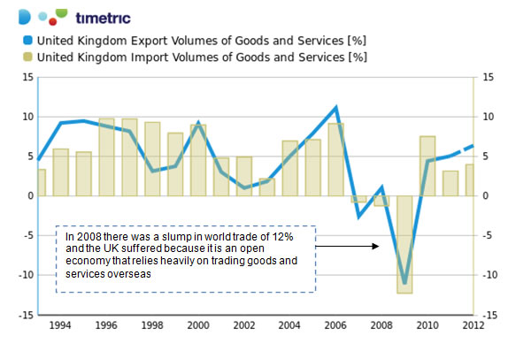

According to a recent trade profile for the UK published by the World Trade Organisation:

1. The UK is the 7th largest exporter of goods in the world & the 4th biggest importer of goods.
2. The UK is the 2nd biggest exporter of commercial services globally and the third.
3. The UK has a 3.7% share of world exports and 5% share of world imports
4. The UK exports 8% of the world’s commercial services
5. 78% of our exports come from the manufacturing sector and 15% from fuels and mining products
6. 62% of our exports go to other members of the EU; 13% to the United States.
7. 50% of our imports come from the EU; 8% from the United States and 6% from [China](http://www.tutor2u.net/blog/index.php/economics/C54/).

**The pattern of merchandise trade (trade in goods for the UK)**

|  |  |  |  |
| --- | --- | --- | --- |
| **Breakdown in economy's total exports** |  | **Breakdown in economy's total imports** |  |
| By main commodity group |  | By main commodity group |  |
| Agricultural products | 5.3 | Agricultural products | 8.8 |
| Mining products | 13.0 | Mining products | 11.7 |
| Manufactures | 77.6 | Manufactures | 65.3 |
| **By main destination** |  | **By main origin** |  |
| 1. European Union | 55.8 | 1. European Union | 50.2 |
| 2. United States | 14.9 | 2. United States | 11.4 |
| 3. Japan | 1.9 | 3. Japan | 3.6 |
| 4. Switzerland | 1.7 | 4. China | 3.0 |
| *Source: World Trade Organisation International Trade Statistics* [*www.wto.org*](http://www.wto.org) | | | |

Britain’s share of total world trade in goods and services has been on a declining trend for many years but remember that the total value of global trade has been growing strongly for most of this time, and also that many fast-growing developing countries have focused on export-led growth as a key part of their development strategy.

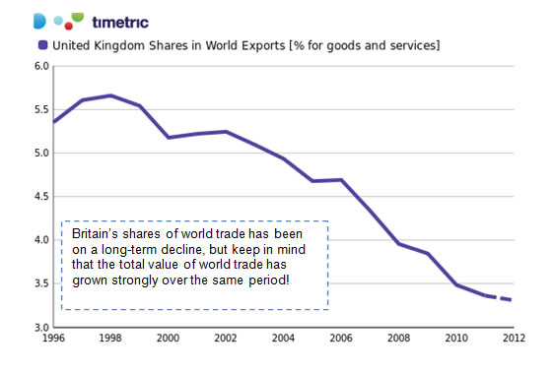

**Why do countries trade? Exploring the gains from trade**

* Trade is the exchange of goods and services between countries. When the conditions are right trade brings benefits to all countries involved and can be a powerful driver for sustained growth and rising living standards.
* One way of expressing the gains from trade in goods and services between countries is to distinguish between the **static gains** from trade (i.e. improvements in allocative and productive efficiency) and the **dynamic gains** (the gains in welfare that occur over time from improved product quality, increased choice and a faster pace of innovative behaviour).

Some of the gains from free trade are outlined below:

* **Welfare gains:** Economists who support the liberalization of trade believe that trade is a **‘positive-sum game’** – all counties engaged in trade and exchange stand to gain.
* **Economies of scale –** trade allows firms to exploit scale economies by operating leading to lower average costs of production that can be passed onto consumers.
* **Competition / market contestability –** trade promotes increased competition particularly for those domestic monopolies that would otherwise face little real competition.
* **Dynamic efficiency gains from innovation -** trade enhances consumer choice and stimulates product and process innovations
* **Access to new technology:** trade, like investment, is also an important mechanism by which countries can have access to new technologies.
* **Rising living standards and a reduction in poverty -** trade can be a powerful force in reducing poverty and raising living standards.

**The World Trade Organization (WTO)**

* The [World Trade Organisation](http://news.bbc.co.uk/1/hi/world/europe/country_profiles/2429503.stm) helps to **promote free trade** by persuading countries to abolish import tariffs and other barriers to open markets.
* The WTO was established in 1995 and was preceded by the **General Agreement on Tariffs and Trade** (GATT).
* Membership of the WTO has expanded to 153 countries (the latest to join was Cape Verde) – with the successful admission of China to the WTO ranking as an event of potentially huge significance.
* Russia and Iran are examples of countries that have not yet entered the WTO system.
* The WTO oversees the rules of [international trade](http://www.tutor2u.net/blog/index.php/economics/C199/). It helps to **settle trade disputes** between governments.

[**Protectionism**](http://www.tutor2u.net/blog/index.php/economics/tagged/tag/protectionism/) **- Import Controls**

Often times there are **trade disputes** between countries perhaps because one or more parties believes that trade is being conducted unfairly, on an uneven playing field, or because they believe that there is an economic or strategic justification for some form of import control.

[**Protectionism**](http://www.tutor2u.net/blog/index.php/economics/tagged/tag/protectionism/) represents any attempt to impose restrictions on trade in goods and services. The aim is to cushion domestic businesses and industries from overseas competition.

* [**Tariffs**](http://www.tutor2u.net/blog/index.php/economics/tagged/tag/tariff/) - A tariff is a tax that raises the price of imported products and causes a contraction in domestic demand and an expansion in domestic supply. The net effect is that the volume of imports is reduced and the government received some tax revenue from the tariff.
* **Quotas** - quantitative limits on the level of imports allowed.
* **Voluntary Export Restraint Arrangements** – where two countries make an agreement to limit the volume of their exports to one another over an agreed period of time.
* **Embargoes** - a total ban on imported goods.
* **Intellectual property laws** (patents and copyrights).
* **Preferential state procurement policies** – where a government favour local/domestic producers when finalizing contracts for state spending e.g. infrastructure projects
* **Export subsidies** - a payment to encourage domestic production by lowering their costs. Soft loans can be used to fund the ‘dumping’ of products in overseas markets. Well known subsidies include Common Agricultural Policy in the EU, or cotton subsidies for US farmers.
* **Domestic subsidies** – government financial help for domestic businesses facing financial problems e.g. subsidies for car manufacturers or loss-making airlines
* **Import licensing** - governments grants importers the license to import goods.
* **Exchange controls** - limiting the foreign exchange that can move between countries.
* **Financial protectionism** – for example when a national government instructs its banks to give priority when making loans to domestic businesses.
* **Murky or hidden protectionism** - e.g. state measures that indirectly discriminate against foreign workers, investors and traders. A government subsidy that is paid only when consumers buy locally produced goods and services would count as an example.

Quotas, embargoes, export subsidies and exchange controls are examples of **non-tariff barriers**

**The Economic and Social Case for Protectionism**

* **Infant industry argument:** Certain industries possess a possible comparative advantage but have not yet exploited [economies of scale](http://www.tutor2u.net/blog/index.php/economics/C231/) . Short-term protection allows the ‘infant industry’ to develop its comparative advantage at which point the protection could be relaxed, leaving the industry to trade freely on the international market.
* **Externalities and market failure:** Protectionism can also be used to internalize the social costs of de-merit goods.
* **Protection of jobs and improvement in the balance of payments**
* **Protection of strategic industries:** The government may also wish to protect employment in strategic industries, although value judgments are involved in determining what constitutes a strategic sector.
* **Anti-dumping duties:** Dumping is a type of **predatory pricing behaviour** and a form of **price discrimination**. Goods are dumped when they are sold for export at less than their normal value. The normal value is usually defined as the price for the like goods in the exporter’s home market. Recent examples of disputes about alleged dumping have included
  + India complaining about the dumping of bus and truck tires from China and Thailand
  + The EU imposing an anti-dumping tariff on Norwegian farmed salmon in response to complaints from farmers in Scotland and Ireland
  + EU shoemakers alleging that Chinese and Vietnamese shoe manufacturers have illegally dumped leather, sports and safety shoes in the EU market
  + In 2009 EU imposed temporary "anti-dumping" taxes on Chinese wire, candles, iron and steel pipes, and aluminum foil from Armenia, Brazil and China.

In the short term, consumers benefit from the low prices of the foreign goods, but in the longer-term, persistent undercutting of domestic prices will force the domestic industry out of business and allow the foreign firm to establish itself as a monopoly.  Once this is achieved the foreign owned monopoly is free to increase its prices and exploit the consumer.  Therefore protection, via tariffs on 'dumped' goods can be justified to prevent the long-term exploitation of the consumer.

The World Trade Organisation allows a government to act against dumping where there is genuine **‘material’ injury** to the competing domestic industry. In order to do that the government has to be able to show that dumping is taking place, calculate the extent of dumping (how much lower the export price is compared to the exporter’s home market price), and show that the dumping is causing injury. Usually an ‘anti-dumping action’ means charging extra import duty on the particular product from the particular exporting country in order to bring its price closer to the “normal value”.  
Tariffs are not a major source of tax revenue for the Government that imposes them. In the UK for example, tariffs are estimated to be worth only £2 billion to the Treasury, equivalent to only around 0.5% of the total tax take. Developing countries tend to be more reliant on tariffs for revenue.

**Economic Arguments against Protectionism**

* **Market distortion**: Protection can be an ineffective and costly means of sustaining jobs.
  1. **Higher prices for consumers**: Tariffs push up the prices faced by consumers and insulate inefficient sectors from competition.  They penalize foreign producers and encourage the inefficient allocation of resources both domestically and globally.
  2. **Reduction in market access for producers:** Export subsidies depress world prices and damage output, [profits](http://www.tutor2u.net/blog/index.php/economics/tagged/tag/profits/), investment and jobs in many developing countries that rely on exporting primary and manufactured goods for their growth.
* **Loss of economic welfare:** Tariffs create a deadweight loss of consumer and producer surplus. Welfare is reduced through higher prices and restricted consumer choice.
* **Regressive effect on the distribution of income:** Higher prices that result from tariffs hit those on lower incomes hardest, because the tariffs (e.g. on foodstuffs, tobacco, and clothing) fall on those products that lower income families spend a higher share of their income.
* **Production inefficiencies:** Firms that are protected from competition have little incentive to reduce production costs. This can lead to X-inefficiency and higher average costs.
* **Trade wars**: There is the danger that one country imposing import controls will lead to “retaliatory action” by another leading to a decrease in the volume of world trade. Retaliatory actions increase the costs of importing new technologies affecting LRAS.
* **Negative** [**multiplier effects**](http://www.tutor2u.net/blog/index.php/economics/tagged/tag/multiplier+effect/): If one country imposes trade restrictions on another, the resultant decrease in trade will have a negative multiplier effect affecting many more countries because exports are an injection of demand into the global circular flow of income.
* **Second best approach:** Protectionism is a ‘second best’ approach to correcting for a country’s balance of payments problem or the fear of structural unemployment. Import controls go against the principles of free trade. In this sense, import controls can be seen as examples of government failure arising from intervention in markets.

**The Importance of Imports**

A simplistic view of trade is that exports are good and imports are bad. But that assumption quickly crumbles when you look more closely. We could consume all the goods and services leaving Britain as exports. We are, in effect, exporting our standard of living. So why do we do it? To paraphrase one Nobel Prize winning economist, “What a country really gains from trade is the ability to pay for the imports that it wants.”

Yet in the public imagination, more imports sounds like a bad idea. The tough global economic environment makes calls for protectionism grow louder. Yet such steps would not be recommended by some economists who analyzed what happened to India when it slashed tariffs in 1991, under pressure from the IMF. As part of those reforms, India reduced duties on imports from an average of 90% in 1991 to 30% in 1997. Not surprisingly, imports doubled in value over this period. But this didn’t cause manufacturing to collapse. In fact, output grew by over 50%. By looking at what was imported and what it was used to make, the researchers found that cheaper and more accessible imports gave a big boost to India’s industrial growth.

Tariff cuts didn’t just mean that Indian consumers could import more consumer goods (though they did). It gave Indian manufacturers access to a variety of intermediate and capital goods, which had earlier been too expensive. The rise in imports of intermediate goods was much higher, at 227%, than the 90% growth in consumer-goods imports.

Theory suggests several ways in which greater access to imports can improve domestic manufacturing. First, cheaper imports may allow firms to produce existing goods using the same inputs as before, but at a lower cost. They could also open up new ways of producing existing goods, and even allow entirely new products to be made. All this seemed to hold in India. Lower import tariffs lead to an expansion in product variety through access to new inputs. About 66% of the growth in India’s imports of intermediate goods after liberalization came from goods the country had simply not bought before the tariff cuts.

*Source: EconoMax, June/July 2009, author Tom White*

**Economic nationalism**

Economic nationalism is a term used to describe policies which are guided by the idea of protecting a country's home economy, i.e. protecting domestic consumption, jobs and investment, even if this requires the imposition of tariffs and other restrictions on the movement of labour, goods and capital.

Examples of economic nationalism include China's controlled exchange of the Yuan, and the United States' use of tariffs to protect domestic steel production.

The term gained a more specific meaning in 2005 and 2006 after several European Union governments intervened to prevent takeovers of domestic firms by foreign companies. In some cases, the national governments also endorsed counter-bids from compatriot companies to create 'national champions'. Such cases included the proposed takeover of Arcelor (Luxembourg) by Mittal Steel (India). And the French government listing of the food and drinks business Danone (France) as a 'strategic industry' to block potential takeover bid by PepsiCo (USA).