**Unemployment**

***Author****:* [*Geoff Riley*](http://www.tutor2u.net/blog/index.php/site/author/3/)***Last updated:*** *Sunday 23 September, 2012*

**Who is unemployed?**

* The unemployed are people able, available and willing to work at the going wage rate but cannot find a job despite an **active search for work**
* Unemployment means that scarce human resources are not being used to produce goods and services to meet people’s needs and wants
* Persistently high levels of joblessness have damaging consequences for an economy causing both economic and social costs
* Problems caused by unemployment occur across a country but are often very bad and deep-rooted in local and regional communities and within particular groups of society – for example in the UK, more than one in six young people are out of work. The figure is much higher in Greece and Spain.

**Measuring unemployment**

* The **Claimant Count** measure includes people who are eligible to claim the Job Seeker's Allowance (JSA). The data is seasonally adjusted to take into account predictable seasonal changes in the demand for labour.
* The **Labour Force Survey** counts those who are without any kind of job including part time work but who have looked for work in the past month and are able to start work immediately. The figure includes those people who have found a job and are waiting to start in the next two weeks.

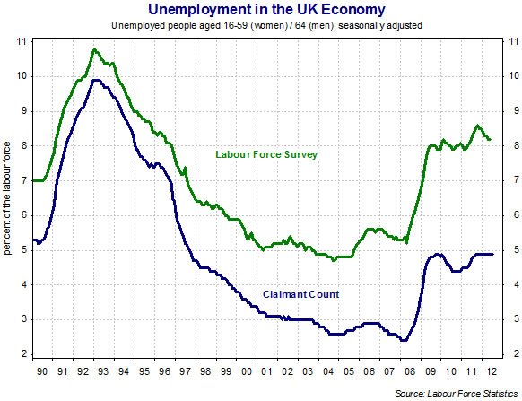

* On average, the labour force survey measure has exceeded the claimant count by about 500,000 in recent years. Because it is a **survey** - albeit a large one and one that provides a rich source of data on the employment status of thousands of households across the UK - there will always be a **sampling error in the data**.
* The Labour Force Survey uses the internationally agreed definition of unemployment and therefore best allows cross-country comparisons of unemployment levels among developed countries.

**Are we measuring unemployment accurately?**

**1 / Discouraged workers**

* No measure of unemployment is ever completely accurate since there are some people out of work but looking for a job who are not picked up by the official statistics
* Official unemployment data misses out the “hidden unemployed” - an example are **discouraged workers** who have been out of work for a long time and who have stopped applying for [jobs](http://www.tutor2u.net/blog/index.php/economics/tagged/tag/jobs/)

**2 / economically inactive –** people who are not actively looking for work – some of the reasons include:

* The need to look after elderly or infirmed relatives
* Parents who are full-time carers for their children
* People who have taken early retirement

**3 / Under-employment:** In many countries data may ignore the extent of **under-employment**, for example people who want full-time work but have to settle for a part-time job. In many lower-income countries the quality of the labour market data may be poor causing published figures to be inaccurate.

There are big differences in unemployment rates across the UK – why do you think some regions suffer from persistently higher jobless problems?

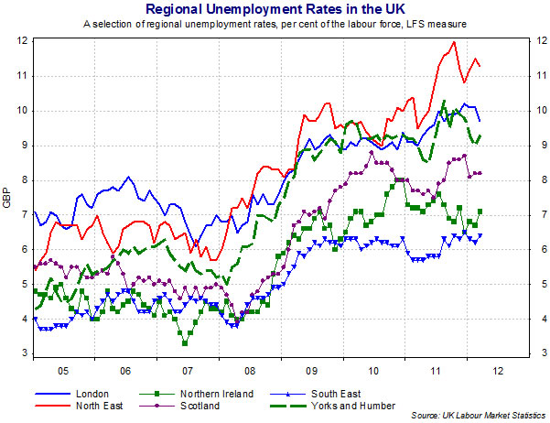

**Types and Causes of Unemployment**

**Frictional Unemployment**

Frictional unemployment is **transitional unemployment** as people move between jobs: For example, newly-redundant workers or people joining the labour market for the first time such as university graduates may take time searching to find work they want at wage rates they are prepared to accept.

* **Imperfect information** in the labour market may make frictional unemployment worse if the jobless are unaware of the available jobs.
* **Incentives problems** can also cause frictional unemployment as some people may stay out of work if they believe the tax and benefit system leaves them little or no better off from taking a job
* When there are **disincentives** for people to accept work, this is known as the **unemployment trap.**

Frictional unemployment happens when it takes time for a country’s labour market to match the available jobs with people seeking work. The chart below shows the monthly level of **unfilled vacancies** in the UK. For most of the current decade there have been between 500,000 and 700,000 unfilled vacancies.

The recession caused a steep decline in the number of available jobs and by the summer of 2010 there were fewer than 500,000 unfilled posts set against a much larger pool of unemployed. The result is that the ratio of unemployed to job vacancies has grown, meaning that there are many people chasing each available job. This makes it tough to get back into paid work.

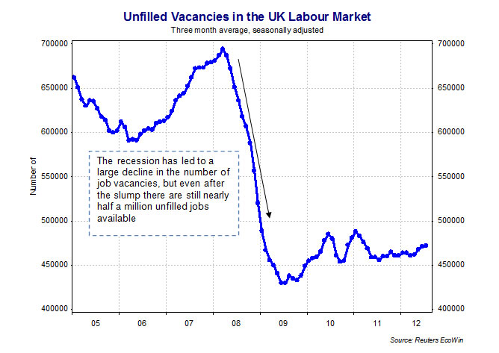

**Structural Unemployment**

Structural unemployment happens when there is a **long-term decline in demand in an industry** leading to fewer jobs being available as the demand for labour falls away – this leads to a decline in employment in a particular industry (sector) or a particular occupation. Examples might include:

* Jobs on a production line being replaced by robots e.g. motor manufacturing
* Unemployment caused by foreign competition (or changes in comparative advantage)

Structural unemployment exists where there is a **mismatch** between their skills and the requirements of the new job opportunities. This problem is due to **occupational and geographical immobility of labour** and requires investment to improve skills, give the unemployed suitable training and work experience and make them able to move location if needed to take a new job.

[**Globalisation**](http://www.tutor2u.net/blog/index.php/economics/tagged/tag/globalisation/) inevitably leads to changes in the patterns of trade between countries. Britain has probably now lost a cost advantage in [manufacturing](http://www.tutor2u.net/blog/index.php/economics/C212/) goods such as motor cars, household goods and audio-visual equipment, indeed our manufacturing industry has lost jobs as some production has shifted to lower-cost centres in Eastern Europe and emerging market countries in Far East Asia.

Many of these workers may suffer from a period of structural unemployment, particularly if they are in regions of above-average unemployment rates where job opportunities are scarce.

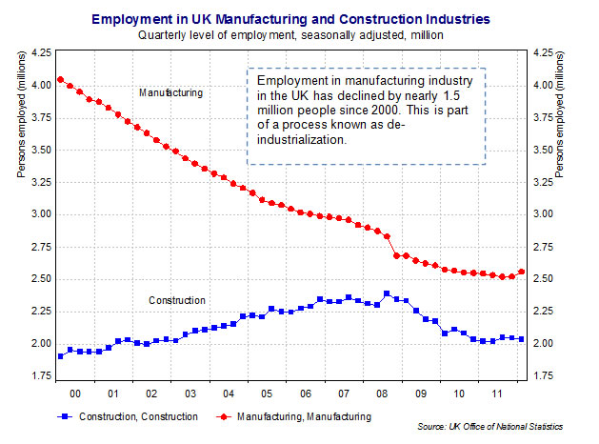

Employment in UK manufacturing industries has fallen year on year for nearly three decades. Since the turn of the century, over 1.5 million jobs have been lost in the manufacturing sector – the decline was amplified by the effects of recession in 2008-2010 although there are tentative signs that manufacturing employment, investment and employment may now be picking up.

Jobs lost in manufacturing and construction creates problems of structural unemployment, but this is a cause of unemployment that can affect people in all sectors of the economy.

**Cyclical Unemployment:**

Cyclical unemployment is **involuntary unemployment** due to a lack of demand for goods and services. This is also known as **Keynesian unemployment** or **demand-deficient unemployment**

When there is a recession or a steep slowdown in growth, we see a rising unemployment because of plant closures, business failures and an increase in worker lay-offs and redundancies. This is due to a fall in demand leading to a contraction in output across many industries.

Firms are likely to reduce employment to cut costs and/or maintain profits – this is called “labour shedding” or “down-sizing”

The economy does not have to go into recession for cyclical unemployment to start rising. Many jobs can be lost even in a slowdown phase and one reason for this is because of rising [productivity](http://www.tutor2u.net/blog/index.php/economics/tagged/tag/productivity/). Say for example that a country’s GDP is expanding at 1 per cent a year but output per worker is growing by 3 per cent. This means that the same national output can be produced using fewer workers.

