**Topic 2) Policy Objectives & Conflicts**

***Use pages 43-87 from the associated study pack to answer the following:***

***Define the term ‘objectives’***

|  |
| --- |
|  |

***Explain the meaning of the following objectives:***

|  |  |
| --- | --- |
| Macroeconomic Objectives | Explanation |
| Stable low inflation |  |
| Sustainable economic growth |  |
| Higher levels of capital investment & Labour productivity |  |
| High employment |  |
| Rising living standards & a fall in poverty |  |
| Sound government finances |  |

***Explain the differences between short-run economic growth & long-run economic growth***

|  |
| --- |
|  |

***Outline a range of advantages and disadvantages of economic growth***

|  |  |
| --- | --- |
| Advantages of economic growth | Disadvantages of economic growth |
|  |  |
|  |  |
|  |  |
|  |  |

***Show the impacts of economic growth on the following diagrams:***

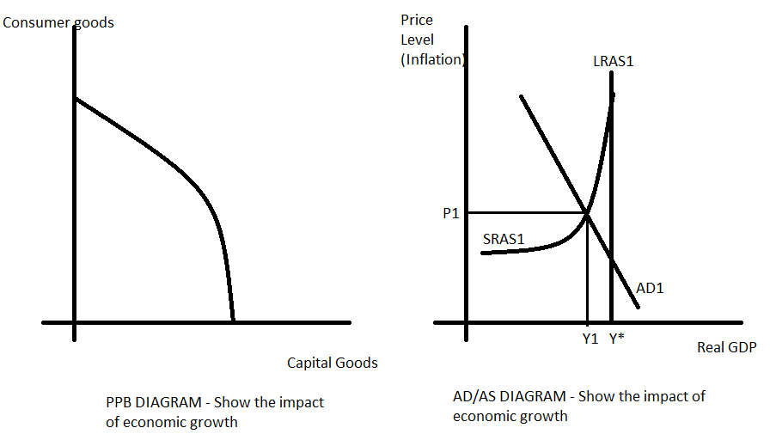

***Define the following key terms:***

|  |  |
| --- | --- |
| Key term | Definition |
| Inflation |  |
| Deflation |  |
| Hyperinflation |  |

***Use diagrams to help you explain the differences between demand-pull and cost-push inflation***

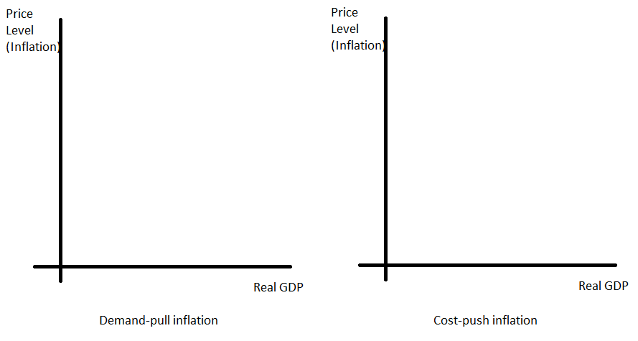

|  |  |
| --- | --- |
| ***Causes of demand-pull inflation*** | ***Causes of cost-push inflation*** |
|  |  |
|  |  |
|  |  |
|  |  |
|  |  |

***Define the following key terms:***

|  |  |
| --- | --- |
| Key term | Explanation |
| Employment |  |
| Unemployment |  |
| Claimant Count |  |
| Labour Force Survey |  |

***Explain in detail the following types of unemployment***

|  |  |
| --- | --- |
| ***Type of unemployment*** | ***Explanation*** |
| Frictional |  |
| Structural |  |
| Cyclical |  |

***Use a PPB diagram to show the impacts of an increase in unemployment***

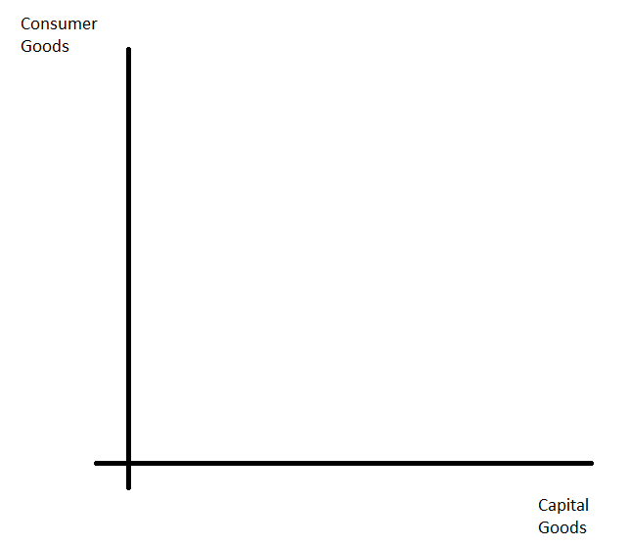

***Explain a range of economic and social costs of unemployment***

|  |  |
| --- | --- |
| Costs of unemployment | Explanation |
|  |  |
|  |  |
|  |  |
|  |  |

***Explain a range of reasons why UK unemployment fell in the first decade of the 21st century (p65)***

|  |  |
| --- | --- |
| Why unemployment fell | Explanation |
|  |  |
|  |  |
|  |  |
|  |  |

***What is international trade?***

|  |
| --- |
|  |

***Explain the benefits of international trade***

|  |  |
| --- | --- |
| Benefits of international trade | Explanation |
|  |  |
|  |  |
|  |  |

***What is the Balance of Payments?***

|  |
| --- |
|  |

***Why are exports vital to the UK Economy?***

|  |  |
| --- | --- |
| Reasons why exports are vital for the UK | Explanation |
|  |  |
|  |  |

***Explain the differences between ‘the trade in goods’ and ‘the trade in services’ AND outline the UK’s performance in both trade in goods and trade in services***

|  |
| --- |
|  |

***Identify the 4 key components of the UK Current Account***

|  |
| --- |
|  |
|  |
|  |
|  |

***Explain reasons why the UK has a trade deficit***

|  |  |
| --- | --- |
| ***Short-term causes of trade deficit*** | ***Explanation*** |
|  |  |
|  |  |
| ***Medium term causes of trade deficit*** | ***Explanation*** |
|  |  |
|  |  |
| ***Long-term causes of trade deficit*** | ***Explanation*** |
|  |  |
|  |  |

***Explain a range of problems for the UK of having a trade deficit***

|  |  |
| --- | --- |
| Problems for UK of trade deficit | Explanation |
|  |  |
|  |  |
|  |  |

***Define the following key terms***

|  |  |
| --- | --- |
| Key term | Explanation |
| Exchange rate |  |
| Currency appreciation |  |
| Currency depreciation |  |

***Scenario: Imagine the UK £ experiences the following appreciation against the US $:***

|  |
| --- |
| ***Original currency value*** |
| £1 = $1.50 |
| £1 = $2 |

***Complete the table below:***

|  |  |  |
| --- | --- | --- |
| Good/service which is  bought/sold | Original price paid (when  £1 = $1.50) | New price paid (when £1 = $2) |
| UK firm selling Computer chips  to the USA for £20 each | Price paid by USA customer =  ***$30*** | Price paid by USA customer = |
| UK firm importing grain from  USA for $30 a bag | Price paid by UK customer =  ***£15*** | Price paid by UK customer = |

***Explain a range of benefits and drawbacks for the UK Economy of a currency appreciation i.e. £ getting stronger against another currency such as US $***

|  |  |
| --- | --- |
| Advantages of a stronger £ | Drawbacks of a stronger £ |
|  |  |
|  |  |
|  |  |
|  |  |

***Use the axis below to show the impacts on the economy of a currency appreciation***

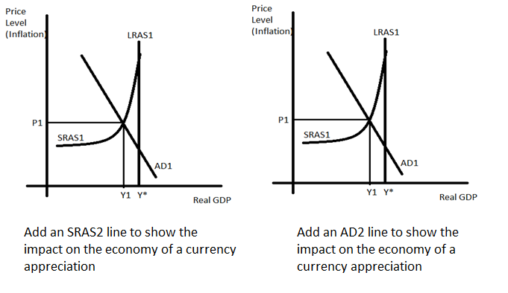

***Scenario: Imagine the UK £ experiences the following depreciation against the US $:***

|  |
| --- |
| ***Original currency value*** |
| £1 = $1.50 |
| £1 = $1 |

***Complete the table below:***

|  |  |  |
| --- | --- | --- |
| Good/service which is  bought/sold | Original price paid (when  £1 = $1.50) | New price paid (when £1 = $2) |
| UK firm selling Computer chips  to the USA for £20 each | Price paid by USA customer =  ***$30*** | Price paid by USA customer = |
| UK firm importing grain from  USA for $30 a bag | Price paid by UK customer =  ***£15*** | Price paid by UK customer = |

***Explain a range of benefits and drawbacks for the UK Economy of a currency depreciation i.e. £ getting weaker against another currency such as US $***

|  |  |
| --- | --- |
| Advantages of a weaker £ | Drawbacks of a weaker £ |
|  |  |
|  |  |
|  |  |

***Use the axis below to show the impacts on the economy of a currency appreciation***

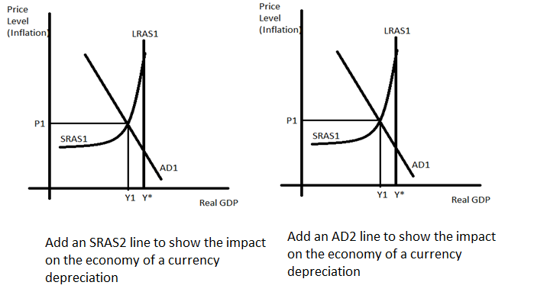

***Explain what economists mean by a ‘trade-off between macro targets***

|  |
| --- |
|  |

***Explain in the detail the theory behind the following trade-offs***

|  |  |
| --- | --- |
| Trade-off | Explanation |
| Unemployment and inflation |  |
| Economic Growth and balance of payments |  |