**Exchange rates**

***Author****:* [*Geoff Riley*](http://www.tutor2u.net/blog/index.php/site/author/3/)***Last updated:*** *Sunday 23 September, 2012*

**Introduction**

The [exchange rate](http://www.tutor2u.net/blog/index.php/economics/C57/) measures the [external value of sterling](http://newsvote.bbc.co.uk/1/shared/fds/hi/business/market_data/currency/default.stm) in terms of how much of another currency it can buy. E.g. in July 2011 £1 would buy you $1.65 and Euro 1.17.

The value of the currency is determined in the **foreign exchange market** where billions of $s of currencies are traded every hour.

The main traders are businesses, international investors and governments

London is the biggest centre of foreign exchange trading.

The table below shows how the pound [sterling](http://www.tutor2u.net/blog/index.php/economics/tagged/tag/sterling/) has changed against a selection of currencies. The sterling index measures the external value of the pound against a basket of currencies – weighted according to how much trade we do with a particular country.

As you can see, there was a significant depreciation in sterling’s value during 2008 and into 2009. The sterling index fell from 103.6 to 80.0 and the pound also dipped in value against the US dollar, the Japanese Yen and the Euro – together over seventy per cent of the UK’s trade is priced in these currencies.

|  |  |  |  |  |
| --- | --- | --- | --- | --- |
|  | Sterling Exchange Rate Index | £/$ | £/€ | £/Yen |
| 2006 | 101.2 | 1.84 | 1.47 | 214.4 |
| 2007 | 103.7 | 2.00 | 1.46 | 235.5 |
| 2008 | 91.1 | 1.85 | 1.26 | 190.9 |
| 2009 | 80.5 | 1.57 | 1.12 | 146.4 |
| 2010 | 80.4 | 1.55 | 1.17 | 135.3 |
| 2011 | 79.9 | 1.60 | 1.15 | 127.7 |

**Floating exchange rates**

***What does a weak pound tell us?***

*As the pound has dropped in value against other major currencies like the dollar and euro, travelling abroad has become much more expensive. Imported goods have also pushed up basic prices for British firms and consumers. UK exporters, however, has welcomed the weaker pound as it makes their goods cheaper to foreign markets. Economists have welcomed the weakening of sterling as heralding a much-needed correction to the UK's chronic trade imbalances. However, as the pound can be seen as a barometer of the UK economy, some perceive its recent weakening as a matter of concern.*

*Source: News Reports, Feb 2011*

The UK operates with a **floating exchange rate system** where the forces of market demand and supply determine the daily value of one currency against another

The value of the pound depends in how strong is demand for the currency relative to supply

If overseas investors want to buy into sterling to take advantage of higher [interest rates](http://www.tutor2u.net/blog/index.php/economics/tagged/tag/interest+rates/) on offer in UK bank accounts, they will swap their own currencies for pounds. This causes an increase in the demand for sterling in the foreign exchange markets, and in the absence of other offsetting factors, this will cause an appreciation.

Currencies tend to go up in value either when a country is running a large **trade surplus** – which brings in extra demand for a currency from sales of exports – or when overseas investors regard the currency as a good one to buy. This might be because attractive interest rates are on offer by putting money into savings accounts in that currency. Or because there are high expected returns from other types of investment notably property, stocks and shares and so on.

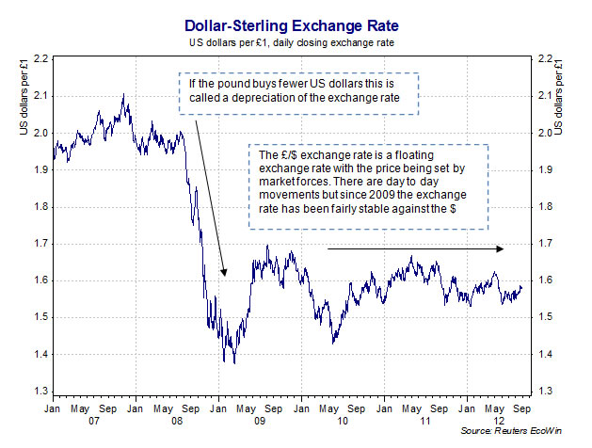

**How does a change in the exchange rate influence the economy?**

* Changes in the [exchange rate](http://www.tutor2u.net/blog/index.php/economics/C57/) can have powerful effects on the macro-economy affecting variables such as the demand for exports and imports; real GDP growth, inflation, business [profits](http://www.tutor2u.net/blog/index.php/economics/tagged/tag/profits/) and jobs
* As with most variables in economics, there are **time lags** involved. The impact of movements in currencies on the economy depends in part on:
* The **scale** of any change in the exchange rate i.e. a 5%, 10% or even larger movement
* Whether the change in the currency is **short-term or long-term –** i.e. is the change in the exchange rate temporary or likely to persist for some time?
* How **businesses and consumers respond** to exchange rate fluctuations – price elasticity of demand is important here i.e. will there be a large change in demand for exports and imports?
* The size of any multiplier and accelerator effects
* When the currency movement takes place – i.e. at which point of an economic cycle

**How can changes in the exchange rate affect the rate of inflation?**

The [exchange rate](http://www.tutor2u.net/blog/index.php/economics/C57/) affects the rate of inflation in a number of direct and indirect ways:

* **Changes in the prices of imports** – this has a **direct effect** on the **consumer price index**. For example, an appreciation of the exchange rate usually reduces the sterling price of imported consumer goods and durables, raw materials and capital goods.
* **Commodity prices and the CAP**: Many commodities are priced in US dollars – so a change in the sterling-dollar exchange rate has a direct impact on the UK price of commodities such as foodstuffs. A stronger dollar makes it more expensive for Britain to import these items.

**Changes in the growth of UK exports**: A higher exchange rate makes it harder to sell overseas because of a rise in relative UK prices. If exports slowdown (price elasticity of demand is important in determining the scale of any change in demand), then exporters may choose to cut their prices, reduce output and cut-back employment levels.

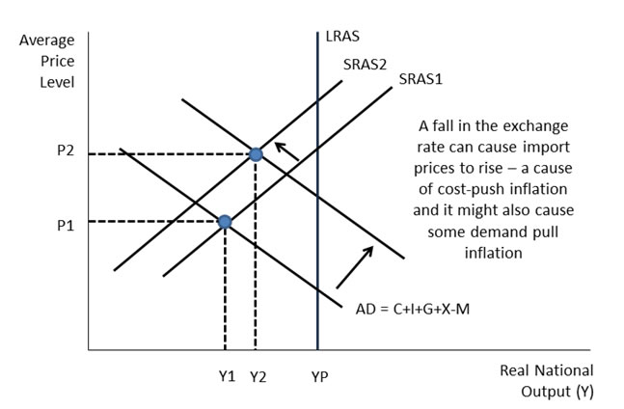

[Bank of England](http://www.tutor2u.net/blog/index.php/economics/tagged/tag/bank+of+england/) research suggests that a10% [depreciation](http://www.tutor2u.net/blog/index.php/economics/tagged/tag/depreciation/) in the exchange rate can add up to 3% to the level of consumer prices three years after the initial change in the exchange rate. But the impact on inflation of a change in the exchange rate depends on what else is going on in the economy. For example a lower pound is unlikely to have the same inflationary effects during a recession.

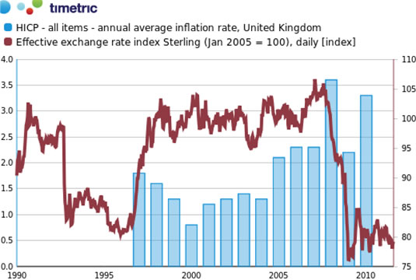

The chart above shows the effective exchange rate index for sterling (a trade-weighted measure of the buying power of sterling against a basket of international currencies) and the annual average rate of consumer price inflation in the UK

**Why the pound is crucial to the economy?**

The [exchange rate](http://www.tutor2u.net/blog/index.php/economics/C57/) is the price of one currency expressed in terms of another and is crucial to businesses selling goods and services abroad as well as those firms who import products from other countries. When the exchange rate rises in value (i.e. an appreciation), this makes exporters' goods, priced in sterling, more expensive in foreign currency. So demand for these dearer exports can be expected to fall, depending on the price elasticity of demand for UK exports and also whether there have been changes in other factors influencing demand.

A decline in exports reduces overall aggregate demand and should lower inflationary pressure - so a higher exchange rate could lead to the Monetary Policy Committee deciding to reduce official base interest rates.

A higher exchange rate also makes imports cheaper when sold in the UK. This is good news for the real purchasing power of British consumers, and also for UK firms who need to import raw materials, components and finished products. But higher prices feed into the consumer price index and can have a direct effect on our rate of inflation.

So a strong pound is good news for keeping inflation under control, but can have negative effects on exports which account for around thirty per cent of aggregate demand. A weaker pound can provide a boost to aggregate demand, a useful tool in lifting the economy out of a recession.

**Evaluation points on the effects of exchange rate changes**

Changes in the exchange rate have quite a powerful effect on the economy but we tend to assume **ceteris paribus** – all other factors held constant – which of course is highly unlikely to be the case

**Counter-balancing use of fiscal and** [**monetary policy**](http://www.tutor2u.net/blog/index.php/economics/C7/)**:** For example the government can alter **fiscal policy** to manage AD

**Time lags –** it takes time for demand for exports and imports to change following a movement in the currency. Businesses need to have the capacity and access to credit to expand their production.

**Low elasticities of demand:** In the short term, the effects of exchange rates on export and import demand tends to be low because of low price elasticity of demand

**Business response to the challenge of a high exchange rate:** Businesses can and do adapt to a high exchange rate. There are several ways in which industries can adjust to the competitive pressures that a strong pound imposes. Some of the options include:

**Cutting their export prices** when selling in overseas markets and therefore accepting lower profit margins to maintain [competitiveness](http://www.tutor2u.net/blog/index.php/economics/tagged/tag/competitiveness/) and market share

**Out-sourcing** components from overseas to keep production costs down

**Seeking** [**productivity**](http://www.tutor2u.net/blog/index.php/economics/tagged/tag/productivity/) **/ efficiency gains** to keep unit labour costs under control or perhaps trying to negotiate a reduction in pay levels

**Investing extra resources in new product lines** where demand is price inelastic and less sensitive to exchange rate fluctuations. This involves producing products with a higher income elasticity of demand, where non-price factors such as product quality, design and effective marketing are as important in securing orders as the actual price