**Managing the Economy – Government Fiscal Policy**

***Author****:* [*Geoff Riley*](http://www.tutor2u.net/blog/index.php/site/author/3/)***Last updated:*** *Sunday 23 September, 2012*

**Introduction**

**Fiscal policy** involves the use of **government spending, taxation and borrowing** to affect the level and growth of aggregate demand, output and jobs

Fiscal policy is also used to change the **pattern of spending** on goods and services

It is also a means by which a redistribution of income & wealth can be achieved

It is an instrument of intervention to correct for free-market failures

Changes in fiscal policy affect **aggregate demand** (AD) and [**aggregate supply**](http://www.tutor2u.net/blog/index.php/economics/C215/) (AS)

In the UK, the Treasury (pictured right) is in charge of fiscal policy decisions

**Fiscal Policy and Aggregate Demand**

Traditionally fiscal policy has been seen as an **instrument of demand management**. This means that changes in government spending, direct and indirect taxation and the budget balance can be used **“counter-cyclically”** to help smooth out some of the volatility of national output particularly when the economy has experienced an **external shock** and is in a recession.

* The **Keynesian school** argues that fiscal policy can have powerful effects on demand, output and employment when the economy is operating below full [capacity](http://www.tutor2u.net/blog/index.php/economics/tagged/tag/capacity/) national output, and where there is a need to provide a **demand-stimulus**.
* **Monetarist economists** believe that government spending and tax changes only have a temporary effect on aggregate demand, output and jobs and that the tools of [monetary policy](http://www.tutor2u.net/blog/index.php/economics/C7/) are a more effective instrument in controlling inflation and maintaining macroeconomic stability

**The fiscal policy transmission mechanism**

This flow-chart identifies some of the channels involved with the fiscal policy transmission mechanism – in the example shown we focus on an expansionary fiscal policy designed to boost demand and output

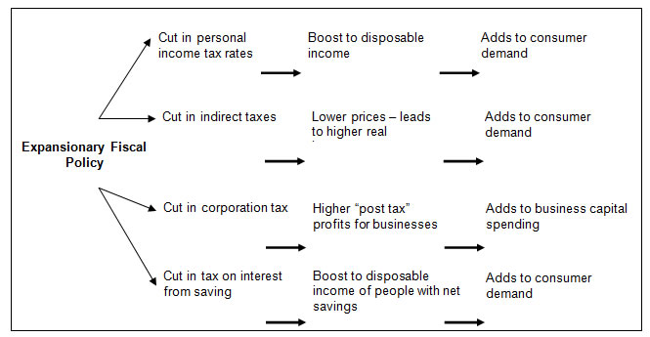

The **multiplier effects of an expansionary fiscal policy** depend on how much spare productive capacity the economy has; how much of any increase in disposable income is spent rather than saved or spent on imports. And also the effects of fiscal policy on variables such as [interest rates](http://www.tutor2u.net/blog/index.php/economics/tagged/tag/interest+rates/)

A **contractionary fiscal policy** would involve one or more of the following:

* A cut in government expenditure either in real terms or as a share of GDP
* An increase in direct and/or indirect taxes
* An attempt to reduce the size of the budget deficit

**Government spending**

Government spending (or public spending) and in Britain, it takes up over 45% of GDP. Spending by the public sector can be broken down into three main areas:

* **Transfer Payments:**
  1. These are **welfare payments** made available through the **social security system** including the Jobseekers’ Allowance, Child Benefit, State Pension, Student Grants, Housing Benefit, Income Support and the Working Families Tax Credit
  2. The main aim of transfer payments is to provide a **basic floor of income** or minimum standard of living for low income households. And they allow the government to change the final distribution of income. In 2010-11 the UK government spent £196bn on welfare benefits, equivalent to 13.4% of GDP
* **Current Government Spending**: i.e. spending on **state-provided goods & services** that are provided on a recurrent basis - for example salaries paid to people working in the NHS and resources for state education and defence. The NHS is the country’s biggest employer with over one million people working within the system!
* **Capital Spending**: Capital spending includes infrastructure spending such as new motorways and roads, hospitals, schools and prisons. This investment spending adds to the economy’s capital stock and can have important demand and supply side effects in the long term.

The main items of UK government spending are shown in the pie chart below- the data is taken from the March 2011 UK Budget Statement available from the HM Treasury website. **Social protection** is the biggest single component of departmental spending and includes the many welfare benefits paid to recipients including the state pension, the jobseekers’ allowance, income support and housing benefit.

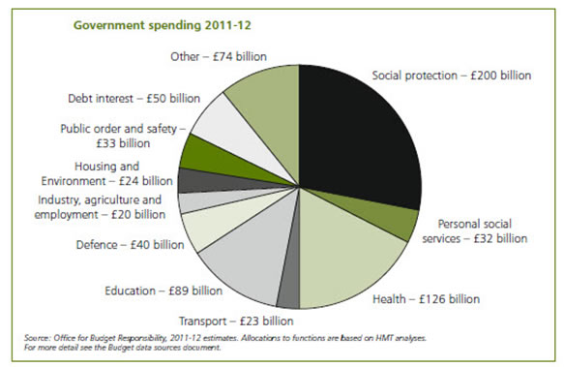

**Economic and Social Justifications for Government Spending**

* To provide a socially efficient level of **public goods and merit goods** and overcome market failure
  1. Public goods and merit goods tend to be under-provided by the private sector
  2. Improved and affordable access to education, health, housing and other public services can help to improve human capital, raise productivity and generate gains for society as a whole
* To provide a **safety-net system of welfare benefits** to supplement the incomes of the poorest in society – this is also part of the **process of redistributing income and** [**wealth**](http://www.tutor2u.net/blog/index.php/economics/tagged/tag/wealth/). Government spending has an important role to play in controlling / reducing the level of relative poverty
* To provide **necessary infrastructure** via capital spending on transport, education and health facilities – an important component of a country’s long run [aggregate supply](http://www.tutor2u.net/blog/index.php/economics/C215/)
* Government spending can be used to **manage the level and growth of AD** to meet macroeconomic policy objectives such as low inflation and higher levels of employment

Government spending can be justified as a way of promoting equity. Well targeted and high value for money public spending is also a catalyst for improving economic efficiency and macro performance.

**Taxation**

* **Direct taxation** is levied on **income, wealth and profit**. Direct taxes include income tax, inheritance tax, national insurance contributions, capital gains tax, and corporation tax.
* **Indirect taxes** are taxes on spending – such as excise duties on fuel, cigarettes and alcohol and Value Added Tax ([VAT](http://www.tutor2u.net/blog/index.php/economics/tagged/tag/vat/) ) on many different goods and services

**What are the main sources of tax revenues for the UK government?**

The table below shows the annual revenue from the main taxes in the UK.

|  |  |
| --- | --- |
| Category of Tax | Tax Revenue in 2010-11 |
| Income tax | 153.3 |
| National insurance contributions | 97.7 |
| Value added tax | 86.3 |
| Corporation tax | 43.0 |
| Fuel duties | 27.3 |
| Council tax | 25.7 |
| Business rates | 23.3 |
| Tobacco duties | 9.1 |
| Stamp duty land tax | 6.0 |
| Vehicle excise duties | 5.8 |
| Beer and cider duties | 3.7 |
| Capital gains tax | 3.6 |
| *Source: Office for Budgetary Responsibility, March 2012* | |

**Progressive, proportional and regressive taxes and the distribution of income**

* With a **progressive tax,** the marginal rate of tax rises as income rises. I.e. as people earn more income, the rate of tax on each extra pound goes up. This causes a rise in the average rate of tax
* With a **proportional tax**, the marginal rate of tax is constant. National insurance contributions are the closest example in the UK of a proportional tax, although low-income earners do not pay NICs below an income threshold
* With a **regressive tax**, the rate of tax falls as incomes rise – I.e. the average rate of tax is lower for people of higher incomes. In the UK, regressive taxes come from excise duties of items of spending such as cigarettes and alcohol. Indirect taxes form a larger percentage of the disposable income of those who earn less, even though they may also spend less

**Income Tax**

Income tax in the UK is **progressive** – here are the current tax rates *(correct to the end of 2011)*

* Most people have a tax free personal allowance worth £7,475 (up to an annual income of £100,000)
* Basic rate of income tax = 20% on incomes up to £37,000
* Higher rate of income tax = 40%
* A top rate of 50% applies to income over £150,000

As income rises, the rate of tax rises so that people on the highest incomes will pay a higher percentage of their income to the government. The progressivity of the income tax system for the UK is shown in the table below. People with an annual income greater than £1 million will pay a tax rate of over 44%.

|  |  |  |  |
| --- | --- | --- | --- |
| **Income Tax Payable by Income in 2010-11** | | | |
|  | Number of taxpayers (thousands) | Average rate of tax (percentages) | Average amount of tax (£) |
| £6,475–£7,499 | 939 | 1.3 | 91 |
| £7,500–£9,999 | 2,620 | 4.3 | 382 |
| £10,000–£14,999 | 6,440 | 7.7 | 956 |
| £15,000–£19,999 | 5,210 | 11.3 | 1,960 |
| £20,000–£29,999 | 6,910 | 13.7 | 3,350 |
| £30,000–£49,999 | 5,680 | 15.4 | 5,800 |
| £50,000–£99,999 | 2,050 | 22.3 | 14,600 |
| £100,000–£149,999 | 342 | 29.8 | 35,700 |
| £150,000–£199,000 | 145 | 33.1 | 55,900 |
| £200,000–£499,999 | 143 | 37.8 | 109,000 |
| £500,000–£999,999 | 26 | 41.4 | 281,000 |
| £1,000,000 and over | 13 | 44.4 | 1,010,000 |
| **All incomes** | **30,500** | **18.3** | **5,220** |

**Corporation Tax**

This is a tax on business profits. There is a tax free allowance for businesses making low annual profits

* Small Profits Rate (for businesses with profits < £300,000) = 20%
* Main rate of Corporation Tax = 25%

**Value Added Tax (VAT)**

Value Added Tax (VAT) is a tax that's charged on most goods and services that VAT-registered businesses provide in the UK. It's also charged on goods and some services that are imported from countries outside the European Union (EU), and brought into the UK from other EU countries

There are three rates of VAT, depending on the goods or services the business provides. The rates are:

* Standard - 20 per cent
* Reduced - 5 per cent i.e. energy bills
* Zero - 0 per cent (i.e. exempt) including children’s clothes, congestion charge, doctor’s fees

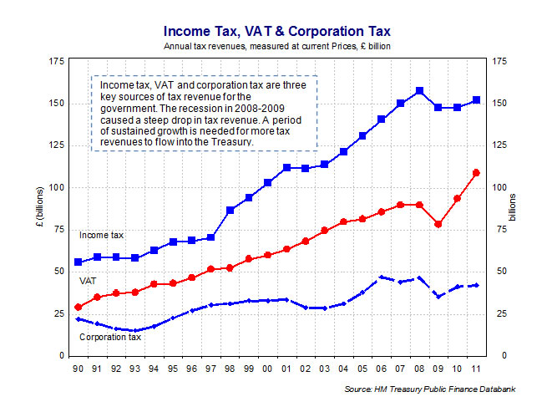

**Automatic stabilisers and discretionary changes in fiscal policy**

**Discretionary fiscal changes** are **deliberate changes** in direct and indirect taxation and govt spending – for example, increased capital spending on roads or more resources going into the NHS.

**Automatic stabilisers** are changes in tax revenues and government spending that come about automatically as an economy moves through the business cycle

**Tax revenues:** When the economy is expanding rapidly the amount of tax revenue increases which takes money out of the circular flow of income and spending

**Welfare spending:** A growing economy means that the government does not have to spend as much on means-tested welfare benefits such as income support and unemployment benefits

**Budget balance and the circular flow:** A fast-growing economy tends to lead to a net outflow of money from the circular flow. Conversely during a slowdown or a recession, the government normally ends up running a larger [budget deficit](http://www.tutor2u.net/blog/index.php/economics/tagged/tag/budget+deficit/).

**Fiscal Policy and** [**Aggregate Supply**](http://www.tutor2u.net/blog/index.php/economics/C215/)

It is important to understand that fiscal policy can have important effects on the **supply-side of the economy**. Indeed many government fiscal decisions are made with improving the supply-side in mind.

The current Coalition government has launched a **Growth Review** – a set of policies that aims to drive stronger GDP growth in the UK as the economy struggles to emerge from the recession. Many of their aims require the active use of fiscal policy to boost supply-side incentives, investment and efficiency.

* **Labour market incentives:**
  1. Changes in income tax can improve incentives for people to actively look for work
  2. Lower taxes might also have a positive effect on work effort and labour productivity
  3. Cuts to national insurance contributions might help to expand the active labour supply
  4. Some economists argue that **welfare benefit reforms** are more important than tax cuts in improving incentives – to create a gap between the incomes of people in a job and the unemployed. Some people favour reducing the relative value of benefits as a way of improving incentives. Others favour a move towards targeted benefits where the transfer payment is linked to participation in employment schemes or community work
* **Capital spending**:
  1. Spending on [infrastructure](http://www.tutor2u.net/blog/index.php/economics/tagged/tag/infrastructure/) (e.g. improvements to our motorway network or an increase in the building programme for new schools and hospitals) helps provide the capacity needed for other businesses to flourish.
  2. Lower rates of corporation tax and other business taxes might attract inward investment from overseas. An aim of the UK government is to have the lowest corporate tax rate in the G7 and among the lowest in the G20 nations
* **Entrepreneurship and investment**:
  1. Government spending can be used to fund an expansion in new small business start-ups
* **Research and development and** [**innovation**](http://www.tutor2u.net/blog/index.php/economics/tagged/tag/innovation/):
  1. Government spending, tax credits and other tax allowances could be used to encourage research and development to improve competitiveness and contribute to a faster pace of innovation and invention
  2. A key aim going forward is to use tax incentives to stimulate an increase in investment in low carbon technologies to promote green growth
* [**Human capital**](http://tutor2u.net/blog/index.php/economics/tagged/tag/human+capital/) **of the workforce**:
  1. Spending on education and increased investment in health and transport can also have important supply-side effects in the long run
  2. Government spending on youth apprenticeships can help to improve human capital, employability and productivity – giving more younger people the chance to make a strong start when they enter the labour market

**The Free Market Agenda**

**Free market economists** are sceptical of the effects of government spending in improving the supply-side of the economy. They argue that lower taxation and tight control of government spending and borrowing is required to allow the private sector of the economy to flourish. They believe in a smaller sized state sector so that in the long run, the overall burden of taxation can come down and thus allow the private sector of the economy to grow and flourish.

**Economics of a Budget (Fiscal) Deficit**

* When the government is running a [**budget deficit**](http://www.tutor2u.net/blog/index.php/economics/tagged/tag/budget+deficit/), it means that in a given year, total government expenditure exceeds total tax revenue
* If the government is running a budget deficit, it has to borrow this money through the issue of debt such as Treasury bills and bonds
* Most of the government debt is bought up by financial institutions but individuals can buy bonds, premium bonds and buy national savings certificates
* The budget balance is the annual difference between tax revenues and government spending
* Gross government debt is the total accumulated debt owed by the government – this is also known as the national debt

The UK government last had a budget surplus in the year 2000 but it has run budget deficits in every year since then.

There was a large rise in the budget deficit from 2008 onwards because of the recession and also attempts by the government to stimulate the economy. The deficit peaked at over 10% of GDP and been declining gradually since.

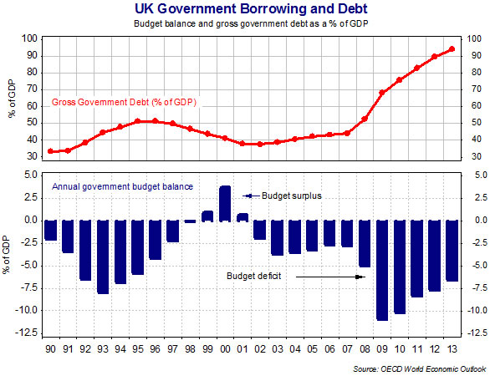

**Does a budget deficit matter?**

A persistently large [budget deficit](http://www.tutor2u.net/blog/index.php/economics/tagged/tag/budget+deficit/) can be a problem:

* **Financing a deficit:** 
  1. If the budget deficit rises to a high level, the government may have to offer higher interest rates to attract sufficient buyers of debt.
  2. This raises the possibility of the government falling into a **debt trap** where it must borrow more to repay the interest on accumulated borrowing.
  3. Many high debt countries in the European Union have suffered from this in recent years – high profile examples have included Ireland, Greece, Spain and Portugal.
* **A government debt mountain:** 
  1. Annual budget deficits over a number of years will cause the total amount of unpaid government debt to climb.
  2. There is an **opportunity cost** involved because interest payments on bonds might be used in more productive ways, for example on health services or extra investment in education. Every 0.05% saved on £220bn of new debt pays one year’s salary for 46,000 teachers.
  3. Higher public sector debt also represents a **transfer of income** from people and businesses that pay taxes to those who hold government debt and cause a redistribution of income and wealth in the economy.
* **Crowding-out:** 
  1. If a larger budget deficit leads to higher interest rates and taxation in the medium term and thereby has a negative effect on growth in consumption and investment spending, then a process of ‘**fiscal crowding-out’** is occurring
  2. The Institute of Fiscal Studies has estimated that reducing the UK budget deficit over the next five years will require every person in the UK to pay £1250 of extra taxes each year.
* **Risk of capital flight**:
  1. Some economists believe that high borrowing risks causing a ’run on a domestic currency’. This is because the government may find it difficult to find sufficient buyers of its debt and the credit-rating agencies may decide to reduce the rating on a nation’s sovereign debt

**Potential benefits of a budget deficit**

1. **Government borrowing can benefit growth:** 
   1. A budget deficit can have positive macroeconomic effects if it is used to finance capital spending that leads to an increase in the **stock of national assets**
   2. For example, spending on transport [infrastructure](http://www.tutor2u.net/blog/index.php/economics/tagged/tag/infrastructure/) improves the **supply-side capacity and productivity of the economy**
   3. Improved provision of public goods can create positive externalities
2. **The budget deficit as a tool of demand management:** 
   1. Keynesian economists support borrowing as a way of managing [aggregate demand](http://www.tutor2u.net/blog/index.php/economics/C214/)
   2. An increase in borrowing can be a **useful stimulus to demand** when other sectors of the economy are suffering from weak or falling spending
   3. A change in the government budget deficit may lead to a more than proportional change in aggregate demand – this is known as the **fiscal multiplier effect**.

**Cutting the deficit – the Coalition policies**

* The Coalition Government wants to halve the budget deficit over a five year period
* They have launched a programme of **fiscal austerity** amounting to £126 billion a year of combined spending cuts and tax rises
* Most of the fiscal austerity is coming through planned reductions in the real level of government spending. 80% will come from spending reductions, 20% is forecast to come from higher taxes
* The “**fiscal squeeze**” is highly controversial and has led to an impassioned debate among economists about the best way to control a budget deficit as an economy struggles to lift itself out of recession and sustain a recovery.
* **Keynesian economists** argue that deficit-reduction policies risk driving the economy into a second recession – known as a **double-dip**. Reducing spending or raising taxes could hurt an already fragile economy and make the fiscal deficit problem even worse. They doubt whether new job creation in the private sector is likely to be able to compensate for job losses in the public sector.
* Keynesians believe that economic growth will help bring down the deficit and that maintaining a sufficiently high level of demand is crucial to achieving this – public expenditure is a component of aggregate demand and hence if public expenditure falls so will aggregate demand C+I+**G**+X-M). Many private sector jobs depend on public sector spending, for example workers in the construction industry who build new roads or social housing.

The government believes that reducing the budget deficit is possible without causing another downturn and that cutting the budget deficit is important to maintain their economic credibility in financial markets. Cuts in public spending are unavoidable given the size of the budget deficit. Their strategy relies less heavily on tax increases; indeed some taxes have been cut in a bid to stimulate private sector investment

