Government Borrowing & the Budget Deficit
In this chapter we consider the effects that government borrowing to finance their spending can have on the wider performance of the economy.
The level of government borrowing is an important part of fiscal policy and management of aggregate demand in any economy. When the government is running a budget deficit, it means that in a given year, total government expenditure exceeds total tax revenue.
If the government is running a budget deficit, it has to borrow this money through the issue of government debt such as Treasury Bills and long-term government bonds. The issue of debt is done by the central bank and involves selling debt to the bond and bill markets. Most of the government debt is bought up by financial institutions but individuals can buy bonds, premium bonds and buy national savings certificates.
Government finances have moved from surplus in the late 1990s to a deficit of over 2% of GDP in 2006. The emergence of a rising budget deficit has been due to a weaker economy and the effects of increases in government spending on priority areas such as health, education, transport and defence. Critics of Gordon Brown argue that he risks losing control of the budget deficit if tax revenues continue to come in below forecast whilst public sector spending remains high. Gordon Brown’s reputation of fiscal prudence has come under pressure over the last few years. He is forecast to be running a budget deficit of over 3% of GDP (in excess of £32 billion) in 2006.
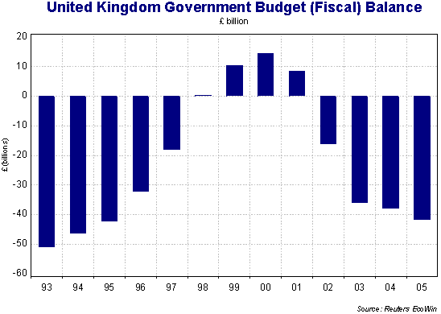
Does a budget deficit matter?
There is a consensus that a persistently large budget deficit can turn out to be a major problem for the government and the economy. Three of the reasons for this are as follows:
- Financing a deficit: A budget deficit has to be financed and day-today, the issue of new government debt to domestic or overseas investors can do this. But it may be that if the budget deficit rises to a high level, the government may have to offer higher interest rates to attract buyers of government debt. In the long run, higher government borrowing today may mean that taxes will have to rise in the future and this would put a squeeze on spending by private sector businesses and millions of households.
- A government debt mountain? In the long run, a high level of government borrowing adds to the accumulated National Debt. This means that the Government has to spend more each year in debt-interest payments to holders of government bonds and other securities. There is an opportunity cost involved here because interest payments might be used in more productive ways, for example an increase in spending on health services. It also represents a transfer of income from people and businesses that pay taxes to those who hold government debt and cause a redistribution of income and wealth in the economy
- Wasteful public spending: Neo-liberal economists are naturally opposed to a high level of government spending. They believe that a rising share of GDP taken by the state sector has a negative effect on the growth of the private sector of the economy. They are sceptical about the benefits of higher spending believing that the scale of waste in the public sector is high – money that would be better off being used by the private sector.
Potential benefits of a budget deficit
What are the main economic and social justifications for a higher level of government spending and borrowing? Two main arguments stand out
- Government borrowing can benefit economic growth: A budget deficit can have positive macroeconomic effects in the long run if it is used to finance extra capital spending that leads to an increase in the stock of national assets. For example, higher spending on the transport infrastructure improves the supply-side capacity of the economy promoting long-run growth. And increased public-sector investment in health and education can bring positive effects on labour productivity and employment. The social benefits of increased capital spending can be estimated through use of cost-benefit analysis.
- The budget deficit as a tool of demand management: Keynesian economists would support the use of changing the level of borrowing as a way of fine-tuning or managing the level of aggregate demand. An increase in borrowing can be a stimulus to demand when other sectors of the economy are suffering from weak spending. The fiscal stimulus given to the British economy during 2002-2005 has been important in stabilizing demand and output at a time of global uncertainty. The argument is that the government can and should use fiscal policy to keep real national output closer to potential GDP so that we avoid a large negative output gap. Maintaining a high level of demand helps to sustain growth and keep unemployment low.

