**Managing the Economy – Conflicts between Macro Objectives**

***Author****:* [*Geoff Riley*](http://www.tutor2u.net/blog/index.php/site/author/3/)***Last updated:*** *Sunday 23 September, 2012*

**Introduction**

**The current macroeconomic policy framework**

Here is a brief overview of the current framework for macroeconomic policy in the UK:

* **Monetary policy**: The Bank of England retains control over monetary policy and sets **policy interest rates** on a monthly basis. Since the spring of 2009 the Bank has also used ‘unconventional’ monetary policy in the form of **quantitative easing** (QE).
* **Fiscal policy**: The government is in charge of fiscal policy. During the recession the government opted to use changes in spending and taxation to cushion the economy from the effects of the downturn. But the Coalition Government which took power in May 2010 have opted to tighten fiscal policy through cuts in government spending and higher taxes and have an aim of halving the size of the budget deficit over the next four years
* **Exchange rates**: The UK operates with a floating exchange rate and the Bank of England has not intervened in the currency markets to manipulate the value of [sterling](http://www.tutor2u.net/blog/index.php/economics/tagged/tag/sterling/) against other currencies. This means that the exchange rate is determined by the market forces of supply and demand.

**Possible conflicts between macro objectives**

* It is rare for a country to achieve all of its main objectives at the same time
* Frequently conflicts appear between the different aims and as a result, choices might have to be made about which objectives are to be given greatest priority.
* This will vary from one country to another since the needs of different nations will differ according to their stage of economic development.

Here are some possible policy conflicts:

* **Inflation and unemployment**: Falling unemployment *might* create demand-pull and cost-push inflationary pressures leading to a fall in the value of money
* **Economic growth and environmental sustainability**: Rapid economic growth and development frequently puts extra pressure on scarce environmental resources threatening the sustainability of living standards in the future
* **Economic growth and inflation** – an overheating economy may suffer accelerating inflation which then has negative effects on trade performance, business profits and jobs
* **Economic growth and the balance of payments**: Strong GDP growth fuelled by high levels of consumer demand for goods and services might lead to a worsening of the trade balance. This is particularly true when an economy has a high marginal propensity to import.

**Unemployment and inflation – the Phillips Curve concept**

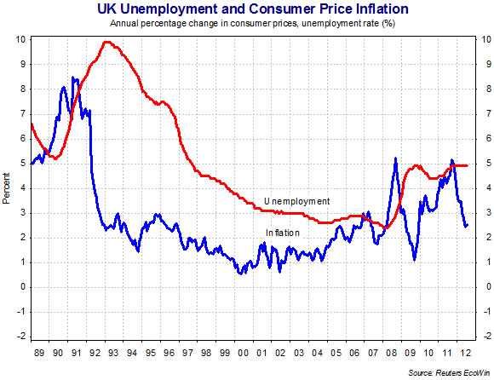

*Unemployment and inflation rates for the UK – inflation measured by the CPI*

In 1958 **AW Phillips** plotted 95 years of data of UK wage inflation against unemployment

It suggested a short-run trade-off between unemployment and inflation

Falling unemployment might cause rising inflation and a fall in inflation might only be possible by allowing unemployment to rise

If a Government wanted to reduce the unemployment rate, it could increase aggregate demand but, although this might temporarily increase employment, it could also have inflationary implications in labour and the product markets.

The key to understanding this trade-off is to consider the possible inflationary effects in both labour and product markets from an increase in national income, output and employment.

* **The labour market**: As unemployment falls, labour shortages may occur where skilled labour is in short supply. This puts pressure on wages to increase and prices may rise as businesses pass on these costs to their customers.
* **Other factor markets**: Cost-push inflation can also come from rising demand for commodities such as oil, copper and processed manufactured goods such as steel, concrete and glass. When an economy is booming, so does the derived demand for components and raw materials.

**Product markets**: Rising demand can lead to suppliers raising prices to increase their profit margins. The risk of rising prices is greatest when demand is out-stripping supply-capacity leading to excess demand (i.e. a positive output gap.)

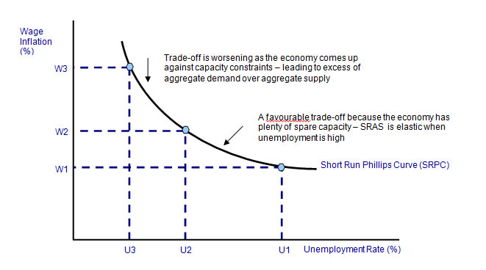

In the late 1980s the UK overheated and suffered a rise in inflation. Unemployment was falling (the economy was moving up a short run Phillips Curve) but the loss of control over inflation caused 15% interest rates and led to a painful recession that caused unemployment to rise to nearly 10 per cent. Higher unemployment helped to bring inflation down once more but the cost was heavy.

The period from 1993 through to 2005 was a remarkable one for the UK. We saw a sustained decrease in the unemployment rate, yet consumer price inflation remained low and fairly stable. Indeed in the mid 1990s both unemployment and inflation were on a falling trend and this was evidence of an improvement in the inflation-unemployment trade-off.

From 2006 onwards the picture began to change once more. Inflation edged higher from below the 2% target to 3% in the spring of 2007. Unemployment leveled off with the claimant count measure flat lining at 3% of the labour force. But in 2008 there was a sharp pick-up in inflation with prices driven higher by a combination of higher fuel and food costs. The rate of inflation peaked at 5.2% in October 2008 just at the time when unemployment started rising again with the economy slowing down and then entering recession.

In 2008 the big danger was thought to be a return to stagflation – a combination of weak growth, high inflation and rising unemployment. In the event the inflationary dangers ebbed away in 2009 as recession started to bite and global commodity prices fell back down. Indeed with unemployment rising sharply and inflation falling, the policy risk has switched to the dangers of a deflationary recession – a combination of high unemployment and a falling price level.

In 2010-11 fears of deflation has ebbed away, indeed consumer price inflation has climbed once more above target. It was only during 2012 that the rate of inflation has fallen back towards the 2% CPI inflation target.

The possible conflict between unemployment and inflation can be moderated if:

* The economy achieves higher labour **productivity** – this raises efficiency, reduces the unit costs of production and also leads to higher real wages which boosts consumer demand
* **Innovation** allows businesses to produce new products at cheaper costs
* **Expectations of inflation** remain stable – a credible inflation target can help here
* The economy is sufficiently flexible to weather external demand and supply-side [shocks](http://www.tutor2u.net/blog/index.php/economics/C207/) such as unexpectedly volatility in the prices of raw materials and components.

**Economic growth and the balance of payments**

A period of fast growth may come into conflict with the balance of payments. Much depends on the income elasticity of demand for traded goods and services. In the case the UK, the evidence is that consumers have a high propensity to consume imports; the income elasticity of demand is strongly positive. Say for example, real disposable incomes grow by 3% and that the income elasticity for imports = +2.5. That would lead to a 7% rise in the volume of imports. Unless there is a corresponding rise in exports, we expect to see a worsening of the balance of trade (i.e. a widening trade deficit).

In a recession, this effect works in reverse as demand for imported products including raw materials, components and ready to consume goods and services declines. The trade balance will improve although the root cause is a drop in economic activity.

**Economic Growth and Inflation**

Most governments hope that they can achieve steady economic growth without it causing acceleration in demand-pull and / or cost-push inflationary pressures. The dangers of a booming economy is that inflationary pressures build and that the economy must slow down or fall into recession for these inflation risks to be controlled.

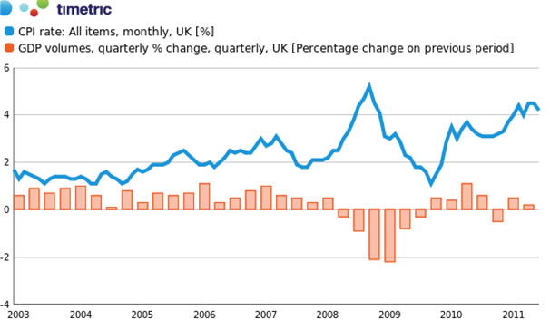

*Economic growth and inflation for the UK economy*

* During the early part of the last decade, the British economy enjoyed a period of steady growth and relatively low and stable inflation
* In 2007-08 the trade-off between growth and inflation worsened
* Inflation surged higher – mainly because of external factors such as high food and oil prices
* The economy suffered a steep descent into recession following the global financial crisis
* In early 2009 the economy experienced recession and higher inflation – some economists warned of a lengthy phase of “**stagflation**” conditions
* Inflation fell back largely because of the recession. But in 2010 and into 2011, inflation has been rising again whilst GDP growth has been weak with the risk of a second downturn (a “double-dip”)

**Stagflation**

Stagflation is a period of economic stagnation accompanied by rising inflation. In other words, both of these key macro objectives are worsening. It can happen when an economy goes into a downturn or a recession but when other external forces are bringing out higher inflation. The obvious example of this is when recession is afflicting a country but the prices of imported products are surging causing prices to rise and real incomes and profits to fall.  The rise in the cost of imports can be shown by an inward shift in the short run aggregate supply curve leading to a contraction in real national output and an increase in prices.

One of the dangers of stagflation is that the fall in real incomes causes consumer and investment spending to fall and thus the rate of economic growth suffers too (a deterioration in a third objective of policy). Wage demand may also pick up as people experience rising prices. The central bank needs to consider appropriate policy responses to this. Too severe a tightening of monetary policy for example will help to curb inflation but risk causing a deep recession.  The combination of deflation and a sustained drop in economic output is termed an economic depression

An improvement in aggregate supply can help to resolve the growth – inflation trade off. We see in the diagram how aggregate supply has moved outwards and this allows aggregate demand (C+I+G+X-M) to operate at a higher level without threatening a persistent increase in the general price level (inflation).

**Overcoming a conflict between economic growth and inflation – increases in AD and AS**

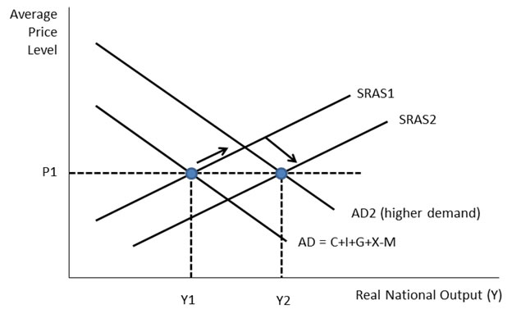

**Conflicts between objectives – the economics of deflation**

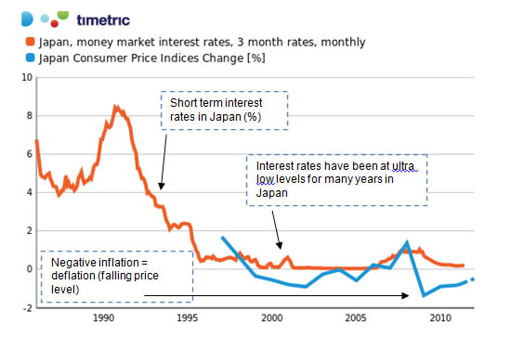

Deflation is a sustained fall in the prices of goods and services, and thus the opposite of inflation. Increased attention has focused on the impact of price deflation in several countries in recent years – notably in Japan (inflation -0.3% in 2010) and in some Euro Area countries such as Ireland Greece where prices have been falling, national output has dropped and unemployment has been rising.

It is normally associated with falling level of AD leading to a negative output gap where actual GDP < potential GDP. But deflation can be caused by rising productive potential, which leads to an excess of aggregate supply over demand.

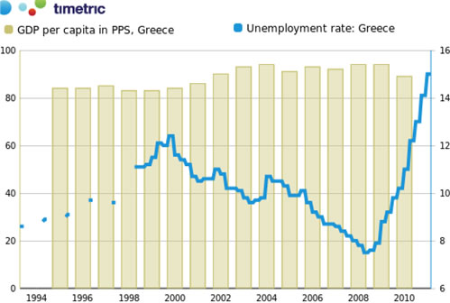

*Greece has suffered from a severe rise in unemployment (right hand scale) and is now seeing her relative living standards fall. A deflationary depression is a risk for Greece*

**Possible damaging consequences of persistent price deflation**

* **Holding back on spending**: Consumers may postpone demand if they expect prices to fall further in the future.
* **Debts increase**: The real value of debt rises when the general price level is falling and a higher real debt mountain can be a drag on consumer confidence and people’s willingness to spend. This is especially the case with mortgage debts and other big loans.
* **The real cost of borrowing increases**: Real interest rates will rise if nominal rates of interest do not fall in line with prices. If inflation is negative, the real cost of borrowing increases and this can have a negative effect on investment spending by businesses
* **Lower profit margins**: Lower prices hit revenues and profits for businesses - this can lead to higher unemployment as firms seek to reduce their costs by shedding labour.
* **Confidence and saving**: Falling asset prices including a drop in property values hits wealth and confidence – leading to declines in AD and the threat of a deeper recession.

**Resolving the threat of price deflation**

* **Using expansionary Monetary Policy**
  + Interest rates: Deep cuts in interest rates can be made to stimulate the demand for money and thereby boost consumption
  + Quantitative Easing – printing money in the hope that, by injecting it into the economy, people and companies will be more likely to spend.
* **Using expansionary Fiscal policy**
  + Keynesian economists believe that fiscal policy is a more effective instrument of policy when an economy is stuck in a deflationary recession and a liquidity trap
  + The key Keynesian insight is that a market system does not have powerful self-adjustments back to full-employment after there has been a negative economic shock. Keynes talked of persistent under-employment equilibrium – an economy operating in semi-permanent recession leading a persistent gap between actual demand and the potential level of GDP.

Keynes argued that this justified an exogenous injection of aggregate demand as a stimulus to get an economy on the path back to full(er) employment and to prevent deflation