**Managing the Economy – Monetary Policy**

***Author****:* [*Geoff Riley*](http://www.tutor2u.net/blog/index.php/site/author/3/)***Last updated:*** *Sunday 23 September, 2012*

**Introduction**

* [Monetary policy](http://www.tutor2u.net/blog/index.php/economics/C7/) influences the decisions that we make about how much we save, borrow and spend
* Decisions made by the central banks that operate monetary policy can have a powerful effect on consumers and businesses
* Changes in interest rates have both demand and supply-side effects.

**What is Money?**

Money is any asset that is acceptable as a medium of exchange in payment for goods and services.  The functions of money are as follows:

* A **medium of exchange** used in payment for goods and services
* A **unit of account** used to relative measure prices and draw up accounts
* A **standard of deferred payment** – for example when using credit to purchase goods and services now but pay for them later
* A **store of value** - money holds its value unless there is a situation of accelerating inflation. As the general price level rises, so the internal value of a unit of currency decreases.

**Interest Rates**

The media often talks about interest rates going up, or interest rates going doing as if there was one single or unique rate of interest in the economy. That isn’t true – indeed there are thousands of different rates in the financial markets – it can get confusing!

For example we distinguish between **savings rates** and **borrowing rates**, interest rates on secured and unsecured loans and short term and long term interest rates on different forms of savings account.

However we find that interest rates tend to move in the same direction. For example if the [Bank of England](http://www.tutor2u.net/blog/index.php/economics/tagged/tag/bank+of+england/) cuts the base rate of interest then we expect to see commercial banks  cutting the rates on their loans and lower rates are offered on savings accounts with Banks and Building Societies.

**The Real Rate of Interest**

* The **real rate of interest** is important to businesses and consumers when making spending and saving decisions
* The real rate of return on savings, for example, is the money rate of interest minus the rate of inflation. So if a saver is receiving a money rate of interest of 6% on his savings, but price inflation is running at 3% per year, the real rate of return on these savings is only + 3%.
* Real interest rates become negative when the nominal rate of interest is less than inflation, for example if inflation is 5% and nominal interest rates are 4%, the real cost of borrowing money is negative at -1%.

**The Bank of England and the operation of Monetary Policy**

* Founded in 1694, nationalized in 1946, the Bank of England is charged with providing monetary and financial stability for the United Kingdom
* The [**Bank of England**](http://www.tutor2u.net/blog/index.php/economics/tagged/tag/bank+of+england/) has been independent since 1997
* The Monetary Policy Committee (MPC) has nine members, some of whom are appointed by the government and some by the Bank of England. The Governor of the Bank has the casting vote if there is an equally split decision on interest rates
* Each month the MPC meets to consider the latest news on the UK and global economy
* Their job is to make a judgement on what is the appropriate level of base interest rates for the [UK economy](http://www.tutor2u.net/blog/index.php/economics/C4/) consistent with the need to meet an **inflation target** set by the government
* That inflation target is **consumer price inflation** **of 2%**
* The MPC has one eye on maintaining growth (although a set rate of GDP growth is not part of their target). Inflation is allowed to vary by 1% either side of the 2% target – so they have some leeway.

**Official UK interest rates in recent years**

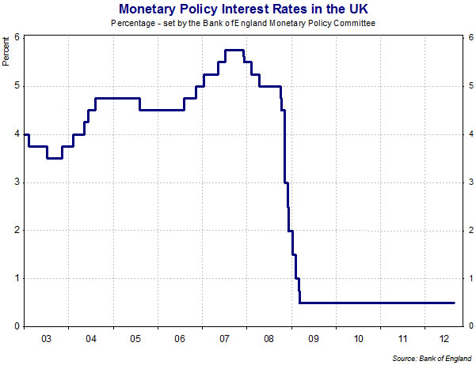

**Factors considered when setting interest rates**

At each of their rate-setting meetings, the members of the MPC consider a huge amount of information on the state of the economy. Here are some of the factors they consider when making rate decisions.

**GDP growth and spare** [**capacity**](http://www.tutor2u.net/blog/index.php/economics/tagged/tag/capacity/): The rate of growth of GDP and the size of the [output gap](http://www.tutor2u.net/blog/index.php/economics/tagged/tag/output+gap/). Their main task is to set monetary policy so that AD grows in line with productive potential.

**Bank lending and consumer credit figures** - including the levels of equity withdrawal from the housing market and also data on credit card lending which supports consumer demand

**Equity markets (share prices) and** [**house prices**](http://www.tutor2u.net/blog/index.php/economics/C9/) - both are considered important in determining household wealth, which then feeds through to borrowing and retail spending. The monetary policy committee has no official target for the annual rate of [house price inflation](http://money.guardian.co.uk/houseprices/0,,594818,00.html) but it has been criticized for not doing enough to prevent the housing bubble in Britain up to 2008.

[**Consumer confidence**](http://tutor2u.net/blog/index.php/economics/tagged/tag/consumer+confidence/) **and business confidence** – confidence surveys can provide “advance warning” of turning points in the economic cycle. These are called ‘leading indicators’.

**Growth of wages, average earnings and unit labour costs** - wage inflation might be a cause of cost-push inflation so the Bank of England looks carefully at what is happening to wages

**Unemployment figures** - and survey evidence on the scale of shortages of skilled labour.

**Trends in global foreign exchange markets** – a weaker exchange rate could be seen as a threat to inflation because it raises the prices of imported goods and services. A strong exchange rate might bring down inflation but risk causing a deeper economic slowdown via a fall in exports

**International data** - including recent developments in the Euro Zone, emerging market countries and the United States and Japan.

*The key point is that the Monetary Policy Committee considers many indicators from both the demand and the supply-side of the economy.*

*They then have to make a judgement about what this evidence says about* ***inflationary pressures*** *over a two year forecast horizon.*

Why do they have to look up to two years ahead? Because when interest rates are changed, it takes time for them to have an effect on aggregate demand and prices. Uncertain time lags in a world of many external economic shocks make the handling of monetary policy a difficult job!

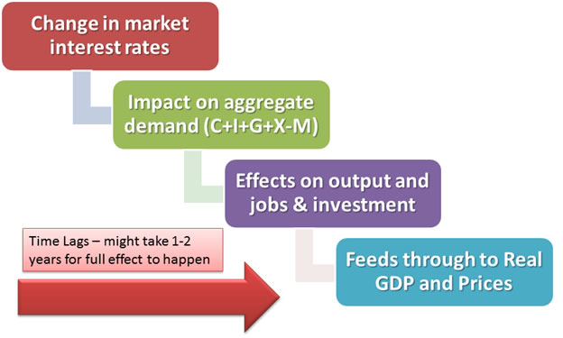

**What are the main effects of changes in interest rates?**

*Before we look at the impact of rate changes, it is worth remembering that when the Bank is making a decision, there will be lots of other events and policy decisions being made elsewhere in the economy, for example changes in fiscal policy by the government, or perhaps a change in world oil prices or the exchange rate. In macroeconomics the ceteris paribus assumption (all other factors held equal) rarely applies!*

* There are several ways in which changes in interest rates influence aggregate demand, output and prices. These are collectively known as the **transmission mechanism of monetary policy**
* One of the channels that the Monetary Policy Committee in the UK can use to influence aggregate demand, and inflation, is via the **lending and borrowing rates** charged in the financial markets.
* When the Bank’s own base interest rate goes up, then commercial banks and building societies will typically increase how much they charge on loans and the interest that they offer on savings.
* This tends to discourage businesses from taking out loans to finance investment and encourages the consumer to save rather than spend — and so depresses aggregate demand
* Conversely, when the base rate falls, banks cut the market rates offered on loans and savings and the effect ought to be a stimulus to demand and output.

A key influence played by interest rate changes is the effect on **confidence** – in particular household’s confidence about their own personal financial circumstances.

Changes in interest rates affect:

* **Housing market & house prices**:
  1. Higher interest rates increase the cost of mortgages and reduce the demand for most types of housing. This will affect household [wealth](http://www.tutor2u.net/blog/index.php/economics/tagged/tag/wealth/) and put a squeeze on **equity withdrawal** (where consumers borrow money secured on rising house prices) which adds directly to consumer spending.
* **Effective disposable incomes of mortgage payers**:
  1. If interest rates increase, the income of homeowners who have variable-rate mortgages will fall – leading to a decline in their effective purchasing power
  2. The effects of a rate change are greater when the level of existing mortgage debt is high as this makes property owners more exposed to higher costs of repaying debts.
* **Disposable income of savers**:
  1. A rise in interest rates boosts the disposable income of people who have paid off their mortgage and who have positive net savings in bank and building society accounts
  2. But if the rate of interest is lower than the rate of inflation, then the annual real return on saving will be negative.
* **Consumer demand for credit:**
  1. Higher interest rates increase the cost of paying the debt on credit cards and should lead to a deceleration in retail sales and spending on consumer durables especially items such as cars and household appliances which are typically bought on credit.
* **Business** [**capital investment**](http://www.tutor2u.net/blog/index.php/economics/C222/)**:**
  1. Firms often take the actual and expected level of interest rates into account when deciding whether or not to go ahead with new capital investment spending
  2. A rise in interest rates may dampen [confidence](http://tutor2u.net/blog/index.php/business-studies/tagged/tag/confidence/) and lead to a reduction in planned capital investment. However, many factors influence investment decisions other than rate changes.
* **Consumer and business confidence:** 
  1. The relationship between interest rates and business and consumer confidence is complex, and depends crucially on prevailing economic conditions
  2. For example, when businesses and consumers are worried about the recession, an interest rate cut can boost confidence because it reassures the public that the Bank is alert to the dangers of a slump
  3. Some people might take emergency interest rate cuts as a sign that the wider economy is in difficulty and hard times lie ahead.
* **Interest rates and the** [**exchange rate**](http://www.tutor2u.net/blog/index.php/economics/C57/)**:**
  1. The link between interest rates and movements in the external value of a currency are important to understand at AS level.
  2. Higher UK interest rates might lead to an appreciation of the exchange rate particularly if UK interest rates rise relative to those in the Euro Zone and the United States attracting inflows of **“hot money”** into the British banking system.
  3. A stronger exchange rate reduces the competitiveness of UK [exports](http://www.tutor2u.net/blog/index.php/economics/tagged/tag/exports/) in overseas markets because it makes our exports appear more expensive when priced in a foreign currency leading to a decline in export volumes and market share.
  4. It also reduces the sterling price of imported goods and services leading to lower prices and rising import penetration. If the **trade deficit** in goods and services widens, this is a net withdrawal of demand from the circular flow and acts to reduce excess demand in the economy.

**Key points:**

* A reduction in interest rates and/or an increase in the supply of money and credit in an economy is called an expansionary monetary policy or a reflationary monetary policy
* An increase in interest rates and/or attempts to control or reduce the supply of money and credit is called a contractionary monetary policy or a deflationary monetary policy
* Over the last few decades, monetary policy has been the main policy instrument for managing the level and rate of growth of aggregate demand and inflationary pressures

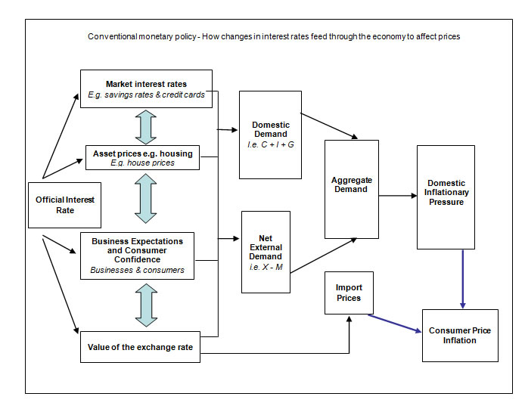

**Monetary Policy Asymmetry**

* Fluctuations in interest rates do not have a uniform impact on the economy. Some industries are more affected by interest rate changes than others, for example exporters and industries connected to the housing market. And, some regions are also more sensitive to a change in the direction of interest rates.
* The markets and businesses most affected by changes in interest rates are those where **demand is interest elastic** in other words, demand responds elastically to a change in interest rates or indirectly through changes in the exchange rate
* Good examples of **interest-sensitive industries** include those directly linked to the housing market¸ exporters of manufactured goods, the construction industry and leisure services
* In contrast, the demand for basic foods and utilities is less affected by short term fluctuations in interest rates and is affected more by changes in commodity prices such as [oil and gas](http://www.tutor2u.net/blog/index.php/economics/C156/).

**Ultra low interest rates in the UK from 2009-2012**

* The Bank of England started cutting monetary policy interest rates in the autumn of 2008 as the [credit crunch](http://www.tutor2u.net/blog/index.php/economics/tagged/tag/credit+crunch/) was starting to bite and business and consumer confidence was taking a huge hit. By the start of 2009 rates were down to 3% and they carried on falling
* By the summer of 2009 the policy interest rate in the UK was 0.5% and the [Bank of England](http://tutor2u.net/blog/index.php/economics/tagged/tag/bank+of+england/) had reached the point of no return when it comes to cutting interest rates
* The decision to reduce official base rates to their minimum was in response to evidence of a deepening recession and fears of price deflation
* Ultra-low interest rates are an example of an expansionary monetary policy i.e. a policy designed to deliberately boost aggregate demand and output. At the time of writing (August 2012) official base interest rates have stayed at 0.5% for over two and a half years and there are few signs that they will increase significantly in the near term.

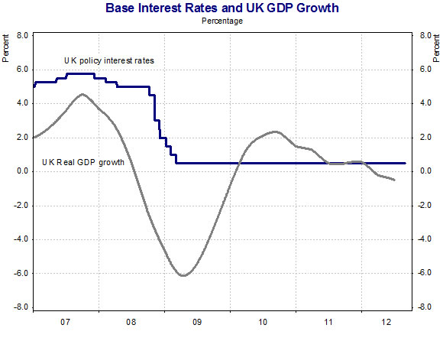

In theory cutting interest rates close to zero provides a big monetary stimulus – this means that:

* Mortgage payers have less interest to pay – increasing their effective disposable income
* Cheaper loans should provide a possible floor for house prices in the property market
* Businesses will be under less pressure to meet interest payments on their loans
* The cost of consumer credit should fall encouraging the purchase of big-ticket items such as a new car or kitchen
* Lower interest rates might cause a depreciation of sterling thereby boosting the [competitiveness](http://www.tutor2u.net/blog/index.php/economics/tagged/tag/competitiveness/) of the export sector
* Lower rates are designed to boost consumer and business [confidence](http://tutor2u.net/blog/index.php/business-studies/tagged/tag/confidence/)

But some analysts argue that in current circumstances, a period of low interest rates has little impact on demand. Several reasons have been put forward for this:

* The unwillingness of banks to lend – most banks have become risk-averse and they have cut the size of their loan books and making credit harder to obtain
* Low consumer confidence – people are not prepared to commit to major purchases because the recession has made people risk averse. Weak expectations lower the effect of rate changes on consumer demand – i.e. there is a low interest elasticity of demand.
* Huge levels of debt still need to be paid off including over £200bn on credit cards
* Falling or slowing rise asset prices makes it unlikely that cheap mortgages will provide an immediate boost to the housing market.
* Although official monetary policy interest rates are now close to zero, the rate of interest charged on loans and overdrafts has actually increased – the cost of borrowing using credit cards and bank loans is a high multiple of the policy rate. Little wonder that many smaller businesses have complained that the Bank of England’s policy of ‘cheap money’ has done little to improve their situation during the recession and in the early stages of the recovery.

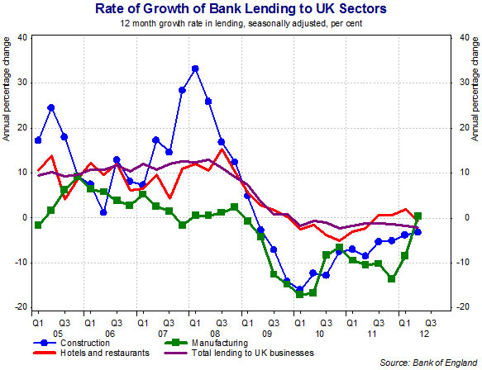

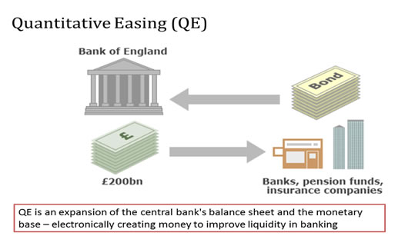

* In March 2009 the Bank of England started a policy of [**quantitative easing**](http://tutor2u.net/blog/index.php/economics/tagged/tag/quantitative+easing/) (QE) for the first time. QE is also called as ‘asset purchase scheme’ or a ‘bond purchase scheme’
* The aim of QE is to support demand in the economy and prevent a period when inflation is persistently below target or becomes negative (deflation).
* The Bank of England can use QE to increase the **supply of money in the banking system**.
* The media call this ‘printing money’ but this is only true in an electronic sense – the Bank does not actually print new £10, £20 and £50 notes in an attempt to inject cash into the economic system.
* Under this **‘unconventional strategy’**, the MPC discusses each month how many **assets**, including government bonds, to buy with central bank money. This money is simply created by the central bank and is the equivalent of turning on the printing press.
* Quantitative easing has been used by other central banks including the USA Federal Reserve
* There are doubts about the effectiveness of quantitative easing – bank lending has struggled to recover since the end of the recession despite bond purchases totalling £375bn as of July 2012

**Funding for Lending Scheme (FLS)**

This was introduced in 2012 as a new policy designed to increase the supply of credit in the British economy. The FLS offers banks and other lenders cheap funding (lower interest rates) secured against some of their assets (known as collateral) if they agree to lend on to businesses and home-buyers.

**Some Evaluation Points on Interest Rates**

* **Time lags** should always be considered when analyzing the effects of interest rate changes.
* Monetary policy is not an exact science – what happens in the macro-economy is the result of millions of decisions taken by households and businesses. We cannot predict with great accuracy the extent to which a change in interest rates will achieved the desired / planned economic effects
* When it comes to inflation targeting there are **many factors affecting costs and prices** and most of these are outside of the Bank of England’s direct control e.g. changes in international commodity prices and fluctuations in the exchange rate (see the next chapter)
* Monetary policy **does not work in isolation**! Always remember consider how the government’s fiscal policy is affecting demand and inflationary pressures.
* Changes in interest rates can have an important effect on the **distribution of income and wealth** in a country. This is discussed briefly below:

**Interest rates and the distribution of income and wealth**

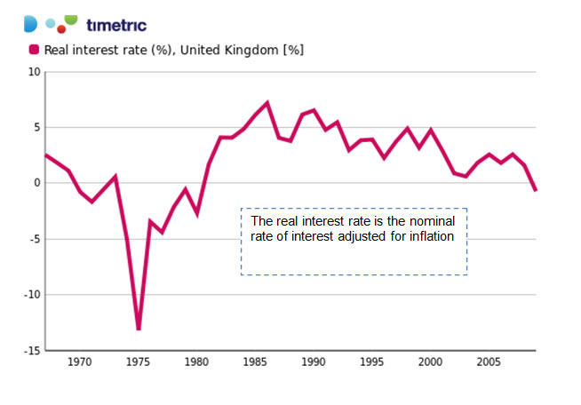

Consider the effect of a fall in interest rates throughout an economy

* **The real income of savers:**
  + If the rate of interest paid on savings falls below the rate of inflation, then people with positive net savings will see a reduction in their real incomes
  + This has become a major policy issue in recent years with interest rates on deposit accounts collapsing in the UK. Rising inflation and falling interest rates have dealt a double-blow to millions of savers many of whom are older and reliant on savings as a source of income. The return is even lower when we consider that most savers pay 20% tax on any interest. Some pay 40% or 50% on their savings interest.
* **The disposable incomes of mortgage-payers**:
  + If interest rates fall, the income of home-owners who have variable-rate mortgages will increase – leading to an rise in their purchasing power
* **Interest rates, house prices and wealth**:
  + Many factors affect house prices but when the cost of a mortgage falls, standard theory predicts that the demand for housing will expand driving property values higher.
  + This increases the net financial wealth of people who own property but makes it more difficult for lower-income families including many young people to find the money to afford to purchase a house or flat.

In summary - when interest rates fall, there is a **re-distribution of income** away from lenders (who receive less) towards those with variable rate loans.

People with positive net savings also stand to lose out from big cuts in interest rates. Little wonder that the Governor of the Bank of England gets many letters of complaints from pensioners when interest rates are cut or remain low for long periods of time!