**Supply-side Economic Policies**

***Author****:* [*Geoff Riley*](http://www.tutor2u.net/blog/index.php/site/author/3/)***Last updated:*** *Sunday 23 September, 2012*

**Introduction**

The **“supply side”** refers to factors affecting the quantity or quality of goods and services produced by an economy such as the level of productivity or investment in research and development.

**What are supply-side policies?**

* Supply-side policies are mainly **micro-economic policies** designed to make markets and industries operate more efficiently and contribute to a **faster underlying-rate of growth of real national output**
* Successful policies have the effect of shifting the LRAS curve to the right leading to a rise in potential output
* Most governments believe that improved supply-side performance is the key to achieving **sustained growth** **without causing a rise in inflation**.
* Supply-side reform on its own is not enough to achieve this growth. There **must also be a high enough level of AD** so that the productive capacity of an economy is actually brought into play.

**Supply-side objectives**

Key concepts to focus on are incentives, enterprise, technology, mobility, flexibility and efficiency.

* Improve **incentives and invest in people’s skills**
* Increase labour and capital **productivity**
* Increase the occupational and geographical **mobility of labour**
* Increase **capital investment** and **research and development** spending by firms
* Promoting more **competition** and stimulate a faster pace of invention and **innovation**
* Provide a platform for sustained **non-inflationary growth** of an economy
* Encourage the start-up and expansion of **new businesses / enterprises**

**Different approaches to the supply side**

***Market-based policies***

* Cutting government spending and taxes and policies to cut government borrowing
* Laws to control trade union powers
* Reducing red-tape to cut the costs of doing business
* Measures to improve the flexibility of the labour market / reforming employment laws
* Policies to boost competition such as deregulation and tough anti-monopoly and anti-cartel laws
* Privatisation of state assets (selling off public sector businesses into the private sector)
* Opening up an economy to overseas trade and investment
* Opening up an economy to inward labour migration

***Interventionist policies***

* State has key role in investing in public services and building critical [infrastructure](http://www.tutor2u.net/blog/index.php/economics/tagged/tag/infrastructure/)
* Tax incentives and welfare reforms can encourage more people into work
* A commitment to a fair minimum wage  / living wage to improve work incentives
* Active regional policy to boost under-performing areas / areas of high unemployment
* Some case for selective import controls to allow domestic industries to expand
* Management of the exchange rate to improve competitiveness of export industries
* Nationalisation of some key industries
* Stronger regulation of industries including finance and transport

*There are two broad approaches to the supply-side. Firstly policies focused on* ***product markets*** *where goods and services are produced and sold to consumers and secondly the* ***labour market*** *– a factor market where labour is bought and sold*

**Product Market Reforms**

* **Product markets** refer to markets in which all kinds of goods and services are made and traded, for example the market for airline travel; smart-phones, new cars; pharmaceutical products and the markets for financial services such as banking, mortgages and pensions.
* Supply-side policies in product markets are designed to **increase** [**competition**](http://www.tutor2u.net/blog/index.php/economics/tagged/tag/competition/) and **efficiency**

**Privatisation**

* Over the last twenty-five years, many former state-owned businesses have been privatised – i.e. transferred from the public to private sector.
* Examples in Britain include British Gas, British Telecom, British Airways, British Steel, British Aerospace, the regional water companies, the main electricity generators and distributors, and the railways.
* Privatization is designed to break-up state monopolies and create more competition. The government also created **utility regulators** such as OFCOM and OFWAT who have in the past imposed price controls and who are now in charge of over-seeing moves towards competitive markets in areas such as gas and electricity supply and telecommunications.
* British Rail was privatised in 1994 but the failure of Railtrack led to the creation of Network Rail, a ‘not for profit’ company in 2002. And in 2008 the government was forced into taking Northern Rock into state ownership following the collapse of the bank. In the space of a year other financial institutions were nationalised. The government now owns or has significant stakes in businesses such as Royal Bank of Scotland, Lloyds TSB and the East Coast train franchise.

**Deregulation of Markets**

* **De-regulation** or **liberalisation** means the **opening up of markets to greater** [**competition**](http://www.tutor2u.net/blog/index.php/economics/tagged/tag/competition/)
* The aim of this is to **increase market supply** (driving prices down) and widen the **choice available to consumers**
* Good examples of deregulation to use include: urban bus transport, post and parcel delivery service, telecommunications, and gas and electricity supply.

**Toughening up of Competition Policy**

* Most supply-side economists believe that competition forces business to become more efficient in the way in which they use scarce resources.
* A tougher competition policy regime includes policies designed to curb anti-competitive practices such as **price-fixing cartels** and other abuses of a dominant market position – in other words – intervention to curb some of the market failure that can come from monopoly power

**A commitment to free (open) trade**

* Trade between nations creates **competition** and should be a catalyst for improvements in costs and lower prices for consumers
* The UK is committed to an expansion of free trade within the **European Union Single Market** and also negotiating a liberalisation of trade in the global economy as part of its membership of the **World Trade Organisation**.

**Measures to encourage small business start-ups / entrepreneurship**

* The small businesses of today often become the larger businesses of tomorrow employing more workers and contributing to innovation that can have positive spill-over effects in other industries.
* Governments of all political persuasions argue that they want to **promote an entrepreneurial culture** and to **increase the rate of new business start-ups**.
* Supply side policies include **loan guarantees** for new businesses; regional policy assistance for entrepreneurs in depressed areas of the country; advice for new firms

**Capital investment and** [**innovation**](http://www.tutor2u.net/blog/index.php/economics/tagged/tag/innovation/)**:**

* Capital spending by firms adds to aggregate demand (C+I+G+(X-M)) but also has an important effect on long run [aggregate supply](http://www.tutor2u.net/blog/index.php/economics/C215/).
* Supply side policies would include tax relief on research and development and reductions in the rate of corporation tax
* A key policy for the Coalition has been the creation of 24 new Enterprise Zones that offer lower taxes and easier planning laws for businesses in  designated areas supported by a Regional Growth Fund

Raising investment is a key ingredient in helping labour productivity to grow. As out chart below shows, in recent years there has been a steep fall in capital investment spending. At the same time the rate of growth of output per worker employed has dropped, indeed productivity at the end of 2011 was lower than it had been in 2007 – this is a supply side weakness for the UK economy.

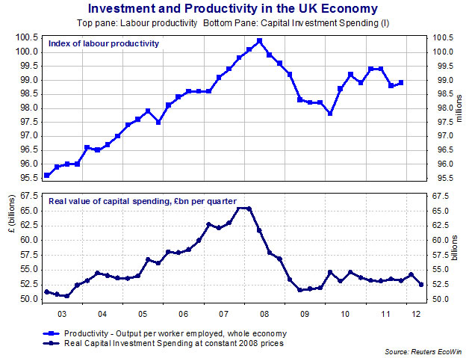

**Supply side policies for the Labour Market**

* These policies are designed to improve the quality and quantity of the **supply of labour** available to the economy
* They seek to make the British labour market more **flexible** so that it is better able to match the labour force to the demands placed upon it by employers in expanding sectors thereby reducing the risk of structural unemployment.
* An expansion in the labour supply increases the productive potential of an economy.
* That expansion in the supply of people willing and able to work can come from several sources for example: [encouraging older people to stay in the workforce](http://www.timesonline.co.uk/article/0,,2622-2209152.html); a [relaxed approach to labour migration](http://news.bbc.co.uk/1/hi/uk/5202852.stm) and measures to get non-working parents to actively look for work.

Along with many other countries, the UK labour market is one that has to contend with a wide range of problems many of which are related to persistently high rates of unemployment. Some of these weaknesses are mentioned in the graphic below. Supply side **labour market reforms** are designed to improve the employment prospects for workers of different ages, in different occupations and industries and in different regions of the country.

**Structural Weaknesses in the UK Labour Market**

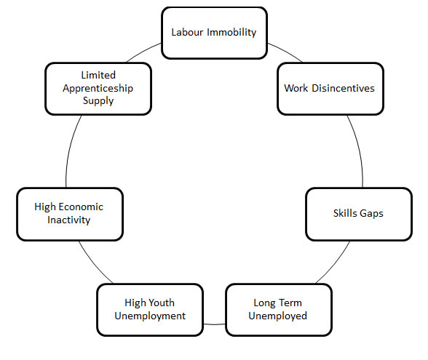

**Skills gap is holding back UK economic growth**

*The UK faces a 10-year gap in its skills profile and damage to its future economic performance unless it tackles the problem of youth unemployment, business leaders and recruiters have warned. They say that failure to acquire work experience and skills at the outset of their careers will not only damage young people prospects but leave deficiencies in the workforce for decades. The UK has 1.02m jobless 16 to 24-year-olds, or 21.9 per cent of the workforce in that age group – just below the EU average*

*Adapted from news reports, 2012*

**Trade Union Reforms**

* Many of the traditional legal protections enjoyed by the trade unions have been taken away – including restrictions on their ability to take industrial action. The result has been a decrease in strike action in virtually every industry and a significant improvement in industrial relations in the UK
* Improved partnerships between trade unions and employers can make a big contribution to raising productivity and improving the flexibility of workers in their jobs

**Increased Spending on Education and Training**

Economists disagree about the scale of the likely economic and social returns to be earned from higher spending on education – but few of them deny that “investment in education” has the potential to raise the skills within the work force and improve the employment prospects of thousands of unemployed workers.

* The economic returns from extra education spending vary according to the stage of [development](http://www.tutor2u.net/blog/index.php/economics/C15/) that a country has achieved
* Government spending on education and training improves workers’ [human capital](http://tutor2u.net/blog/index.php/economics/tagged/tag/human+capital/)
* Economies that have invested heavily in education are those that are well set for the future. Most economists agree, with the move away from industries that required manual skills to those that need mental skills, that investment in education, and the retraining of previously manual workers, is vital.
* Improved training, especially for those who lose their job in an old industry should improve the occupational mobility of workers. This should help reduce the problem of **structural unemployment**.
* A well-educated workforce acts as a magnet for **foreign investment** in the economy.
* Improved education increases opportunities which means that incentives can work more effectively

**Income Tax Reforms and the Incentive to Work**

* Economists who support supply-side policies believe that lower rates of income tax provide a short-term boost to demand, and they improve incentives for people to work longer hours or take a new job – because they get to keep more of the money they earn.
* Cutting tax rates for lower paid workers may help to reduce the extent of the ‘unemployment trap’ – where people calculate that they may be no better off from working than if they stay outside the labour force.
* Do lower taxes always help to increase the active labour supply in the economy? It seems obvious that lower taxes should boost the incentive to work because tax cuts increase the reward from a job. But some people may choose to work the same number of hours and simply take a rise in their post-tax income! Millions of other workers have little choice over the hours that they work.

**Showing the effects of supply-side improvements in the economy**

* Supply-side factors often help to explain why it is that some countries grow faster than others
* In a world of [**globalisation**](http://www.tutor2u.net/blog/index.php/economics/tagged/tag/globalisation/), it is becoming clearer that maintaining and improving **competitiveness** is vital in achieving success in international markets.
* A rising share of GDP in most countries is devoted to [international trade](http://www.tutor2u.net/blog/index.php/economics/C199/). Markets are becoming more competitive and those countries whose supply-side lets those down can find a rising level of import penetration into their domestic markets and a weak export performance in goods and services.

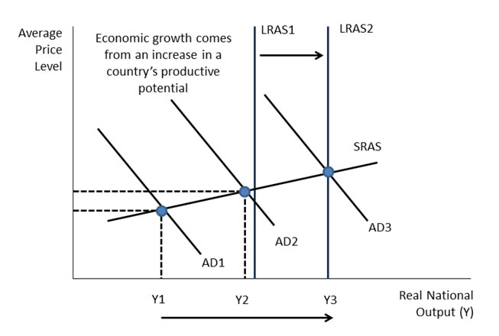

**How can supply-side policies help lift a country out of recession?**

* Recessions are often the result of negative demand-side shocks that hit real incomes of consumers and demand and profits for businesses
* The consequences show through in higher unemployment, a fall in capital investment and an increasing rate of business failures
* There is a danger that a deep recession and slow recovery will have harmful effects on the supply side leading to a reduction in the growth rate of potential GDP and a loss of productive capacity
* This is known as a hysteresis effect
* Most macroeconomic policies in a recession centre on boosting demand and confidence in a bid to generate a rebound in output, jobs and incomes within the circular flow  and prevent hysteresis

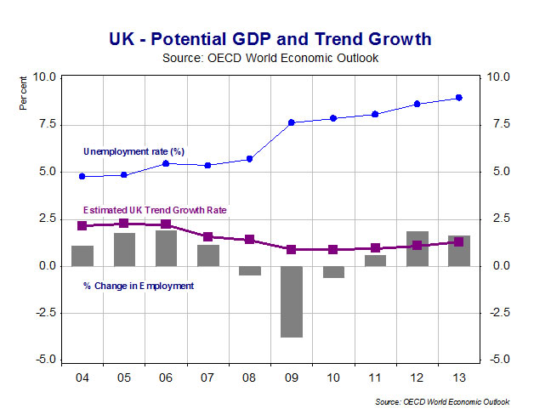

The chart above provides an illustration of the damaging effects of a recession. 2009 was a year of recession and as a result employment contracted and the unemployment rate jumped sharply. There has been a modest recovery in employment since 2009 but unemployment has continued to climb. The estimated trend growth rate for the UK has declined and this suggests that the economy will struggle to achieve a strong recovery.

What role can supply-side policies play during an economic downturn?

* **Extra capital spending on an economy’s critical infrastructure** - this might be funded by the government for example bringing forward some investment spending on hospital re-building, transport projects and environmental schemes. Other big capital spending projects might be partly financed by the private sector perhaps as part of a public-private partnership. These projects are often labour-intensive and can create a sizeable multiplier effect
* **Reductions in business taxation** - for example lowering the rate of corporation tax (to stimulate investment) or reducing employers’ national insurance contributions (to boost the demand for labour). Lower taxes for business research and development spending or tax relief for inward investment projects also have a supply-side aspect to them
* Policies designed **at improving the quality of and access to education and training for all**. This is particularly relevant when coming out of a recession because many of the new jobs in an economy as recovery gathers momentum are not in the same industries as before a downturn. It is hugely important to prevent cyclical unemployment from turning into structural unemployment
* **Measures to stimulate business start-ups** – seed-corn finance and other help for new enterprises can provide a flow of new jobs as an economy picks up
* **Relaxation of planning controls** designed to increase the rate of new house-building
* Policies to maintain the **openness to trade and investment from overseas** - instead of choosing protectionist policies, politicians should understand the importance of trade and competition as a means of generating new demand and creating extra jobs.

**Productivity**

* Productivity is a measure of the **efficiency** with which a country combines capital and labour to produce more with the same level of factor inputs. We commonly focus on labour productivity measured by output per person employed or output per person hour.
* A better measure of productivity growth is **total factor productivity** which takes into account changes in the amount of capital to use and also changes in the size of the labour force.
* To give a numerical example, if the size of the capital stock grows by 3% and the employed workforce expands by 2% and output (GDP) increases by 8%, then total factor productivity has increased by 3%.

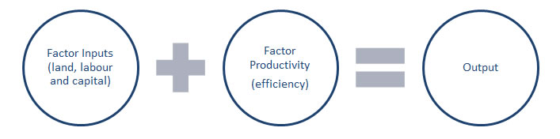

Productivity is an important determinant of living standards – it quantifies how an economy uses the resources it has available, by relating the quantity of inputs to output. As the adage goes, productivity isn't everything, but in the long run it’s almost everything.  
Higher productivity can lead to:

* **Lower unit costs**: These cost savings might be passed onto consumers in lower prices, encouraging higher demand, more output and an increase in employment.
* **Improved competitiveness and trade performance**: Productivity growth and lower unit costs are key determinants of the competitiveness of firms in global markets.
* **Higher profits**: Efficiency gains are a source of larger profits for companies which might be re-invested to support the long term growth of the business.
* **Higher wages**: Businesses can afford higher wages when their workers are more efficient.
* **Economic growth**: If an economy can raise the rate of growth of productivity then the trend growth of national output can pick up.
* **Productivity improvements** mean that labour can be released from one industry and be made available for another – for example, rising efficiency in farming will increase production yields and provide more food either to export or to supply a growing urban population.
* **If the size of the economy is bigger**, higher wages will boost consumption, generate more tax revenue to pay for public goods and perhaps give freedom for tax cuts on people and businesses.

***Project Merlin - Banking finance to support the supply of credit to UK businesses***

The financial crisis has led to a reduction in the supply of credit for smaller businesses and higher interest rates. This has become a major political as well as economic issue.   
Without credit being available at an affordable cost, it is very hard for businesses to find the money to expand, e.g. to fund a rise in production, an export-drive or a new capital investment project.  
In February 2011, the five largest banks operating in the UK (Barclays, HSBC, Lloyds Banking Group (LBG), The Royal Bank of Scotland (RBS) and Santander) agreed to make £190 billion of new credit available to businesses this year. This was part of Project Merlin.  
However research from the Bank of England finds that, although lending to larger businesses has recovered quite well, there are still many barriers facing small to medium-sized enterprises. Small firms are reported as being reluctant to approach commercial banks in case it led to an increase in the cost of existing borrowings, or reductions in their overdraft limits.  
The supply and cost of credit from the financial system is a really important factor in driving enterprise and investment – two key ingredients of a stronger supply-side economic performance.

**Research and Development (R&D)**

* Spending on research and development (R&D) in the UK has remained low as a % of GDP – usually between 1.5 and 2% of national income
* This **‘research gap’** is a constraint on innovation and affects global competitiveness
* Only two British firms are in the top 50 global research spenders. Other countries e.g. Finland, Germany and Israel devote higher share of GDP to research
* The biggest barriers to innovation are **risk aversion**, uncertainty about ability to exploit research and make a profit, a **lack of high-skilled workers** and a lack of information on technology and markets
* There is some evidence of higher R&D spending in the UK among smaller businesses in computing technology, biotechnology and nanotechnology
* The top EU companies for research are Nokia, Volkswagen, Bosch and Siemens
* Siemens holds about 53,300 patents, and filed a further 8,600 in 2011 – just under 40 per working day
* The top two UK firms are GlaxoSmithKline and AstraZeneca
* The British government has tried to boost R&D spending through tax credits but critics say that this policy has been ineffective. Recently the government has introduced an incentive known as a **Patent Box** – where profits from research projects are taxed at a lower rate
* Research is important for supply-side competitiveness but a key evaluation point is that the level of research spending is not necessarily a guide to the pace and success of innovation in a country.
  + Many businesses do not patent all their most innovative ideas, preferring instead to keep them as trade secrets
  + Steve Jobs once said, “Innovation has nothing to do with how many R&D dollars you have. When Apple came up with the Mac, IBM was spending at least 100 times more on R&D.”

**Measures of International Competitiveness**

Competitiveness is the ability of an economy to compete fairly and successfully in markets for internationally traded goods and services that allows for rising standards of living over time.

* **Cost competitiveness** – differences in unit costs between producers – reflected in prices
* **Non-price competitiveness** – this encompasses technical factors such as product quality, design, reliability and performance, choice, after-sales services, marketing, branding and the availability and cost of replacement parts

**Unit labour costs**

* These are the labour costs of supplying goods and services per unit of output – in simple terms, how expensive it is to make something
* Unit labour costs are determined by
  + The costs of employing people (wage rates, salaries, payroll taxes)
  + The productivity of these people
* Data on unit labour costs is normally expressed in relative terms i.e. we compare unit labour costs in one country relative to another
* Unit labour costs will rise when wages rise faster than the annual improvement in productivity

**Non-wage costs**

These are also important when it comes to sustaining an improvement in competitiveness in global markets. The main non wage costs for businesses:

* The costs of meeting environmental regulations
* Environmental taxes
* Employment protection laws and health and safety laws
* Requirements to provide business pensions

**World Economic Forum – Global Competitiveness Report**

This is a report published annually and is an attempt to rank countries using a group of indicators.

* Institutions (property rights protection, trust, judicial independence, corruption)
* Infrastructure (transport, telephony, and energy, ports)
* Macroeconomic environment (including stability of key macro indicators)
* Health and primary education, Higher education and training
* Goods market efficiency, labour market efficiency
* Financial markets (including stability of markets, strength of banks)
* Technological readiness (readiness to exploit, adapt to new technologies)
* Market size (linked to population size and per capita incomes)
* Business sophistication (quality of supply chains, industrial clusters, quality of management)
* Innovation

**UK ranking in global competitiveness**: The UK was ranked 10th in 2012

*Strengths included:*

* Efficiency of its labour market (7th)
* Sophisticated (8th) and innovative (13th) businesses
* A very large market (it is ranked 6th for market size)

*Weaknesses included:*

* Macroeconomic environment (85th)
* Large fiscal deficit in 2010 (placing the country 138th) and high public debt (77 percent of GDP in 2010, 120th)

Comparatively low national savings rate (12.3 percent of GDP in 2010, 119th)