**Topic 3) Macroeconomic policies**

***Use pages 86-110 from the associated study pack to answer the following:***

***Explain why there is a need for macroeconomic policy***

|  |
| --- |
|  |

***Identify a range of objectives of macroeconomic policy***

|  |
| --- |
|  |
|  |
|  |
|  |
|  |
|  |

***Explain a range of problems the government faces when trying to manage the economy***

|  |  |
| --- | --- |
| Problems government faces  when trying to manage the  economy | Explanation |
|  |  |
|  |  |
|  |  |

Briefly explain the following policies designed to influence the economy

|  |  |
| --- | --- |
| Policy | Explanation |
| Fiscal Policy |  |
| Monetary Policy |  |
| Supply-side Policies |  |

***Monetary Policy – provide a basic explanation as to how this works in the UK***

|  |
| --- |
|  |

***Define the following key terms***

|  |  |
| --- | --- |
| Key term | Definition |
| Interest rates |  |
| Real interest rates |  |

***Explain in detail a range of ways that higher interest rates will impact on the UK Economy***

|  |  |
| --- | --- |
| Impact of higher interest rates  on the economy | Explanation |
|  |  |
|  |  |
|  |  |
|  |  |

***Explain in detail when (considering the economic cycle) when interest rates will be cut and how this will impact on the economy***

|  |
| --- |
|  |

***Fiscal Policy – provide a basic explanation as to how this works in the UK]***

|  |
| --- |
|  |

***Explain the meaning of ‘expansionary fiscal policy’***

|  |
| --- |
|  |

***Explain how the following examples of expansionary fiscal policy impact on the UK Economy***

|  |  |
| --- | --- |
| Example of expansionary fiscal policy | How this impacts on the economy |
| Cut in personal income tax |  |
| Cut in indirect taxes |  |
| Cut in Corporation tax |  |

***Explain the following types of government spending***

|  |  |
| --- | --- |
| Type of government spending | Explanation |
| Transfer Payments |  |
| Current Government Spending |  |
| Capital Spending |  |

***Define the following key terms***

|  |  |
| --- | --- |
| Key term | Definition |
| Automatic stabilisers |  |
| Direct taxes |  |
| Indirect taxes |  |
| Progressive taxes |  |
| Proportional taxes |  |
| Regressive taxes |  |

***Explain a range of ways that fiscal policy can shift out the LRAS curve***

|  |  |
| --- | --- |
| How fiscal policy can shift out LRAS | Explanation |
|  |  |
|  |  |
|  |  |

***Define the following key terms***

|  |  |
| --- | --- |
| Key term | Definition |
| Government borrowing |  |
| Budget deficit |  |
| Budget surplus |  |

***Use a diagram to help you explain the key term ‘supply-side policies’***

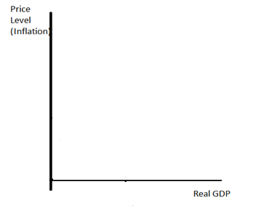

|  |
| --- |
|  |

***Explain how the following supply-side policies will increase LRAS***

|  |  |
| --- | --- |
| Supply-side policy | Explanation |
| Privatisation |  |
| Income tax reforms and  Incentive to work |  |
| Competition Policy |  |
| Encourage  entrepreneurship |  |
| Capital investment  And innovation |  |
| Trade Union reform |  |
| Spending on education  and training |  |