**Calculating a Firm's Costs**

***Author****:* [*Geoff Riley*](http://www.tutor2u.net/blog/index.php/site/author/3/)***Last updated:*** *Sunday 23 September, 2012*

In the **short run,** because **at least one factor of production is fixed**, output can be increased only by adding more **variable factors.** Hence we consider both **fixed and variable costs**

**Fixed costs**

Fixed costs are business expenses that do not vary directly with the level of output i.e. they are treated as **independent** of the level of production.

Examples of fixed costs include the rental costs of buildings; the costs of leasing or purchasing capital equipment such as plant and machinery; the annual business rate charged by local authorities; the costs of full-time contracted salaried staff; the costs of meeting interest payments on loans; the depreciation of fixed capital (due solely to age) and also the costs of business insurance.

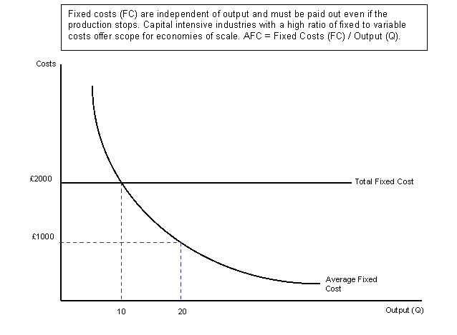

Fixed costs are the **overhead costs** of a business. They are important in markets where the fixed costs are high but the variable costs associated with making a small increase in output are relatively low. We will come back to this when we consider **economies of scale.**

* Total fixed costs            (TFC)                remain constant as output increases
* Average fixed cost          (AFC)    =          total fixed costs divided by output

**Average fixed costs must fall continuously as output increases** because total fixed costs are being spread over a higher level of production. In industries where the ratio of fixed to variable costs is extremely high, there is great scope for a business to exploit lower fixed costs per unit if it can produce at a big enough size.  Consider the new Sony portable play station. The fixed costs of developing the product are enormous, but these costs can be divided by millions of individual units sold across the world.

A change in fixed costs has no effect on marginal costs. Marginal costs relate only to variable costs!

**Variable Costs**

Variable costs are costs that **vary directly with output**. Examples of variable costs include the costs of **intermediate raw materials** and other components, the wages of part-time staff or employees paid by the hour, the costs of electricity and gas and the depreciation of capital inputs due to wear and tear. Average variable cost (AVC) = total variable costs (TVC) /output (Q)

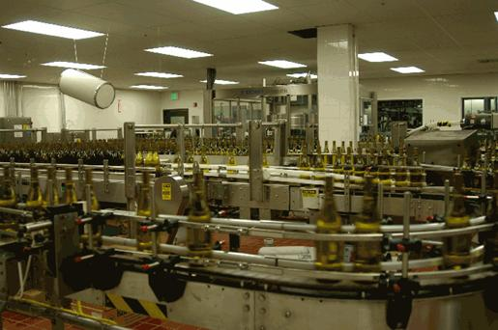  
*Variable costs are those associated with changes in short run production – what are the variable costs associated with an increase in the production of Californian wine shown in the picture above?*

**Average Total Cost (ATC or AC)**  
Average total cost is simply the cost per unit produced  
Average total cost (ATC) = total cost (TC) / output (Q)

**Marginal Cost**

Marginal cost is the **change in total costs from increasing output by one extra unit**.

The marginal cost of supplying an extra unit of output is linked with the **marginal productivity of labour.** The **law of diminishing returns** implies that the marginal cost of production will rise as output increases. Eventually, rising marginal cost will lead to a rise in average total cost. This happens when the rise in AVC is greater than the fall in AFC as output (Q) increases.

**Worked example of short run production costs**

A simple numerical example of short run costs is shown in the table below. Fixed costs are assumed to be constant at £200. Variable costs increase as more output is produced.

|  |  |  |  |  |  |
| --- | --- | --- | --- | --- | --- |
| Output (Q) | Total Fixed Costs (TFC) | Total Variable Costs (TVC) | Total Cost | Average Cost Per Unit | Marginal Cost  (the change in total cost from a one unit change in output) |
| (TC= TFC + TVC) | (AC = TC/Q) |
| 0 | 200 | 0 | 200 |  |  |
| 50 | 200 | 100 | 300 | 6 | 2 |
| 100 | 200 | 180 | 400 | 4 | 2 |
| 150 | 200 | 230 | 450 | 3 | 1 |
| 200 | 200 | 260 | 460 | 2.3 | 0.2 |
| 250 | 200 | 280 | 465 | 1.86 | 0.1 |
| 300 | 200 | 290 | 480 | 1.6 | 0.3 |
| 350 | 200 | 325 | 525 | 1.5 | 0.9 |
| 400 | 200 | 400 | 600 | 1.5 | 1.5 |
| 450 | 200 | 610 | 810 | 1.8 | 4.2 |
| 500 | 200 | 750 | 1050 | 2.1 | 4.8 |

In our example, average cost per unit is minimised at a range of output between 350 and 400 units. Thereafter, because the marginal cost of production exceeds the previous average, so the average cost rises (for example the marginal cost of each extra unit between 450 and 500 is 4.8 and this increase in output has the effect of raising the cost per unit from 1.8 to 2.1).

**Short Run Cost Curves**

When diminishing returns set in (beyond output Q1) the marginal cost curve starts to rise. Average total cost continues to fall until output Q2 where the rise in average variable cost equates with the fall in average fixed cost. Output Q2 is the lowest point of the ATC curve for this business in the short run. This is known as the output of **productive efficiency**.

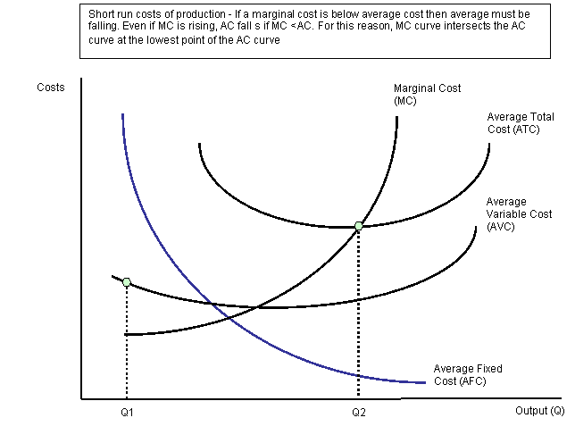

**A change in variable costs**

A rise in the variable costs of production leads to an upward shift both in marginal and average total cost. The firm is not able to supply as much output at the same price. The effect is that of an inward shift in the supply curve of a business in a competitive market.  
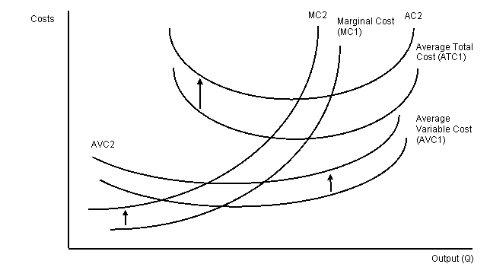

An increase in fixed costs has no effect at all on variable costs of production. This means that only the average total cost curve shifts. There is no change at all on the marginal cost curve leading to no change in the profit maximising price and output of a business. The effects of an increase in the fixed or overhead costs of a business are shown in the diagram below.

