**Long-run costs - economies & diseconomies of scale**

***Author****:* [*Geoff Riley*](http://www.tutor2u.net/blog/index.php/site/author/3/)***Last updated:*** *Sunday 23 September, 2012*

**Economies of Scale**

* In the long run **all costs are variable** and the scale of production can change (no fixed inputs)
* [Economies of scale](http://www.tutor2u.net/blog/index.php/economics/tagged/tag/economies+of+scale/) are the **cost advantages** from **expanding the scale of production in the long run**. The effect is to **reduce average costs** over a range of output.
* These lower costs represent an improvement in **productive efficiency** and can give a business a **competitive advantage** in a market. They lead to lower prices and higher [profits](http://www.tutor2u.net/blog/index.php/economics/tagged/tag/profits/) – this is called a **positive sum game** for producers and consumers (i.e. the welfare of both will improve)
* We make no distinction between fixed and variable costs in the long run **because all factors of production can be varied**.
* As long as the long run average total cost curve (LRAC) is declining, then internal economies of scale are being exploited. The table below shows a numerical example of falling LRAC

|  |  |  |
| --- | --- | --- |
| **Long Run Output (Units)** | **Total Costs (£s)** | **Long Run Average Cost (£ per unit)** |
| 1000 | 12000 | 12 |
| 2000 | 20000 | 10 |
| 5000 | 45000 | 9 |
| 10000 | 80000 | 8 |
| 20000 | 144000 | 7.2 |
| 50000 | 330000 | 6.6 |
| 100000 | 640000 | 6.4 |
| 500000 | 3000000 | 6 |

**Returns to Scale and Costs in the Long Run**

The table below shows how changes in the scale of production can, if **increasing returns to scale** are exploited, lead to lower long run average costs.

|  |  |  |  |  |  |  |  |  |
| --- | --- | --- | --- | --- | --- | --- | --- | --- |
|  | **Factor Inputs** | | |  | **Production** |  | **Costs** | |
|  | (K) | (La) | (L) |  | (Q) |  | (TC) | (TC/Q) |
|  | Capital | Land | Labour |  | Output |  | Total Cost | Average Cost |
| **Scale A** | 5 | 3 | 4 |  | 100 |  | 3256 | *32.6* |
| **Scale B** | 10 | 6 | 8 |  | 300 |  | 6512 | *21.7* |
| **Scale C** | 15 | 9 | 12 |  | 500 |  | 9768 | *19.5* |
| *Costs: Assume the cost of each unit of capital = £600, Land = £80 and Labour = £200* | | | | | | | | |

Because the % change in output exceeds the % change in factor inputs used, then, although total costs rise, the average cost per unit falls as the business expands from scale A to B to C.

**Increasing Returns to Scale**

Much of the new thinking in economics focuses on the **increasing returns** available to a company growing in size in the long run.

An example of this is the software business.

* The **overhead costs** of developing new software programs or computer games are huge - often running into hundreds of millions of dollars
* But the **marginal cost** of one extra copy for sale is close to zero, perhaps just a few cents or pennies.
* If a company can establish itself in the market, positive feedback from consumers will **expand the installed customer base**, raise demand and encourage the firm to increase production.
* Because marginal cost is so low, the extra output reduces average costs creating **economies of size**.

**Capacity utilisation, fixed costs and profits**

Lower costs normally mean **higher profits** and increasing financial returns for the [shareholders](http://www.tutor2u.net/blog/index.php/economics/tagged/tag/shareholders/). What is true for software developers is also important for telecoms companies, transport operators and music distributors.

We find across many different markets that, when a high percentage of costs are fixed the higher the level of production the lower will be the average cost of production. Strong demand means that **capacity utilization** rates are high and this lowers the unit cost of supply.

**Long Run Average Cost Curve**

The long run average cost curve (LRAC) is known as the **‘envelope curve’** and is usually drawn on the assumption of their being an infinite number of plant sizes – hence its smooth appearance in the next diagram below.

The **points of tangency** between LRAC and SRAC curves do not occur at the minimum points of the SRAC curves except at the point where the minimum efficient scale (MES) is achieved.

If LRAC is falling when output is increasing then the firm is experiencing **economies of scale**.  For example a doubling of factor inputs might lead to a more than doubling of output.

Conversely, When LRAC eventually starts to rise then the firm experiences **diseconomies of scale**, and, If LRAC is constant, then the firm is experiencing constant returns to scale

The working assumption is that a business will choose the least-cost method of production in the long run. Moving down the LRAC means there are cost advantages from a bigger scale of operations.

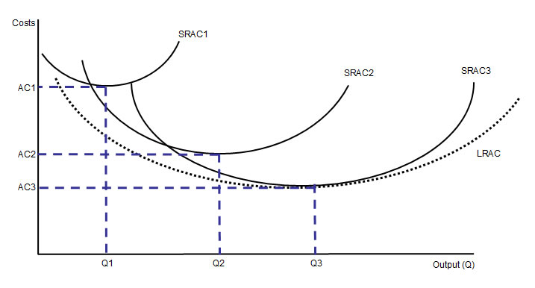

**Sources of Internal Economies of Scale (IEoS)**

Internal [economies of scale](http://www.tutor2u.net/blog/index.php/economics/tagged/tag/economies+of+scale/) come from **the long-term growth of the firm.** Examples include:

1. **Technical economies of scale**:

These refer to gains in productivity from scaling up production.

* 1. **Expensive (indivisible) capital inputs:** Large-scale businesses can afford to invest in **specialist capital machinery**. For example, a supermarket might invest in database technology that improves stock control and reduces transportation and distribution costs.
  2. **Specialization of the workforce**: Larger firms can split the production processes into separate tasks to boost **productivity**. Examples include the use of [**division of labour**](http://www.tutor2u.net/blog/index.php/economics/tagged/tag/division+of+labour/) in the mass production of motor vehicles and in manufacturing electronic products.
  3. **The law of increased dimensions** (also known as the **“container principle”**) This is linked to the **cubic law** where doubling the height and width of a tanker or building leads to a more than proportionate increase in the cubic capacity
     1. The application of this law opens up the possibility of scale economies in distribution and [freight industries](http://news.bbc.co.uk/1/hi/england/suffolk/6118032.stm) and also in travel and leisure sectors with the emergence of super-cruisers such as [P&O’s Ventura](http://news.bbc.co.uk/1/hi/england/hampshire/6398919.stm). Consider the new generation of super-tankers and the development of enormous passenger aircraft such as the Airbus 280 which is capable of carrying over 500 passengers on long haul flights.
     2. The law of increased dimensions is also important in the energy sectors and in industries such as office rental and warehousing. [Amazon](http://www.tutor2u.net/blog/index.php/economics/tagged/tag/amazon/) for example has invested in several huge warehouses at its central distribution points – capable of storing hundreds of thousands of items.
  4. **Learning by doing:** The average costs of production decline in real terms as a result of production experience as businesses cut waste and find the most productive means of producing output on a bigger scale. Evidence across a wide range of industries into so-called “**progress ratios**”, or “**experience curves**”, indicate that *unit**manufacturing costs typically fall by between 70% and 90% with each doubling of**cumulative output*.

1. **Marketing Economies - Monopsony Power**: A large firm can **purchase its factor inputs** in bulk at discounted prices if it has[**monopsony**](http://www.tutor2u.net/blog/index.php/economics/tagged/tag/monopsony/) **(buying) power**. A good example would be the ability of the electricity generators to negotiate lower prices when finalizing coal and gas supply contracts. The national food retailers have monopsony power when purchasing their supplies from farmers and wine growers and in completing supply contracts from food processing businesses. Other controversial examples of the use of monopsony power include the [prices paid by coffee roasters and other middlemen to coffee producers](http://news.bbc.co.uk/1/hi/business/6637995.stm) in some of the poorest parts of the world.
2. **Managerial economies of scale**: This is a form of [**division of labour**](http://www.tutor2u.net/blog/index.php/economics/tagged/tag/division+of+labour/) where firms can employ specialists to supervise production systems. Better management; increased investment in human resources and the use of specialist equipment, such as networked computers can improve communication, raise productivity and thereby reduce unit costs.
3. **Financial economies of scale**: Larger firms are usually rated by the financial markets to be more **‘credit worthy’** and have access to credit with favourable rates of borrowing. In contrast, smaller firms often pay higher rates of interest on overdrafts and loans. Businesses quoted on the stock market can normally raise new financial capital more cheaply through the sale of equities to the capital market. The credit crunch and fragility of the banking system has made raising finance harder for businesses of all sizes – bank overdraft and loan interest rates have increased across the board, but it remains true that larger corporations can still access credit at a cheaper cost.
4. **Network economies of scale**: There is growing interest in the concept of a **network economy**. Some networks and services have huge potential for economies of scale. That is, as they are more widely used (or adopted), they become more valuable to the business that provides them.

**Case Study: Small businesses and financial economies of scale**  
A Bank of England survey on financial and credit conditions finds that smaller businesses are finding it tough to get the credit they need to finance an upturn in sales and production.   
Interest rate spreads on new loans are rising and it is larger firms that seem to be benefitting from lower borrowing costs. According to the report “larger businesses are enjoying a reduction in the cost of borrowing and improved access to credit as banks favour lower-risk custom.”   
The main commercial banks continue to adopt a risk-averse approach to new lending and this may hamper prospects of recovery. Unsecured loans for consumers have also become harder to get and more expensive despite the ultra-low interest rate policy of the Bank of England. In 2006, the top 10 average rate for a £3,000 personal loan was 6.49%, but today it is 14.92%, analysis by price comparison website moneysupermarket.com has shown.   *Source: Tutor2u economics blog, April 2010*

**What are Network Economies of Scale?**

The power of **networks** is becoming increasingly recognized in the economics of long run costs, revenues and profits.

Many networks have huge potential for **economies of scale**. That is, as they are more widely used (or adopted), they become more valuable to the business that provides them.

Good examples to use include online auction sites such as eBay, social networking sites, wireless service providers, air and rail transport networks and businesses such as Amazon.

In most cases, the **marginal cost** of adding one more user or customer to a network is close to zero, but the resulting financial benefits may be huge because each new user to the network can then interact, trade with all of the existing members or parts of the network.

Given the **high fixed costs** of establishing a network, the more users there are the lower are the fixed costs per unit. Thus as the network expands, not only are there potential gains from extra revenues, but the long run cost per user diminishes - an internal economy of scale.

In some cases an industry that requires a network to fulfill customer needs and wants across a country or region might be classified as a **natural monopoly** - an industry where long run average cost falls over a huge range of output and where the minimum efficient scale is a large percentage of market demand.

Consider as examples the networks required by the major utilities such as water, gas, electricity and (fixed line) broadband suppliers. And perhaps businesses such as Network Rail and the Royal Mail might also claim to have aspects of a natural monopoly given the requirement for the former to maintain and improve a national rail infrastructure and, for the latter, to keep a universal postal service running to add postal addresses in the country - this is of course a loss-making aspect of their business model.

Where there are strong grounds for believing an industry is a natural monopoly, there might be a case for nationalizing and/or regulating the network element of the business but introducing competition into the actual service provision - e.g. franchise bids for train operating companies, and partial or complete deregulation of parcel and letter collection, sorting and delivery.  
*Source: Tutor2u Economics Blog*

**Analysis: Economies of Scale – Effects on Price, Output and Profits**

Consider the diagram:

* Scale economies allow a supplier to move from SRAC1 to SRAC2
* A profit maximizing producer will produce at a higher output (Q2) and charge a lower price (P2) as a result – but the total profit is also much higher (compare the two shaded regions)
* Both consumer and producer surplus has increased – there has been an improvement in economic welfare and efficiency – the key is whether cost savings are passed onto consumers!

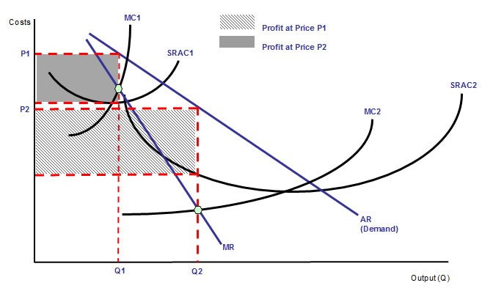

**Analysis Diagram for External Economies of Scale (EEoS)**

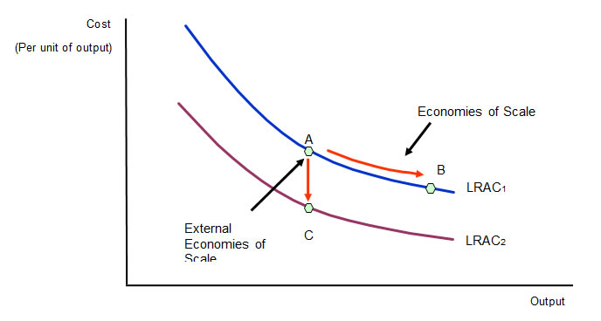

* External economies of scale occur **outside of a firm but within an industry**.
* For example investment in a **better transportation network** servicing an industry will resulting in a decrease in costs for a company working within that industry.
* Another example is the development of **research and development facilities** in **local universities** that several businesses in an area can benefit from.
* Likewise, the **relocation of component suppliers** and other support businesses close to the centre of manufacturing are also an external cost saving.
* **Agglomeration economies** may also result from the **clustering** of businesses in a distinct geographical location e.g. software in Silicon Valley or investment banks in the City of London

**Economies of Scale – The Importance of Market Demand**

The **market structure of an industry** is affected by the extent of economies of scale available to individual suppliers and by the total size of market demand.

* In many industries, it is possible for smaller firms to make a profit because the cost disadvantages they face are relatively small. Or because **product differentiation** allows a business to charge a **price premium** to consumers which more than covers their higher costs.
* A good example is the retail market for furniture. The industry has major players in different segments (e.g. flat-pack and designer furniture) including the Swedish giant IKEA. However, much of the market is taken by smaller-scale suppliers with consumers willing to pay higher prices for bespoke furniture owing to the low **price elasticity of demand** for high-quality, hand crafted furniture products.
* Small-scale manufacturers can extract the **consumer surplus** that is present when demand is estimated to have a low elasticity of demand.

**Economies of Scope**

* **Economies of scope** occur where it is cheaper to produce a **range of products** rather than specialize in just a handful of products.

For example, in the competitive world of postal services and business logistics, **service providers** such as Royal Mail, UK Mail, Deutsche Post and parcel carriers including TNT, UPS, and FedEx are broadening the range of their services and making better use of their collection, sorting and distribution networks to reduce costs and earn higher [profits](http://www.tutor2u.net/blog/index.php/economics/tagged/tag/profits/) from higher-profit-margin and fast growing markets.

* A company’s **management structure**, **administration systems** and **marketing departments** are capable of carrying out these functions for more than one product.
* **Expanding the product range** to exploit the value of existing brands is a good way of exploiting economies of scope.
* A good example of “brand extension” is the [Easy Group](http://www.easy.com/) under the control of Stelios where the distinctive Easy Group business model has been applied (with varying degrees of success) to a wide range of markets – easy Pizza, easy Cinema, easy Car rental, easy Bus and easy Hotel to name just a handful!
* [Procter and Gamble](http://www.pg.com/) is the largest consumer household products maker in the world. Its brands include Crest, Duracell, Gillette, Pantene, and Tide, to name just a few. Twenty four of its brands make over $1 billion in sales annually.

Another example of an economy of scope might be a **restaurant** that has catering facilities and uses it for multiple occasions – as a coffee shop during the day and as a supper-bar and jazz room in the evenings.   
A computing business can use its network and databases for many different uses.

**Long Run Costs – Importance of Minimum Efficient Scale (MES)**

* The minimum efficient scale (MES) is the scale of output where the **internal economies of scale have been fully exploited.**
* MES corresponds to the **lowest point on the long run average cost curve** and is also known as an output range over which a business achieves **productive efficiency**.
* MES is not a single output level – more likely, the MES is a range of outputs where **the firm achieves constant returns to scale** and has reached the **lowest feasible cost per unit**.

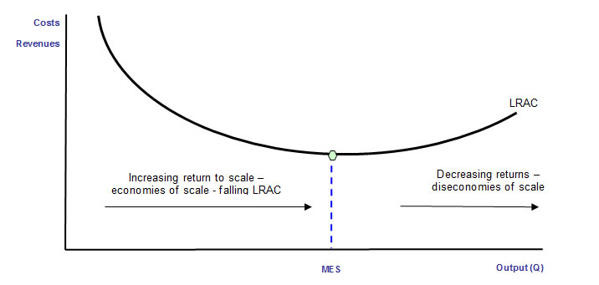

The minimum efficient scale depends on the **nature of costs of production in a specific industry.**

How many firms can "fit" in a market?  It depends on the size of the market compared to the size of the minimum efficient scale

In industries where the **ratio of fixed to variable costs is high**, there is scope for reducing unit cost by increasing the scale of output. This is likely to result in a concentrated market structure (e.g. an [oligopoly](http://www.tutor2u.net/blog/index.php/economics/C187/), a [duopoly](http://www.tutor2u.net/blog/index.php/economics/tagged/tag/duopoly/) or a [monopoly](http://www.tutor2u.net/blog/index.php/economics/C180/)) – indeed economies of scale may act as a **barrier to entry** because existing firms have achieved cost advantages and they then can force prices down in the event of new businesses coming in

There might be only limited opportunities for scale economies such that the MES turns out to be a small % of market demand. It is likely that the market will be **competitive** with many suppliers able to achieve the MES. An example might be a large number of hotels in a city centre or a cluster of restaurants in a town. Much depends on how we define the market!

With a **natural monopoly**, the long run average cost curve continues to fall over a huge range of output, suggesting that there may be room for perhaps one or two suppliers to fully exploit all of the available economies of scale when meeting market demand.

**Diseconomies of scale**

***Nokia, diseconomies of scale and lost competitive advantage***  
*Nokia is a Finnish conglomerate business that turned itself into the world’s leading mobile phone company in the 1990s. Nokia is profitable, but revenues are under pressure and in 2010, Nokia appointed a new CEO - Stephen Elop - to drive strategic change*

*In February 2011 - Elop issued the famous “burning platform” memo bluntly explaining the strategic challenges facing Nokia. Elop announced a strategic partnership with Microsoft to jointly-develop smart phones using the Windows mobile platform - ditching Nokia’s investment in its homegrown Symbian platform*

*Nokia had missed the major change in its market - the Smartphone revolution. It had continued to focus on mobile phone devices (hardware) rather than applications (software). The consumer transition from traditional mobile phones to smart phones has been dramatic and caught Nokia off-guard. According to Elop "There is intense heat coming from our competitors, more rapidly than we ever expected. Apple disrupted the market by redefining the Smartphone and attracting developers to a closed, but powerful ecosystem.”*

*Nokia has also faced intense competition from mobile phone producers in emerging markets who can make fast, cheap handset. At the same time there was recognition within the business that diseconomies of scale were hurting its competitiveness. Many in Nokia regretted that the business had become too product-led rather than customer-led. It was felt that the business lacked innovation with an overly-bureaucratic organisational structure with poor accountability.*

Diseconomies are the result of **decreasing returns to scale** and lead to a rise in average cost  
**Diseconomies of scale** a business may experience relate to:

1. **Control** – monitoring the productivity and the quality of output from thousands of employees in big corporations is imperfect and expensive – this links to the concept of the **principal-agent problem** i.e. the difficulties of shareholders monitoring the performance of managers.
2. **Co-ordination** - it can be difficult to co-ordinate complicated production processes across several plants in different locations and countries. Achieving efficient **flows of information** in large businesses is expensive as is the cost of **managing supply contracts** with hundreds of suppliers at different points of an industry’s supply chain.
3. **Co-operation** - workers in large firms may develop a **sense of alienation** and loss of morale. If they do not consider themselves to be an integral part of the business, their productivity may fall leading to wastage of factor inputs and higher costs. Traditionally this has been seen as a problem experienced by the larger state sector businesses, examples being the [Royal Mail](http://news.bbc.co.uk/1/hi/business/6252202.stm) and the [Firefighters](http://www.fbu.org.uk), the result being a poor and costly industrial relations performance. However, the problem is not concentrated solely in such industries. A good recent example of a bitter [industrial relations dispute](http://search.bbc.co.uk/cgi-bin/search/results.pl?tab=ns&q=industrial%20dispute&recipe=all&scope=all&edition=d) was between [Gate Gourmet](http://news.bbc.co.uk/1/hi/business/4153366.stm) and its workers.

**Avoiding diseconomies of scale**

Here are three of the reasons to doubt the persistence of diseconomies of scale:

1. **Human resource management** (HRM) focuses on improvements in recruitment, training, promotion, retention and support of faculty and staff. This becomes critical to a business when the skilled workers it needs are in short supply.
2. **Performance related pay schemes (PRP)** can provide financial incentives for the workforce leading to an improvement in industrial relations and higher productivity. Another [aim of PRP](http://www.incomesdata.co.uk/studies/perfpay.htm) is for businesses to reward and hang onto their most efficient workers. The [John Lewis Partnership](http://www.johnlewispartnership.co.uk/) is often cited as an example of how a business can empower its employees by giving them a stake in the financial success of the organization.
3. Increasingly companies are engaging in **out-sourcing** of manufacturing and distribution as they seek to supply to ever-distant markets. Out-sourcing is a tried and tested way of reducing costs whilst retaining control over production although there may be a price to pay in terms of the impact on the job security of workers whose functions might be outsourced overseas.