**Topic 1) Theory of Production**

***Use pages 1-17 from the associated study pack to answer the following:***

***Define the following key terms:***

|  |  |
| --- | --- |
| Key term | Definition |
| TFC |  |
| AFC |  |
| TVC |  |
| AVC |  |
| TC |  |
| ATC |  |
| MC |  |

***Complete the following table:***

|  |  |  |  |  |  |  |  |
| --- | --- | --- | --- | --- | --- | --- | --- |
| Output | FC | AFC | VC | AVC | TC | ATC | MC |
| 1 | 5 | 5 | 4 | 4 | 9 | 9 | 4 |
| 2 | 5 | 2.5 | 7 | 3.5 |  | 6 |  |
| 3 | 5 |  | 9 |  |  | 4.7 | 2 |
| 4 | 5 | 1.25 | 15 |  |  |  |  |
| 5 | 5 |  | 25 | 5 | 30 |  | 10 |

***Use the data above to plot the following on the axis below: AFC, AVC, ATC, MC:***

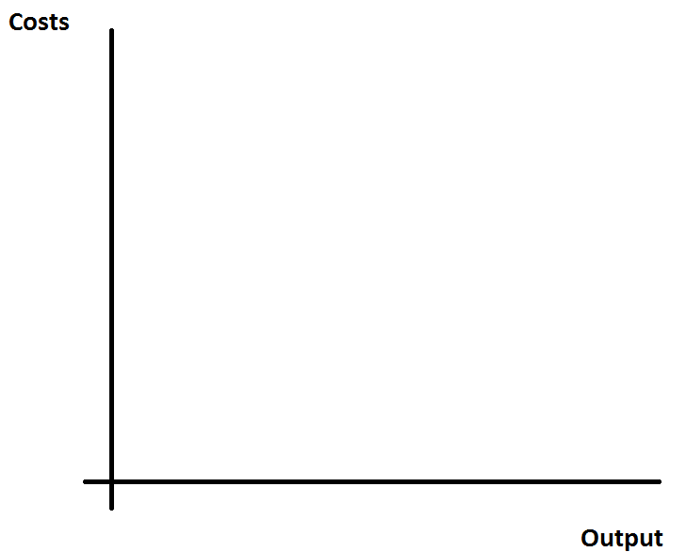

***Define the following key terms:***

|  |  |
| --- | --- |
| Key term | Definition |
| Total product (TP) |  |
| Average product (AP) |  |
| Marginal product (MP) |  |
| Inputs |  |
| Outputs |  |

***Explain the differences between short-run and l-run production:***

|  |  |
| --- | --- |
| Short-run production |  |
| Long-run production |  |

***Complete the table below (shows short-run production):***

|  |  |  |  |  |
| --- | --- | --- | --- | --- |
| Capital input | Labour input | Total output | Marginal product | Average product of labour |
| 10 | 1 | 2 | 2 | 2 |
| 10 | 2 | 5 | 3 | 2.5 |
| 10 | 3 | 10 |  |  |
| 10 | 4 | 14 |  | 3.5 |
| 10 | 5 | 15 | 1 | 3 |

***Use the data above to plot the Marginal product (MP) and the average product of labour (APL) on the axis below:***

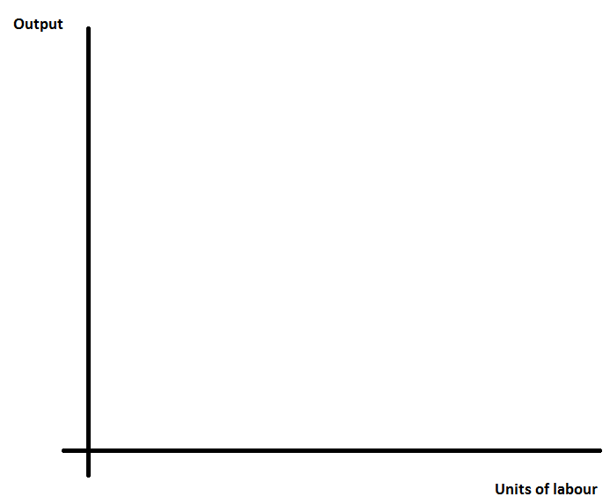

***On your graph indicate where this firm is experiencing:***

* Increasing marginal returns
* Diminishing marginal returns

***Define the following key terms:***

|  |  |
| --- | --- |
| Key term | Definition |
| Increasing marginal returns |  |
| Diminishing marginal returns |  |
| Constant marginal returns |  |
| Law of diminishing marginal returns |  |

***Long-run cost curves***

***Define the following key terms:***

|  |  |
| --- | --- |
| Key term | Definition |
| Economies of scale |  |
| Diseconomies of scale |  |
| Minimum efficient scale |  |

***Identify and explain a range of examples of economies of scale***

|  |  |
| --- | --- |
| Economies of scale | Explanation |
|  |  |
|  |  |
|  |  |
|  |  |
|  |  |
|  |  |
|  |  |

***Explain the meaning of ‘economies of scope’ and give an example of a firm who benefits from economies of scope***

|  |
| --- |
|  |

***Identify and explain a range of examples of diseconomies of scale***

|  |  |
| --- | --- |
| Diseconomies of scale | Explanation |
|  |  |
|  |  |
|  |  |
|  |  |

***Complete the table below:***

|  |  |  |  |  |  |
| --- | --- | --- | --- | --- | --- |
| Output | TFC | TVC | TC | MC | ATC |
| 1 | 10 | 5 | 15 | 5 | 15 |
| 2 | 10 | 9 | 19 | 4 |  |
| 3 | 10 | 12 | 22 | 3 | 7.33 |
| 4 | 10 | 16 | 31 |  |  |
| 5 | 10 | 22 |  |  |  |
| 6 | 10 | 30 | 40 |  | 6.67 |

***Use the data above to plot the MC and ATC curves on the axis below:***

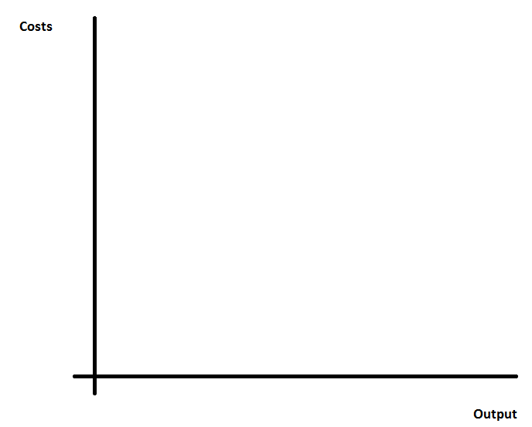

***On your graph identify where the firm experiences economies of scale, diseconomies of scale AND where MES occurs***