**Profits**

***Author****:* [*Geoff Riley*](http://www.tutor2u.net/blog/index.php/site/author/3/)***Last updated:*** *Sunday 23 September, 2012*

**The Nature of Profit**

[Profit](http://www.tutor2u.net/blog/index.php/economics/tagged/tag/profits/http:/www.tutor2u.net/economics/presentations/a2economics/micro/Profits/default.html) measures the **return to** [**risk**](http://www.tutor2u.net/blog/index.php/economics/tagged/tag/risk/) when committing scarce resources to a market or industry.

**Entrepreneurs** organise factors of production and take risks for which they require an **adequate rate of return**. The higher the market risk and the longer they expect to have to wait to earn a positive return, the greater will be the minimum required return that an entrepreneur is likely to demand.

Economists distinguish between different types of profit:

**Normal profit -** is the **minimum level of profit required to keep factors of production in their current use in the long run**.

Normal profits reflect the **opportunity cost** of using funds to finance a business. If you put £200,000 of savings into a new business, those funds could have earned a low-risk rate of return by being saved in a bank account. You might use the rate of interest on that £200,000 as the minimum rate of return that you need to make from your investment

Because we treat normal profit as an **opportunity cost** of investing financial capital in a business, we include an estimate for normal profit in the average total cost curve, thus, if the firm covers its AC then it is making normal profits.

**Sub-normal profit** - profit less than normal (P < average cost)

**Abnormal profit -** is any **profit achieved in excess of normal profit** - also known as **supernormal profit**. When firms are making abnormal [profits](http://www.tutor2u.net/blog/index.php/economics/tagged/tag/profits/), there is an incentive for other producers to enter a market to try to acquire some of this profit. Abnormal profit persists in the long run in imperfectly competitive markets such as [**oligopoly**](http://www.tutor2u.net/economics/presentations/a2economics/micro/OligopolyCartelsCollusion/default.html) and [**monopoly**](http://www.tutor2u.net/blog/index.php/economics/C180/) where firms can successfully block the entry of new firms. We will come to this later when we consider [**barriers to entry in monopoly**](http://www.tutor2u.net/economics/presentations/a2economics/micro/MonopolyEntryBarriers/default.html)**.**

**Calculating economic profit**

Consider the following example:The table shows data for an owner-managed firm for a particular year.

* Total revenue £320,000
* Raw material costs £30,000
* Wages and salaries £85,000
* Interest paid on bank loan £30,000
* Salary that the owner could have earned elsewhere £32,000
* Interest forgone on capital invested in the business £20,000

In a simple accounting sense, the business has total revenue of £320,000 and costs of £145,000 giving an accounting profit of £175,000. But profit according to an economist should take into account the opportunity cost of the capital invested and the income that the owner could have earned elsewhere. Taking these two items into account we find that the economic profit is £123,000.

**Accounting Profit and Economic Profit**

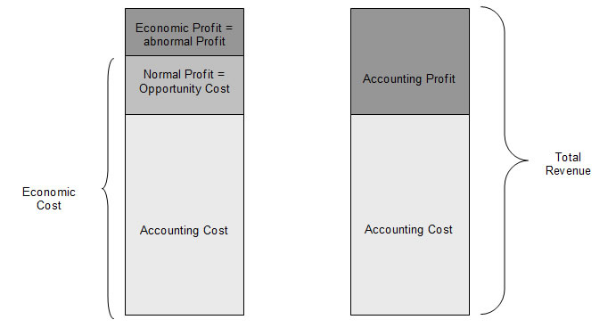

**Short Run Profit Maximisation**

***Profits are maximised when marginal revenue = marginal cost***

|  |  |  |  |  |  |  |
| --- | --- | --- | --- | --- | --- | --- |
| Price Per Unit (AR) (£) | Demand /  Output (units) | Total  Revenue (TR) (£) | Marginal  Revenue (MR) (£) | Total  Cost (TC) (£) | Marginal  Cost (MC) (£) | Profit (£) |
| 50 | 33 | 1650 |  | 2000 |  | -350 |
| 48 | 39 | 1872 | 37 | 2120 | 20 | -248 |
| 46 | 45 | 2070 | 33 | 2222 | 17 | -152 |
| 44 | 51 | 2244 | 29 | 2312 | 15 | -68 |
| 42 | 57 | 2394 | 25 | 2384 | 12 | 10 |
| 40 | 63 | 2520 | 21 | 2444 | 10 | 76 |
| 38 | 69 | 2622 | 17 | 2480 | 6 | 142 |
| 36 | 75 | 2700 | 13 | 2534 | 9 | 166 |
| 34 | 81 | 2754 | 9 | 2612 | 13 | 142 |

Consider the example in the table above. As price per unit declines, so demand expands. Total revenue rises but at a decreasing rate as shown by the column showing marginal revenue. Initially the firm is making a loss because total cost exceeds total revenue. The firm moves into profit at an output level of 57 units. Thereafter profit is increasing because the marginal revenue from selling units is greater than the marginal cost of producing them. Consider the rise in output from 69 to 75 units. The MR is £13 per unit, whereas marginal cost is £9 per unit. Profits increase from £142 to £166.

But **once marginal cost is greater than marginal revenue, total profits are falling**. Indeed the firm makes a loss if it increases output to 93 units.

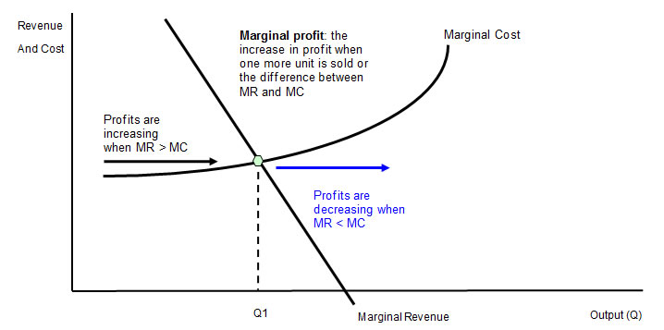

As long as marginal revenue > marginal cost, total profits will be increasing (or losses decreasing). The profit maximisation output occurs when **marginal revenue = marginal cost**.   
In the next diagram we introduce average revenue and average cost curves into the diagram so that, having found the profit maximising output (where MR=MC), we can then find (i) the profit maximising price (using the demand curve) and then (ii) the cost per unit.

* The difference between price and average cost marks the profit margin per unit of output.
* Total profit is shown by the shaded area and equals the profit margin multiplied by output

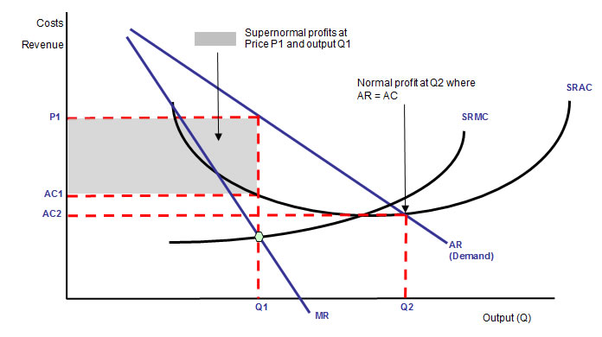

**The Short Run Supply Decision - The Shut-down Price**

A business needs to make at least normal profit in the long run to justify remaining in an industry but in the short run a firm will continue to produce as long as **total revenue covers total variable costs** or **price per unit > or equal to average variable cost** (AR = AVC). This is called the short-run [shutdown price](http://www.tutor2u.net/blog/index.php/economics/tagged/tag/shut+down+price/).

The reason for this is as follows. A business’s fixed costs must be paid regardless of the level of output. If we make an assumption that these costs cannot be recovered if the firm shuts down then the loss per unit would be greater if the firm were to shut down, provided variable costs are covered.

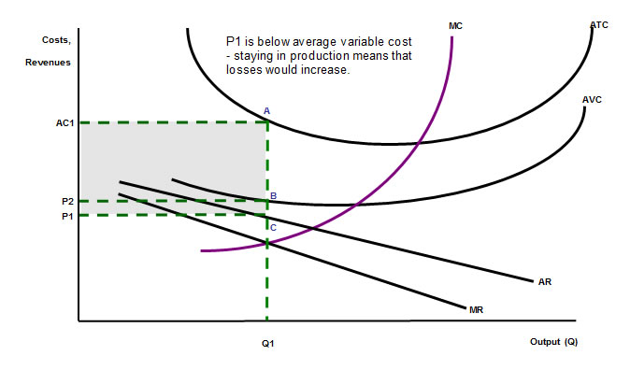

* Average revenue (AR) and marginal revenue curves (MR) lies below average cost, so whatever output produced, the business faces making a loss
* At P1 and Q1 (where marginal revenue equals marginal cost), the firm would shut down as price is less than AVC. The loss per unit of producing is vertical distance AC. No contribution is made to fixed costs
* If the firm shuts down production the loss per unit will equal the fixed cost per unit AB.
* In the short-run, provided that the price is greater than or equal to P2, the business can justify continuing to produce
* In the long run the shut down point is AVC=AR because all cost are variable

**Recession and factory closures**

* The concept of the [shutdown point](http://www.tutor2u.net/blog/index.php/economics/tagged/tag/shut+down/) has become topical due to the recession and the weak subsequent recovery
* Many businesses have opted to close down loss-making production plants and retailers have announced the closure of retail outlets in a bid to cut their losses.

Some of the plant closures have been temporary, for example some high-profile car manufacturers mothballed their factories and reduced the number of shifts. But for other businesses, the downturn brought about an end to trading. We have seen the demise of a large number of well-known retail businesses.

**Deriving the Firm’s Supply Curve in the Short Run**

* In the short run, the supply curve for a business operating in a competitive market is the **marginal cost curve above average variable cost**.
* In the long run, a firm must make a normal profit, so when price = average cost, this is the **break-even point**. It will therefore shut down at any price below this in the long run.
* As a result the long run supply curve will be the **marginal cost curve above average total cost**.

The concept of a ‘supply curve’ is inappropriate when dealing with monopoly because a monopoly is a price-maker, not a “passive” price-taker, and can thus select the price and output combination on the demand curve so as to maximise profits where marginal revenue = marginal cost.

**Changes in demand**

* A change in demand and/or production costs will lead to a change in the profit maximising price and output.
* In exams you may often be asked to analyse how changes in demand and costs affect the equilibrium output for a business. Make sure that you are confident in drawing these diagrams and you can produce them quickly and accurately under exam conditions.
* In the diagram below we see the effects of an outward shift of demand from AR1 to AR2 short run costs of production remain unchanged). The increase in demand causes a rise in the price from P1 to P2 (consumers are now willing and able to buy more at a given price) and an expansion of supply (the shift in AR and MR is a signal to firms to move along their marginal cost curve and raise output). Total profits have increased.

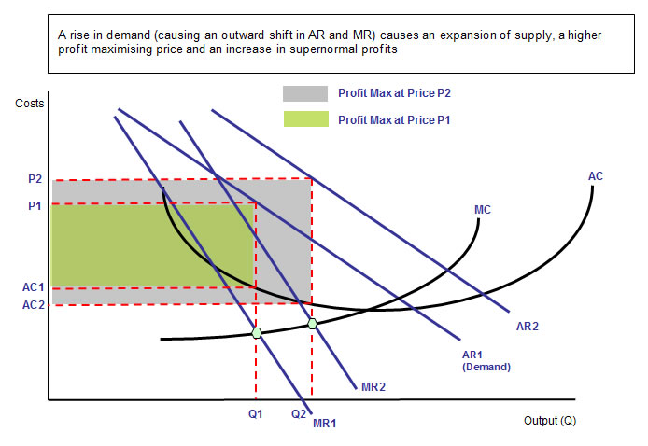

**Functions of Profit in a Market Economy**

*Milk farmers could lose thousands of pounds a year after suppliers imposed a huge cut in milk prices. The average cow produces 7,500 liters of milk a year, meaning an annual loss of £45,000 for a typical herd of 120 cows. The number of dairy farmers has halved in the past ten years.*  
*Robert Wiseman Dairies, Arla Foods UK and Dairy Crest – intend to cut the prices paid to farmers for milk. The processors say the move is a result of deterioration in the commodity markets for skimmed milk powder and wholesale cream. Some of the major retailers have corporate responsibility strategies which include terms to protect farmers. Tesco and Sainsbury's pay a price per liter that covers the cost of production, with Sainsbury's paying 30.56p per liter. Waitrose pays a market leading price, aiming to top the prices paid by the other retailers*

[Profits](http://www.tutor2u.net/blog/index.php/economics/tagged/tag/profits/http:/www.tutor2u.net/economics/presentations/a2economics/micro/Profits/default.html) serve a variety of purposes in a market economy:

1. **Finance for investment** Retained profits are source of finance for companies undertaking investment. The alternatives such as issuing new shares (equity) or bonds may not be attractive depending on the state of the financial markets especially in the aftermath of the [credit crunch](http://www.tutor2u.net/blog/index.php/economics/C204/).
2. **Market entry:** Rising profits **send signals** to other producers within a market. When existing firms are earning supernormal profits, this signals that profitable entry may be possible. In [**contestable markets**](http://www.tutor2u.net/blog/index.php/economics/C179/), we would see a rise in market supply and lower prices. But in a monopoly, the dominant firm(s) can protect their position through [barriers to entry](http://www.tutor2u.net/blog/index.php/economics/tagged/tag/barriers+to+entry/).
3. **Demand for factor resources:** Scarce factor resources flow where the *expected rate of return or profit is highest*. In an industry where demand is strong more land, labour and capital are then committed to that sector.
4. **Signals about the health of the economy:** The profits made by businesses throughout the economy provide important signals about the health of the macro economy. Rising profits might reflect improvements in supply-side performance (e.g. higher productivity or lower costs through innovation). Strong profits are also the result of high levels of demand from domestic and overseas markets. In contrast, a [string of profit warnings](http://news.bbc.co.uk/1/hi/business/6899536.stm) from businesses could be a lead indicator of a macroeconomic downturn.