**Technological Change, Costs and Supply in the Long-run**

***Author****:* [*Geoff Riley*](http://www.tutor2u.net/blog/index.php/site/author/3/)***Last updated:*** *Sunday 23 September, 2012*

**Innovation and invention**

* The Oxford English Dictionary defines [innovation](http://www.tutor2u.net/blog/index.php/business-studies/tagged/tag/innovation/) as “**making changes to something established**”
* Invention is the act of “**coming upon or finding: discovery**”
* **Product innovation** is often associated with **small, subtle changes** to the characteristics and performance of a product.

**New markets and “synergy demand”:**

* Product innovation creates **new markets**, especially when new technology creates radically different products for consumers.
* Innovation is also a source of **synergy demand**. For example, the British ‘challenger-brand’ King of Shaves launched a new razor (the Azor) in 2008 and its success has generated extra demand for its range of shaving oils and gels.

**Sustaining and disruptive innovations**

* Many new products are similar to existing ones on the market – companies are often satisfied with “**sustaining innovations”**
* **“Disruptive innovations”** have the power to upset the status quo. Joseph Schumpeter made reference to innovation creating “[gales of creative destruction](http://www.econlib.org/Library/Enc/bios/Schumpeter.html)”.

**Examples of** [disruptive innovations](http://economist.com/displayStory.cfm?Story_id=3307440):

* Consider online music download businesses such as [iTunes](http://www.apple.com/itunes) and [Spotify](http://www.spotify.com/en/)
* Voice over Internet Protocol VoIP e.g. [Skype](http://www.skype.com) versus traditional telephone and mobile phone providers.

**Innovation and dynamic efficiency**

* **Dynamic efficiency** occurs over time and focuses on changes in **consumer choice** available in a market together with the **quality/performance of goods and services** that we buy.

**Joseph Schumpeter and Creative Destruction**  
*Austrian economist Joseph Schumpeter stated that innovation is the primary cause of economic progress and development. Innovation is a process of ‘creative destruction’ in which old ways of doing things are repeatedly destroyed and replaced by new, better ways. This forces existing businesses and industries to adapt to new conditions by innovating to keep up or resisting change and risking being made obsolete.*

Innovation can stimulate improvements in dynamic efficiency, always providing that the innovations that come to market are appropriate in satisfying our changing needs and wants.  
**Innovation as a barrier to entry**

* Innovation can be a **barrier to entry** in markets.
* **Property rights** embedded in product innovations might be protected by **patent laws**.
* There can be a **“**[**first mover advantage**](http://www.pearsoned.co.uk/Bookshop/article.asp?item=312)**”** for successful innovators that gives them scope to exploit some [monopoly power](http://www.tutor2u.net/blog/index.php/economics/tagged/tag/monopoly+power/) in a market.
* But high rates of innovation reduce [barriers to entry](http://www.tutor2u.net/blog/index.php/economics/tagged/tag/barriers+to+entry/) if they challenge power of well-established businesses
* Technology may free businesses from a single source of supply – e.g. Open Source software  v Microsoft
* Technology may not necessarily be a source of competitive advantage – if competitors exploit it too

**Process innovation**

* **Process innovations** involve **changes to the way in which production takes place**, be it on the factory floor, business logistics or innovative behaviour in managing employees in the workplace.
* The effects can be both on a firm’s **cost structure** (i.e. the ratio of fixed to variable costs) as well as the **balance of factor inputs** used in production (i.e. labour and capital)

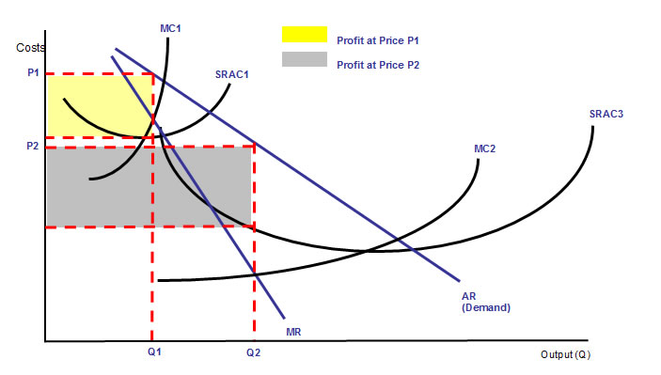

Cost reducing innovations cause an **outward shift in market supply** and they provide the scope for businesses to enjoy **higher profit margins** with a given level of demand. Process innovation should also lead to a **more efficient use of resources**.

The diagram above uses cost and revenue curves to show the effect of driving down production costs from SRAC1 to SRAC2 – leading to lower prices and a higher output. You could also use this diagram to show the gains in **producer and consumer surplus** that come from cost-reducing innovation and technological change. Consumers stand to gain from such innovation in that they should be able to expect **lower prices**. This increases their **real incomes**.

|  |  |  |
| --- | --- | --- |
| **Technology Mechanism** | **How It Creates an Advantage** | **Example** |
| **A new process** | Produce faster, at lower cost or better quality | Internet banking |
| **Solve a complex problem** | Do something competitors find hard to master | Google search engine |
| **A new product** | The first product to market | The iPod |
| **Protect a valuable idea** | Have something others can only sell if they pay for a licence | Pfizer’s Viagra |
| **Rewrite the rules** | A completely new approach which makes other products and markets redundant | Digital cameras |

**Government Policy and Innovation**

**Supply-side strategies** are usually linked directly with attempts to promote more innovative behaviour. Indeed the focus of government policy is firmly focused on improvements in the microeconomics of markets.   
Which policies might encourage more innovation?

* Tax credits / capital investment allowances.
* Policies to encourage small business creation and entrepreneurship.
* Toughening up of competition policy to expose [cartel](http://tutor2u.net/blog/index.php/economics/tagged/tag/cartel/) behaviour, but to allow and promote [joint ventures](http://www.tutor2u.net/blog/index.php/economics/tagged/tag/joint+venture/) to fund research and development.
* Lower corporation taxes to encourage innovative foreign companies to establish in Britain.
* Increased funding for research in our universities.
* Lower corporation taxes on profits generated from the exploitation of patents – this is known as a Patent Box and is geared towards incentivising research and development

**Important developments:**

1. **Increasingly much innovation is done by smaller firms** **and by entrepreneurs**– indeed multinational corporations are now out-sourcing their research and development spending to small businesses at home and overseas – much is being shifted to cheaper locations “offshore”—in India and Russia. [See this article on entrepreneurship in the Economist](http://economist.com/displaystory.cfm?story_id=5601890).
2. **Innovation is now a continuous process** – in part because the length of the **product cycle** is getting shorter as innovations are rapidly copied by competitors, pushing down profit margins and (according to a recent article in the economist) “transforming today's consumer sensation into tomorrow's commonplace commodity”
3. **Innovation is not something left to chance** – the most successful firms are those that pursue innovation in a systematic fashion – it becomes part of their corporate culture.
4. **Demand innovation is becoming more important:** In many markets, demand is either stable or in decline. The response is to go for “demand innovation” - discovering fresh demand from consumers and adapting an existing product to meet them – the toy industry is a classic example of this.

**The recession and slow recovery** may be a stimulus to innovation; many of the successful ‘new’ products of today were developed and tested during the last recession.