**Topic 2) The Objectives of firms**

***Use pages 18-39 from the associated study pack to answer the following:***

***Define the following key terms:***

|  |  |
| --- | --- |
| Key term | Definition |
| Total revenue |  |
| Marginal revenue |  |
| Average revenue |  |
| Price maker |  |
| Price taker |  |

***Complete the table below:***

|  |  |  |  |  |
| --- | --- | --- | --- | --- |
| Price per unit (£) | Demand level | Total revenue | Average revenue | Marginal revenue |
| 14 | 0 | 0 | 0 | 0 |
| 12 | 1 | 12 | 12 | 12 |
| 10 | 2 |  | 10 | 8 |
| 8 | 3 | 24 |  | 4 |
| 6 | 4 |  | 6 | 0 |
| 4 | 5 | 20 | 4 |  |

***Use the data above to plot the following on the axis below; AR and MR:***

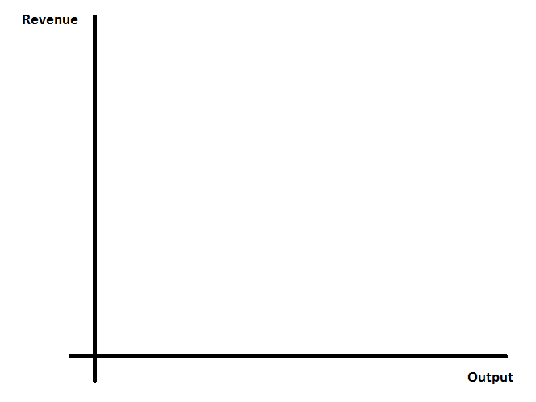

***Define the following key terms:***

|  |  |
| --- | --- |
| Key term | Explanation |
| Normal profit |  |
| Abnormal (supernormal) profit) |  |
| Sub-normal profit |  |

***Complete the table below:***

|  |  |  |  |  |  |  |
| --- | --- | --- | --- | --- | --- | --- |
| Price per unit | Output | TR | MR | TC | MC | PROFIT |
| 10 | 1 | 10 | 10 | 10 | 7 |  |
| 8 | 2 | 16 | 6 | 16 | 6 |  |
| 6 | 3 |  |  | 20 |  |  |
| 4 | 4 | 16 | -2 | 23 |  |  |
| 2 | 5 |  |  | 28 | 5 |  |

***Use the data above to plot the MR and MC curves on the axis below:***

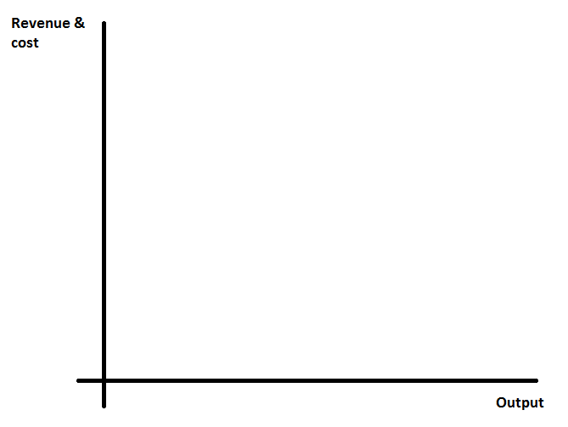

***Indicate on your diagram the profit maximising output for this firm***

***Why does profit maximisation occur when MR = MC?***

|  |
| --- |
|  |

***Complete the table below:***

|  |  |  |  |  |  |  |
| --- | --- | --- | --- | --- | --- | --- |
| Output | TR | ATR | MR | TC | ATC | MC |
| 1 | 20 |  | 20 | 18 | 18 | 18 |
| 2 | 36 | 18 | 16 | 30 |  |  |
| 3 | 48 |  |  | 40 |  | 10 |
| 4 | 56 |  | 8 | 52 |  | 12 |
| 5 | 60 |  | 4 | 68 |  |  |

***Use the data above to draw the following on the axis below; ATR, MR, ATC, MC***

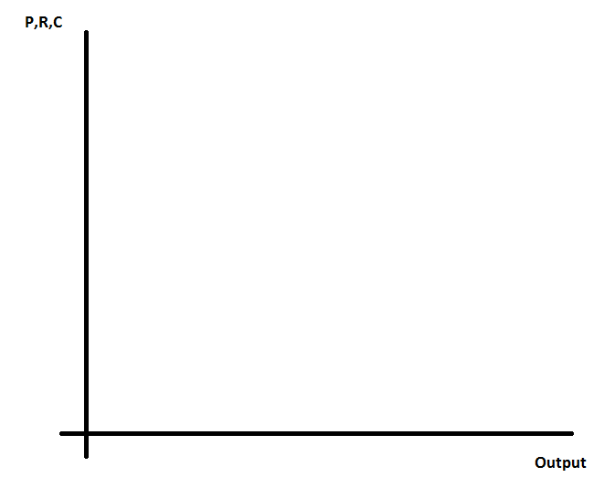

***On your diagram above indicate the profit maximising output and shade in the area of supernormal profits***

***Profit maximisation is therefore an important objective for firms. Please fill in the table below which analyses profit as a motive for entrepreneurism in more depth***

|  |  |  |
| --- | --- | --- |
| Objective | Functions of profit include (p25, 29-30): | Why is profit maximisation is not necessarily the correct objective? Explain concepts of ‘divorce of ownership & control’ and Business ethics (p29-30) |
| Profit maximisation |  |  |

***Why do firms want to expand?***

|  |
| --- |
|  |

***Outline the following growth strategies:***

|  |  |  |  |
| --- | --- | --- | --- |
| What is internal/organic growth? | Examples? | Benefits? | Drawbacks? |
|  |  |  |  |

|  |  |  |  |
| --- | --- | --- | --- |
| What is external growth? (include horizontal, vertical and lateral integration) | Examples? | Benefits? | Drawbacks? |
|  |  |  |  |

***What is innovation/dynamic efficiency (include examples)?***

|  |
| --- |
|  |