**Perfect Competition - Economics of Competitive Markets**

***Author****:* [*Geoff Riley*](http://www.tutor2u.net/blog/index.php/site/author/3/)***Last updated:*** *Sunday 23 September, 2012*

**Perfect competition – a pure market**

[Perfect competition](http://www.tutor2u.net/economics/presentations/a2economics/micro/PerfectCompetition/default.html) describes a **market structure** whose assumptions are strong and therefore unlikely to exist in most real-world markets. Economists have become more interested in pure competition partly because of the growth of **e-commerce** as a means of buying and selling goods and services. And also because of the popularity of **auctions** as a device for allocating scarce resources among competing ends.

**Assumptions for a perfectly competitive market**

* **Many sellers** each of whom produce a low percentage of market output and cannot influence the prevailing market price.
* **Many individual buyers,** none has any control over the market price
* **Perfect freedom of entry and exit from the industry.** Firms face **no sunk costs** and entry and exit from the market is feasible in the long run. This assumption means that all firms in a perfectly competitive market make **normal profits** in the long run.
* **Homogeneous products** are supplied to the markets that are **perfect substitutes**. This leads to each firms being “**price takers**” with a perfectly elastic demand curve for their product.
* **Perfect knowledge** – consumers have all readily available information about prices and products from competing suppliers and can access this at zero cost – in other words, there are few transactions costs involved in searching for the required information about prices. Likewise sellers have perfect knowledge about their competitors.
* **Perfectly mobile factors of production** – land, labour and capital can be switched in response to changing market conditions, prices and incentives.
* **No externalities** arising from production and/or consumption.

**Evaluation – Understanding the real world of imperfect competition!**

It is often said that perfect competition is a market structure that belongs to out-dated textbooks and is not worthy of study! Clearly the assumptions of pure competition do not hold in the vast majority of real-world markets, for example, some suppliers may exert control over the amount of goods and services supplied and exploit their [**monopoly power**](http://www.tutor2u.net/blog/index.php/economics/tagged/tag/monopoly+power/).

On the demand-side, some consumers may have [**monopsony**](http://www.tutor2u.net/blog/index.php/economics/tagged/tag/monopsony/) **power** against their suppliers because they purchase a high percentage of total demand. Think for example about the **buying power** wielded by the major supermarkets when it comes to sourcing food and drink from food processing businesses and farmers. The [Competition Commission](http://www.tutor2u.net/blog/index.php/economics/tagged/tag/competition+commission/) has recently been involved in lengthy and detailed investigations into the market power of the major supermarkets.

In addition, there are nearly always some **barriers to the** [**contestability**](http://www.tutor2u.net/blog/index.php/economics/tagged/tag/contestability/) **of a market** and far from being homogeneous; most markets are full of **heterogeneous products** due to **product differentiation** – in other words, products are made different to attract separate groups of consumers.

Consumers have **imperfect information** and their preferences and choices can be influenced by the effects of **persuasive marketing** and **advertising**. In every industry we can find examples of **asymmetric information** where the seller knows more about quality of good than buyer – a frequently quoted example is the market for second-hand cars! The real world is one in which **negative and positive externalities** from both production and consumption are numerous – both of which can lead to a divergence between private and social costs and benefits. Finally there may be imperfect competition in related markets such as the market for key raw materials, labour and capital goods.

Adding all of these points together, it seems that we can come close to a world of perfect competition but in practice there are nearly always barriers to pure competition. That said there are examples of markets which are highly competitive and which display many, if not all, of the requirements needed for perfect competition. In the example below we look at the global market for currencies.

**Currency markets - taking us closer to perfect competition**

* The global foreign exchange market is where all buying and selling of world currencies takes place. There is 24-hour trading, 5 days a week.
* Trading volume in the Forex market is around $3 trillion per day – equivalent to the annual GDP of France! 31% of global trading takes place in London alone.
* Most trading in currencies is ‘speculative.’

The main players in the currency markets are as follows:

* **Banks** both as “market makers” dealing in currencies and also as end-users demanding currency for their own operations.
* **Hedge funds** and other institutions (e.g. funds invested by asset managers, pension funds).
* **Central Banks** (including occasional currency intervention in the market when they buy and sell to manipulate an exchange rate in a particular direction).
* **Corporations** (for example airlines and energy companies who may use the currency market for defensive ‘hedging’ of exposures to risk such as volatile oil and gas prices.)
* **Private investors** and people remitting money earned overseas to their country of origin / **market speculators** trading in currencies for their own gain / tourists going on holiday and people traveling around the world on business.

**Why does a currency market come close to perfect competition?**

* **Homogenous output**: The "goods" traded in the foreign exchange markets are homogenous - a US dollar is a dollar and a euro is a euro whether someone is trading it in London, New York or Tokyo.
* **Many buyers and sellers meet openly to determine prices**: There are large numbers of buyers and sellers - each of the major banks has a foreign exchange **trading floor** which helps to "make the market". Indeed there are so many sellers operating around the world that the currency exchanges are open for business twenty-four hours a day. No one agent in the currency market can, on their own influence price on a persistent basis - all are ‘price takers’. According to Forex_Broker.net "The intensity and quantity of buyers and sellers ready for deals doesn't allow separate big participants to move the market in joint effort in their own interests on a long-term basis."
* Currency values are determined solely by **market demand and supply factors**.
* **High quality real-time information and low transactions costs**: Most buyers or sellers are well informed with access to real-time market information and background research analysis on the factors driving the prices of each individual currency. Technological progress has made more information immediately available at a fraction of the cost of just a few years ago. This is not to say that information is cheap - an annual subscription to a Bloomberg or a Reuter’s news terminal will cost several thousand dollars. But the market is rich with information and transactions costs for each batch of currency bought and sold has come down.
* **Seeking the best price**: The buyers and sellers in foreign exchange only deal with those who offer the best prices. Technology allows them to find the best price quickly.

What are the limitations of currency trading as an example of a *competitive market*?

* Firstly the market can be influenced by **official intervention** via buying and selling of currencies by governments or central banks operating on their behalf. There is a huge debate about the actual impact of intervention by policy-makers in the currency markets.
* Secondly there are high fixed costs involved in a bank or other financial institution when establishing a new trading platform for currencies. They need the capital equipment to trade effectively; the skilled labour to employ as currency traders and researchers. Some of these costs may be counted as sunk costs – hard to recover if a decision is made to leave the market.

Despite these limitations, the foreign currency markets take us reasonably close to a world of perfect competition. Much the same can be said for trading in the equities and bond markets and also the ever expanding range of future markets for financial investments and internationally traded commodities. Other examples of competitive markets can be found on a local scale – for example a local farmers’ market where there might be a number of farmers offering their produce for sale.

**The internet and perfect competition**

* Advances in web technology have made markets more competitive. It has reduced [barriers to entry](http://www.tutor2u.net/blog/index.php/economics/tagged/tag/barriers+to+entry/) for firms wanting to compete with well-established businesses – for example specialist toy retailers are better able to battle for market share with the dominant retailers such as ToysRUs and Wal-Mart.
* One of the most important aspects of the internet is the ability of consumers to find information about prices for many goods and services. There are an enormous number of [price comparison sites](http://paler.com/price_comparison.html) in the UK covering everything from digital cameras to package holidays, car insurance to CDs and jewellery.
* That said the price comparison web sites themselves have come under criticism. For example the sites offering to compare hundreds of different motor insurance policies or mortgage products draw information from the insurance and mortgage brokers but might use limiting assumptions about the different types of consumers looking for the best price – the result is a range of prices facing the consumer that don’t accurately reflect their precise needs – and consumers may only realise this when, for example, they make a claim on an insurance policy bought over the internet which turns out not to provide the specific cover they needed.
* And in the market for price comparison sites there is monopoly power too! Moneysupermarket.com currently has around 40% of the overall comparison site market, with Confused.com its nearest rival with a share of about 10%.

**Price and output in the short run under perfect competition**

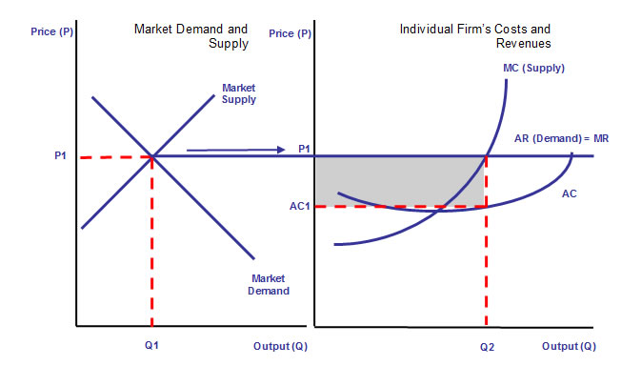

* In the short run, the interaction between demand and supply determines the **“market-clearing” price**. A price P1 is established and output Q1 is produced. This price is taken by each firm. The average revenue curve is their individual demand curve.
* Since the market price is constant for each unit sold, the AR curve also becomes the marginal revenue curve (MR) for a firm in perfect competition.
* For the firm, the **profit maximising output** is at Q2 where MC=MR. This output generates a total revenue (P1 x Q2). Since total revenue exceeds total cost, the firm in our example is making abnormal (economic) profits.
* This is not necessarily the case for all firms in the industry since it depends on the position of their short run cost curves. Some firms may be experiencing sub-normal profits if average costs exceed the price – and total costs will be greater than total revenue.

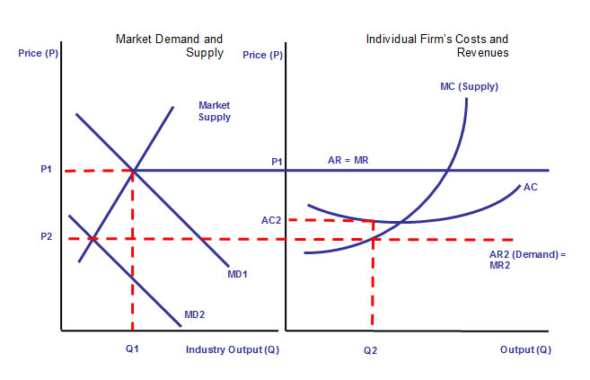

**The adjustment to the long-run equilibrium in perfect competition**

* If most firms are making **abnormal profits** in the short run, this encourages the **entry of new firms** into the industry
* This will cause an outward shift in market supply forcing down the price
* The increase in supply will eventually reduce the price until **price = long run average cost.** At this point, each firm in the industry is making normal profit.
* Other things remaining the same, there is no further incentive for movement of firms in and out of the industry and a long-run equilibrium has been established. This is shown in the next diagram.

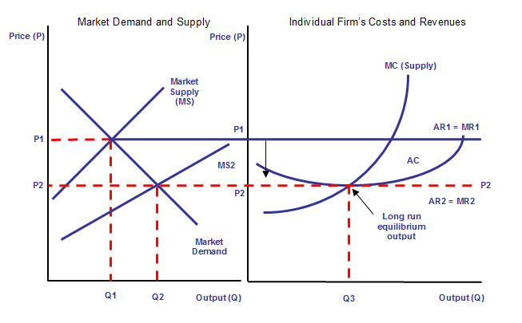

We are assuming in the diagram above that there has been no shift in market demand.

* The effect of increased supply is to force down the price and cause an expansion along the market demand curve.
* But for each supplier, the price they “take” is now lower and it is this that drives down the level of profit made towards normal profit equilibrium.

In an exam question you may be asked to trace and analyse what might happen if

* **There was a change in market demand** (e.g. arising from changes in the relative prices of substitute products or complements.)
* **There was a cost-reducing innovation** affecting all firms in the market or an external shock that increases the variable costs of all producers.

**Adam Smith on Competition**  
 “The natural price or the price of free competition ... is the lowest which can be taken. [It] is the lowest which the sellers can commonly afford to take, and at the same time continue their business.”  
*Source: Adam Smith, the Wealth of Nations (1776), Book I, Chapter VII*

**Characteristics of competitive markets**

The common characteristics of markets that are considered to be “competitive” are:

* **Lower prices** because of many competing firms. The **cross-price elasticity** of demand for one product will be high suggesting that consumers are prepared to switch their demand to the most competitively priced products in the marketplace.
* **Low** [**barriers to entry**](http://www.tutor2u.net/blog/index.php/economics/tagged/tag/barriers+to+entry/) – the entry of new firms provides competition and ensures prices are kept low in the long run.
* **Lower total profits** and profit margins than in markets which dominated by a few firms.
* **Greater entrepreneurial activity** – the [Austrian school of economics](http://www.mises.org/etexts/austrian.asp) argues that competition is a **process**. For competition to be improved and sustained there needs to be a genuine desire on behalf of entrepreneurs to innovate and to invent to drive markets forward and create what [Joseph Schumpeter](http://cepa.newschool.edu/het/profiles/schump.htm) called the “gales of creative destruction”.
* **Economic** [**efficiency**](http://www.tutor2u.net/blog/index.php/economics/tagged/tag/efficiency/) – competition will ensure that firms move towards productive efficiency. The threat of competition should lead to a faster rate of technological diffusion, as firms have to be responsive to the changing needs of consumers. This is known as **dynamic efficiency**.

**The importance of non-price competition**

In competitive markets, **non-price competition** can be crucial in winning sales and protecting or enhancing [market share](http://www.tutor2u.net/blog/index.php/economics/tagged/tag/market+share/).

**Perfect competition and efficiency**

Perfect competition can be used as a **yardstick** to compare with other market structures because it displays high levels of **economic efficiency**.

1. [**Allocative efficiency**](http://www.tutor2u.net/blog/index.php/economics/tagged/tag/allocative+efficiency/)**:** In both the short and long run we find that price is equal to marginal cost (P=MC) and thus allocative efficiency is achieved. At the ruling price, consumer and producer surplus are maximised. No one can be made better off without making some other agent at least as worse off – i.e. we achieve a **Pareto optimum** allocation of resources.
2. **Productive efficiency:** Productive efficiency occurs when the equilibrium output is supplied at minimum average cost. This is attained in the long run for a competitive market. Firms with high unit costs may not be able to justify remaining in the industry as the market price is driven down by the forces of competition.
3. **Dynamic efficiency**: We assume that a perfectly competitive market produces homogeneous products – in other words, there is little scope for [innovation](http://www.tutor2u.net/blog/index.php/business-studies/tagged/tag/innovation/) designed purely to make products differentiated from each other and allow a supplier to develop and then exploit a competitive advantage in the market to establish some [monopoly power](http://www.tutor2u.net/blog/index.php/economics/tagged/tag/monopoly+power/).

Some economists claim that perfect competition is not a good market structure for high levels of **research and development** spending and the resulting **product and process innovations**. Indeed it may be the case that monopolistic or oligopolistic markets are more effective long term in creating the environment for research and innovation to flourish. A cost-reducing innovation from one producer will, under the assumption of perfect information, be immediately and without cost transferred to all of the other suppliers.

That said a [**contestable**](http://www.tutor2u.net/blog/index.php/economics/tagged/tag/contestable/) **market** provides the discipline on firms to keep their costs under control, to seek to minimise wastage of scarce resources and to refrain from exploiting the consumer by setting high prices and enjoying high profit margins. In this sense, competition can stimulate improvements in both **static and dynamic efficiency** over time.

The long run of perfect competition, therefore, exhibits optimal levels of economic [efficiency](http://www.tutor2u.net/blog/index.php/economics/tagged/tag/efficiency/). But for this to be achieved *all of the conditions of perfect competition must hold* – including in related markets. When the assumptions are dropped, we move into a world of **imperfect competition** with all of the potential that exists for various forms of market failure

