***Topic 3) Perfect Competition***

***Use pages 40-47 from your associated study pack to answer the following***

***Identify the characteristics of perfect competition***

|  |
| --- |
|  |

***Explain why the currency market ‘comes close to the characteristics of perfect competition’***

|  |
| --- |
|  |

***Explain the meaning of the following key terms***

|  |  |
| --- | --- |
| Key term | Explanation |
| Imperfect competition |  |
| Barriers to entry/exit |  |
| Contestability |  |
| Monopsony |  |

***Complete the table below for a firm in perfect competition who is a ‘price taker’***

|  |  |  |  |  |  |  |  |
| --- | --- | --- | --- | --- | --- | --- | --- |
| Output Level | TR | ATR | MR | TC | ATC | MC | PROFIT |
| 1 | 10 | 10 | 10 | 14 | 14 | 10 |  |
| 2 | 20 | 10 |  | 22 | 11 | 8 |  |
| 3 | 30 | 10 | 10 | 28 |  | 6 |  |
| 4 | 40 |  |  | 38 |  | 10 |  |
| 5 | 50 |  |  | 52 | 10.4 | 14 |  |
| 6 | 60 |  |  | 72 | 12 | 20 |  |

***Use the data above to plot the following for this firm in perfect competition; ATR, ATC, MR, MC:***

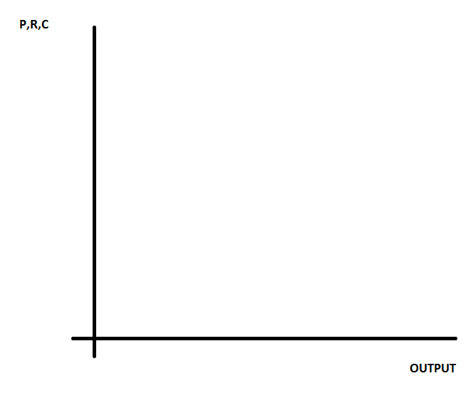

***On your diagram indicate the profit maximising output and shade in the area of supernormal profit***

***Explain why this supernormal profit will not exist in the long-run***

|  |
| --- |
|  |

***Define the following key terms:***

|  |  |
| --- | --- |
| Key term | Explanation |
| Allocative efficiency |  |
| Productive efficiency |  |
| Dynamic efficiency |  |

***Use a diagram to help explain why firms under perfect competition achieve static efficiency and achieve only normal profit in the long-run***

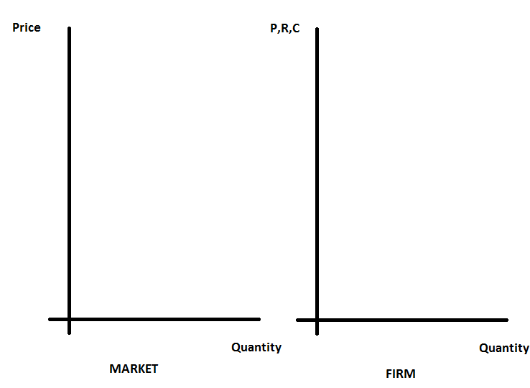

|  |
| --- |
| ***Explanation of diagram above*** |

***Outline the benefits and drawbacks for consumers of buying from firms in perfect competition***

|  |  |
| --- | --- |
| Benefits | Drawbacks |
|  |  |

***Explain why a firm in perfect competition will not achieve dynamic efficiency***

|  |
| --- |
|  |