**Monopoly & economic efficiency**

***Author****:* [*Geoff Riley*](http://www.tutor2u.net/blog/index.php/site/author/3/)***Last updated:*** *Sunday 23 September, 2012*

The standard case against monopolistic businesses is no longer straightforward. Markets are changing all of the time and so are the conditions in which businesses must operate regardless of whether they have any noticeable market power.

When a company lowers its price, is that genuine competition that benefits consumers or an attempt to monopolise the market? If a company gains market share, is that a result of improved efficiency or merely a competitive threat in the long run? When a company develops innovative products that competitors cannot easily duplicate, is that monopolization? If several companies look to limit excess output because of difficult trading conditions – is this necessarily collusive behaviour that competition policy should look to stop?

**The economic case against monopoly**

* A profit-maximising firm will produce at the productively and allocatively efficient level of output in a perfectly competitive industry
* The conventional argument against market power is that monopolists can earn **abnormal (supernormal) profits** at the expense of [**efficiency**](http://www.tutor2u.net/blog/index.php/economics/tagged/tag/efficiency/) and the welfare of consumers and society.
* The [monopoly](http://www.tutor2u.net/blog/index.php/economics/C180/) price is assumed to be higher than both marginal and average costs leading to a **loss of** [**allocative efficiency**](http://www.tutor2u.net/blog/index.php/economics/tagged/tag/allocative+efficiency/) and a **failure of the market**. The monopolist is extracting a price from consumers that is above the cost of resources used in making the product and, consumers’ needs and wants are not being satisfied, as the product is being **under-consumed**.
* The higher average cost if there are inefficiencies in production means that the firm is not making optimum use of scarce resources. Under these conditions, there may be a case for [government intervention](http://www.tutor2u.net/blog/index.php/economics/C185/) for example through [competition policy](http://www.tutor2u.net/blog/index.php/economics/C13/) or market deregulation.

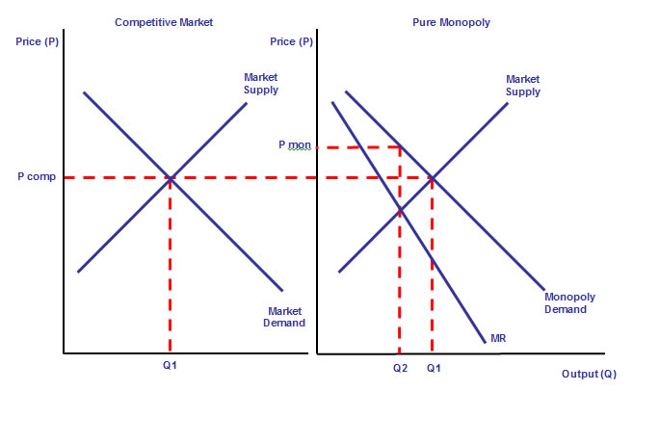

**X Inefficiencies under Monopoly**

* The lack of competition may give a monopolist less incentive to invest in new ideas. Even if the monopolist benefits from [economies of scale](http://www.tutor2u.net/blog/index.php/economics/C231/), they have little incentive to control their costs and **'X' inefficiencies** will mean that there will be no real cost savings compared to a competitive market.
* A competitive industry will produce in the long run where market demand = market supply. Consider the diagrams below. Equilibrium output and price is at Q1 and Pcomp on the left hand diagram and Pcomp and Q1 on the right hand diagram. At this point, Price = MC and the industry meets the conditions for [allocative efficiency](http://www.tutor2u.net/blog/index.php/economics/tagged/tag/allocative+efficiency/).
* If the industry is taken over by a monopolist the profit-maximising point (MC=MR) is at price Pmon and output Q2. The monopolist is able to charge a higher price restrict total output and thereby reduce welfare because the rise in price to Pmon reduces [consumer surplus](http://tutor2u.net/blog/index.php/economics/tagged/tag/consumer+surplus/).
* Some of this reduction in welfare is a pure transfer to the producer through higher profits, but some of the loss is not reassigned to any other agent. This is known as the **deadweight welfare loss** or the **social cost of monopoly** and is equal to the area ABC.

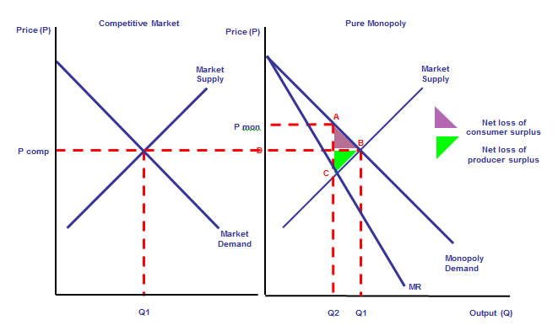

A similar result is seen in the next diagram which makes the assumption of constant long-run average and marginal costs under both competition and monopoly. The **deadweight loss of welfare** under monopoly (whose profit maximising price is P1 and Q1) is shown by the triangle ABC. The competitive price and output is Pc and Qc respectively.

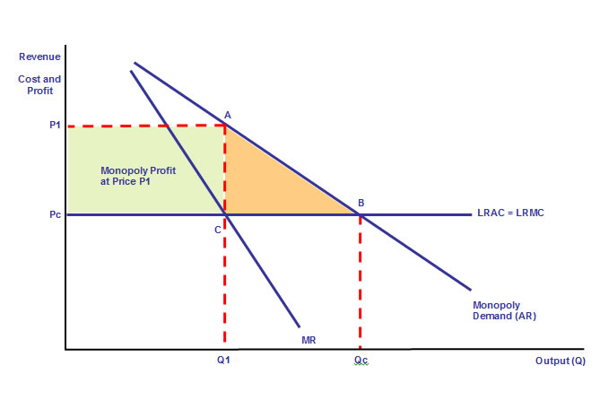

**Potential Benefits from Monopoly**

A high market concentration does not always signal the absence of competition; sometimes it can reflect the success of firms in providing better-quality products, more efficiently, than their rivals

One difficulty in assessing the welfare consequences of [monopoly](http://www.tutor2u.net/blog/index.php/economics/C180/), [duopoly](http://www.tutor2u.net/blog/index.php/economics/tagged/tag/duopoly/) or [oligopoly](http://www.tutor2u.net/blog/index.php/economics/C187/) lies in defining precisely what a market constitutes! In nearly every industry a market is **segmented** into different products, and **globalization** makes it difficult to gauge the degree of [monopoly power](http://www.tutor2u.net/blog/index.php/economics/tagged/tag/monopoly+power/).

What are the main advantages of a market dominated by a few sellers?

**Economies of Scale**

A monopolist might be better placed to exploit **increasing returns to scale** leasing to an equilibrium that gives a higher output and a lower price than under competitive conditions. This is illustrated in the next diagram, where we assume that the monopolist is able to drive marginal costs lower in the long run, finding an equilibrium output of Q2 and pricing below the competitive price.

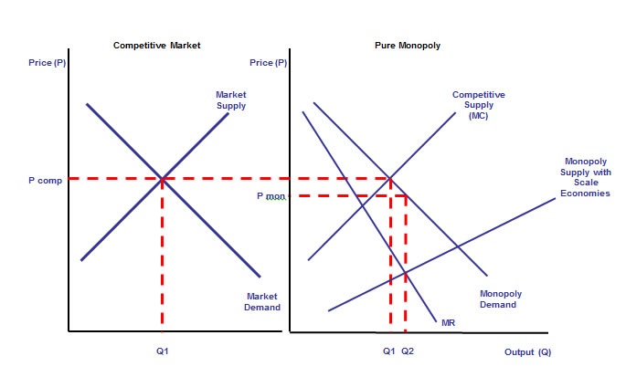

**Monopoly Profits, Research and Development and Dynamic Efficiency**

* Patents provide legal protection of an idea or process. Generic patents allow legal copying of a product.
* As firms are able to earn abnormal profits in the long run there may be a **faster rate of technological development** that will reduce costs and produce better quality items for consumers.
* Monopoly power can be good for [innovation](http://www.tutor2u.net/blog/index.php/business-studies/tagged/tag/innovation/).  Despite the fact that the market leadership of firms like Microsoft, Toyota, GlaxoSmithKline and Sony is often criticised, investment in research and development can be beneficial to society because they **expand the technological frontier** and open new ways to prosperity. Many innovations are developed by firms with patents on ‘leading-edge’ technologies.

**Baumol – Oligopoly and Innovation**

William Baumol an economist from Princeton University wrote “The Free Market Innovation Machine” in which he argued that the structure that fosters productive innovation best is [**oligopoly**](http://www.tutor2u.net/blog/index.php/economics/C187/). The Baumol hypothesis is that oligopolists compete by making their products differ slightly from their rivals. Highly innovative firms are often quick to license new technology or to become members of **technology-sharing consortia**.

**Natural Monopoly**

There are several interpretations of what a natural monopoly us

1. It occurs when one large business can supply the entire market at a lower price than two or more smaller ones
2. A natural monopoly is a situation in which there cannot be more than one efficient provider of a good. In this situation, competition might actually increase costs and prices
3. It is an industry where the minimum efficient scale is a large share of market demand such there is room for only one firm to fully exploit all of the available internal economies of scale
4. An industry where the long run average cost curve falls continuously as output expands
5. Private utilities are natural monopolies in local markets

The key point is that a natural monopoly is characterized by **increasing returns to scale at all levels of output** – thus the long run cost per unit (LRAC) will drift lower as production expands. LRAC is falling because long run marginal cost is below LRAC. This can be illustrated in the diagram above. There may be room only for one supplier to fully exploit [**economies of scale**](http://www.tutor2u.net/blog/index.php/economics/tagged/tag/economies+of+scale/), reach the **minimum efficient scale** and achieve productive efficiency.

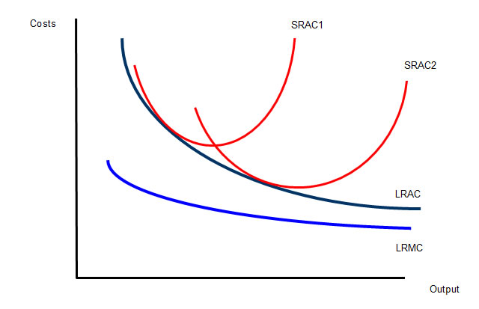

Because there is no single definition of a [natural monopoly](http://tutor2u.net/blog/index.php/economics/tagged/tag/natural+monopoly/), none of the examples below are purely national monopolies – their cost structure does take them close to a common-sense interpretation:

* [**British Telecom**](http://search.bbc.co.uk/cgi-bin/search/results.pl?scope=all&tab=ns&recipe=all&q=British+Telecom+) building and maintaining the UK telecommunications network for the broadband industry – especially the ‘final mile’ copper wiring from the local exchanges to each household
* The [**Royal Mail’s**](http://search.bbc.co.uk/cgi-bin/search/results.pl?scope=all&tab=ns&recipe=all&q=royal+mail) postal distribution network – collection / sorting / delivery
* [**Camelot**](http://search.bbc.co.uk/cgi-bin/search/results.pl?scope=all&tab=ns&recipe=all&q=Camelot) operating the national network for the UK lottery
* [**National Rail**](http://search.bbc.co.uk/cgi-bin/search/results.pl?scope=all&tab=ns&recipe=all&q=national+rail) owning, maintaining and leasing out the UK rail network
* [**National Grid**](http://www.nationalgrid.com/), which owns and operates the National Grid high-voltage electricity transmission network in England and Wales. Since April 1, 2005 it also operates the electricity transmission network in Scotland. Owns and operates the gas transmission network (from terminals to distributors).
* [**London Underground**](http://search.bbc.co.uk/cgi-bin/search/results.pl?tab=ns&q=London+Underground&scope=all&uri=%2F), **Tyne and Wear Metro**

Key point: A natural monopoly does not mean that there is only one business operating in the market or that only one firm can survive in the long run. Indeed there may be many smaller businesses operating profitably in smaller ‘niche’ segments of a market (however that is defined).

**Possible conflicts between economic** [**efficiency**](http://www.tutor2u.net/blog/index.php/economics/tagged/tag/efficiency/) **and economic welfare**   
It is often said that a natural monopoly raises difficult questions for [competition policy](http://www.tutor2u.net/blog/index.php/economics/C13/) because

* On the one hand – it is more **productively efficient** for there to be one dominant provider of a national infrastructure e.g. a rail network or electricity generating system
* Natural monopolies require enormous **investment spending** to maintain and improve the networks
* Businesses monopoly power (huge barriers to entry) might be tempted to **exploit that power** by raising prices and making huge **supernormal profits** – damaging **consumer welfare**

The **profit-maximizing price** is P1 at an output of Q1. Price is well above the marginal cost of supply and high supernormal profits are made – but output is high too and there is still a sizeable amount of **consumer surplus** because of the internal economies of scale that have brought down the unit cost for all consumers. *(We are ignoring the possibility of price discrimination here).*

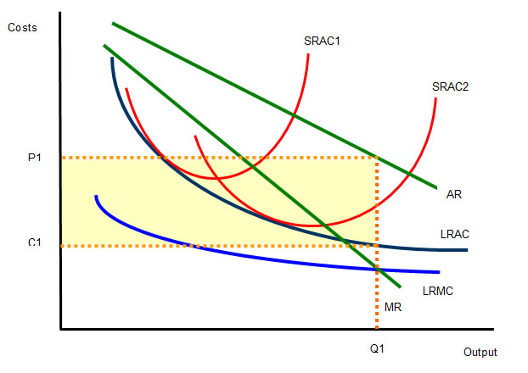

**Options for** [**competition policy**](http://www.tutor2u.net/blog/index.php/economics/C13/) **in industries that resemble a natural monopoly**

1. **Nationalization**: Bringing some of these industries into state ownership
   1. **Network Rail** is a not-for-profit business (formerly Railtrack plc) – nationalized in 2001
   2. **National Air Traffic Services** – Owned by the UK government (49%); The Airline Group (42%) which is a consortium of British Airways, BMI, easyJet, Monarch Airlines, Thomas Cook Airlines, Thomsonfly and Virgin Atlantic; BAA (4%); and NATS employees (5%).
2. **Price controls by the regulatory agencies**
   1. For many utilities, the government introduced industry regulators to oversee these businesses when they were privatized in the 1980s and early 1990s
   2. For many years utility businesses such as British Telecom and British Gas were subject to price capping– most of these have now finished although some remain – [for more details – see this link](http://www.tutor2u.net/economics/revision-notes/a2-micro-privatisation-deregulation.html)
   3. On 26 November 2009 the water regulator Ofwat announced that water bills must be cut by an average of £3 a year per household over the next five years and that there must be an extra £1 billion investment by water companies
3. **Fines for anti-competitive behaviour**: In 2008 the Microsoft computer software company was fined €1.68 billion by the European Competition Commission for pre-installing its browser, Internet Explorer, on computers running the Windows operating system. In December 2009, Microsoft agreed to allow consumers to choose their web browser on setup. Removing the pre-installation of the software will mean that more firms will be able to enter the market.
4. **Introducing competition into the industry** -this has been a favoured policy
   1. Basically involves separating out **infrastructure** from the **final service to the consumer** – for example:
      1. **British Telecom** was eventually forced to open-up local telecom exchanges and allow rivals to install equipment (‘unbundling the local loop’) – who then sell services such as broadband to households – competitors pay BT an access charge designed to give BT a 10% rate of return from running the network.
      2. **BAA:** In March 2009 the UK Competition Commission required British Airports Authority to sell off three of its seven airports, starting with Gatwick and then Stansted
      3. **National Rail** runs the network – but train-operating companies have to bid for the franchise to run passenger services – and the industry regulator can take their franchise away if the quality of service isn’t good enough. The government took the East Coast line into public ownership in July 2009 following the financial problems facing National Express.
      4. **Camelot** has successfully bid to operate the National Lottery until 2017

**SPEW**  
Here is a good way to remember some of the issues we have covered regarding monopoly, efficiency and economic welfare  
**Service -** does the lack of competition affect the quality of service to consumers?  
**Prices -** how high are prices compared to competitive / contestable market  
**Efficiency -** productive, allocative and dynamic  
**Welfare -** what are the overall welfare outcomes? Is there a net loss of welfare in markets dominated by businesses with monopoly power?  
*Acknowledged source: Ruth Tarrant*

**Case study: EU competition commission enforces price cap on mobile phone charges**  
The EU Competition Commission has [enforced a price cap](http://news.bbc.co.uk/1/hi/world/europe/8010352.stm) on the cost of sending text messages when abroad and has introduced a maximum charge for receiving and making a phone call. At a time when both external and internal economies of scale were lowering the unit costs of domestic phone calls, international roaming charges remained high and the Commission decided there was an exploitation of monopoly power.  
The Commission has had to balance the desire for competition with the need to avoid over-regulation. Vodafone made a pre-emptive strike ahead of the likely regulation in roaming charges, by saying it would cut the cost of using other companies’ networks when abroad by at least 40 per cent; it has since announced an end to roaming charges.   
Under the new limits there is a single tariff covering all 27 EU member states - bringing the maximum charge for making a call while abroad down to 37p per minute. Receiving calls now costs a maximum of 17p per minute. Sending a text message from another country inside the EU will cost no more than 10p. Data transfer prices have also fallen, with one megabyte of data now costing 85p.