***Econ 3 – Topic 4) Monopoly***

**Outline the characteristics of monopoly market structure**

High barriers to entry and exit, market dominated by 1 firm, price maker

**Outline a range of barriers to entry which monopoly firms may be able to exploit**

These are designed to restrict new firms from entering a market and competing with the established firm. Examples include:

* Patents, limit pricing e.g. predatory, cost advantages, brand image, R and D, sunk costs

**Draw a diagram which shows the profit maximisation point and supernormal profits earned by a monopoly**

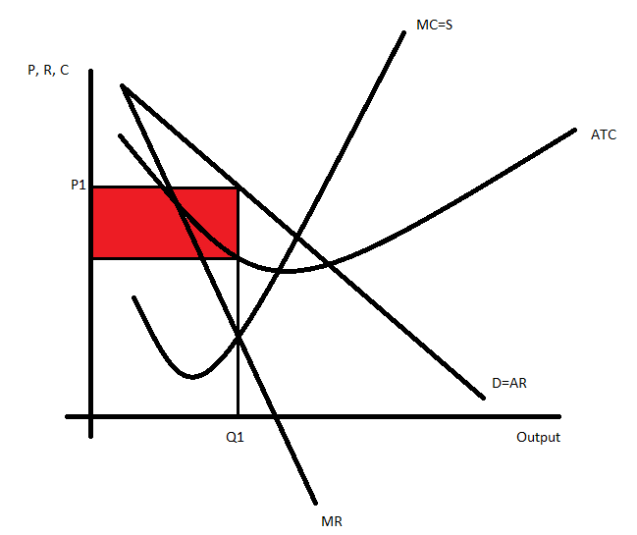

Profit max occurs when MC=MR. Difference between ATC and AR = supernormal profits (shaded area)

**On the diagram above indicate the PE point and AE point.**

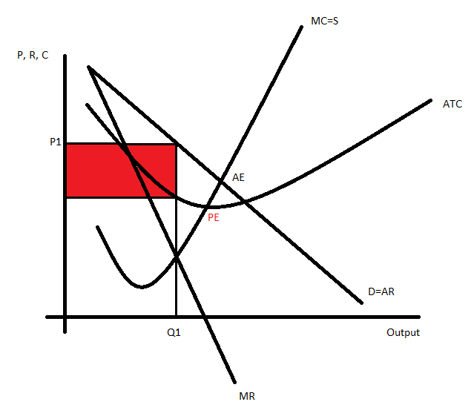

PE = productive efficency (where MC = ATC)

AE = allocative efficiency (D=S)

PE and AE combined = static efficiency

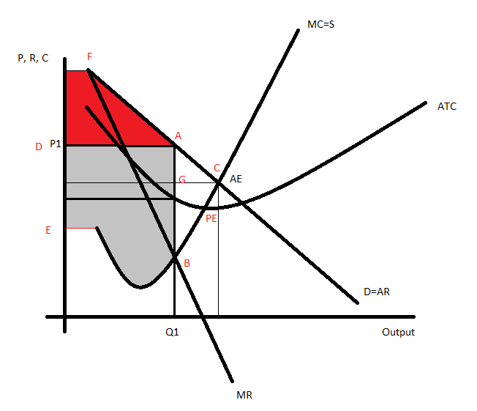

On above diagram we can see some of the problems of monopoly in terms of not achieving allocative efficiency i.e. consumer and producer surplus is not maximised

Shaded area EDBA = producer surplus at profit max output Q1

Shaded area DFA = consumer surplus at profit max output Q1

ACG = lost consumer surplus

GCB = lost producer surplus

Full triangle ACB therefore = lost surplus because of output being below allocative efficient output

**Explain why monopolies can achieve l-run supernormal profits and don’t operate statically efficient**

Supernormal profits would normally attract new entrants into the market, which would in turn compete prices downwards, which would in turn eradicate supernormal profits. Monopolies however operate behind high barriers to entry and exit, which prevent competition. This allows monopolies to maintain high profits

Monopolies have no need to be efficient due to the lack of competition preventing the need to reduce average costs

**Use the static efficiency diagram to explain why firms in perfect competition are better for the consumer than firms in monopoly market structure**

**Use a diagram which shows why monopoly might be better than perfect competition (dynamic efficiency)**

**What is price discrimination and why can monopolies get away with this?**

Outline the benefits and drawbacks for customers of buying from monopolies

|  |  |
| --- | --- |
| Benefits | Drawbacks |
|  |  |