**Oligopoly – Non Collusive Behaviour**

***Author****:* [*Geoff Riley*](http://www.tutor2u.net/blog/index.php/site/author/3/)***Last updated:*** *Sunday 23 September, 2012*

**What is an oligopoly?**

* An oligopoly is an industry where there is a **high level of market concentration**.
* Examples of markets that can be described as oligopolies include the markets for petrol in the UK, soft drinks producers and the high street banks. In the global market for sports footwear – 60% is held by Nike and Adidas.
* **Oligopoly is best defined by the conduct (or behaviour) of firms within a market**.

The **concentration ratio** measures the extent to which a market or industry is dominated by a few leading firms. A rule of thumb is that an oligopoly exists when the **top five firms** in the market account for more than **60%** of total market sales.

**Characteristics of an oligopoly**

There is **no single theory** of price and output under oligopoly. If a **price war** breaks out, oligopolists may produce and price much as a highly competitive industry would; at other times they act like a pure [monopoly](http://www.tutor2u.net/blog/index.php/economics/C180/).

An [oligopoly](http://www.tutor2u.net/blog/index.php/economics/C187/) usually exhibits the following features:

* **Product branding**: Each firm in the market is selling a branded product.
* **Entry barriers**: Entry barriers maintain supernormal profits for the dominant firms. It is possible for many smaller firms to operate on the periphery of an oligopolistic market, but none of them is large enough to have any significant effect on prices and output
* **Inter-dependent decision-making**: Inter-dependence means that firms must take into account the *likely reactions* of their rivals to any change in price, output or forms of non-price competition.
* **Non-price competition**: Non-price competition is a consistent feature of the competitive strategies of oligopolistic firms.

**Duopoly**

* [**Duopoly**](http://www.tutor2u.net/blog/index.php/economics/tagged/tag/duopoly/) **is a form of oligopoly**
* In its purest form **two firms** control all of the market, but in reality the term duopoly is used to describe any market where two firms dominate with a significant market share.
* There are many examples of duopoly
  + Coca-Cola and Pepsi (soft drinks), Unilever and Proctor & Gamble (detergents)
  + Bloomberg and Reuters (Financial information services), Sotheby’s and Christie’s (auctioneers of antiques/paintings)
  + Standard and Poor’s and Moody’s (credit rating agencies),
  + BSkyB and ESPN (live Premiership football),
  + Airbus and Boeing (aircraft manufacturers).
* In these markets **entry barriers** are high although there are usually smaller players in the market surviving successfully. The high entry barriers in duopolies are usually based on one or more of the following: brand loyalty, product differentiation and huge research economies of scale.

**Kinked Demand Curve Model of Oligopoly**

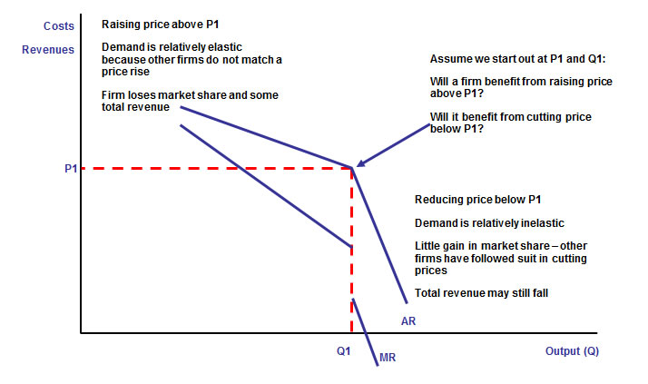

The kinked demand curve model assumes a business might face a **dual demand curve** for its product based on the **likely reactions of other firms** to a change in its price or another variable. The common assumption is that firms in an oligopoly are looking to **protect and maintain their market share** and that **rival firms are unlikely to match another’s price increase** but **may match a price fall.** I.e. rival firms within an oligopoly react asymmetrically to a change in the price of another firm.

* If a business raises price and others leave their prices constant, then we can expect quite a large **substitution effect** making **demand relatively price elastic**. The business would then lose market share and expect to see a fall in its total revenue.
* If a business reduces its price but other firms follow suit, the **relative price change is smaller** and demand would be inelastic. Cutting prices when demand is inelastic leads to a fall in revenue with little or no effect on market share.

The kinked demand curve model makes a prediction that **a business might reach a stable profit-maximising equilibrium at price P1 and output Q1** and have little incentive to alter prices.

* The kinked demand curve model predicts there will be **periods of relative price stability** under an [oligopoly](http://www.tutor2u.net/blog/index.php/economics/C187/) with businesses focusing on **non-price competition** as a means of reinforcing their market position and increasing their supernormal profits.
* Short-lived price wars between rival firms can still happen under the kinked demand curve model. During a price war, firms in the market are seeking to snatch a short term advantage and win over some extra market share.

Recent examples of price wars include the [major UK supermarkets](http://news.bbc.co.uk/player/nol/newsid_6750000/newsid_6759400/6759411.stm?bw=bb&mp=wm&news=1&ms3=6&nol_storyid=6759411), [price discounting of computers in China](http://news.bbc.co.uk/player/nol/newsid_6680000/newsid_6682800/6682819.stm?bw=bb&mp=wm&nol_storyid=6682819&news=1) and a price war between [cross channel speed ferry services](http://news.bbc.co.uk/player/nol/newsid_6520000/newsid_6528800/6528815.stm?bw=bb&mp=wm&nol_storyid=6528815&news=1). Price competition is frequently seen in the [telecommunications industry](http://news.bbc.co.uk/1/hi/business/6712787.stm).

**Changes in costs using the kinked demand curve analysis**

One prediction of the kinked demand curve model is that changes in variable costs might not lead to a rise or fall in the profit maximising price and output. This is shown in the next diagram where it is assumed that a rise in costs such as energy and raw material prices leads to an upward shift in the marginal cost curve from MC1 to MC2. Despite this shift, the equilibrium price and output remains at Q1. It would take another hike in costs to MC3 for the price to alter.

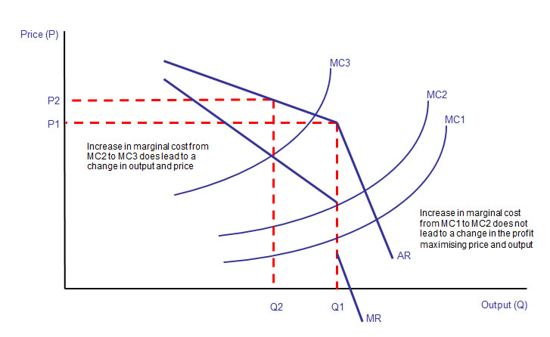

There is **limited real-world evidence** for the kinked demand curve model. The theory can be criticised for not explaining *why* firms start out at the equilibrium price and quantity. That said it is one possible model of how firms in an oligopoly *might* behave if they have to consider the likely responses of their rivals.

**The importance of non-price competition under oligopoly**

Oligopolistic theory predicts that firms in this market structure will tend to prefer non-price competition rather than price competition due to the self-defeating outcome of a price-war.  
**Non-price competition** involves advertising and marketing strategies to increase demand and develop brand loyalty among consumers. Businesses will use other policies to increase market share:

* **Better quality of service** including guaranteed delivery times for consumers and low-cost servicing agreements.
* **Longer opening hours** for retailers, 24 hour online customer support.
* **Discounts on product upgrades** when they become available in the market.
* **Contractual relationships with suppliers** - for example the system of tied houses for pubs and contractual agreements with franchises (offering exclusive distribution agreements). For example, Apple has signed **exclusive distribution agreements** with T-Mobile of Germany, Orange in France and O2 in the UK for the iPhone. The agreements give Apple 10 percent of sales from phone calls and data transfers made over the devices.

**Advertising**

**Advertising spending** runs in millions of pounds for many firms. Some simply apply a profit maximising rule to their marketing strategies. A promotional campaign is profitable if the marginal revenue from any extra sales exceeds the cost of the advertising campaign and marginal costs of producing an increase in output. However, it is not always easy to measure accurately the incremental sales arising from a specific advertising campaign. Other businesses see advertising simply as a way of increasing sales revenue. If **persuasive advertising** leads to an outward shift in demand, consumers are willing to pay more for each unit consumed. This increases the potential [consumer surplus](http://tutor2u.net/blog/index.php/economics/tagged/tag/consumer+surplus/) that a business might extract.

High spending on marketing is important for new business start-ups and for firms trying to break into an existing market where there is consumer or brand loyalty to the existing products in

**Brand loyalty**

A brand name is a name used to distinguish one product from its competitors. It can apply to a single product, an entire product range, or even a company (e.g. Virgin, Ferrari, Bang and Olufsen)  
Brand loyalty is hugely important in all kinds of industries and markets. The costs of acquiring a new customer vastly outweigh the expense of selling more to existing buyers and most of the mobile phone suppliers in this oligopolistic industry focus an enormous effort in building brand identity and brand loyalty to reduce the rate of customer churn (people who switch brands).

According to a new report, over eight in ten iPhone users said they would pick iPhone again when they replace their mobile, while 60 per cent of consumers who use smart phones running Google’s Android said they would stick with phones using the same software. Blackberry users have notably less attachment to their mobiles

When brand loyalty is strong, the cross-price elasticity of demand for price changes between two substitutes weakens and fewer consumers will switch their demand when there is a change in relative prices in the market. Robust brand loyalty makes it easier to charge premium prices and enjoy supernormal profits in the long run because loyalty is a barrier to entry.

When we become strongly attached to a brand, our purchasing decisions are more likely to stay in default mode and we may no longer even consider rival products.

**Competitiveness – a key to success in an oligopoly**

Traditionally, the main measures of competitiveness are in financial or marketing terms. For example, a competitive business might be expected to achieve one or more of the following:

* A higher growth rate (sales, revenues) than competitors and the market as a whole
* Higher-than average net profit margin (compared with others in the same industry)
* Better than average returns on investment – again, compared with competitors
* A high (perhaps leading) market share – measured in either value or volume terms. The leading firms in a market usually enjoy a significant proportion of the available revenues or customer demand, unless the market is highly fragmented.
* The strongest brand reputation in the market – e.g. brand awareness
* A clearly defined unique selling point (“USP”) that enables the business to differentiate its product or service in the eyes of customers
* Significant access to, or control of, distribution channels in the market (e.g. products or brands that are widely stocked or demanded by intermediaries who provide distribution to the final consumers)
* Better product quality – e.g. reliability, product features, performance
* Better customer service – e.g. after-sales support, customer information, handling of problems & complaints
* Better than average efficiency – e.g. being able to produce at a lower unit cost than most other competitors, either though better productivity or economies of scale
* Faster and more effective decision-making and communication – e.g. with employees involved in customer-facing roles empowered to handle customer issues or able to pass on key market information to managerial decision-makers.
* A more motivated and loyal workforce – which in turn should benefit productivity, efficiency, quality, customer service etc.