***Topic 5) Oligopoly***

***Use pages 71-85 from your associated study pack to complete the following:***

***Identify the characteristics of an oligopoly market structure***

|  |
| --- |
|  |

***Explain the key term ‘interdependence’***

|  |
| --- |
|  |

***Game Theory***

|  |  |  |  |
| --- | --- | --- | --- |
|  |  | Prisoner A |  |
|  |  | Confess | Deny |
| Prisoner B | Confess | (3 years, 3 years) | (1 year, 10 years) |
|  | Deny | (10 years, 1 year) | (2 years, 2 years) |

***Explain using the table above Game Theory and The Prisoner’s Dilemma***

|  |
| --- |
|  |

***Explain using the example below how the Prisoner’s Dilemma applies to businesses (information refers to profits)***

|  |  |  |  |
| --- | --- | --- | --- |
|  |  | Firm B |  |
|  |  | High output | Low output |
| Firm A | High output | £5m, £5m | £12m, £4m |
|  | Low output | £4m, £12m | £10m, £10m |

|  |
| --- |
|  |

***Draw a Kinked demand curve ion the axis below and use this to explain why oligopoly firms may avoid price competition***

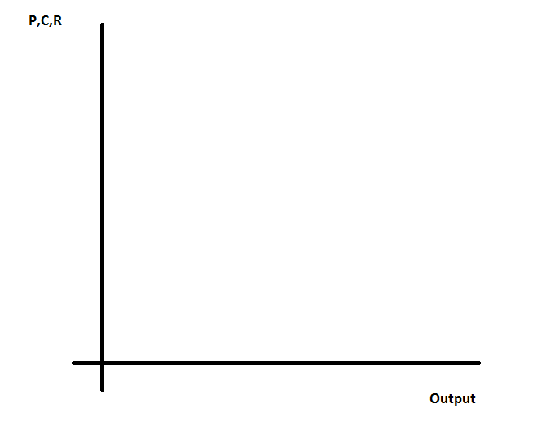

|  |
| --- |
|  |

***Define the following key terms:***

|  |  |
| --- | --- |
| Key term | Explanation |
| Price-competition |  |
| Non-price competition |  |
| Price collusion |  |
| Price fixing |  |
| Cartels |  |

***Outline the benefits and drawbacks for consumers of oligopoly market structures***

|  |  |
| --- | --- |
| ***Benefits*** | ***Drawbacks*** |
|  |  |