**Contestable Markets**

***Author****:* [*Geoff Riley*](http://www.tutor2u.net/blog/index.php/site/author/3/)***Last updated:*** *Sunday 23 September, 2012*

**What is a contestable market?**

* For a contestable market to exist there must be **low barriers to entry and exit** so that new suppliers can come into a market to provide fresh competition.
* For a perfectly contestable market, entry into and exit out must be *costless*
* **No market is perfectly contestable** but **virtually every market is contestable to some degree** even when it appears that the monopoly position of a dominant seller is unassailable.
* This can have implications for the behaviour (**conduct**) of existing firms and then affects the **performance of a market** in terms of **allocative, productive and dynamic efficiency**.
* A contestable or competitive environment is common in most industries – here is an example relating to the main competitors for Costa Coffee

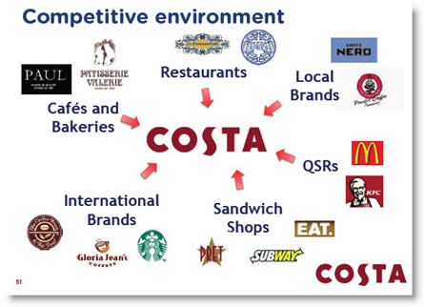

**Difference between Contestable Markets and Perfect Competition**  
Contestable markets are different from perfect competitive markets. For example, it is feasible in a contestable market for **one firm** to have **price-setting power** and for firms in a market to produce a **differentiated product**.  
There are three main conditions for pure market contestability:

* **Perfect information** and the ability and/or the right of all suppliers to make use of the best available production technology in the market.
* The **freedom to market** / advertise and enter a market with a competing product.
* The **absence of sunk costs** – this reduces the risks of coming into a market.

**Sunk Costs – a Barrier to Contestability**

Barriers to market [contestability](http://www.tutor2u.net/blog/index.php/economics/tagged/tag/contestability/) exist when there are **sunk costs** i.e. costs that have been committed by a business cannot be recovered once a firm has entered the industry.

**Increasing Contestability of Markets**

One feature of the British and European economy in recent years has been an increase in the number of markets and industries that are genuinely [contestable](http://www.tutor2u.net/blog/index.php/economics/tagged/tag/contestable/).

Several factors explain this development:

**Entrepreneurial zeal**: It is often the case that markets become more competitive because of the **persistence of entrepreneurs** who simply do not accept that the existing market structure is a given. A new supplier may have the advantage of **product** [**innovation**](http://www.tutor2u.net/blog/index.php/business-studies/tagged/tag/innovation/) or a more **competitive business model** based on **different pricing strategies**. A good example of this is the battle that King of Shaves is having as the challenger brand to companies such as Gillette and Wilkinson Sword. Metro Bank has recently opened in the UK in a bid to break the stranglehold of the existing UK high street retail banks, retailers such as Tesco are trying to follow suit.

**The recession** – an economic downturn can have the effect of opening up markets to new businesses. An example was the demise of Setanta Sports in the summer of 2009 which went into administration after failing to reach a break even target for the number of subscribers. Within days of Setanta closing down its programming in the UK, US sports channel ESPN (owned by the Walt Disney Corporation) was able to purchase the rights to show a number of live Premiership games and to launch a new sports channel in August 2009.  The recession has also led to an increase in market share for a number of discount food retailers such as Aldi and Lidl – taking away some of the market share of the dominant food retailers.

**De-regulation of markets** – De-regulation involves the **opening up of markets to competition** by reducing some of the **statutory** [**barriers to entry**](http://www.tutor2u.net/blog/index.php/economics/tagged/tag/barriers+to+entry/) that exist. Good examples of recent deregulation include the liberalisation of telecommunications and postal services as part of the European Union competition initiatives. And also the Open Skies initiative in aviation that is aimed at opening up trans-Atlantic air travel.

[**Competition Policy**](http://www.tutor2u.net/blog/index.php/economics/C13/)**:** Tougher competition laws acting against **predatory behaviour** by existing firms are designed to make markets more contestable. In both the UK and the EU this has included tougher rules against **price fixing cartels**.

**The EU Single Market:** The development of the Single European Market has opened up the markets for member nations. A good example of this is home and car insurance and also the entry of Western European clothes retailers onto the UK high streets and shopping malls.

**Technological Change:** New technology has brought down some of the entry costs in some markets leading to an increase in capital mobility.  A huge investment in open source software is changing the contestability of the market for web browsers; there is no fierce competition between Microsoft’s Internet Explorer, Chrome and Android (Google), Firefox (Mozilla) and Safari (Apple).

**Technological spill-over** can see the emergence of products that imitate the characteristics of the products of the incumbent firms. Just a few years after the launch of Viagra, the anti-impotence drug, Levitra, the first market rival to the hugely profitable Viagra, is now being manufactured by the German firm, Bayer AG, and marketed by British firm GlaxoSmithKline.

**How does the threat of competition affect a firm’s behaviour?**

How might the contestability of a market affect the conduct and performance of businesses? It is worth emphasising in essays and data questions that it is the **actual behaviour of agents** in the market that is more important that a simple picture of market share.

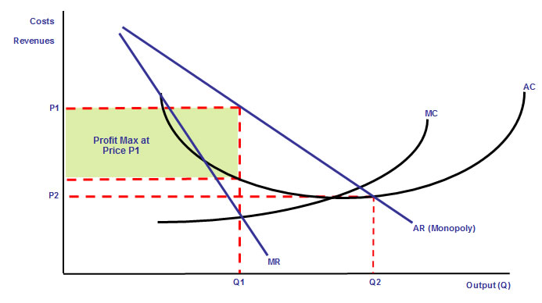

In the diagram above a pure monopoly might price at P1 – the profit maximising equilibrium.

If a market is [contestable](http://www.tutor2u.net/blog/index.php/economics/tagged/tag/contestable/), there is **downward pressure on price**, because the presence supernormal profits signals for new firms to enter the market and if the existing monopolist is producing at too high a price or has allowed their average total costs to drift higher, entrants can undercut the monopolist and some of the abnormal profit will be competed away.

Normal profit equilibrium occurs when average revenue equals average total cost (at output Q2 and price P2). A lower price and higher output causes an increase in [**consumer surplus**](http://tutor2u.net/blog/index.php/economics/tagged/tag/consumer+surplus/).

When markets are [contestable](http://www.tutor2u.net/blog/index.php/economics/tagged/tag/contestable/) – we expect to see **lower profit margins** than when a monopoly operates without competition.

The threat of competition may be just as powerful an influence on the behaviour of the existing firms in a market than the actual entry of new businesses

If a market is contestable, industry structure and firm behaviour is determined by the threat of competition - **'hit-and-run' entry**. The market will resemble perfect competition, regardless of the number of firms, since incumbents behave as if there were intense competition.