***Topic 6) Competition Policy and Contestable Markets***

***What is competition policy and what does it seek to achieve?***

|  |
| --- |
|  |

***Outline the role of regulators***

|  |
| --- |
|  |

***What is anti-trust policy?***

|  |
| --- |
|  |

***Explain the following examples of anti-competitive practice***

|  |  |
| --- | --- |
| Anti-competitive practice | Explanation |
| Predatory pricing |  |
| Vertical restraint in the market |  |
| Collusive practices |  |

***What is market liberalisation?***

|  |
| --- |
|  |

***What is state aid in markets?***

|  |
| --- |
|  |

***Use the table below to draw a D & S diagram on the axis provided:***

|  |  |  |
| --- | --- | --- |
| Price | Demand | Supply |
| 2 | 20 | 4 |
| 4 | 16 | 8 |
| 6 | 12 | 12 |
| 8 | 8 | 16 |
| 10 | 4 | 20 |

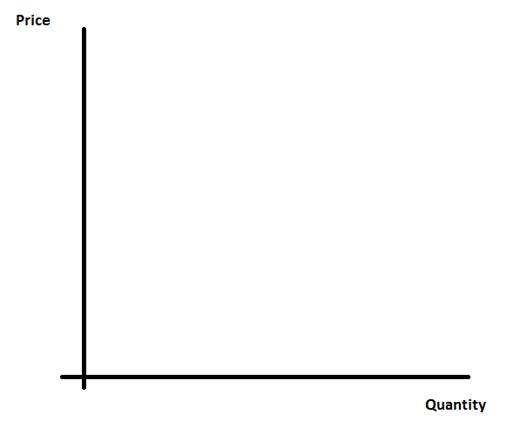

***Use your diagram above to explain the concepts of ‘consumer surplus’ & ‘producer surplus’***

|  |
| --- |
|  |

***Use your diagram above to explain the concept of ‘allocative efficiency’***

|  |
| --- |
|  |

***Explain a range of characteristics of a ‘Contestable market’***

|  |
| --- |
|  |

***Explain the differences between perfect competition & a contestable market***

|  |
| --- |
|  |

***Explain using examples how a market can be made more contestable***

|  |
| --- |
|  |

***How does the threat of competition affect a firm’s behaviour?***

|  |
| --- |
|  |

***Explain using examples the concept of ‘privatisation’***

|  |
| --- |
|  |

***Identify a range of organisations/industries which are still ‘nationalised’***

|  |
| --- |
|  |

***Outline the economic arguments for & against privatisation***

|  |  |
| --- | --- |
| Arguments supporting privatisation | Arguments against privatisation |
|  |  |

***Explain using examples the concept of ‘deregulation’***

|  |
| --- |
|  |

***Identify a range of examples of regulators***

|  |  |
| --- | --- |
| Regulator | Industry they regulate |
|  |  |
|  |  |
|  |  |

***Explain using examples how price capping works***

|  |
| --- |
|  |

***Explain why & how the Role of the Utility Regulator is changing***

|  |
| --- |
|  |

***Complete the following table on market structures***

|  |  |  |  |
| --- | --- | --- | --- |
| Characteristic | Perfect competition | Oligopoly | Monopoly |
| Number of firms |  |  |  |
| Type of product |  |  |  |
| Barriers to entry |  |  |  |
| Supernormal s-run profit? |  |  |  |
| Supernormal l-run profit? |  |  |  |
| Pricing |  |  |  |
| Non-price competition |  |  |  |
| Economic efficiency (allocative & productive) |  |  |  |
| Innovative behaviour |  |  |  |